2009
Limnology Midterm

Name_________________________________________________

1. Give a SHORT definition for 10 of the following terms. (1 pt each)

PAR

Development of shoreline

Holomictic

Maar lake

Mean depth

Langmuir circulation

Hypsographic curve

Seiche

Lotic

Monomictic

Meromictic

Monimolimnion

Trophic state index

Deffeyes diagram

2. Which process is more important in the distribution of oxygen molecules in a lake, molecular diffusion or turbulent diffusion? (2 pts)

3. You have a 50 ml water sample, some 0.01 mM HCl, a burette, a conductivity meter, a Secchi disk, a 1969 Porsche 911 in excellent condition, and a pH meter. You want to know the alkalinity (aka ANC) of the sample. How would you determine it with the equipment provided? Give as much detail as you can. (12 pts)

4. If you had didn’t have the equipment mentioned above but you did have an atomic absorption spectrophotometer that allows you to measure the concentration of major ions in the sample, what alternative method could you use to determine the alkalinity? (5 pts)

5. If a water sample had the following characteristics: alkalinity = 1.5 meq/L, specific conductance = 125 uS/cm, and pH=8.2. What is the most abundant species of inorganic carbon? (1 pt)

6. If a sample had a pH of 9.5 and all the other characteristics were the same as in question 5 what would be the most abundant species of inorganic carbon?

What is the most likely cause of such a high pH in a lake ? (2 pt)

7. Here is some light data from Lake Obama. (Note: answering this correctly requires knowing which curve on the figure is the light intensity data and which one is the ln (light intensity).

What is the light extinction coefficient? (I know you can’t be real precise, but just use the information in the figure as best you can. You can draw on the figure to illustrate how you calculated the extinction coefficient) (12 pts)

8. The data in Q7 was collected on a sunny day. Would the light extinction coefficent be higher, lower, or the same if it had been a overcast day with light intensity at the surface reduced by half? Explain the reason for your answer (3 pts)

9. Describe how temperature influences the density of water (you may draw an illustration to partially answer this question). Describe the significance of this relationship in limnology. (10 pts)

10. Describe the annual cycle of temperature stratification in a 30-m deep lake located in a continental, temperate climate (say South Dakota). (an illustration may be helpful) Be sure to describe the significant features using standard limnological jargon.) (10 Pts)

11. Why are some lakes blue? Why aren’t all lakes blue? (5 pts)

12. What are three ways that lakes can be formed? Give an example of a lake formed by each of the three mechanisms that you describe. (6 points)

13. Mark Rosenkranz mentioned 7 ways the Oswego Corporation is reducing P loading the Oswego Lake. Name 4 of them (4 pt)s

14. Below is a diagram of the nitrogen cycle. What processes are denoted by the transitions labeled? (4 pts)

a._______________________________ b.___________________________________

c.________________________________ d.___________________________________

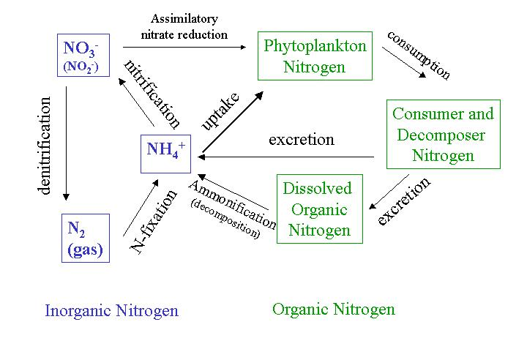
a
b
c
d

15. Why is iron important in the phosphorus cycle in lakes? (10 pts)

