**Assignment #4**

**ESM 221**

**Spring 2017**

Turn in via D2L dropbox

Due date – see D2L

**1. Species area curves**

The number of species changes with area and can be fit to the equation S=CAz. This question explores the meaning of the two parameters, C and z.

Generate 4 species vs area curves using these sets of parameters for areas from 10 hectares to 1000 hectares:

|  |  |
| --- | --- |
| C | z |
| 5 | .2 |
| 5 | .3 |
| 10 | .2 |
| 10 | .3 |

|  |  |  |  |  |
| --- | --- | --- | --- | --- |
| area | 5&.2 | 5&.3 | 10&.2 | 10%.3 |
| 10 | 7.92 | 9.98 | 15.85 | 19.95 |
| 30 | 9.87 | 13.87 | 19.74 | 27.74 |
| 50 | 10.93 | 16.17 | 21.87 | 32.34 |
| 100 | 12.56 | 19.91 | 25.12 | 39.81 |
| 300 | 15.65 | 27.68 | 31.29 | 55.35 |
| 500 | 17.33 | 32.26 | 34.66 | 64.52 |
| 1000 | 19.91 | 39.72 | 39.81 | 79.43 |

You can do this in Excel or other spreadsheet program.

Describe how the curves change with C or z.

Be able to calculate these values with a calculator also.

For one of these sets (C=5 and Z=.2) generate a log species vs. log area graph. Describe how this line fits the equation log(S) = log(C) +z*log(A), i.e. what on the graph corresponds to log(C) and z?

The Y intercept (x=0) = C and the slope of the line is Z.

The Y intercept (x=0) = C and the slope of the line is Z.

**2. Island Biogeography Theory**

The number of species on an island at steady state is a dynamic situation that results from continual immigration and local extinction. This theory is based on observations on a single island and also comparison of species found on multiple islands with different sizes and locations.

Draw an example curve (i.e. no data but representing the processes) for the number of species on a newly formed island vs time. What do the different regions of your curve represent (such as immigration rate, etc.)

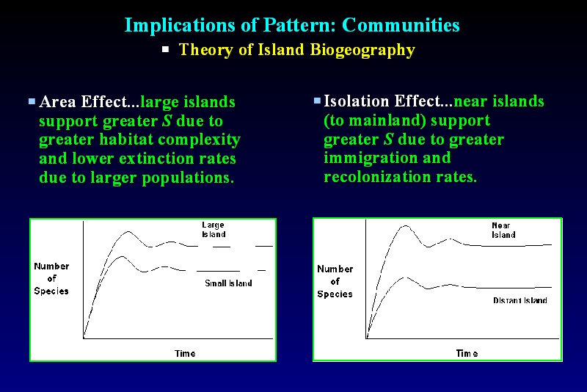

from lecture 11

Draw example sets of points for the extinction rate on islands that have different **EQUILIBRIUM** populations **THAT** are the same **DISTANCE FROM THE MAINLAND BUT DIFFERENT SIZES** from a mainland (that would lay on a curve for extinction rate vs. species number).

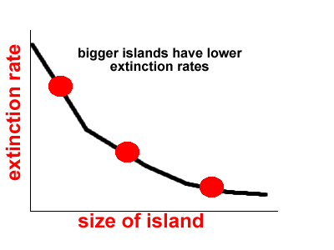

Draw example sets of points for the immigration rate on islands that have different **EQUILIBRIUM** populations **THAT** are the same size **BUT DIFFERENT DISTANCES** from a mainland (that would lay on a curve for extinction rate vs. species number).

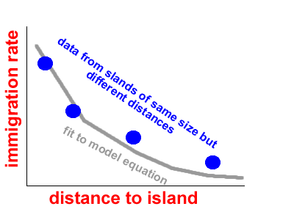

Explain what happens in the two shaded region of this graphical interpretation of the Island Biogeography Theory. What is happening to the number of species in zones 1, 2, or 3? Where is the equilibrium point and why is it at that exact point?

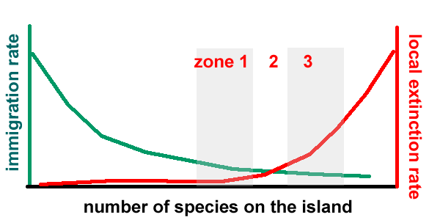

* Zone 1 – more immigration than extinction, species numbers will continue to increase into zone 2
* Zone 2 – immigration = extinction, population will be at dynamic equilibrium
* Zone 3 – extinction rate > immigration rate, number of species will decrease back to zone 2

3. Island Biogeography Theory can applied to urban reserves and corridors.

Draw a map that has one big source of biodiversity and two small parks that have different levels of connectivity.

Create a figure or immigration and extinction rates vs. species number (like we used in Island Biogeography Theory) but showing that the parks have different connectivity (instead of distances).

Explain how manipulating connectivity is analogous to distances in IBT.