draft2-dec5-Xpm.doc

1. Project Title

The influence of humic substances on the growth of Aphanizomenon flos-aquae in Upper Klamath Lake.

2. Project proposer

The principle investigators are John Rueter and Mark Sytsma from the Center for Lakes and Reservoirs associated with the Environmental Sciences and Resources Program at Portland State University. The project is part of a research collaboration with two other investigators, Stan Geiger from Aquatic Scientific Resources and Michael Purdue from Georgia Tech University, working through the firm RealSoft. Curricula vitae are in attachment A.

3. Program information

Upper Klamath Lake has a severe water quality problem due to the growth of Aphanizomenon flos-aquae (AFA). Efforts to understand and control excessive blooms of these cyanobacteria are crucial to restoring the lake for ecosystem health and human uses. The current plan to restore water quality focuses on the reduction of phosphorus loading. Using the TMDL model approach for selecting procedures for reducing phosphorus loading is a scientifically solid approach that should lead to decreased magnitude and frequency of AFA blooms over the long term. Estimates on the time for the TMDL model to lead measurable decreases vary from a decade to longer.

This work proposed here will explore a shorter term control mechanism for AFA. We are proposing that AFA could be inhibited by dissolved organic (specifically humic acids) that are natural products of wetlands and marshes. The simple version of this model ties together the following processes:
1) photoreactive dissolved organic materials (DOM) are created by natural decomposition processes in the marshes,
2) DOM flushed out into the open water of the lake during the spring,
3) DOM has an inhibitory effect on the early-season growth of AFA,
4) even slight retardation of the spring bloom of AFA can lead to a more diverse algal assemblage in the lake during the summer, and
5) a more diverse assemblage of algae (even if AFA is dominant) would have fewer blooms that exceed the crucial threshold and lead to dissolved oxygen and pH problems.
A more detailed description of this model and how we have used this model to identify specific hypotheses is presented in the Background section. Sections 6, and 7 describe the specific tasks and methods we will address these hypotheses.

This proposal describes the first of three phases of work t our consortium plans to conduct. The three phases of the work build in complexity from elucidation of effects of individual factors on AFA, to examination of the interaction of individual factors, and ultimately to an integrated and complex model of the effect of humics on the biological community. The proposed research addresses several processes at season time scales and space scales as small as a particular littoral marsh that could be employed to decrease the frequency and magnitude of AFA blooms.
Phase 1: During the first part of this work it is essential to demonstrate individual effects.
Phase 2: Use the techniques and indicators developed in phase 1 both look at the interactions between individual parameters and increased resolution of the studies.
Phase 3: Develop an integrated model the effect of marsh humics on AFA community ecology that could be used to address the problems of magnitude and frequency of nuisance blooms.

There are several key, individual pieces of the above model that need to be demonstrated in this first phase of the research program;1) we need to demonstrate that humics can inhibit the growth of AFA, 2) we need to understand the biology of AFA filaments, flakes in both the lake and in cultures, 3) we need to put this in the context of the ecology of marsh-lake interactions, and 4) we need to chemically characterize marsh DOM products. We have assembled a research consortium that brings together the expertise to address these questions individually and to build an integrated understanding. The four principle investigators on this proposal have experience in photosynthetic efficiency measurements, lake ecology, nuisance species, AFA biology, and humic acid chemistry. The research plan for the first year has multiple approaches to addressing the potential inhibition and characterization of the humic acids. We will also perform tasks that support the transition later phases such as characterization of potential marsh input, preparation of data for inclusion in a larger model context, and development of techniques required for research in subsequent phases.

WE believe that a successful research program on the effect of humics on AFA will build the capacity to address and evaluate adaptive management strategies for AFA in Upper Klamath Lake. Further, our approach is based upon an integrated pest management paradigm for management of AFA, which incorporates a variety of tools to management problem species that are based upon a thorough understanding of the pest’s biology and ecology. In this context, our work will provide a mechanism for addressing AFA blooms during the period when the nutrient reduction efforts under the TMDL are implemented and prior to their taking effect. Thus, the proposed research complements the TMDL approach.

4. Background

The biology of AFA is crucial its control as a nuisance species.
One of the most important principles of controlling nuisance species is to understand the biology as completely as possible. This understanding helps managers identify both conditions that need to be avoided and also to identify crucial stages in the life history that are most easily disrupted. Aphanizomenon flos-aquae is a poorly understood algal species. Particularly annoying to algal physiologists is that, although this species is a nuisance species in lakes, there are no readily available, stable lab cultures that can be used for autecological work. Several key questions are pertinent to the dominance of AFA in Upper Klamath and Agency Lakes.

- Filaments vs. flakes. Are there physiological differences between AFA filaments vs. flakes? Do flakes help protect the cells from photoinhibition? Do flakes resist predation by zooplankton?
- Strains: Is the AFA we see in the lake just one genetic strain or are their multiple strains that occur throughout the seasons.
- Collapse: Are there particular factors that can lead to the observed catastrophic collapse of the AFA, i.e. are there triggers that lead to an autocatalytic cell death and disruption.

There are spatial and temporal correlations between humics and AFA.
Humic substances, of DOM, are recognized as significant components of many natural waters, and their effects on biota are complex (Steinberg and Muenster, 1985, Stewart and Wetzel 1982, Wetzel 1993). Studies indicate that they can block transmission of harmful UV wavelengths in the water column, but nevertheless result in the inhibition of algae due to binding of essential metals or promotion of the formation of damaging forms of oxygen (Gjessing and Kaellqvist 1991, Imai et al. 1999, Kaczmarska et al. 2000, West et al. 1999). Other effects of DOM on algae include inhibition of alkaline phosphatase (Kim and Wetzel 1993); reduction of light availability (Havens et al 1998); interactions with dissolved iron and phosphorus (Jones et al 1993; Guildford et al 1987, Jackson and Hecky 1980); and complexation of toxic metals (Xue and Sigg 1999). See Section 4.0 of the Geiger et al. 2004 (the ASR report included on the CD) for a review of effects of dissolved organics on algae.

Planktonic algae have been the focus of past work on UKL due to the prominence of AFA during late spring, summer and fall and the role of AFA in influencing lake water quality. Little work has been done on algae present in the wetland areas and in areas of the lake influenced by wetland discharge. Bureau of Reclamation funding for the Klamath Tribes’ data collection supports examination of limnetic samples. A sole exception to the limnetic location of sample sites, has been the Pelican Bay site monitored from 1990-1997. The Pelican Bay station data suggests that the wetlands may influence growth of AFA. Biomass of AFA at the Klamath Tribes Pelican Bay station (in the vicinity of the Upper Klamath Lake NWR) is lower than at other locations (mid-north and mid lake stations of the Klamath Tribes monitoring program) (Figure 1).

Figure 1. Aphanizomenon flos-aquae biomass at the Klamath Tribes-Bureau of Reclamation Pelican Bay monitoring station adjacent to Upper Klamath Lake NWR marsh at two open water stations in Upper Klamath Lake (Mid-Lake and Mid North). Numbers on the x-axis are the numbers of sampling occasions from start of sampling in 1990 through 1995.

Areas in the lake where AFA is not dominant, or is absent, are of obvious interest since environmental factors in these areas may provide clues that could lead to AFA inhibition and control. Absence of AFA, presence of brown water, and pH at mid-day considerably lower than southern lake sites were observed in the summer of 2004 approximately one mile south of the mouth of Thompson Creek (UKL NWR) in north UKL (S. Geiger, personal observation). The absence or reduction of AFA downstream from or within marsh environments have also been noted by others studying the UKL marshes. Forbes (1997) noted the absence of AFA except at the waters off the edge of Hanks Marsh, and Sartoris, Sisneros and Campbell (1993) noted the same in their report on characteristics of Upper Klamath Marsh National Wildlife Refuge. Perdue et al. (1981) noted the absence of AFA in Upper Klamath Lake at a location heavily influenced by the Williamson River that drains extensive wetland areas upstream. Marsh-influenced areas of the lake also may have different zooplankton assemblages than midlake areas. Four species of zooplankton were described as typical in marsh-influenced areas but not in the open waters of the lake (USCOE 1982).

Perdue et al., (1981) observed a correlation between nuisance blooms of Aphanizomenon flos-aquae in Upper Klamath Lake and the flow rate of the Williamson River immediately below Klamath Marsh in 1977-1997. The abstract of the Perdue et al. report concludes with:
“The cessation of flow of humic-rich water from Klamath Marsh during the summer months drastically decreased the flux of aquatic humus, iron, amino acids, and other marsh-derived solutes in the post-marsh Williamson River. At the time of cessation of flow from Klamath Marsh, nuisance blooms of Aphanizomenon flos-aquae appeared in Upper Klamath Lake. Furthermore, when flow from the marsh was re-established with the first major winter rains in November or December, Aphanizomenon flos-aquae abruptly ceased to grow in Upper Klamath Lake. Further studies are planned to determine whether this correlation is causal or coincidental.”

One of the objectives of the proposed research is to determine whether the observed correlation is representative of longer-term behavior of this ecosystem.

Humic acids have important chemical characteristics and biological activity.
From previous studies on humic acids in the marshes in the UKL basin (Barber et al. 1999; Lytle and Perdue, 1981; Peek 1963; Perdue et al.1981) we know that there are a wide variety of materials coming out of different types of marshes. We have no a priori basis for choosing any particular marsh type for producing potentially algistatic or algicidal organics. We do, however, have an end constraint in the context ofmanagement; only certain types of marshes could be included in the lake in sufficient areas to be a viable strategy. For this reason we focused our exploration of the humic components coming from the major marshes represented in the lake already.

The main features that we needed to know about the water coming out of marshes are the total dissolved organic content, the photoreactivity of that material, and the biological activity. All of these factors are multidimensional. For our purposes we would like to have easily measured indicators of amount and reactivity that relate to the inhibitory potentency. For this reason, our analysis of total organic carbon, and absorbance or fluorescence characteristics focused on indices rather than full characterization. For the amount of work that it would take to do a full chemical characterization of the water, we could directly measure inhibition potential using bioassays with algae.

One of the complicating aspects of this type of work is that there are so many possible inhibitory mechanisms. These mechanisms could be acting individually or in combinations to produce the net end-effect. Below is a list of mechanisms that have been demonstrated or proposed by others for the effects of humics on algae:
a. inhibition of cell membrane processes;
b. indirect inhibition of photosynthesis through the production of hydroxyl-radicals from hydrogen peroxide (photo-Fenton reaction) (Van der Zee et al. 1993, Scully et al. 1996);
c. inhibition of alkaline phosphatase and other surface enzymes (Stewart and Wetzel 1982, Kim and Wetzel 1993);
d. impacts on phosphorus and iron availability (Stewart and Wetzel 1982, Francko 1986, Purdue et al. 1981, Klug 2002, Peek 1963, Jones 1998);
e. a large number of possible community structure changes associated with organic carbon availability (for example heterotrophic bacteria competing withautotrophic algae for nutrients) (Williamson et al. 1999, Vahatalo et al. 2003).

The current long-term equilibrium model for controlling AFA blooms is the TMDL model.
Oregon DEQ and other agencies have developed a comprehensive Total Maximum Daily Load (TMDL) model to help meet the requirements of the federal Clean Water Act. This model justifies targetting phosphorus on the basis that this will be the most practical mechanism to reduce algal biomass and thus reduce water quality problems associated with algal blooms (high pH) and die-off (low dissolved oxygen). The estimate for the phosphorus load is derived from empirical relationships between Chlorophyll-a (as a proxy for total algal biomass) and lake-mean phosphorus (Walker 2001). One of the critical assumptions in this model is the rate and amount of the external load (Kann and Walker 2001) compared to how much P is internally recycled (Walker 2001). This factor is not crucial for whether or not the TMDL model will work, but rather how fast the total P in the lake might change; higher internal loading could mean much longer times for the system to come to equilibrium.

Seasonal models of AFA ecology could be combined with and complement the TMDL model to provide more flexible management approaches over the short-term.
Our working model for the seasonal growth of AFA in the lake is that it starts out as individual filaments in the early spring. After a period of rapid growth in well mixed spring conditions, these filaments aggregate into colonies. It is hypothesized that the colonies confer several advantages to AFA including faster floating rates, protection from photoinhibition and UV and reduced susceptibility to grazing. The net effect of this pattern of growth (as shown in Figure 2) is that colonies can accumulate to high densities. It is also hypothesized that the high net colony growth that results in AFA blooms might be kept in check if Daphnia were able to graze the filaments fast enough to keep them below a critical level.

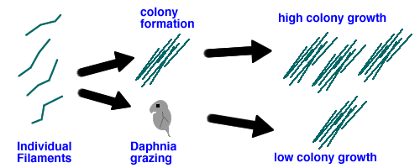
Figure 2. Possible paths for AFA growth. Upper path is when colony formation exceeds grazing and results in a population of colonies that are resistant to grazing. The lower path illustrates the condition in which colony formation from filaments is slow relative to grazing and very few colonies are formed.

The potential importance of the growth rate of individual filaments can be demonstrated with a simple dynamic model. In this model, individual filament growth leads to colony formation. Colonies that are formed grow at a much slower level but are not grazed by Daphnia. Results from this model demonstrate that a reduction of the filament growth rate by only a third (Figure 3) leads to a much different seasonal pattern for the eventual bloom of AFA colonies, i.e. there is a critical tipping point for single filaments necessary to result in very large blooms. If the filament growth is retarded only partially, for example by humic acid inhibition, could lead to suppression of the largest blooms.

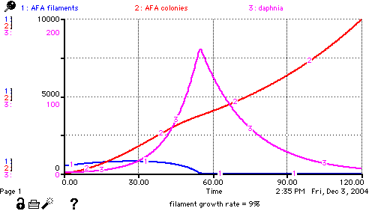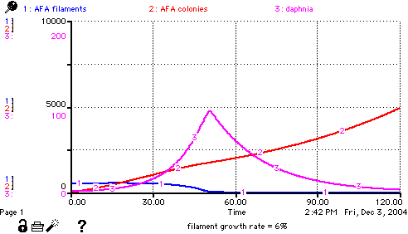
Figure 3. Comparison of AFA bloom dynamics in a community model in which AFA colonies grow at the same rate (1% per day), Daphnia can only eat the filaments, but in which initial filament growth rate is either 9% per day or, reduced by a third to 6% per day from the inflow of marsh water.

Hypotheses:
Based on these background ideas, there three major hypothesis that will be addressed during the summer of 2005.
1. AFA bloom formation is the result of a dynamic combination of processes including single filament growth rate, grazing rates, colonial growth rates and competitive advantages conferred by the colonial form.
2. Natural humic acids that are formed as marsh decomposition products can inhibit algal growth, including AFA.
3. Different marsh composition and marsh environments will produce distinctive chemical signatures.

5. Project Objectives

This proposed research is designed to help decrease the uncertainty associated with implementing projects that help reduce the dense populations of AFA in the lake. Our research consortium have developed hypotheses, and specific tasks to address these hypotheses, that address the interactions between humic acid input from marshes and AFA ecology with multiple approaches and across a range of temporal and spatial scales.

The principle objective of this work is to demonstrate that there is an immediate effect of the humic acid input from current marshes on the annual growth pattern of AFA. The research is also designed to set a framework for estimating the conditions necessary for that local effect (of the immediate inhibition of AFA by humics) to have a larger scale effect on regions of the lake or even the entire lake.

The objectives our research is important because it may suggest additional lake management strategies (involving marsh water input) that could be employed to attain the general goal of the Hatfield Restoration Program to restore a healthy ecosystem, with better water quality and improved habitat for fish.

6. Tasks

Each of our major hypotheses is addressed with several tasks. In addition there are tasks included in this proposal that prepare for the consortium to move to phase 2 in some areas of the work.

There are two tasks that address the hypothesis that filaments and flakes of AFA have different physiologies.
a. Maintain Aphanizomenon flos-aquae cultures, developed by Eric Henry during performance of present ASR contract with FWS, and amplify these cultures for use in laboratory experiments at PSU in early spring 2005.

b. Characterize the photosynthetic productivity of cultures and natural samples of AFA with a series of productivity vs. irradiance energy curves with particular focus on the sensitivity to photoinhibition and differences between filament and colony response. We will use PAM Fluorometery at time scales of tens of seconds to minutes and O2 electrode analysis at time scales of 10 to 60 minutes. We will be able to examine the sensitivity of these forms to stresses (such as high light, temperature, or ultraviolet radiation) as potential factors that might lead to bloom collapse.

There are four tasks that address the hypothesis that humic acids can inhibit AFA.
task c. Demonstrate a spatio-temporal relationship between AFA counts, AFA photosynthetic efficiency, Chla, DOC, pH using transects that link humic sources (Williamson River, Hank’s marsh and Shoalwater Bay marsh) and long-term lake monitoring sites.

task d. Examine the response of natural samples of AFA from the main lake to additions of filtered humic rich water collected from the marsh endpoints of the transects.

task e. Determine whether the correlation previously observed (Perdue et al 1981) between AFA and humic input from the Williamson River has been presented in any subsequent studies.

task f. Examine the photosynthetic response of cultures and natural samples of AFA and their sensitivity to doses of concentrated humic substances that were collected from three different marsh sources.

There are 2 tasks that address the hypothesis that different marsh areas have distinct chemical signatures and biological activity.

task f from above addresses the biological activity of the different marsh sources

task g. Isolate a large quantity of DOM from Klamath Marsh as it flows down the Williamson River, Hanks Marsh and Shoalwater Bay Marsh that can be chemically and spectroscopically using RO .

There are four tasks that help develop background information and techniques that will be necessary for subsequent phases. These are included in the current proposed work because the work could be efficiently included along with the phase 1 tasks.

h. Obtain genetic characterization of the AFA culture and natural samples collected through the growing season of 2005 to determine if there are a progression of genetically distinct strains throughout the year.

i. Follow up on the ongoing preliminary multivariate analysis of the Klamath Tribes’ water chemistry and algae-zooplankton data base (1990-2003). This work is currently part of work being done by ASR for the FWS. The task will be to coordinate a review of analysis with Klamath Tribes, and prepare for relating the analysis to additional environmental variables at UKL such as Williamson River flow and current and wind direction.

j. Continue development of the humic production model that is detailed in Geiger et al. 2004. The task is to improve the estimates the pre-colonial and present aerial production of dissolved organic materials, including humates.

k. Continue development of in-lake enclosure assay techniques and explore using these to assay the effects of dissolved organic materials on growth of Aphanizomenon.

7. Methods

The methods of sampling and analysis are given for every task listed in section 6.

Methods for task a. Maintain Aphanizomenon flos-aquae cultures
Under the current FWS contract with Aquatic Scientific Resources, cultures of Aphanizomenon flos-aquae were established from samples of UKL water obtained August 2003 and July 2004. Methods for establishing cultures and results are provided in Geiger, et al. 2004. A set of the cultures presently at Oregon State University will be selected and moved to Portland State University and maintained in suitable conditions and at an appropriate location there for laboratory testing. In early spring selected cultures will be amplified for use in laboratory assays.

Methods for task b. photosynthetic characterization
The photosynthetic potential of AFA will be characterized at two different time scales, using two different methods. The first method is to examine the oxygen production rate as a function of light (and other factors). This is a standard method and will be done using a Hansatech system that has a Clark-type oxygen electrode built into the design of a 3 mL cuvette. This approach allows us to examine photosynthetic oxygen production and respiration over time scales of tens of minutes to hours. This time scale is appropriate for estimating the net growth rate of cells in the variable light environment they would experience in the lake.

The other method is to use Pulse Amplitude Modulated Fluorometery (PAM Fluorometery). The PAM fluorometer is a very flexible instrument that makes rapid measurements of the fluorescence before and after pulses of different strengths of light. After at least 5 minutes in the dark, the fluorescence should be at a minimum (called F0). This is because all the electron acceptors are oxidized and readily accept electrons. After a saturating light pulse the fluorescence should be at a maximum (Fm). This high fluorescence is because there are few electron acceptors left in the available state to absorb electrons, and the energy is dissipated as fluorescence. The difference between the minimum and maximum fluorescence values (Fv) is an indicator of the number of photons that were absorbed and utilized in the pre-flash condition. Fv/Fm is a robust measurement of potential photosynthetic efficiency of cells. Because this is a ratio of the almost instantaneous measurement, this parameter is particularly useful when studying flakes of AFA. Individual readings of F0 and Fm may differ because of the geometry of the flakes in the cuvette, but the ratio is very robust. The PAM fluorometer also has the capacity to expose the cells to an internally generated (and calibrated) range of light. This is used to generate a relationship between light energy and electron transport rate (ETR). Many studies with different algae and higher plants have shown that ETR is a suitable proxy for short-term photosynthesis under non-stressed conditions (Gilbert et al. 2000). In our work, the light exposures were usually chosen to be light values of 0, 50, 100, 200, 400, 800, and 1200 and 2000 μE m⁻² s⁻¹. A crucial piece of our hypotheses is that under spring conditions with high humics, single filaments of AFA are more sensitive to photoinhibition. We can measure this photoinhibition as the proportion of the short term photosynthesis rate that doe not return after an exposure to high light. Photoinhibition of AFA by humics and light exposure should only be reversible by the synthesis of new cellular material. This means that a 50% photoinhibition should set the cells back one division time.

Both the oxygen electrode and PAM fluorometery methods can be employed to look at either cultures, natural samples from the lake, or incubations.

Methods for task c. marsh-lake transects
Three areas have been identified for further study; Klamath Marsh water that flows into Upper Klamath Lake from the Williamson River, the marsh that is occupies the southern end of Shoalwater Bay, and Hank’s Marsh. We expect that the water that comes into the lake from these marshes will have very different patterns do to the physical situation of each. The design of transects into Hank’s marsh and the marsh in Shoalwater Bay is fairly straightforward. It will be challenging to design a transect sampling strategy into the variable flow of the Williamson outfall because it not only changes with time but the pattern of dispersal of water in the lake changes with wind and current directions. The marsh influence should be highest at the source and decrease with the distance into the lake. In order to connect the measurements on each of these three marsh to existing data, we will perform transects that cover and area from the source to the nearest long term monitoring stations. The location of these transects are given in Figures 5 and 6.

The factors that will be measured in these transects are:
- algal counts for AFA and other major species that might be prevalent in the marshes
- photosynthetic efficiency of algae in the transect (using PAM Fluorometery)
- in vivo/in situ Chlorophyll fluorescence using a Turner Designs Self Contained Underwater Fluorescence Apparatus (SCUFA)
- water chemistry (pH, total and dissolve phosphorus, dissolved organic carbon and nitrogen)
- spectral quality of the water (spectrographic scans of UV wavelengths)

Particular care will be taken to specify the exact methods for counting AFA units, colonies and cells because there has been considerable confusion over the meaning of these counts. A total of at least 100 algae units will be counted in randomly selected fields, where reasonable, for each sample to achieve a ± 20% estimate of unit density (USGS 1989). Taxonomic identification will focus on identifying changes in the phytoplankton community along the marsh-to-lake transects.

The analysis of correlation (in particular an inverse correlation) of DOM against AFA density is obviously the most important analysis for this task. We will also look at the variance spectra for different components of the system. For example, in a study that examined the patchiness of krill in the Southern Ocean, the variance spectra of temperature, Chla fluorescence and krill were compared over a range of scales (Weber et al 1986). In this study of krill, the Fourier spectrum of variability for krill decreased with scale. Our high-resolution transects of the marsh/lake interface would be addressed in a similar manner. With spatial resolution of around 10 meters and temporal resolution of multiple days to weeks, we will have a data set that can be used to address the multiple scale process of humic production and AFA inhibition.

Methods for task d. Examine the response of mixtures of natural AFA and filtered marsh water.
Two protocols were used previously to explore humic and light exposure. In both protocols lake water containing AFA was mixed with filtered water containing (or not containing) high concentrations of humic material. In the first protocol these mixtures were exposed to artificial light sources that have only a PAR spectrum or a PAR spectrum plus 8% higher UV light than a sunlight. This system is easy to control but the maximum PAR is in the range of 100 μE m⁻² s⁻¹ and the UVR is only around 5 μE m⁻² s⁻¹. The second protocol used natural light for exposure. This allowed us to give PAR dose rates up to around 1600 μE m⁻² s⁻¹ and UVR doses up to 106 μE m⁻² s⁻¹. In the future, this second protocol should be modified to provide multiple light levels (using neutral screening), UVA + PAR (using a Mylar filter) and just PAR (using a Plexiglas filter).

Methods for task e. Study the correlation between humic input from the Williamson River and depression of AFA.
Perform a thorough literature review to find all documentable instances where the timing of blooms of Aphanizomenon flos-aquae can be established with reasonable accuracy and the flow rate of the Williamson River at WR50 can be determined from the USGS gauging data or modeled by comparing historical gauging data with meteorological data (rainfall, temperature, and barometric pressure) that are also available (e.g., from Kingsley Field at Klamath Falls). A consistent pattern was observed in 1977-79 (Perdue et al 1981). An important aspect of this task is to make appropriate connections between different data sources.

Methods for task f. Examine the effect of concentrated humic substances on AFA.
The DOM collected from Klamath Marsh (see next task) will be used for bottle or cubitainer scale experiments in Upper Klamath Lake at the onset of the annual bloom of Aphanizomenon flos-aquae. Generally, the concentrated DOM samples from Klamath Marsh should first be amended with major cations, anions, silica, and iron until the inorganic chemical composition, which will be perturbed during the RO process, has been restored. For example, if major cations are removed during RO using an H⁺-saturated cation exchange resin, then those cations should be added back to the concentrated DOM, either as their respective hydroxides or carbonates. After re-adjustment of the inorganic composition, the concentrated sample from Klamath Marsh will contain inorganic matter and DOM in the same proportions as they existed in un-concentrated water from Klamath Marsh. The experimental protocol should probably include a series of cubitainers into which variable quantities of the concentrated DOM can be added. In this fashion, the growth response of Aphanizomenon flos-aquae can be examined over a realistic range of DOM concentrations. The response of AFA in these cubitainers will be followed with both cell counts over several days and short term changes in the photosynthetic activity using either PAM fluorometery or the oxygen electrode apparatus.

Methods for task g. Isolate and characterize large quantities of DOM from Marsh water
Large quantities of dissolved organic matter (DOM) from Klamath Marsh will be isolated using the reverse osmosis (RO) methodology that has been developed at Georgia Tech (Serkiz and Perdue, 1990; Sun et al., 1995). A portable RO system can be deployed at Klamath Marsh in the spring time, while the flow rate at WR50 is still very high. In a few days a large quantity of DOM can be collected. In ten days, we can process 15,000 L of water from Klamath Marsh to obtain more than 600 grams of DOM in a volume of 20-30 25-L carboys, which is easily transported by van to Upper Klamath Lake.

Most of the concentrated DOM from Klamath Marsh will be used directly in reconstitution experiments (see task h below); however, a small aliquot of the concentrated DOM will be further purified in the laboratory to remove major cations, anions, and silica using well-established methods. Then the purified samples will be freeze-dried. The elemental composition (C, H, O, N, S), acidic functional groups (carboxylic acids and phenols), number-average molecular weight (by vapor pressure osmometry), and apparent distribution of molecular weights (by size-exclusion chromatography) of the freeze-dried sample of DOM from Klamath Marsh will be determined in the laboratory or in a suitable commercial laboratory. From the elemental composition, carboxyl content, and number-average molecular weight, the method of analytical constraints modeling (Perdue, 1984) will be used to estimate the most probable distribution of aliphatic, aromatic, and other unsaturated carbon in this sample. Predictions of the structural-compositional model will be compared with the distribution of carbon that is obtained from CP-MAS ¹³C nuclear magnetic resonance spectrometry. The elemental composition will also be used to calculate the degree of unsaturation (rings and pi-bonds) and the average oxidation state of organic carbon in the sample.

Such characteristic properties of the DOM from Klamath Marsh will be compared with similar properties for representative standard and reference humic substances (data are available from the International Humic Substances Society) to determine the degree to which the DOM from Klamath Marsh differs from those well-characterized materials. These bulk characteristics also provide insight into the bioavailability of the DOM to riverine bacteria, the photochemical properties of the DOM, its redox properties, its acid-base properties, and its metal complexation properties. These chemical characteristics of the DOM will be compared to optical characteristics of the source waters.

Methods for task h. Obtain genetic characterization of Aphanizomenon
The most direct way to determine if there are multiple strains of AFA over the season is to use molecular techniques. Carmichael Labs will perform genetic taxonomy for Aphanizomenon in samples from UKL during the 2004 AFA growing season. The lab analyses will be genetic taxonomy based PCR profile testing on six Klamath Lake (water/algae) samples to be received during the course of the project. The samples will be analyzed similar to the protocol described in Li et al. 2000 and Li and Carmichael 2003. Following PCR analyses, the original samples (if not lyophilized), will be stored for one month or for the length of the study period (which ever is longest), and the extracts can be stored for 1 year.

Methods for task i. Associate Klamath Tribes’ chemistry and algae-zooplankton data base with other UKL information and environmental variables
This work will follow on the preliminary multivariate analysis of the Klamath Tribes’ data base that is presently a work element of the current ASR FWS contract (see Geiger et al. 2004). ASR will continue to work with the Tribes to clarify analytical procedures for the multivariate analysis and to sort out methodological and quality assurance issues to develop the 1990 – 2003 algae and zooplankton data set to accompany the lake water chemistry data set for the same period. Results from the first stages of the multivariate analysis will be shared with the Klamath Tribes for input to further more focused analyses.

In addition to this multivariate effort to assess water chemistry or biological influences on the growth of Aphanizomenon, we will examine the feasibility of using other information to further evaluate the influence of factors other than water chemistry on the growth of AFA. All available information will be organized in a manner that will allow us to get a more qualitative picture of what is going on in the lake. We will integrate the biological and chemical data with a variety of other types of information including satellite images, aerial photographic images of the lake, Williamson River flows and quality, Wood River-Sevenmile Canal flows and quality, wind and currents at UKL, UV measurements, and solar radiation.

Methods for task j. Develop humic production model
The natural humic production and transport form inlake wetlands along with the wetland hydrodynamic factors are necessary for developing a model that can be used to estimate humic production and timing of the release. This type of model can then be used to interact with existing lake models that show the effects of advection, wind mixing, and stratification in Upper Klamath Lake. A water balance around an existing inlake wetland that interacts both with inflows and groundwater would be used to determine these factors.

Determining the water balance through a littoral wetland is essential for modeling export of humics into the lake. There are difficulties because of the complexity of the inputs and outputs of water and the hydraulic considerations. Factors that are difficult to parameterize in lake wetlands are listed below:

- groundwater addition via the bottom of the wetland
- diffused shallow groundwater and surface flows into the wetland
- groundwater recharge
- outflows from the extensive wetland margin/s with the lake
- inflows from the extensive wetland margin/s with the lake
- condensation and ET from wetland plant community (micro-meteorological factors)
- hydroperiod of wetland compared to lake-energy gradient for mass transfer
- seasonal wetland plant moisture content
- moisture content (storage) in the detritus material and shallow soil layer

The approach to determining the water levels and specific water quality factors such as conductance and temperature will involve the use of portable multilevel probes placed strategically in a transect in the inlake wetland. Data loggers will capture hourly data for the critical months in terms of inflow and lake elevation change. This data along with the humic concentration measured weekly at this point and points with the lake adjacent to the inlake wetlands will be used to calibrate the model.

Model development will start with hydraulic models presently used by one of us (Gearheart) to determine head loss through constructed and restored wetland. This model depends on estimating the headloss through the litter layer and through the aquatic plants at various hydroperiods in the wetland. Wetland ET is also a factor in large wetland systems as is the groundwater flux through the wetland.

Methods for task k. continue development of a limno-corral methodology for community studies
In-lake enclosure development, deployment and testing have been described in Section 5.0 of Geiger et al. 2004. We will construct eight 1.3 m diameter enclosures for deployment at the previously chosen test location in UKL near the NE end of the Skillet Handle at Running Y Ranch Resort. We anticipate that the enclosures will be used to test effects of concentrated samples of water from two or three marshes and from flooded field barley decomposition on growth of AFA. ASR has been developing this technology and will assist PSU staff or students with maintenance and monitoring of the enclosures through the test period. Counts of AFA from vertical tube samples of enclosure and lake water will be done by ASR (see description of methods in Task c above). ASR will assist with removal of the enclosure array on cessation of testing.

8. Specific Work Products

A comprehensive report will be produced at the end of the first season of field and laboratory work. This report will include an extensive background section that sets our three major hypotheses in the context of adaptive management goals for the Upper Klamath Lake system. The results from each task will be presented. This report will explicitly address the status of each of hypothesis and whether the tasks need to be modified to make further progress. The report will contain specific recommendations for application of the results of this study and an evaluation of further studies that will be required.

9. Project Duration

a. The project would start as early as possible in Spring 2005 to catch the start of the AFA population before the bloom and sample the Williamson River during peak humic concentration. The field work (specifically the transects described in task c) will span the time from early May to September.

b. At the end of this year of work, the project report will specifically address which tasks need more work before we are ready to address more complex interactions between factors (i.e. move to phase 2). For example, a crucial decision will be whether there is a chemical signature from marsh water that indicates its AFA inhibitory activity. Such a chemical signature would allow us to increase the spatial and temporal resolution on our transect studies of the interaction between marsh water and AFA inhibition.

c. A month-by-month time table for the tasks is given below. The notification date is assumed to be sometime in April. The crucial parts of this time table are the collection of early bloom samples in May and the coordination between the collection/concentration of DOM material and the use of these in biological assays. Some tasks are ongoing and would be addressed before field season and throughout the project. Other tasks would be performed after the field season.

The number of x’s indicates the relative intensity of this project within any given month.

TASK | on-  going | Apr | May | Jun | Jul | Aug | Sep | after  field | Jan-  Mar  2006
a. maintain cultures | xxx
b. characterize  photosynthesis of AFA |  | xxx | xx | x | x | x | x
c. transects from marsh to lake |  | xx | xx | xx | xx | xx | xx
d. AFA + marsh water |  | xx |  | xx |  | xx
e. Williamson flow and AFA correlation -literature | xxx
f. AFA + concentrated humics |  |  |  | xxx | xxx
g. isolate large quantities of DOM |  | xxx | xxx
h. genetic characterization of AFA |  | x | x | x | x | x | x | xxx
i. Multivariate analysis of data | xxx
j. estimation of humic production on an aerial basis | xxx
k. development of large scale in-lake assay techniques |  |  |  |  |  | xxx | xxx
collaboration on data analysis and writing report |  |  |  |  |  |  |  |  | xxx

10. Permits

Our consortium currently has a scientific use permit for working in the refuge system. This was issued to the consortium by Dave Mauser.

11. Landowner Participation

There are no tasks that require explicit landowner approval or cooperation in this phase of the research.

12. Data Handling and Storage

During the project the data that is collected will be made available to the consortium through a website maintained by CLR. At this point the data will not be publicly available. As the report is written, the data and information for each task will be evaluated and reviewed. The annual report for this phase of the project will include the relevant data. Other data will be made available on the website and published on a CD that will accompany the final report.

13. Cost-Sharing

Portland State University has agreed to contribute the difference between the 15% overhead rate allowed on this project and the Federally negotiated indirect cost rate of 42% for this project. This difference is shown as a cost-share provided by PSU.

14. Budget

The budget forms are provided as Attachment C.

15. Project Location

This proposed work would focus on three locations in Upper Klamath Lake; a transect near the mouth of the Williamson to the Klamath Tribes long-term station Mid-North, a transect from the marsh to the Shoalwater Bay station, and a transect from Hanks marsh out to the North Buck Island station. These are shown in figures 4, 5 and 6 below.
Figure 4. Map of the in-lake stations in Upper Klamath Lake and Agency Lake. The sites MN-Mid North, SB – Shoalwater Bay and NB – North Buck Island are the focus of this project.
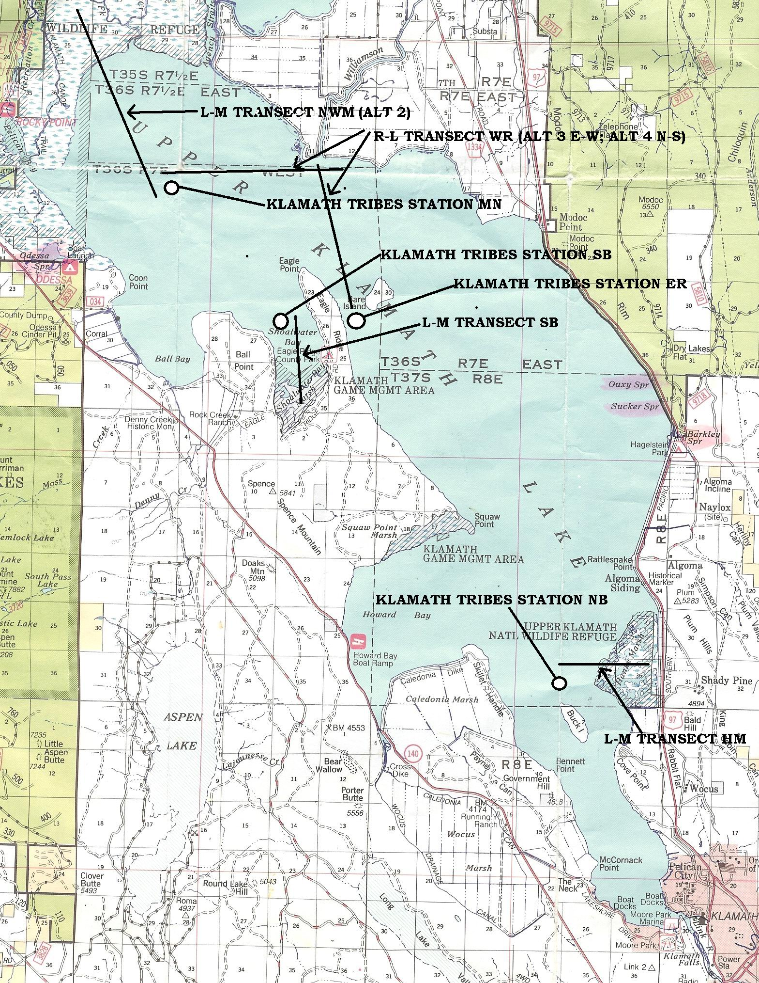

Figure 5. Proposed location of three marsh-lake monitoring transects and Klamath Tribes-Bureau of Reclamation water chemistry and phytoplankton-zooplankton monitoring stations. Map source Winema National Forest 1994 map (common grid square width = 1 mile). This map also shows some alternative transects that we are considering that link the mouth of the Williamson with the ER station and a transect from station MN into Pellican Bay.

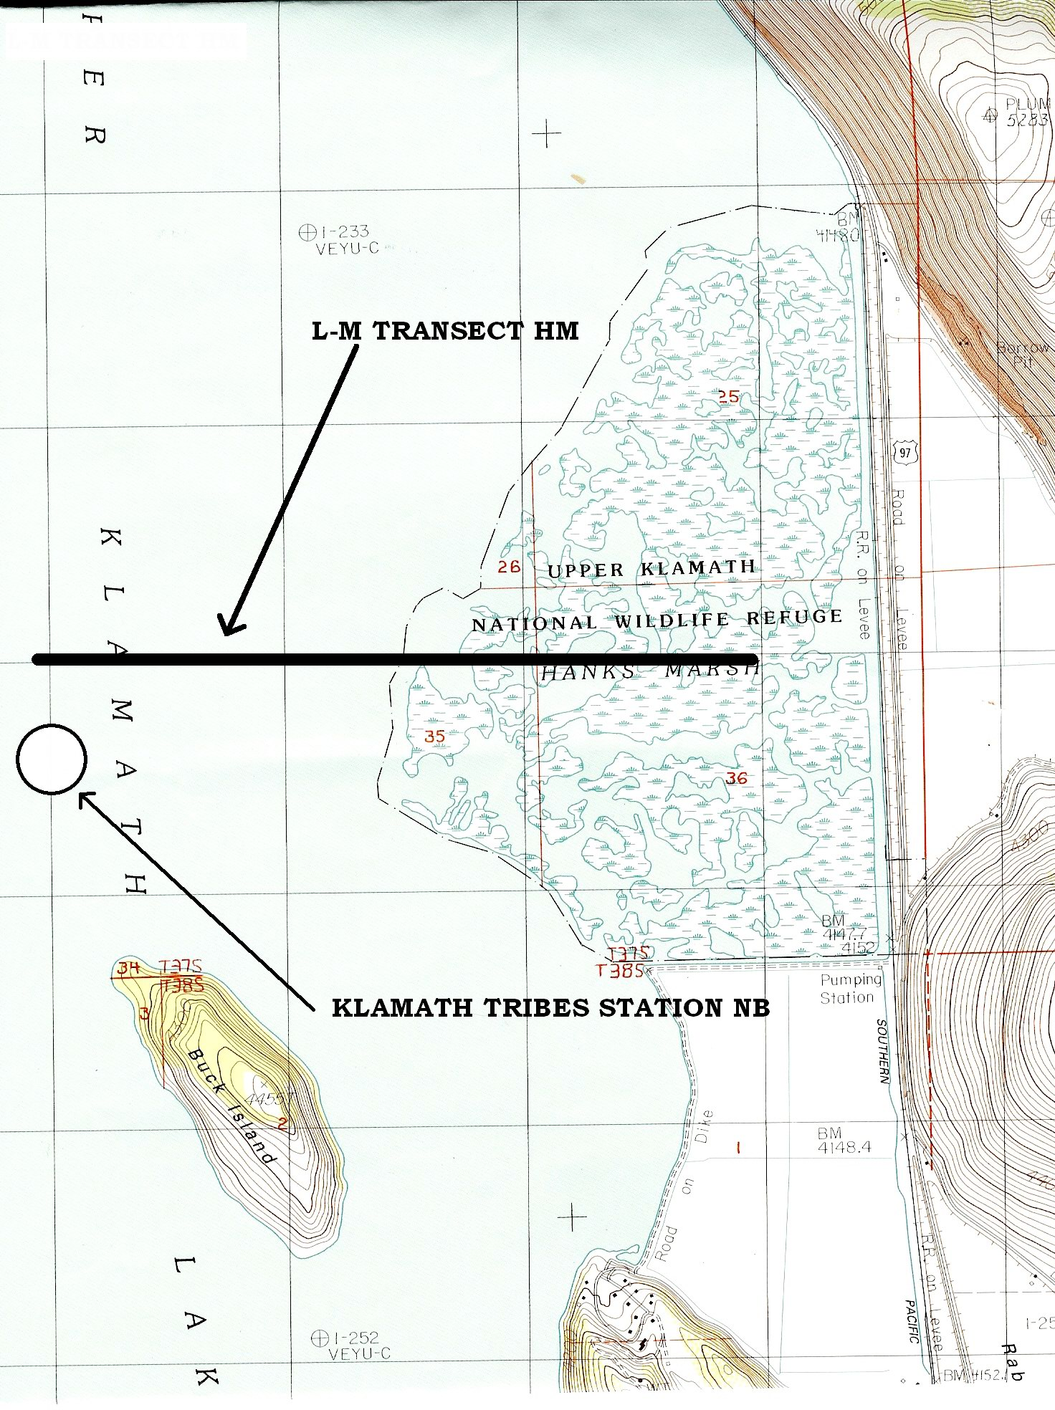
Figure 6. Detail of proposed location of the Hanks Mash marsh-lake transect in relation to location of the North Buck Island Klamath Tribes-Bureau of Reclamation water quality monitoring station. Map source USGS 1985 7.5 min. topo. Quad. (grid square width = 1 kilometer).

16. Other Partners/Cooperation

This project is and extension of a previous collaborative effort. The project is being coordinated through PSU’s Center for Lakes and Reservoirs. The previous project involved John Rueter, Stan Geiger, Eric Henry and Bob Gearhart. Stan Geiger will continue to this collaboration extends that to include Mike Purdue as a sub-contractor who will focus on the

17. Performance Plan

number of sample times and sites
successful sample series – that creates useful data series
the data
outcome is the report with recommendations and plan for next phases

18. Literature Cited

Barber, Larry B., Jerry A. Leenheer, Ted I. Noyes, and Eric A. Stiles. 1999. Wetlands and riparian habitat initiative. Transformation of dissolved organic carbon in constructed wetland systems. Prepared for the Bureau of Reclamation, Denver, Co. Prepared by the U. S. Geological Survey, National Research Program, Boulder, Colorado. January 1999.

Forbes, Margaret. 1997. Horizontal zonation of periphyton in Hanks Marsh, Upper Klamath Lake, Oregon. MS thesis presented to the faculty of Humboldt State University, Environmental Systems: Engineering, Arcata, California. February 1997.

Forbes, Margaret G., James J. Sartoris, and David Sisneros. 1998. Selected water quality dynamics and horizontal zonation of water quality in Hanks Marsh. Technical Memorandum No. 8220-98-11. Technical Service Center, Denver, Colorado. Bureau of Reclamation. July 24, 1998.

Francko, D. A. 1986. Epliminentic phosphorus cycling: Influence of humic materials and iron on coexisting major mechanisms. Can. J. Fish. Aquat. Sci. 43: 302-310.

Geiger, N. Stan, Robert Gearhart, Eric Henry and John Rueter (2004) “Preliminary Research on Aphanizomenon flos-aquae at Upper Klamath Lake, Oregon: Investigations to set direction for research of factors with potential for influencing Aphanizomenon growth at Upper Klamath Lake.”– also provided on the CD

Gilbert, Matthias, Christian Wilhelm and Michael Richter. 2000. Biooptical modelling of oxygen evolution using in vivo fluorescence: Comparison of measured and calculated photosynthesis/irradiance (P-I) curves in four representative phytoplankton species. J. Plant Physiology (Berlin). 157:307-314.

Gjessing, ET; Kaellqvist, T. 1991 . Algicidal and chemical effects of u.v.- radiation of water containing humic substances. Water Research vol. 25, no. 4, pp. 491-494.

Guildford, S.J., F.P. Healey, R.E. Hecky. 1987. Depression of primary production by humic matter and suspended sediment in limnocorral experiments at Southern Indian Lake, Northern Manitoba. Canadian Journal of Fisheries and Aquatic Sciences. 44:1407-1408.

Havens, K.E., E. J. Phlips, M. F. Cichra, and B. Li. 1998. Light availability as a possible regulator of cyanobacteria species composition in a shallow subtropical lake. Freshwater Biology 39:547-556.

Hillebrand, Helmut, Claus-Dieter Durselen, David Kirschtel and Utsa Pollingher and Tamar Zohary. 1999. Biovolume calculation for pelagic and benthis microalgae. J. Phycol. 35:403-424.

Imai, A; Fukushima, T; Matsushige, K. 1999. Effects of iron limitation and aquatic humic substances on the growth of Microcystis aeruginosa. Canadian Journal of Fisheries and Aquatic Sciences Vol. 56, no. 10, pp. 1929-1937.

Jackson, T.A., R.E. Hecky. 1980. Depression of primary productivity by humic matter in lake and reservoir waters of the boreal forest zone. Canadian Journal of Fisheries and Aquatic Sciences. 37: 2300- 2317.

Jones, Roger I. 1998. Phytoplankton, primary production and nutrient cycling, Chapter 7. In: Aquatic Humic Substances, D.O. Hessen and L. J. Tranvik (eds). Ecological Studies, Vol. 133. Springer- Verlag, Berlin. pp 145- 175.

Jones, R.I., P. J. Shaw, H. DeHaan. 1993. Effects of dissolved humic substances on the speciation of iron and phosphate at different pH and ionic strength. Environmental Science and Technology 27:1052-1059.

Kaczmarska I, Clair TA, Ehrman JM, MacDonald SL, Lean D, Day KE. 2000. The effect of ultraviolet B on phytoplankton populations in clear and brown temperate Canadian lakes. Limnology and Oceanography 45 (3): 651-663.

Kann, Jacob. and W. Walker. 1999. Nutrient and hydrologic loading to Upper Klamath Lake, Oregon 1991-1998 (Draft Report). Prepared for the Bureau of Reclamation, Klamath Falls, Oregon. November 1999.

Kann, J. and W. W. Walker. 2001. Nutrient and hydrological loading to upper Klamath Lake, Oregon. 1991-1998, prepared for Klamath Tribes Natural Resources Department & U.S. Bureau of Reclamation.

Kim, Bomchul and Robert G. Wetzel. 1993. The effect of dissolved humicsubstances on the alkaline phosphatase and the growth of microalgae. Verh. Internat. Verein. Limnol. 25: 129-132.

Klug, Jennifer L. 2002. Positive and negative effects of allochthonous dissolved organic matter and inorganic nutrients on phytoplankton growth. Can. J. Fish. Aquat. Sci. 59: 85 95.

Li, R., Carmichael, W.W., Liu, Y. and Watanabe, M.M. 2000. Taxonomic re-evaluation of Aphanizomenon flos-aquae NH-5 based upon morphology and 16S rRNA gene sequences. Hydrobiologia, 438(1): 99-105.

Li, R.H. and W.W. Carmichael. 2003. Morphological and 16S rRNA gene evidence for reclassification of the paralytic shellfish toxin producing Aphanizomenon flos-aquae LMECYA 31 as Aphanizomenon issatschenkoi. J. of Phycol. 39. 814-818.

Lytle, Charles R. and Edward M. Perdue. 1981. Free, proteinaceous, and humic-bound amino acids in river water containing high concentrations of aquatic humus. Environmental Science & Technology 15(2):222-228.

Peek, Chester Allen. 1963. The humic water of Klamath Marsh and its effect on the growth of Anabaena cyclindrica Lemm. 1963. Ph.D Thesis, Oregon State University. 138 pp.

Perdue, E.M., C. R. Lytle, M. S. Sweet, and J. W. Sweet. 1981. The chemical and biological impact of Klamath Marsh on the Williamson River, Oregon. Environmental Sciences and Resources, Portland State University, Portland, Oregon, March 1981

Sartoris, J.J., D. Sisneros and S. G. Campbell, 1993. Upper Klamath Lake Wetlands Study. Pages 189-221 in S.G. Campbell, editor.Environmental Research in the Klamath Basin, Oregon - 1991Annual Report. USDI, Bureau of Reclamation, Denver Office, Research and Laboratory Services Division, Applied Sciences Branch. Bureau of Reclamation Report R-93-16. September, 1993.

Scully, N. M., D. J. McQueen, D. R. S. Lean and W. J. Cooper. 1996. Hydrogen peroxide formation: The interaction of ultraviolet radiation and dissolved organic carbon in lake waters along a 43- 75°N gradient. Limnol. Oceanogr. 41(3): 540-548.

Steinberg, C and U. Muenster. 1985. Geochemistry and geological role of humic substances in lake water. Pages 105-145 in G. R. Aiken, D. M. McKnight, R. L. Wershaw, and P. MacCarthy, eds. Humic substances in Soil, Sediment, and Water: Geochemistry, Isolation, and Characterization. John Wiley & Sons, New York.

Stewart, A. J. and R. G. Wetzel. 1982. Influence on dissolved humic materials on carbon assimilation and alkaline phosphatase activity in natural algal-bacterial assemblages. Freshwater Biology. 12: 369-380.

U. S. Army Corps of Engineers. 1982. Upper Klamath Lake, Oregon. Potential eutrophication control measures for Upper Klamath Lake, Basin Water Resources Development Project. Contract No. DACW07-81-C-0045. USACE, San Francisco District. October 1982.

U. S. Geological Survey. 1989. Techniques of Water-Resources Investigations of the United States Geological Survey. Book 5, Chapter A4: Laboratory Analysis. Methods for collection and analysis of aquatic biological and microbiological samples. E. J. Briton and P. E. Greeson eds.

Vahatalo, Anssi V., Kalevi Salonen, Uwe Munster, Marko Jarvinen, and Robert G. Wetzel. 2003. Photochemical transformation of allochthonous organic matter provides bioavailable nutrients in a humic lake. Arch. Hydrobiol. 156 (3):287-314.

Van der Zee, Jolanda, Bellona B. H. Krootes, Colin F. Chignell, Tom M. A. R. Dubbelman, and John Van Steveninck. 1993. Hydroxyl radical generation by a light-dependent fenton reaction. Free Radical Biology and Medicine. 14:105-113.

Walker, W. W. 2001. Development of a phosphorus TMDL for Upper Klamath Lake, Oregon. Report prepared for Oregon Department of Environmental Quality. http://www.dequ.or.us/wq/UprKlamath/Walker_Report.pdf.

Weber, L.H., S.Z. El-Sayed, and I. Hampton. 1986. The variance of phytoplankton, krill and water temperature in the Antarctic Ocean south of Africa. Deep-Sea Research 33: 1327-1343.

West L. J.A, Greenberg B.M, Smith R.E.H. 1999. Ultraviolet radiation effects on a microscopic green alga and the protective effects of natural dissolved organic matter. Photochemistry and Photobiology 69 (5): 536-544.

Wetzel, Robert. 1993. Humic compounds from wetlands: complexation, inactivation, and reacivation of surface-bound and extracellular enzymes. Verh. Internat. Verein. Limnol. 25:122-128.

Williamson, Craig E., Donald P. Morris, Michael L. Pace and Olaf G. Olson. 1999. Dissolved organic carbon and nutrients as regulators of lake ecosystems: Resurrection of a more integrated paradigm. Limnol. Oceanogr. 44(3, part 2): 795-803.

Xue, H., L. Sigg. 1999. Comparison of the complexation of Cu and Cd by humic and fulvic acids and by ligands observed in lake waters. Aquatic Geochemistry. 5:313-335.

19. Land Management Plan

Not applicable

20. Project Summary

Please see Attachment D

List of Attachments

Attachments A: Curricula vitae for both principle Investigators and both contractors
Attachments B: Letters from both contractors stating their willingness to collaborate.
Attachment C: Budget forms
Attachment D: Hatfield Restoration Program, Fiscal Year 2005, Project Summary Sheet.

CD – contains the draft report by Aquatic Scientific Resources Wetland Research Consortium on : Geiger, N. Stan, Robert Gearhart, Eric Henry and John Rueter (2004) “Preliminary Research on Aphanizomenon flos-aquae at Upper Klamath Lake, Oregon: Investigations to set direction for research of factors with potential for influencing Aphanizomenon growth at Upper Klamath Lake.”

The CD also contains a pdf version of this proposal “PSU-proposal”

