draft1-dec4-2pm.doc

1. Project Title
The influence of humic substances on the ecology of Aphanizomenon flos-aquae in Upper Klamath Lake.

2. Project proposer
The principle investigators are John Rueter and Mark Sytsma from the Center for Lakes and Reservoirs associated with the Environmental Sciences and Resources Program at Portland State University. The project is part of research collaboration with two other investigators, Stan Geiger from Aquatic Scientific Resources and Michael Purdue from Georgia Tech University, working through the firm RealSoft. Curricula vitae are in attachment A.

3. Program information
Upper Klamath Lake has a severe water quality problem due to the growth of Aphanizomenon flos-aquae (AFA). Efforts to understand and control excessive blooms of these cyanobacteria are crucial to restoring the lake ecosystem for both ecosystem health and human uses. The current plan to restore water quality focuses on the reduction of phosphorus loading. Using the TMDL model approach for selecting procedures for reducing phosphorus loading is a scientifically solid approach that should lead to decreased magnitude and frequency of AFA blooms over the long term. Estimates on the time for the TMDL model to lead measurable decreases vary from a decade to longer (reference*).

This proposed work will explore a short-term response model of AFA to dissolved organic (specifically humic acids) that are natural products of wetlands and marshes. The simple version of this model ties together the following processes:
1) photoreactive dissolved organic materials are created by natural decomposition processes in the marshes,
2) during a natural water year, these materials would flush out into the open water of the lake during the spring,
3) this DOM has an inhibitory effect on the early growth of AFA,
4) even slight retardation of the spring bloom of AFA can lead to a more diverse algal assemblage in the lake during the summer, and
5) a more diverse assemblage of algae (even if AFA is dominant) would have fewer blooms that exceed the crucial threshold and lead to DO and pH problems.
A more detailed description of this model is presented in the section “4. Backround” and how we have used this model to identify specific hypotheses. Sections 5, 6, and 7 describe in detail how we will address these hypotheses.

This proposal describes the first of three phases of work on five topics that our consortium plans to conduct. The three phases of the work build in complexity from individual factors to interacting factors to an integrated and complex model of the effect of humics on the biological community.
Phase 1: During the first part of this work it is essential to demonstrate
Phase 2: Use the techniques and indicators developed
Phase 3: Develop and integrated model for

The five topics are: 1) the direct inhibition of AFA populations by humics, 2) the characterization of humic material and specific inhibitory activity, 3) the interactive effects of humics, AFA and the rest of the biological community, 4) the potential input of the amount and quality of humics from different sources in the basin, and 5) an integrated model for short term changes in AFA bloom frequency and size based on hydrology, humic production rates and community ecology. In this first phase, there are several key, individual pieces of the above model that need to be demonstrated. In particular we need to demonstrate that natural marsh products inhibit the growth of AFA and we need to characterize the products. The research plan for the first year has six approaches to addressing the potential inhibition and it has two approaches to characterizing the humic acids. During this time we will also perform tasks that support the transition later phases such as characterization of potential marsh input, preparation of data for inclusion in a larger model context and developing techniques required for the larger studies.

Our consortium is working on the assumption that part of a successful research program on the effect of humics on AFA will be to build the capacity to address and evaluate adaptive management strategies. In this context we are working on providing insight into a short-term model for processes that could complement the TMDL approach. For example, it may be desirable for ecosystem managers to have the flexibility to use a combination of approaches during the period of time that it takes for the TMDL approach to start having an effect. This proposal addresses several processes on time scales of seasons and space scales as small as a particular littoral marsh area that could be employed to decrease the frequency and magnitude of AFA blooms.

4. Background

Crucial aspects of the biology of AFA as a nusiance species
AFA is a cyanobacterial nuisance species
it is crucial to understand the ecology of nuisance species
several key questions about AFA
filaments vs. flakes (advantage, protection)
genetics of the species (are there multiple strains during the year)
collapse (is there a cue to the onset, pH, O2, temp, respiration, photoinhibition,
found autocatalytic collapses in previous work that seemed to be triggered by hydroxyl-radical and other ROS species

Spatial and temporal observations on the relationship between humics and AFA
Although humic substances are recognized as significant components of
many natural waters, their effects on biota are complex (Steinberg and
Muenster, 1985, Stewart and Wetzel 1982, Wetzel 2001). Some studies
indicate that even though they can block transmission of harmful UV
wavelengths in the water column, they can nevertheless result in the
inhibition of algae due to binding of essential metals or promotion of the
formation of damaging forms of oxygen (Gjessing and Kaellqvist 1991,
Imai et al. 1999, Kaczmarska et al. 2000, West et al. 1999). Other effects
of dissolved organic matter on algae have been reported including
humics inhibiting alkaline phosphatase (Kim and Wetzel 1993); the effect
of dissolved organic material on light availability (Havens et al 1998);
various interactions among dissolved iron, dissolved organic matter and
phosphorus (Jones et al 1993; Guildford et al 1987, Jackson and Hecky
1980); and complexation of toxic metals by dissolved organic matter (Xue
and Sigg 1999). See Section 4.0 of this ASR for a review of other effects
of dissolved organics on algae.

The prominence of AFA during late spring, summer and fall in UKL and
the role of AFA in influencing lake water quality has resulted in the
primary focus of past work on the planktonic algae of the open waters of
the lake. This focus has, however, diverted attention from other algae
that are present in the wetland areas and areas of the lake influenced by
these wetlands during and after the times of the year when AFA is
typically dominant. Bureau of Reclamation funding for the Klamath
Tribes’ data collection supports examination of limnetic samples. A sole
exception to the limnetic location of sample sites, has been the Pelican
Bay site monitored from 1990-1997. The potential influence of wetlands
in the lake on the growth of AFA is suggested by the data on this species’
biomass at the Klamath Tribes Pelican Bay station (in the vicinity of the
Upper Klamath Lake NWR) compared with its biomass at other locations
(mid-north and mid lake stations of the Klamath Tribes monitoring
program) (see Appendix A file UKL PHYTO 1990-1996). Figure 9 shows
the very significant reduction in AFA biomass in the vicinity of the marsh
at Pelican Bay compared with the other open lake stations.

Figure 9. Seasonal occurrence of Aphanizomenon flos-aquae biomass
at the Klamath Tribes-Bureau of Reclamation Pelican Bay monitoring
station adjacent to Upper Klamath Lake NWR marsh as compared with
its biomass at two open water stations in Upper Klamath Lake (Mid-Lake
and Mid North). Numbers on the x axis are the numbers of sampling
occasions from start of sampling in 1990 through 1995.

Areas in the lake where AFA is not dominant or is absent are of obvious
interest since environmental factors in these areas may provide clues that could lead to AFA control. Recent observations of water quality
conditions by the author approximately one mile south of the mouth of
Thompson Creek (UKL NWR) in north UKL were of the absence of AFA,
presence of brown water, and pH in mid-day considerably lower than
southern lake sites. The absence or reduction of AFA just downstream,
at or within marsh environments has been noted by those few scientists
who have spent time obtaining data on marsh character. Forbes (1997)
noted the absence of AFA except at the waters off the edge of Hanks
Marsh, and Sartoris, Sisneros and Campbell (1993) noted the same in
their report on characteristics of Upper Klamath Marsh National Wildlife
Refuge. Perdue et al. (1981) noted the absence of AFA in Upper Klamath
Lake at a location heavily influenced by the Williamson River that drains
extensive wetland areas upstream. The difference of the marsh
influenced areas of the lake was also suggested by a note on zooplankton
differences in the lake where four species of zooplankton were typical
here but not in the open waters of the lake (USCOE 1982).

To determine whether the correlation that was observed in 1977-79 by Perdue et al., 1981 between nuisance blooms of Aphanizomenon flos-aquae in Upper Klamath Lake and the flow rate of the Williamson River immediately below Klamath Marsh is representative of longer-term behavior of this ecosystem. This objective will be accomplished through a comprehensive review of the published and “gray” literature, including public-domain data for the flow rate of the Williamson River below Klamath Marsh (U.S. Geological Survey) and meteorological data for Klamath Falls, Oregon.

The abstract of my 1981 report (Perdue et al., 1981) concludes with the following paragraph:

“The cessation of flow of humic-rich water from Klamath Marsh during the summer months drastically decreased the flux of aquatic humus, iron, amino acids, and other marsh-derived solutes in the post-marsh Williamson River. At the time of cessation of flow from Klamath Marsh, nuisance blooms of Aphanizomenon flos-aquae appeared in Upper Klamath Lake. Furthermore, when flow from the marsh was re-established with the first major winter rains in November or December, Aphanizomenon flos-aquae abruptly ceased to grow in Upper Klamath Lake. Further studies are planned to determine whether this correlation is causal or coincidental.”

marsh water characteristics

characterization of humics and their potential effect
previous chemical studies
Purdue
Hank’s marsh
consortium’s data – short-term inhibition effects from a variety of sources

From previous studies on humic acids in the marshes in the UKL basin
(Barber et al. 1999; Lytle and Perdue, 1981; Peek 1963; Perdue et al.
1981) we know that there are a wide variety of materials coming out of
different types of marshes. We have no a priori basis for choosing any
particular marsh type for producing potentially algistatic or algicidal
organics. We do, however, have an end constraint in the context of
management; only certain types of marshes could be included in the lake
in sufficient areas to be a viable strategy. For this reason we focused our
exploration of the humic components coming from the major marshes
represented in the lake already.

The main features that we needed to know about the water coming out of
marshes are the total dissolved organic content, the photoreactivity of
that material, and the biological activity. All of these factors are multidimensional.
For our purposes we would like to have easily measured
indicators of amount and reactivity that relate to the inhibitory
potentency. For this reason, our analysis of total organic carbon, and
absorbance or fluorescence characteristics focused on indices rather
than full characterization. For the amount of work that it would take to
do a full chemical characterization of the water, we could directly
measure inhibition potential using bioassays with algae.

One of the complicating aspects of this type of work is that there are so
many possible inhibitory mechanisms. These mechanisms could be
acting individually or in combinations to produce the net end-effect.
Below is a list of mechanisms that have been demonstrated or proposed
by others for the effects of humics on algae:
a. inhibition of cell membrane processes;
b. indirect inhibition of photosynthesis through the
production of hydroxyl-radicals from hydrogen
peroxide (photo-Fenton reaction) (Van der Zee et al.
1993, Scully et al. 1996);
c. inhibition of alkaline phosphatase and other surface
enzymes (Stewart and Wetzel 1982, Kim and Wetzel
1993);
d. impacts on phosphorus and iron availability (Stewart
and Wetzel 1982, Francko 1986, Purdue et al. 1981,
Klug 2002, Peek 1963, Jones 1998);
e. a large number of possible community structure
changes associated with organic carbon availability
(for example heterotrophic bacteria competing with
autotrophic algae for nutrients) (Williamson et al.
1999, Vahatalo et al. 2003).

The current long-term equilibrium model for controlling AFA blooms is the TMDL model.
TMDL, P loading, P resuspension, input of P to the lake from natural and uncontrollable sources,
time it takes for P loading to change
correlation between P loading and Chla across many lakes may not represent the process within a single lake (Scheffer model) – transition may have to progress to a very low loading level to jump to the alternative state, would still show up as a point on the long-term equilibrium curve

There are short-term models for control of seasonal blooms that could be combined with and complement the TMDL model.
components are AFA response, humic input, community processes (zooplankton grazing), bloom formation processes in a more spatially and temporally heterogeneous algal community

cartoon of processes, filament growth, either to daphnia or protected from grazing by colony formation

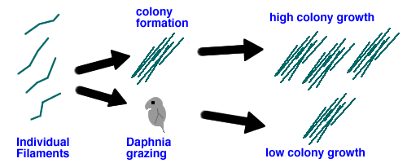
Figure X. Possible paths for AFA growth. Upper path is when colony formation exceeds grazing and results in a population of colonies that are resistant to grazing. Lower path is when colony formation from filaments is slow relative to grazing and very few colonies are formed.

simple dynamic model of this situation shows sensitivity of eventual bloom to inhibition of single filament by only a third
model also shows that this situation is extremely sensitive to the propensity to form filaments (too much leads to lower initial growth, too little leads to no protection)

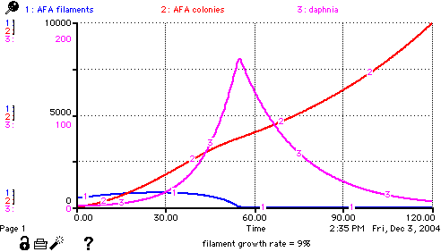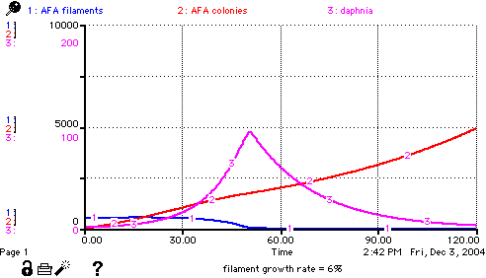
Figure - ***. Comparison of AFA bloom dynamics in a community model in which AFA colonies grow at the same rate (1% per day), Daphnia can only eat the filaments, but in which initial filament growth rate is either 9% per day or, reduced by a third to 6% per day from the inflow of marsh water.

Hypotheses:
Based on these background ideas, there three major hypothesis that will be addressed during the summer of 2005.
1. AFA bloom formation is the result of a dynamic combination of processes including single filament growth rate, grazing rates, colonial growth rates and competitive advantages conferred by the colonial form.
2. Natural humic acids that are formed as marsh decomposition products can inhibit algal growth, including AFA.
3. Different marsh composition and marsh environments will produce distinctive chemical signatures.

5. Project Objectives
Our project has several main objectives:
From proposal – justify proposal area

6. Tasks
Each of our major hypotheses is addressed with several tasks. In addition there are tasks included in this proposal that prepare for the consortium to move to phase 2 in some areas of the work.

There are two tasks that address the hypothesis that filaments and flakes of AFA have different physiologies.
a. Maintain Aphanizomenon flos-aquae cultures, developed by Eric Henry during performance of present ASR contract with FWS, and amplify these cultures for use in laboratory experiments at PSU in early spring 2005.

b. Characterize the photosynthetic productivity of AFA with a time series of productivity vs. irradiance energy curves and parameters, with particular focus on the sensitivity to photoinhibition and differences between filament and colony response. Using PAM Fluorometery at time scales of tens of seconds to minutes and O2 electrode analysis at time scales of 10 to 60 minutes. Examine the sensitivity of these forms to internal and external stresses (such as high light or ****) as potential factors that might lead to bloom collapse.

There are five tasks that address the hypothesis that humic acids can inhibit AFA.

task a from above

task c. Demonstrate a spatio-temporal relationship between AFA counts, AFA photosynthetic efficiency, Chla, DOC, pH using transects that link humic sources (marshes or Williamson River) and long-term lake monitoring sites.

task d. Examine the response of natural samples of AFA to additions of filtered humic rich water collected from the marsh endpoints of the transects.

task e. Determine whether the correlation previously observed (Perdue et al 1981) between AFA and humic input from the Williamson River has been presented in any subsequent studies.

task f. Examine cultures of AFA for P vs. E and sensitivity to doses of concentrated humic substances that were collected from three different marsh sources.

There are 2 tasks that address the hypothesis that different marsh areas have distinct chemical signatures and biological activity.

task f from above

task g. Isolate a large quantity of DOM from Klamath Marsh and two other sources that can be chemically and spectroscopically using RO .

There are four tasks that help develop background information and techniques that will be necessary for subsequent phases. These are included in the current proposed work because the work could be efficiently included along with the phase 1 task and some of these tasks would have to be worked out for a efficient overall project.

h. Obtain genetic characterization of AFA culture and samples collected through the growing season of 2005.

i. Following on the work of performing a preliminary multivariate analysis of the Klamath Tribes’ water chemistry and algae-zooplankton data base (1990-2003), presently included as a work element in ASR present contract with FWS, coordinate review of analysis with Klamath Tribes, and prepare for relating the analysis to additional environmental variables at UKL such as Williamson River flow and current and wind direction.

j. Continue development of the humic production model in the ASR 2004 draft final report (Section 6.0) that estimates the pre-colonial versus present aerial production of dissolved organic materials, including humates.

k. Continue development of in-lake enclosure assay techniques and assist with late spring and early summer assays of effects of dissolved organic materials on growth of Aphanizomenon.

7. Methods
The methods of sampling and analysis are given for every task listed in section 6.

methods for task a. Maintain Aphanizomenon flos-aquae cultures

Under the current FWS contract with Aquatic Scientific Resources, cultures of Aphanizomenon flos-aquae were established from samples of UKL water obtained August 2003 and July 2004. Methods for establishing cultures and results are provided in Geiger, et al. 2004. A set of the cultures presently at Oregon State University will be selected and moved to Portland State University and maintained in suitable conditions and at an appropriate location there for laboratory testing. In early spring selected cultures will be amplified for use in laboratory assays.

methods for task b. photosynthetic characterization

need text style correction here –change to Times
The photosynthetic potential of AFA will be characterized at two different time scales, using two different methods. The first method is to examine the oxygen production rate as a function of light (and other factors). This is a standard method and will be done using a Hansatech system that has a Clark-type oxygen electrode built into the design of a 3 mL cuvette. This approach allows us to examine photosynthetic oxygen production and respiration over time scales of tens of minutes to hours. This time scale is appropriate for estimating the net growth rate of cells in the variable light environment they would experience in the lake.

The other method is to use Pulse Amplitude Modulated Fluorometery (PAM Fluorometery). The PAM fluorometer is a very flexible instrument that makes rapid
measurements of the fluorescence before and after pulses of different
strengths of light. After at least 5 minutes in the dark, the fluorescence
should be at a minimum (called F0). This is because all the electron
acceptors are oxidized and readily accept electrons. After a saturating
light pulse the fluorescence should be at a maximum (Fm). This high
fluorescence is because there are few electron acceptors left in the
available state to absorb electrons, and the energy is dissipated as
fluorescence. The difference between the minimum and maximum
fluorescence values (Fv) is an indicator of the number of photons that
were absorbed and utilized in the pre-flash condition. Fv/Fm is a robust
measurement of potential photosynthetic efficiency of cells. Because this
is a ratio of the almost instantaneous measurement, this parameter is
particularly useful when studying flakes of AFA. Individual readings of
F0 and Fm may differ because of the geometry of the flakes in the
cuvette, but the ratio is very robust.
The PAM fluorometer also has the capacity to expose the cells to an
internally generated (and calibrated) range of light. This is used to
generate a relationship between light energy and electron transport rate
(ETR). Many studies with different algae and higher plants have shown
that ETR is a suitable proxy for short-term photosynthesis under non-stressed
conditions (Gilbert et al. 2000). In our work, the light exposures
were usually chosen to be light values of 0, 50, 100, 200, 400, 800, and 1200
and 2000 μE m-2 s-1.
A crucial piece of our starting hypothesis is that under certain
conditions, AFA is sensitive to photoinhibition. We think these
conditions are the combination of high light exposure and the presence
of photo-reactive compounds. There are protective mechanisms that allow algae to
respond to high light with a temporary decrease in photosynthesis. Our
preliminary work is not concerned with these photoprotective
mechanisms except as they dictate the time scale of our measurements
of photoinhibition . The decrease in photosynthesis that persists after an
hour is what we call "photoinhibition". Photoinhibition of AFA by humics
and light exposure should only be reversible by the synthesis of new
cellular material. This means that a 50% photoinhibition should set the
cells back one division time.

Both the oxygen electrode and PAM fluorometery methods can be employed to look at either cultures, natural samples from the lake, or incubations.

methods for task c. marsh-lake transects

Three areas have been identified for further study; Klamath Marsh water that flows into Upper Klamath Lake from the Williamson River, the marsh that is occupies the southern end of Shoalwater Bay, and Hank’s Marsh. We expect that the water that comes into the lake from these marshes will have very different patterns do to the physical situation of each. The design of the transects into Hank’s marsh and the marsh in Shoalwater Bay is fairly straightforward. It will be challenging to design a transect sampling strategy into the variable flow of the Williamson outfall because it not only changes with time but the pattern of dispersal of water in the lake changes with wind and current directions. The marsh influence should be highest at the source and decrease with the distance into the lake. In order to connect the measurements on each of these three marsh to existing data, we will perform transects that cover lines (or areas) from the source to the nearest long term monitoring stations.

The factors that will be measured in these transects are:
algal counts for AFA and other major species that might be prevalent in the marshes
photosynthetic efficiency of algae in the transect (using PAM Fluorometery)
in vivo/in situ Chlorophyll fluorescence using a Turner Designs Self Contained Underwater Fluorescence Apparatus (SCUFA)
water chemistry (pH, total and dissolve phosphorus, dissolved organic carbon and nitrogen)
spectral quality of the water (spectrographic scans of UV wavelengths)

the following details need shortening

Collection and Preservation for algal counts

- Samples (10 algal counts per transect x 3 transect locations x 10 visits to UKL = 300 samples) will be collected and preserved by members of the project team and shipped to or delivered to ASR in Portland. Methods of sample preservation will be discussed with ASR prior to sample collection. Samples will be examined for adequate preservation prior to analysis. Presumed unpreserved samples will not be analyzed.

- Samples will be stored for possible use in future analyses and ultimately shipped back to principal investigator at end of study. Reduction of sample volume and an addition of preservation enhancements for long-term archiving of samples may be an option to discuss before project completion.

- Taxonomic references used for identifications will be provided with results, along with copies of drawings of unknown species (with sample numbers, dates, etc.).

Sample Analysis and Reporting

- All samples will be analyzed using a Zeiss inverted phase contrast microscope with maximum magnification of 1250x. Algae in appropriate volumes of sample from both phytoplankton and periphyton samples will be settled into the base of the settling chambers (10 – 100 ml capacity). A Nova (Vision series 950ES) trinocular phase contrast microscope (max magnification 1000x) will be used during analyses to check diatom identifications or examine wet material for selected species and will be used for photomicrography of selected taxa.

- Counts will be made of algae units (typically randomly distributed individuals of naturally occurring algae species) e.g. flagellated cells such as Euglena = one unit; multicellular algae such as Pediastrum, Aphanizomenon, Scenedesmus = one unit. Because periphyton algae “units” are often not randomly distributed but associated in a matrix with other species, these algae units may include many otherwise free-living individuals, and biovolume estimates may include an average cluster number as well as the average of the species individual dimensions. This is an inherent complication with periphyton analysis; a necessary caveat for those who assess periphyton data. A total of at least 100 algae units will be counted in randomly selected fields, where reasonable, for each sample to achieve a ± 20% estimate of unit density (USGS 1989).

- Measurements will be made of an appropriate number of individuals of at least the top ten taxa to determine the average biovolume of the algae units. Biovolumes will be calculated on the basis of the applicable geometric form (see e.g. Hillebrand et al. 1999).

- Total density (e.g. units/ml or units/l) per taxa and sample as well as total biovolume per taxa and per sample (e.g. cubic micrometers/ml) will be calculated.

- Results of the analyses will be provided in an MS Excel format with paper copies and digital files.

- QA/QC: Taxa for which species identifications cannot reasonably be obtained will be identified to genus and numbered, and described with a drawing or microphotograph for later optional investigation in consultation with a regional expert (if available).

The analysis of correlation (in particular an inverse correlation) of DOM against AFA is obviously the most important analysis for this research. We can also look at the variance spectra for different components of the system. For example, in a study that examined the patchiness of krill in the Southern Ocean, the variance spectra of temperature, Chla fluorescence and krill were compared over a range of scales. In this study of krill, the Fourier spectrum of variability for krill decreased with scale. A two-scale model was required to interpret the difference between variation in algae (chlorophyll fluorescence) and krill. Our high-resolution transects of the marsh/lake interface would be addressed in a similar manner (Weber et al 1986). With spatial resolution of around 10 meters and temporal resolution of multiple days to weeks, we will have a data set that can be used to address the multiple scale process of humic production and AFA inhibition.

methods for task d. Examine the response of mixtures of natural AFA and filtered marsh water.

Two protocols were used to explore humic and light exposure. In both protocols lake water containing AFA was mixed with filtered water containing (or not containing) high concentrations of humic material. In the first protocol these mixtures were exposed to artificial light sources that have only a PAR spectrum or a PAR spectrum plus 8% higher UV light than a sunlight. This system is easy to control but, unfortunately the maximum PAR is in the range of 100 μE m-2 s-1 and the UVR is only around 5 μE m-2 s-1. The second protocol used natural light for exposure. This allowed us to give PAR dose rates up to around 1600 μE m-2 s-1 and UVR doses up to 106 μE m-2 s-1. In the future, this second protocol should be modified to provide multiple light levels (using neutral screening), UVA + PAR (using a Mylar filter) and just PAR (using a Plexiglas filter).

methods for task e. Study the correlation between humic input from the Williamson River and depression of AFA.
Perform a thorough literature review to find all documentable instances where the timing of blooms of Aphanizomenon flos-aquae can be established with reasonable accuracy and the flow rate of the Williamson River at WR50 can be determined from the USGS gauging data or modeled by comparing historical gauging data with meteorological data (rainfall, temperature, and barometric pressure) that are also available (e.g., from Kingsley Field at Klamath Falls). I believe that a consistent pattern similar to that which we observed in 1977-79 will emerge from such a detailed analysis. Because I have not been involved in all the recent research on this subject, I do not know if such a detailed analysis has already been completed, but, based on the draft proposal, I believe that it has not been done.

methods for task f. Examine the effect of concentrated humic substances on AFA.
The DOM collected from Klamath Marsh will be used for bottle or cubitainer scale experiments in Upper Klamath Lake at the onset of the annual bloom of Aphanizomenon flos-aquae. Generally, the concentrated DOM samples from Klamath Marsh should first be amended with major cations, anions, silica, and iron until the inorganic chemical composition, which will be perturbed during the RO process, has been restored. For example, if major cations are removed during RO using an H⁺-saturated cation exchange resin, then those cations should be added back to the concentrated DOM, either as their respective hydroxides or carbonates. After re-adjustment of the inorganic composition, the concentrated sample from Klamath Marsh will contain inorganic matter and DOM in the same proportions as they existed in un-concentrated water from Klamath Marsh. The experimental protocol should probably include a series of cubitainers into which variable quantities of the concentrated DOM can be added. In this fashion, the growth response of Aphanizomenon flos-aquae can be examined over a realistic range of DOM concentrations.

methods for task g. Isolate and characterize large quantities of DOM from Marsh water

Large quantities of dissolved organic matter (DOM) from Klamath Marsh will be isolated using the reverse osmosis (RO) methodology that I have developed at Georgia Tech (Serkiz and Perdue, 1990; Sun et al., 1995). My portable RO system can be deployed at Klamath Marsh in the spring time, while the flow rate at WR50 is still very high. In a few days we can collect a really large quantity of DOM. Assuming conservatively a processing rate of 3 L/min, we can concentrate nearly 1500 L/day [8 hr x 60 min/hr x 3 L/min] of marsh water to a final volume of about 50-75 L (i.e., 2-3 25-L carboys!). We can use analytical data from 1977-79 to estimate the daily yield of DOM. In 1977-79, the average TOC concentration at WR50 was 1878 μM (22.5 mg/L), so the concentration of DOM (approximately 2*TOC) was 45 mg/L. If we recover a typical 90% of DOM, then the daily yield of DOM is projected to be approximately 60,750 mg! In ten days, we can process 15,000 L of water from Klamath Marsh to obtain more than 600 grams of DOM in a volume of 20-30 25-L carboys, which is easily transported by van to Upper Klamath Lake.

Most of the concentrated DOM from Klamath Marsh will be used directly in reconstitution experiments (task h); however, a small aliquot of the concentrated DOM will be further purified in my laboratory to remove major cations, anions, and silica using well-established methods. Then the purified samples will be freeze-dried. The elemental composition (C, H, O, N, S), acidic functional groups (carboxylic acids and phenols), number-average molecular weight (by vapor pressure osmometry), and apparent distribution of molecular weights (by size-exclusion chromatography) of the freeze-dried sample of DOM from Klamath Marsh will be determined in my laboratory or in a suitable commercial laboratory. From the elemental composition, carboxyl content, and number-average molecular weight, the method of analytical constraints modeling (Perdue, 1984) will be used to estimate the most probable distribution of aliphatic, aromatic, and other unsaturated carbon in this sample. Predictions of the structural-compositional model will be compared with the distribution of carbon that is obtained from CP-MAS ¹³C nuclear magnetic resonance spectrometry. The elemental composition will also be used to calculate the degree of unsaturation (rings and pi-bonds) and the average oxidation state of organic carbon in the sample.

Such characteristic properties of the DOM from Klamath Marsh will be compared with similar properties for representative standard and reference humic substances (data are available from the International Humic Substances Society) to determine the degree to which the DOM from Klamath Marsh differs from those well-characterized materials. These bulk characteristics also provide insight into the bioavailability of the DOM to riverine bacteria, the photochemical properties of the DOM, its redox properties, its acid-base properties, and its metal complexation properties. Any or all of this information may be relevant to the goals of the proposed research.

methods for task h. Obtain genetic characterization of Aphanizomenon

Carmichael Labs will perform genetic taxonomy for Aphanizomenon in samples from UKL during the 2004 AFA growing season. The lab analyses will be genetic taxonomy based PCR profile testing on six Klamath Lake (water/algae) samples to be received during the course of the project. The samples will be analyzed similar to the protocol described in Li et al. 2000 and Li and Carmichael 2003.

Following PCR analyses, the original samples (if not lyophilized), will stored for one month or for the length of the study period (whichever is longest), and the extracts are stored for 1 year. Electronic copies of report(s) will be maintained in access-restricted electronic archives for 5 years.

methods for task i. Associate Klamath Tribes’ chemistry and algae-zooplankton data base with other UKL information and environmental variables

This work will follow on the preliminary multivariate analysis of the Klamath Tribes’ data base that is presently a work element of the current ASR FWS contract (see Geiger et al. 2004). ASR will continue to work with the Tribes to clarify analytical procedures for the multivariate analysis and to sort out methodological and quality assurance issues to develop the 1990 – 2003 algae and zooplankton data set to accompany the lake water chemistry data set for the same period. Results from the first stages of the multivariate analysis will be shared with the Klamath Tribes for input to further more focused analyses.

In addition to this multivariate effort to assess water chemistry or biological influences on the growth of Aphanizomenon, ASR will examine the feasibility of using other information to further evaluate the influence of factors other than water chemistry on growth of AFA. Included in the organization of ancillary information and environmental variables of potential value for extending the value of the data base will be: satellite images and aerial photographic images of the lake, Williamson River flows and quality, Wood River-Sevenmile Canal flows and quality, wind and currents at UKL, UV measurements, and solar radiation.

methods for task j. Develop humic production model

The natural humic production and transport form inlake wetlands along with the wetland hydrodynamic factors are necessary understandings in developing a model that can be used to estimate humic production and timing of the release. This type of model can then be used to interact with existing lake models that show the effects of advection, wind mixing, and stratification in Upper Klamath Lake. A water balance around an existing inlake wetland that interacts both with inflows and groundwater would be used to determine these factors.

Determining the water balance through a littoral wetland is essential for modeling export of humics into the lake. There have been no attempts to develop water balances for inlake wetlands at Upper Klamath Lake. For that matter there have been very few attempts to model inlake water balance for any wetland systems. The difficulties in the complexity of the inputs and outputs of water and the hydraulic considerations. Factors that are difficult to parameterize in lake wetlands are listed below:

- groundwater addition via the bottom of the wetland
- diffused shallow groundwater and surface flows into the wetland
- groundwater recharge
- outflows from the extensive wetland margin/s with the lake
- inflows from the extensive wetland margin/s with the lake
- condensation and ET from wetland plant community (micro-meteorological factors)
- hydroperiod of wetland compared to lake-energy gradient for mass transfer
- seasonal wetland plant moisture content
- moisture content (storage) in the detritus material and shallow soil layer

The approach to determining the water levels and specific water quality factors such as conductance and temperature will involve the use of portable multilevel probes placed strategically in a transect in the inlake wetland. Data loggers will capture hourly data for the critical months in terms of inflow and lake elevation change. This data along with the humic concentration measured weekly at this point and points with the lake adjacent to the inlake wetlands will be used to calibrate the model.

Model development will start with hydraulic models presently used by the PI (Gearheart) to determine head loss through constructed and restored wetland. This model depends on estimating the headloss through the litter layer and through the aquatic plants at various hydroperiods in the wetland. Wetland ET is also a factor in large wetland systems as is the groundwater flux through the wetland.

methods for task k. continue development of a limno-corral methodology for community studies
In-lake enclosure development, deployment and testing have been described in Section 5.0 of Geiger et al. 2004. We will construct 8 1.3 m diameter enclosures for deployment at the previously chosen test location in UKL near the NE end of the Skillet Handle at Running Y Ranch Resort. We anticipate that the enclosures will be used to test effects of concentrated samples of water from 2-3 marshes and from flooded field barley decomposition on growth of AFA in May-June 2004. ASR will assist PSU staff or students with maintenance and monitoring of the enclosures through the test period. Counts of AFA from vertical tube samples of enclosure and lake water will be done by ASR (see description of methods in Task c above). ASR will assist with removal of the enclosure array on cessation of testing.

8. Specific Work Products
A comprehensive report will be produced at the end of the first season of field and laboratory work. This report will include an extensive background section that sets our three major hypotheses in the context of adaptive management goals for the Upper Klamath Lake system. The results from each task will be presented. This report will explicitly address the status of each of hypothesis and whether the tasks need to be modified to make further progress. The report will contain specific recommendations for application of the results of this study and an evaluation of further studies that will be required.

9. Project Duration
a. The project would start as early as possible in Spring 2005 to catch the start of the AFA population before the bloom and sample the Williamson River during peak humic concentration. The field work (specifically the transects described in task c) will span the time from early May to September.

b. At the end of this year of work, the project report will specifically address which tasks need more work before we are ready to address more complex interactions between factors (i.e. move to phase 2). For example, a crucial decision will be whether there is a chemical signature from marsh water that indicates its AFA inhibitory activity. Such a chemical signature would allow us to increase the spatial and temporal resolution on our transect studies of the interaction between marsh water and AFA inhibition.

c. A month-by-month time table for the tasks is given below. The notification date is assumed to be sometime in April. The crucial parts of this time table are the collection of early bloom samples in May and the coordination between the collection/concentration of DOM material and the use of these in biological assays. Some tasks are ongoing and would be addressed before field season and throughout the project. Other tasks would be performed after the field season.

The number of x’s indicates the relative intensity of this project within any given month.

TASK | on-  going | Apr | May | Jun | Jul | Aug | Sep | after  field | Jan-  Mar  2006
a. maintain cultures | xxx
b. characterize  photosynthesis of AFA |  | xxx | xx | x | x | x | x
c. transects from marsh to lake |  | xx | xx | xx | xx | xx | xx
d. AFA + marsh water |  | xx |  | xx |  | xx
e. Williamson flow and AFA correlation -literature | xxx
f. AFA + concentrated humics |  |  |  | xxx | xxx
g. isolate large quantities of DOM |  | xxx | xxx
h. genetic characterization of AFA |  | x | x | x | x | x | x | xxx
i. Multivariate analysis of data | xxx
j. estimation of humic production on an aerial basis | xxx
k. development of large scale in-lake assay techniques |  |  |  |  |  | xxx | xxx
collaboration on data analysis and writing report |  |  |  |  |  |  |  |  | xxx

10. Permits
Our consortium currently has a scientific use permit for working in the refuge system. This was issued to the consortium by Dave Mauser.

11. Landowner Participation
There are no tasks that require explicit landowner approval or cooperation in this phase of the research.

12. Data Handling and Storage

During the project the data that is collected will be made available to the consortium through a website maintained by CLR. At this point the data will not be publicly available. As the report is written, the data and information for each task will be evaluated and reviewed. The annual report for this phase of the project will include the relevant data. Other data will be made available on the website and published on a CD that will accompany the final report.

13. Cost-Sharing
Portland State University has agreed to contribute the difference between the 15% overhead rate allowed on this project and the Federally negotiated indirect cost rate of 42% for this project. This difference is shown as a cost-share provided by PSU.

14. Budget
The budget forms are provided as Attachment C.

15. Project Location

description of the transect and sampling sites goes here

Figure ** Map of the in-lake stations in Upper Klamath Lake and Agency Lake.

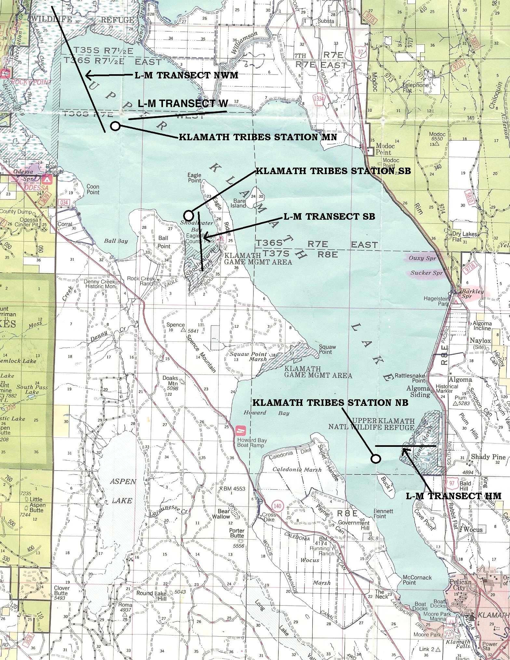

Proposed location of three marsh-lake monitoring transects and Klamath Tribes-Bureau of Reclamation water chemistry and phytoplankton-zooplankton monitoring stations. Map source Winema National Forest 1994 map (common grid square width = 1 mile).

Map of transects for Hank’s Marsh
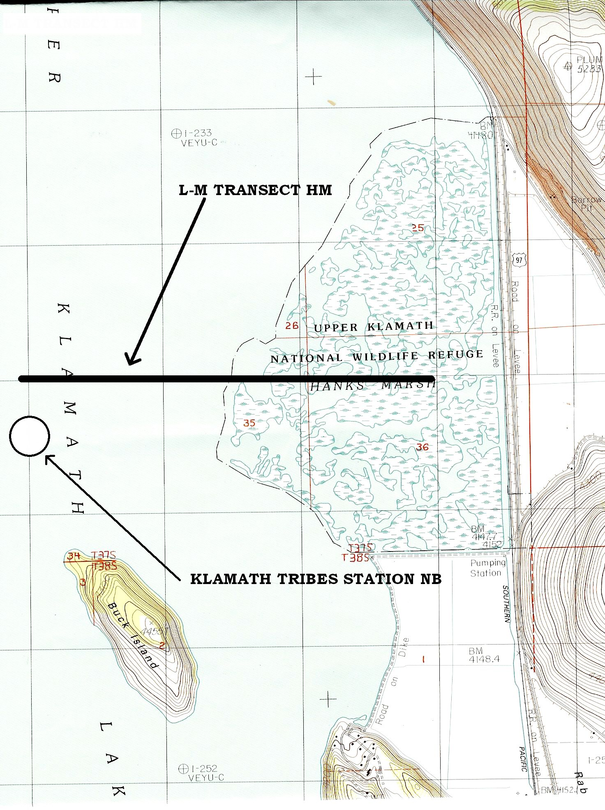
Figure ** Detail of proposed location of the Hanks Mash marsh-lake transect in relation to location of the North Buck Island Klamath Tribes-Bureau of Reclamation water quality monitoring station. Map source USGS 1985 7.5 min. topo. Quad. (grid square width = 1 kilometer).

16. Other Partners/Cooperation
This project is and extension of a previous collaborative effort. The project is being coordinated through PSU’s Center for Lakes and Reservoirs. The previous project involved John Rueter, Stan Geiger, Eric Henry and Bob Gearhart. Stan Geiger will continue to this collaboration extends that to include Mike Purdue as a sub-contractor who will focus on the

17. Performance Plan
number of sample times and sites
successful sample series – that creates useful data series
the data
outcome is the report with recommendations and plan for next phases

18. Literature Cited

Weber, L.H., S.Z. El-Sayed, and I. Hampton. 1986. The variance of phytoplankton, krill and water temperature in the Antarctic Ocean south of Africa. Deep-Sea Research 33: 1327-1343.

19. Land Management Plan
NA

20. Project Summary
Please see Attachment D

List of Attachments
Attachments A: Curricula vitae for both principle Investigators and both contractors
Attachments B: Letters from both contractors stating their willingness to collaborate.
Attachment C: Budget forms
Attachment D: Hatfield Restoration Program, Fiscal Year 2005, Project Summary Sheet.

CD – contains the draft report by Aquatic Scientific Resources Wetland Research Consortium on : Geiger, N. Stan, Robert Gearhart, Eric Henry and John Rueter (2004) “Preliminary Research on Aphanizomenon flos-aquae at Upper Klamath Lake, Oregon: Investigations to set direction for research of factors with potential for influencing Aphanizomenon growth at Upper Klamath Lake.”

