 |  | World Development
 |  | globalization | regionalization
Ecosystem  Management | reactive | 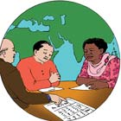  Global Orchestration |   Order from Strength
 | proactive | 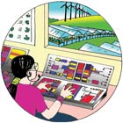  TechnoGarden |   Adapting Mosaic

