AFM Study of High Solubility Carbon Nanotubes
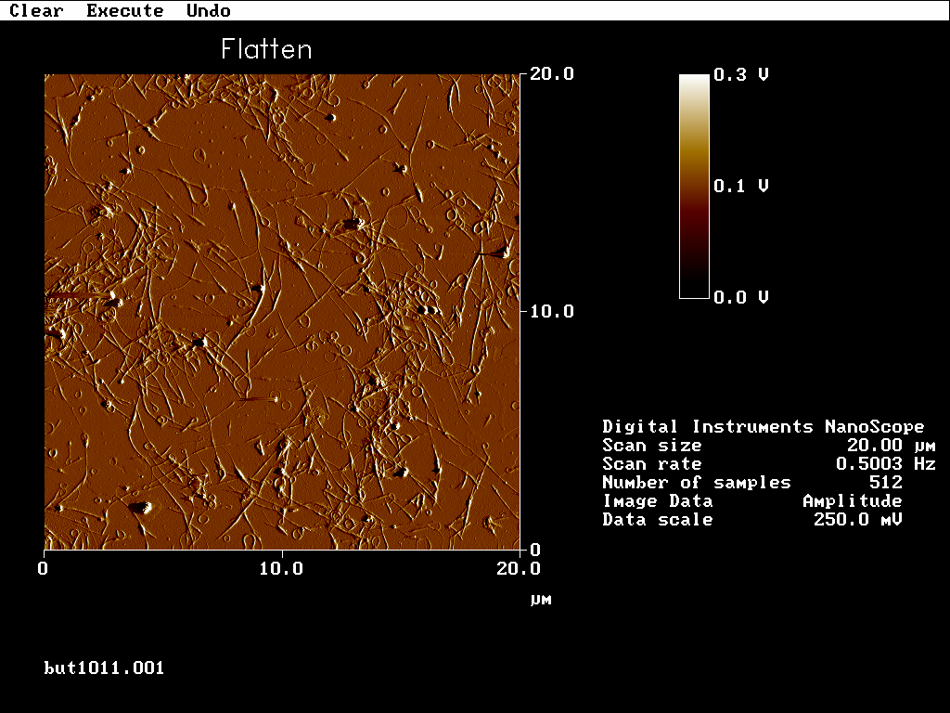

Silver Nanoparticles on Glass (AFM)

Controlled Deposition of Silver Nanoparticles

(Soft Lithography)
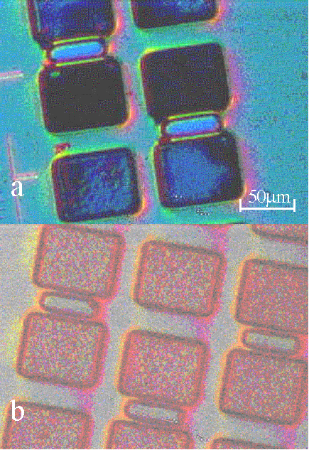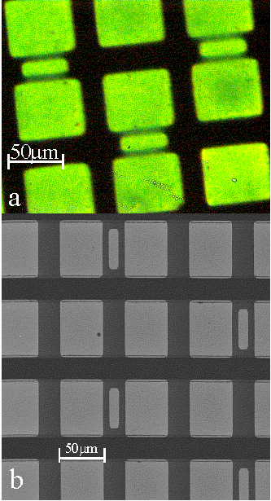
Figure 1 a) a.) Optical image of Cu IC chip and b.) PDMS stamp.
Figure 2 a.) Optical and b.) SEM image of selectively deposited silver.

Linewidth Control

