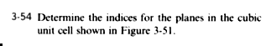

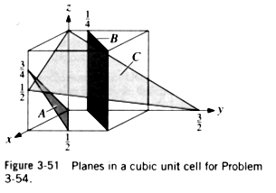

Plane A:

Since plane A passes through the origin, one option is to move the origin one unit in the positive x direction.

X = -1, y = ½, z = ¾
1/x = -1, y = 2, z = 4/3
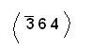

Plane B:

X = -1/4, y = ¼, z = infinity
1/x = -4, y = 4, z = 0
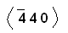

Plane C:

X = 2, y = 3/2, z = 1
1/x = 1/2, y = 2/3, z = 1
(3 4 6)

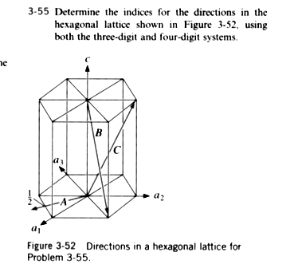

A:
1 0 – 0 0 0 = [1 0]

Using the equations below:

u = ^{1/}₃ (2U-V)
v = ¹/₃ (2V-U)
t = -¹/₃ (U+V)
w = W
u = 1, v = -1, t = 0, w = 0
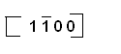

B:
1 1 0 – 0 0 1 = 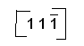

u = 1/3, v = 1/3, t = -2/3, w = -1
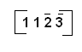

C:

0 1 1 – 0 0 0 = 0 1 1

u = -1/3, v = 2/3, t = -1/3, w = 1

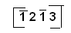

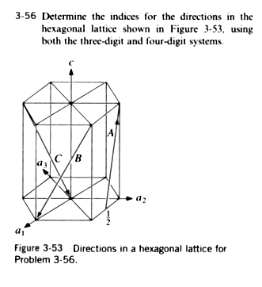
Direction A:

0 1 1 - 1/2 1 0 = 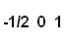

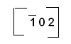

Using the equations below:

u = ^{1/}₃ (2U-V)
v = ¹/₃ (2V-U)
t = -¹/₃ (U+V)
w = W
u = 1/3 , v = -2/3 , t = 1/3, w = 1

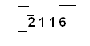

Direction B:

1 0 0 – 1 1 1 = 0 -1 -1

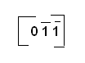

u = 1/3
v = -2/3
t = 1/3
w = -1

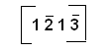

Direction C:

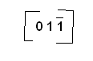
0,0,0 – 0, -1, 1 =

