Tunneling of classical waves

geometrical optics approximation: light travels as a ray (which is a subset of wave optics), in essence: all apertures are large, true wave properties do not matter (much), pretty similar to classical mechanics as a subset of quantum mechanics
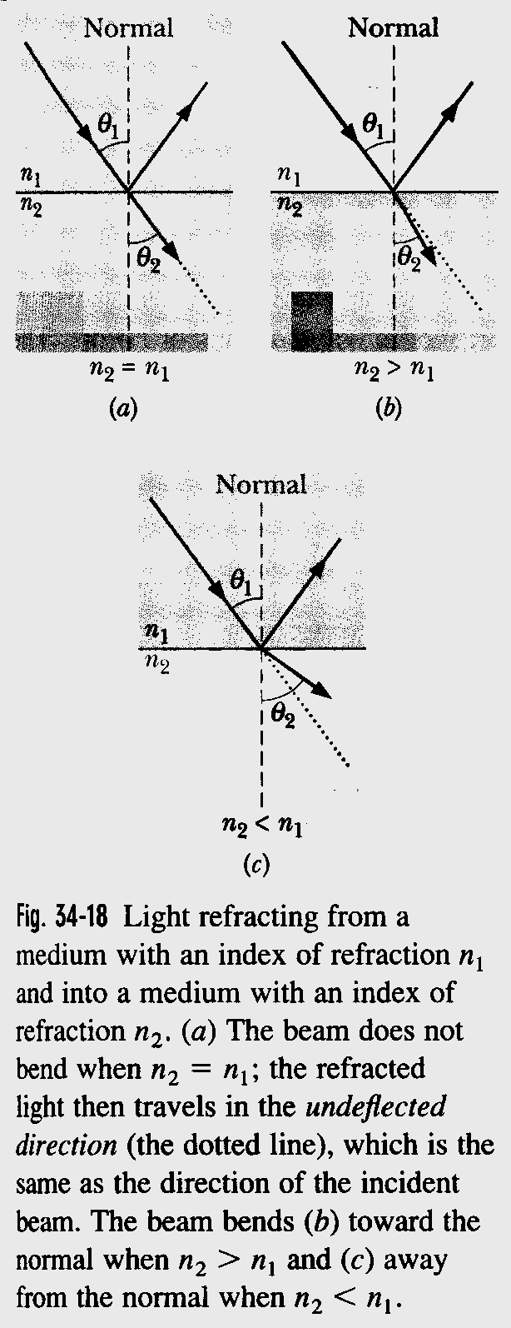
reflection: angle of incidence equals angle of reflection (Schnell’s law)

refraction: travel of light through a surface where there is a change of refractive index usually changes its direction, is said to be bent,

law of refraction:
coming from 1 going to 2
n₁ sin θ₁ = n₂ sin θ₂

for θ₂ = 90 °, there is no refracted beam any more, this sets a critical angle condition for θ₁
this critical angle $θ_{c}=\text{arcsin}\frac{n_{2}}{n_{1}}$ coming from a denser medium, i.e. n₁ > n₂

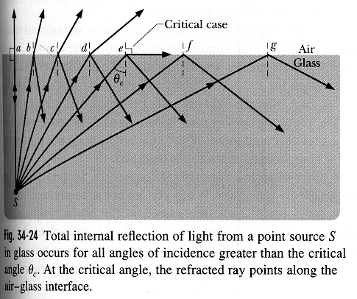

with a sufficiently high refractive index n₁) we do not have a refracted beam anymore, because a sine of an angle cannot exceed unity, n₂ cannot exceed n₁ in this equation, ray stays in the medium, e.g. glass, and gets totally internally reflected, in

this means: in ray optics: there is an infinitely high barrier at the interface

now in wave treatment, we have tunneling, frustrated total internal reflection, because
wave equation of sound, light, water,$\frac{∂^{2}y}{∂x^{2}}=\frac{1}{v^{2}}\frac{∂^{2}y}{∂t^{2}}$,

which works for all classical waves, that have either a photon associated with it or a pseudo-particle (such as a phonon), we also have wave functions whose amplitude is not zero in a barrier

index of refraction: absolute = 1 is ratio of speed of light in vacuum to speed of light in vacuum

relative: ration of speed of light in vacuum to speed of light in medium, for visible light greater than 1 (for X-rays slightly smaller than 1)
light is slower in more dense medium, example: optical “flint” glass: c_{n} ≈ 1.8 10 ⁸ ms⁻¹, n ≈ 1.65

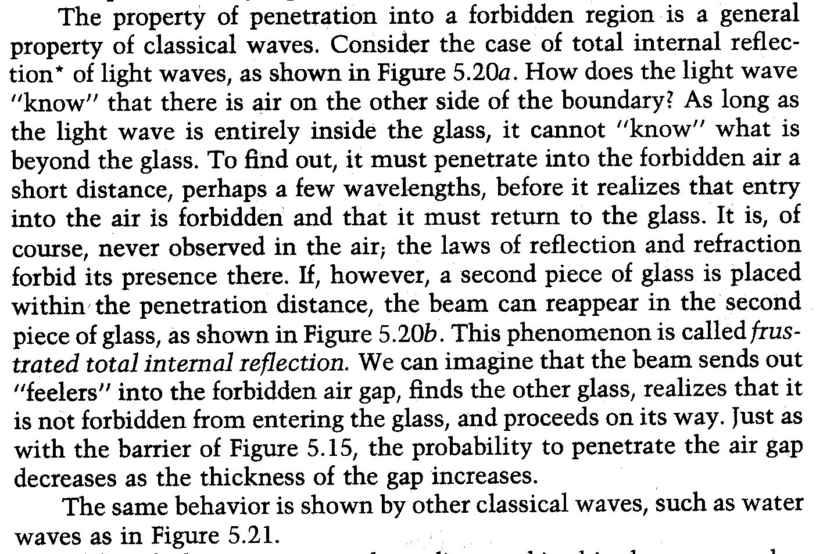

water waves are slower close to the shore where the ocean is shallower

by analogy, we can have the equivalent of total internal reflection for a combination of sudden increase in water dept, where the speed of the wave would be higher, with just the right combination of change in “refractive index” and incident angle, we get total internal reflection as evidenced by the interference pattern

so the area of the deep water is the barrier over which the water can not penetrate (if we do the experiment just right), there is,
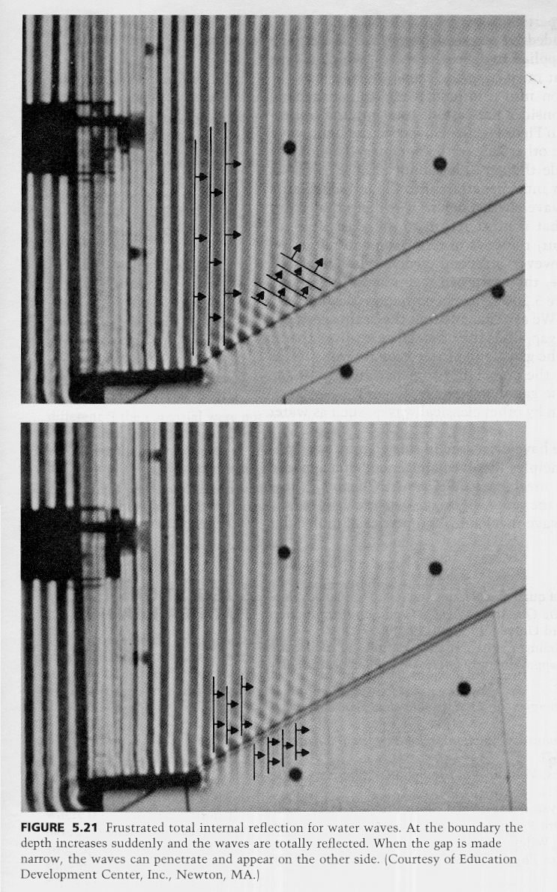
however, again tunneling, if the barrier is “thin” enough, we can have a measurable effect, pick up the water wave again, just as we did with frustrated total internal reflection of light conclusion: tunneling is a real wave phenomena, all wave’s can do it, in principle

