Nuclear decays, Radioactivity

Rutherford makes classification/nomenclature

α-rays penetrates the least produces most ionization (of air), is nuclei of ⁴He , i.e. ${}_{2}^{4}{}\text{He}$arise from tunneling, i.e. have quantum mechanical explanation, Gamow, Gurney and Condon, 1928

β-rays between the extremes, is either electrons (or positrons, but Rutherford does not know positrons exist, only discovered 1932), so there is really β⁻ rays, i.e. electron rays and β⁺ rays, i.e. positrons

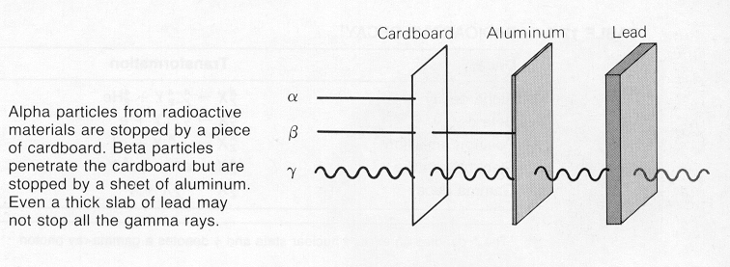
γ penetrates the most produces the least ionization (of air), is electromagnetic radiation of extremely short wavelength (10⁻¹¹ to 10⁻¹³ m, 0.1-10 MeV, arise from relaxation of exited states within the nucleolus (there is some overlap in the energy with X-rays, if it comes due to processes within the nucleolus, we call it γ-ray, if it comes out of X-ray formation mechanism, we call it X-rays
without neutrinos
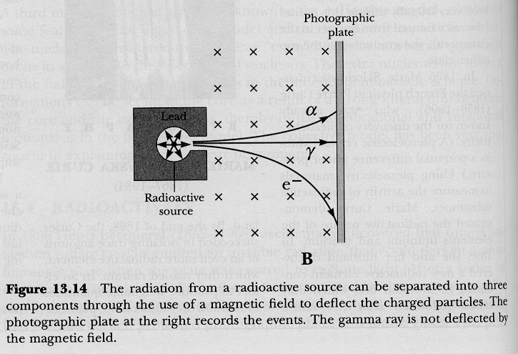
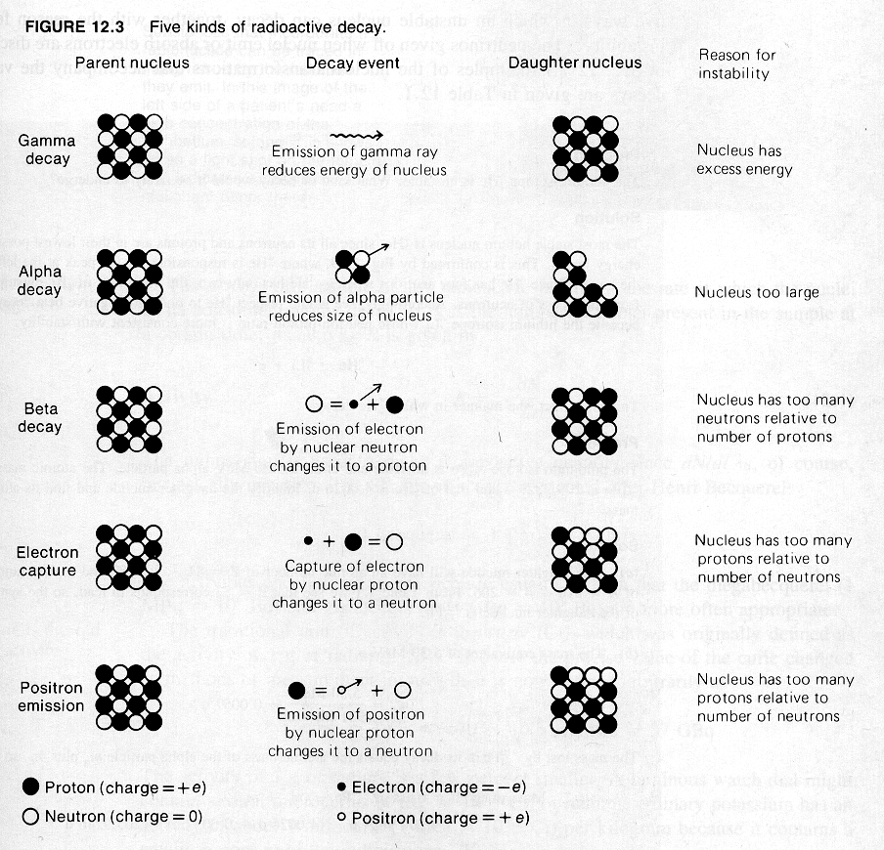
in a magnetic field, γ rays are not deflected, 2 times positively charged α particles are deflected to one side

just the same side as positrons, β+ particles, the antiparticles to electrons are deflected to the same side at α-particles

one times negatively charged β-particles are deflected to the other side

by the Lorentz force

Alpha decay

${}_{Z}^{A}{}X→{}_{Z−2}^{A−4}{}Y+{}_{2}^{4}{}\text{He}$ ${}_{\text{92}}^{\text{238}}{}U→{}_{\text{90}}^{\text{234}}{}\text{Th}+{}_{2}^{4}{}\text{He}$
A is sum of protons and neutrons, Z is number of protons also called atomic number, the principle number that defines the place of an element in the periodic table, X is called parent nucleus for example and Y is called daughter nucleus

remember, α-decaying atoms had variations in their half-lives of more than 10 orders of magnitude, it was due to a tunneling effect

Beta decays and electron capturing

${}_{Z}^{A}{}X→{}_{Z+1}^{A}{}Y+e^{−}$ ${}_{6}^{\text{14}}{}\text{Cu}→{}_{7}^{\text{14}}{}\text{Ni}+e^{−}$

or simply n⁰ → p⁺ + β⁻+ $\bar{ν}$

neutron (n) without a charge, proton (p) with charge +, beta particle with negative charge is an electron
$\bar{ν}$ is the electron neutrino

${}_{Z}^{A}{}X→{}_{Z−1}^{A}{}Y+e^{+}$ ${}_{\text{29}}^{\text{64}}{}\text{Cu}→{}_{\text{28}}^{\text{64}}{}\text{Ni}+e^{+}$

p⁺ → n⁰ + β⁺+ $ν$
beta particle with positive charge is positron, $ν$ is the positron neutrino
process that competes with β decay is electron capturing from the innermost shell, this electron is simply absorbed

${}_{Z}^{A}{}X+e^{−}→{}_{Z−1}^{A}{}Y$ ${}_{\text{29}}^{\text{64}}{}\text{Cu}+e^{−}→{}_{\text{28}}^{\text{64}}{}\text{Ni}$

into the nucleolus, where it does not exist as such and

p⁺ + β⁻ → n⁰ Ni is more stable because it has an even number of protons

the neutron that is formed out of it and the proton that captured it is not simply composed of both particles

Radioactive decay laws

quantum mechanically it is just oscillating expectation values (in the dipole model) as we had them earlier for radiative transitions when we derived selection rules

rate at which radioactive nuclei decay is called activity (R): number of decays per second (some texts A for activity some other texts)

SI unit, 1 Bq = 1 decay per second, pretty slow

1 Ci = 3.7 10¹⁰ Bq, per definition, pretty fast, so usual mCi or μCi (1 Ci originally the rate of decay of 1 gram of pure Ra)

decay constant
say we have an activity (R) of 1 Ci, i.e. 3.7 10¹⁰ nuclei decay every second, and a sample of one mole, i.e. 6.022 10 ²³ atoms

so we can also say: each nucleolus in this sample has a probability of decaying during each second of 3.7 10¹⁰ nuclei
s⁻¹ divided by 6.022 10²³ nuclei total = 6.14 10⁻¹⁴ this quantity is called decay constant λ (and really is a probability per second)

decay constant (probability) does not depend on the history of the sample, we can not predict when any one atom (we may watch) will decay, we just watch the whole process for a large collection of atoms and get a pretty constant decay constant

it is a fully statistical process: only for a large sample we will measure the prescribed decay constant, for a small sample it may be higher only to change in the next instant to be smaller that the prescribed decay rate

activity, on the other hand, does depend on number of radioactive nuclei (N) (mole number) and the probability for each nucleolus to decay

R = λ N the more radioactivity nuclei you have to more
radio-activity comes out of the sample

now both R and N are functions of time (t)

as sample decays, N decreases, there are fewer radioactive nuclei left,

as λ is taken to be a constant, activity R, i.e. decays per second, must decrease as well, so a radioactive sample becomes less and less active (and dangerous) over time, because there are fewer and fewer radioactive nuclei

we can regard R as the change in the number of radioactive nuclei per unit time

R = $−\frac{\text{dN}}{\text{dt}}$ N is decreasing with time, that’s where the negative sign comes from

Now $−\frac{\text{dN}}{\text{dt}}=λN$ as R = λN above, which we can rearrange as

$\frac{\text{dN}}{N}=−λ\text{dt}$

$\int{\frac{\text{dN}}{N}}=−λ\int{\text{dt}}$ where N₀ is number of radioactive
nuclei at t = 0
$\text{ln}(\frac{N}{N_{0}})=−λt$

$\frac{N}{N_{0}}=e^{−λt}$ so finally we have $N=N_{0}e^{−λt}$
so we have an exponential (pretty fact) decay over time

now N and No are notoriously difficult to measure so we multiply both sides with the “constant λ” , i.e. the decay constant and get the law for the time dependency of the activity

$$R=N_{0}{λe}^{−λt}=R_{0}e^{−λt}$$

where R₀ is the original activity

now we define half-live: it is the time it takes for half of a given number of radioactive nuclei to decay

we set N = $\frac{N_{0}}{2}$ and t = T_{½} and get

$$\frac{N_{0}}{2}=N_{0}e^{−{λT}_{12}}$$
divided by N₀ we get $\frac{1}{2}=e^{−{λT}_{12}}$ or $2=e^{{λT}_{12}}$

taking the ln from both sides gives

$T_{12}=\frac{\text{ln}2}{λ}≈\frac{0\text{.}\text{693}}{λ}$ which is measured in seconds
or any multiple of it

this is convenient for relating half-life to decay constant

e.g. half life of a radio isotope is 5 hour, what is it decay constant

$λ=\frac{0\text{.}\text{693}}{T_{12}}=\frac{0\text{.}\text{693}}{5⋅\text{3600}s}=3\text{.}\text{85}⋅{\text{10}}^{−5}s^{−1}$ that is the probability for any one nucleolus to decay per second, some will decay within the first millisecond after t₀ some will not decay for the next 100,000 years, (if we do have a large initial amount N₀ say mole or more the statistics will be pretty accurate)

this means if the sample is large enough, that is N₀ is large, the actual fraction of it that decays in a certain time span will be very close to the probability for any individual nucleolus to decay

to say that a certain radio-isotope has a half life of 5 h means that every radioactive nucleolus has a 50 % chance of decaying every five hours period

so on average, 50 % of all the nuclei will actually do so – but this does by no means imply that there is a 100 % probability of decaying of all the nuclei in 10 hours!!

the nucleolus has no internal clock that tells him how long he is already around and “kills” him off finally - it’s a quantum mechanical object
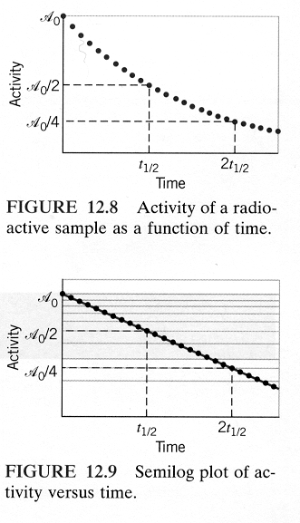
so after one half time T_{½} , $\frac{N_{0}}{2}$ radioactive nuclei remain, per definition

after two half times 2T_{½} , $\frac{N_{0}}{4}$ radioactive nuclei remain, per definition

after three half times 3T_{½} , $\frac{N_{0}}{8}$ radioactive nuclei remain, per definition

Quantum weirdness: the decay probability of each nucleolus (λ) is constant over time until it actually does decay

half life 5 h implies 75 % decay in 10 h, 87.5 % decay in 15 h, 93.75 % in 20 h, 95.3125 % in 25 hours 96.09375 % in 30 hours

it’s approaching 100 % even more slowly the longer after t₀

Many decays in nature follow exponential laws, but quantum objects are different to macroscopic and living nature,

for example “decaying of people”
decaying can be “manipulated”, e.g. better medicine, healthier conditions, avoiding of “bad” cholesterol, wearing seat belts in cars, delays the “decay” of people – no such manipulations for quantum objects as λ is a constant

rephrased for the purpose of “cheating” you on your live insurance policy: in principle a sufficiently detailed analysis of all of the relevant circumstances of a person’s health, environment, .. and medical history allows one to predict when this person is going to die “of old age and all other prevailing causes such as strike by lightening, … ”, there are physiological mechanism within individuals that make a kind of internal clock

no such thing as an internal clock in quantum objects, decaying is purely statistical and time of decay event impossible to predict for any one atom, all we ever know from a quantum mechanical calculation is the probability of decay – which is stationary – never changes in time

if the average life expectancy of people were, say 75 years and we select a group of 100 years old people, we can be pretty sure that they are not going to live for another 75 years,

with quantum objects it is again different, a single atom may “live” 100000000000000000000000000000000000000 or any number you chose of life times without decaying, provided there is enough radioactive material

there is also mean half live τ also called life time, per definition: $τ=\frac{1}{λ}$

this means N(τ) = N₀ e⁻¹

life time is the time required for the number of particles in the excited state to decrease for any initial value by a factor of e ≈ 2.7182818…

same reasoning for activity,
if t = τ, R=R₀ e⁻¹ ≈ 0.3678794 R₀

also means life time (mean half life) it the time when the activity has dropped to about 37 %.$τ=\frac{T12}{\text{ln}2}$ $T_{12}=\text{ln}2⋅τ$
So is radioactivity really only a “bad thing” a decaying of our “nice” elements beyond ₈₃Bi?

the earth is about 4.5 10⁹ years old, it is believed to have formed as a cold aggregate of smaller bodies, containing a lot of Fe, Ni, and silicates, then the whole thing melted due to the energy released by radioactive processes!!!

the metals went down (as they are heavier) and make up the core, they are believed to be still molten - because we think the earth spinning about an axis produced the earth magnetic field we observe), the silicates went up as they are lighter and cooled down, forming the crust that supports the biosphere and us

there are lots of radioactive isotopes trapped in the silicates, the main culprit is ²³⁸U (99.28 % relative abundance of all U), there is still lots of it left as ²³⁸U has a half life of 4.47 10⁹ years

²³⁵U isotope has only (0.72 % relative abundance) and a half life of 7.04 10⁸ years

the energy released by radioactivity drives all geological processes, moving of tectonic plates, folding up of the Tibetan mountains, the great San Francisco Earth quake, break out of Mount St. Helens, …

Radioactivity is also bothering our health there is lots of charlatans and scaremonger out there, so I try to be fair
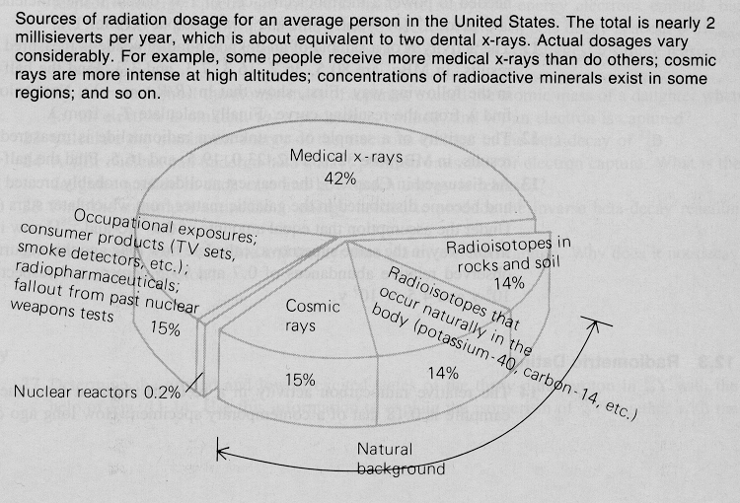

unit of radiation dosage is sieverts (Sv), 1 Sv radiation has the same effect as 1 kg body tissue absorbing 1 J of energy from γ- or X-rays

chances of dying from cancer are 1 in 20 for a dose of 1Sv per year, 1 in 10,000 for a dose of the 2 mSv per year as given above in the pie chart, so 9999 people die of other causes, 1 as a direct result of the 2 mSv “background”, it’s a fact of live
you can’t really do much about “natural background”, decide on where you want to live, e.g. better not on rocky granite ground, e.g. Aberdeen in Scotland where people do have as life expectancy that is about 5 years shorter than in the rest of the U.K., where there are high levels or the inert gas radon in the houses coming out from the ground

do better not live at really high elevation, (you catch more than your fair share of cosmic radiation), frequent flyer is in comparison really a minor issue, but pilots have here a major an occupational hazard

problem is, there is a long time between exposure to radioactivity and outbreak of disease, so people do not tend to worry about it much

taking ionizating radiation collectively: the one thing you can do is refuse to have too many X-rays taken, it’s really bad for your health, e.g. the screening of healthy woman for breast cancer killed more women directly that it saved by early cancer treatment – don’t trust the physicians or dentist, don’t let them X-ray you with old equipment, 1 computer tomography image is 8 mSv, one top modern X-ray may be only 0.02 Sv, so do not have more than 5 X-rays or so taken per year, if you can avoid it

Medical X-ray personal and researcher into X-ray diffraction and spectroscopy are allowed to get 20 mSv exposure, so 10 times the “natural background” dose and they statistically do die earlier than the rest of the population

in comparison, nuclear power plants and everything that goes with them like storage, waste disposal, … is comparatively save

only major accidents may cause trouble, but mainly locally,

the cousin of my father (lives in Canada and was involved all his professional live with nuclear power research and safety at Canada’s prime research site in Chalk River), was actually at one time heading an international committee on safety of nuclear power plants, according to the information he has, the effect of Chernobyl is negligible outside the Ukraine, maybe 10 extra deaths from cancer in all of North America of all the people that were living at that time the accident happened.

nuclear bomb testing above ground in the 50 and 60 is a much much greater health risk that everybody my age has, worldwide, that’s why it got banned internationally !

we are all in the same boot and there better be no nuclear war of whatever kind over ground

Radiometric dating

for living things${}_{6}^{\text{14}}{}C$is radioactive, constantly produces on earth

${}_{7}^{\text{14}}{}N+{}_{0}^{1}{}n→{}_{6}^{\text{14}}{}C+{}_{1}^{1}{}H$

gets incorporated in all organic (living) beings, when these beings die there is no exchange with sounding any more, so the level of ${}_{6}^{\text{14}}{}C$in the “corpse” (literally or in the paper, cloths, …) does not get replenished, it decays with half live 5730 years

limit of applicability of ${}_{6}^{\text{14}}{}C$dating is about 50,000 years

for geological dating nuclei with larger half lives are required, e.g.

²³⁵U → ²⁰⁷Pb 0.7 10 ⁹ years
⁴⁰K → ⁴⁰Ar, 1.3 10 ⁹ years
²³⁸U → ²⁰⁶Pb 4.5 10 ⁹ years, about the age of the earth

there is a series of decay series ending is stable daughter nuclei, e.g.

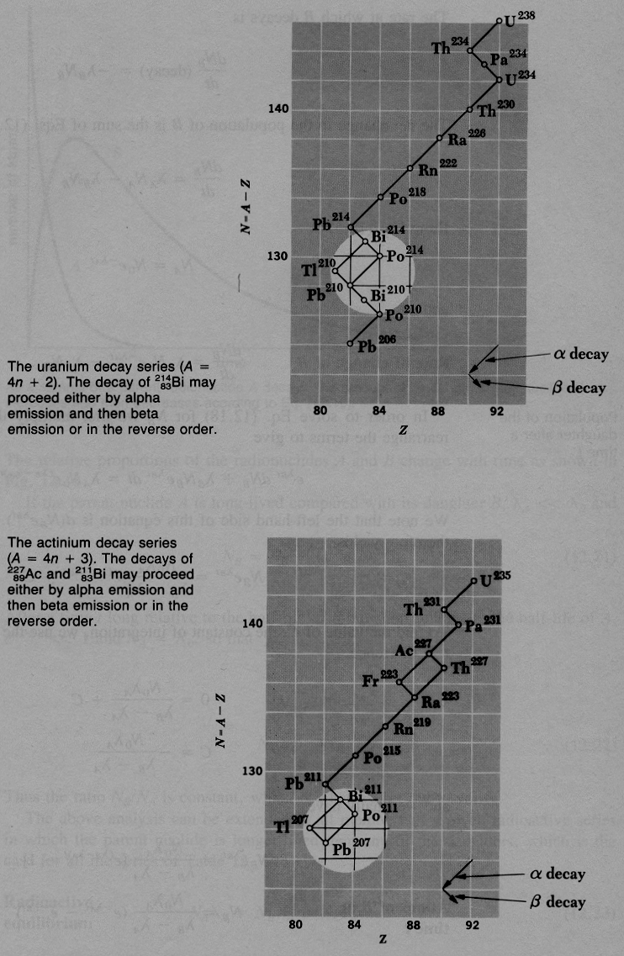
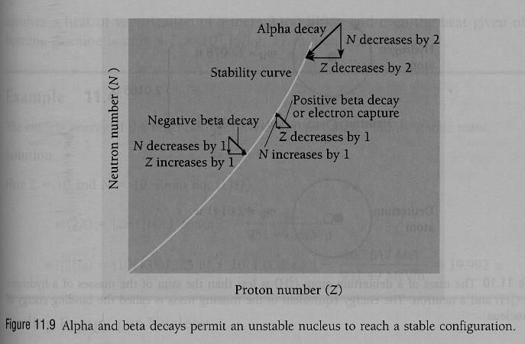

α- and β⁻ - decays (i.e. ⁴He and electron emissions)
are most frequently observed decaying processes

how old is the moon? we think about 4.5 10⁹ years, just the same as the earth, but the “youngest rocks” were only about 3 10⁹ years, so igneous activity such as volcanic eruptions must have stopped at that time, it’s a pretty “dead” object, except for some recent foot prints
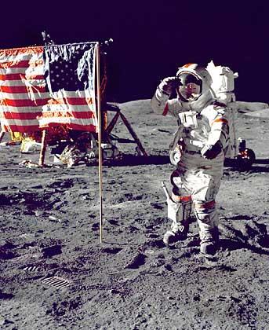
who invented radiometric dating of biological material, sure no archeologist or biologist, a bunch of physicists of course, they figured out cosmic rays and how the resultant radiocarbon may be used, along the same lines, who discovered X-rays? no physician, a physicist of course!

nuclear decays/reactions are all to be described by quantum mechanical tunneling

remember α-decay is ${}_{2}^{4}{}\text{He}$ tunneling out of the finite (≈ 25 MeV) potential energy well of the nucleolus

beta decay and weak interaction

while, γ and α-decay could be explained from tunneling β-decay seemed to fly in the face of all conservation principles:

n → p + e⁻ + (electron neutrino, with is an antiparticle)?

conservation of mass/energy, kinetic energy of emerging photon should be as calculated, but hardy ever was observed to be so

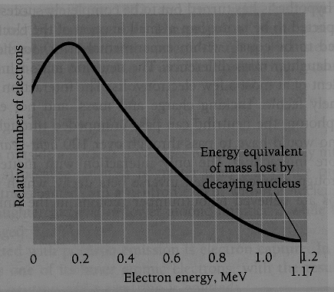

conservation of linear momentum, angular momentum, recoil directions of electron and neutron were not opposite

conservation of angular momentum, neutron, proton, electron have all spin, so “new spin” seemed to have been created

to resolve: Pauli in 1930 “desperate measure” in β-decay, there is also an additional particle with zero or tiny mass, no charge, spin ¹/₂"

as this particle - that became to be known as neutrino “the little one” in Italian after Fermi – has little mass and no charge, it is extremely difficult to detect,
nevertheless, it has been observed indirectly by the “inverse β-decay” from the neutrons coming out of a nuclear reactor in 1953

p + $\bar{ν}$→ n + e⁺

the positron meets an electron and gets annilated in 2 characteristic γ-rays both about 0.51 MeV, the masses of both particles) the neutron got captured by a Cd nucleus, that emits a 8 MeV γ-rays time delayed

to sum up: a proton converted into a positron and a neutron, a antineutrino (also called electron neutrino) must have triggered this reaction !!

in order to describe β-decay, the weak force had also to be introduced

it is believed that just four forces explain all interactions in the universe, characteristic time is time it takes for particles that are within the force action range to “react”, propositional to the strength of the force
Type | Range | Relative Strength | Characteristic time | Typical particles | Mediating particle
Strong | Fm | 1 | < 10 ⁻²² s | n, p, π | Gluon
Electromagnetic | ∞ | 10⁻² | 10⁻¹⁴ – 10⁻²⁰ | e, n, p, μ, π | Photon
Weak | 10⁻³ fm | 10⁻⁷ | 10⁻⁸ – 10⁻¹³ | all | Weak boson
Gravitational | ∞ | 10⁻³⁸ | Years | all | Graviton

