Statistical mechanics / physics / thermodynamics

A theory is the more impressive the greater the simplicity of its premises, the more different kinds of things it relates, and the more extended its area of applicability. Hence the deep impression that classical thermodynamics made upon me. It is the only physical theory of universal content concerning which I am convinced that, within the framework of the applicability of its basic concepts, it will never be overthrown (for the special attention of those who are skeptics on principle). Albert Einstein

Ludwig Boltzmann, who spend much of his life studying statistical mechanics, dies in 1906 by his own hand. Paul Ehrenfest, carrying on his work, died similarly in 1933. Now it is our turn to study statistical mechanics. Perhaps it will be wise to approach the subject cautiously. D.L. Goodstein, States of Matter, Dover Press, 1985)

J. Willard Gibbs, Elementary Principles in Statistical Mechanics developed with especial reference to the rational foundation of thermodynamics,
New York: Charles Scribner’s Sons, London: Edward Arnold, 1902

From the preface:

The usual point of view in the study of mechanics is that where the attention is mainly directed to the changes with take place in the course of time in a given system. The principle problem is the determination of the condition of the system with respect to configuration and velocities at any required time, when its condition in these respects has been given for some one time, and the fundamental equations are those which express the changes continually taking place in the system. Inquiries of this kind are often simplified by taking into consideration conditions of the system other than those through which it actually passes or is supposed to pass, but our attention is not usually carried beyond conditions differing infinitesimally form those which are regarded as actual.

For some purposes, however, it is desirable to take a broader view of the subject. We may imagine a great number of systems of the same nature, but differing in the configurations and velocities which they have at a given instant, and differing not merely infinitesimally, but it may be so as to embrace every conceivable combination of configuration and velocities. And here we may set the problem, not to follow a particular system through its succession of configurations, but to determine how the whole number of systems will be distributed among the various conceivable configurations and velocities at any required time, when the distribution has been given for some other time. The fundamental equation for this inquiry is that which gives the rate of change of the number of systems which fall within any infinitesimal limits of configuration and velocity.

Such inquiries have been called by Maxwell statistical. …The laws of thermodynamics, as empirically determined, express the appropriate and probable behavior of systems of a great number of particles, or more precisely, they express the laws of mechanics for such systems as they appear to beings who have not the fineness of perception to enable then to appreciate quantities of the order of magnitude of those which relate to single particles, and who cannot repeat their experiments often enough to obtain any but the most probably results. The laws of statistical mechanics apply to conservative systems of any number of degrees of freedom, and are exact….

The laws of thermodynamic may be easily obtained from the principles of statistical mechanics, of which they are the incomplete expression, ..

1. What thermodynamics is and historic overview

Deals with “bulk” properties of matter and the processes by which these properties are changed, bulk is a system that is large enough that certain fluctuations can be “treated statistically-mathematically”

Two primary divisions, statistical mechanics (frequently called statistical physics interchangeable) & macroscopic thermodynamics

There is a part of thermodynamics that predated statistical physics – statistical physics delivered the mathematical structure – underpinning, rational basis so to speak - with extending the range of thermodynamics to basically all physical phenomena

up to about 1850, classic (Newtonian) mechanical viewpoint, whole universe is a Perfect Machine that runs by strict unvarying deterministic law

Lagrange 1790 and Hamilton 1840 added computational power to Newton’s approach

Laplace: It is possible – in principle – to have a perfect knowledge of the universe, one can know – in principle – all the positions, masses and velocities of all particles in the universe, using Newton’s mechanics and all kind of forces that govern all interactions, one can calculate – in principle – the whole past of the universe and the whole future of the universe, cause and effect calculations go both ways
Wait a minute: how about modern physics? $Δx⋅{Δp}_{x}≥ℏ2$
$$ΔE⋅Δt≥ℏ2$$

Einstein always thought quantum mechanic is incomplete, there must still be a cause and effect relationship to everything “God does not play dice” , i.e. quantum mechanical uncertainty is not the last word on the matter, Bohr’s reply: “It is not for you Einstein to tell god what to do.”

Quantum mechanics has been made compliant to special relativity by Dirac in 1928, but is still not compliant to general relativity, perhaps superstring theory by Edden, Hawkin’s “theory of everything”?

One of these two theories “has to go in its present form” either current quantum mechanics or current general relativity, both of them are very likely to survive as approximations to a more general theory

after about 1850, statistical physics and better thermodynamics, driven by industrial revolution, it was necessary to have better steam engines, … locomotives were running, but nobody really knew how

energy and entropy are central in thermodynamics
Joule 1843, demonstrate the mechanical equivalent of heat, energy of falling weight is transferred to internal energy in water as manifested by an increase of its temperature
Clausius: S = ^{Q}/_{T} gas molecules do not all travel at the same speed, there should be certain well defined distribution of speeds

Maxwell: equilibrium (most probable) speed distribution for gas molecules having speeds between v and v+dv at a specific temperature, … Maxwell relations

Boltzmann: approach to equilibrium problem, how does a gas reach at a specific temperature the most probable speed distribution? Boltzmann constant, S = k. ln W, Boltzmann statistics

Helmholtz, free energy and it’s minimization, F = E –TS, dF = -SdT – pdV + μdN

Gibbs, Gibbs free energy = chemical potential - and it’s minimization,
G = E – TS + pV, dG = -SdT +Vdp + μdN

Einstein, 1905, explains Brownian Motion on the atom hypothesis, indicating that atoms are real

Bose & Einstein: Bose & Einstein statistics

Fermi & Dirac: Fermi & Dirac statistics
2. Statistical physics in general following 3rd year Modern Physics texts

2.1. Statistical distributions: Maxwell-Boltzmann statistics: classical particle statistics

2.2. When is Maxwell-Boltzmann statistics applicable / ideal gas

2.3. Quantum statistics (note there are two different versions for fermions and bosons)

2.4. Application of Bose-Einstein statistics: Blackbody Radiation, Einstein’s Theory of Specific Heat

2.5. Application of Fermi-Dirac statistics: Free electron theory of metals


An Austrian, i.e. quasi German professor in Berkeley at the turn of the century, sticking to his guns !!!
2.1. Statistical distributions: - Maxwell-Boltzmann statistics, classical particle statistics

Ludwig Boltzmann (1844-1908)

Josiah Willard Gibbs (1839-1903)

James Clerk Maxwell (1831-1879)

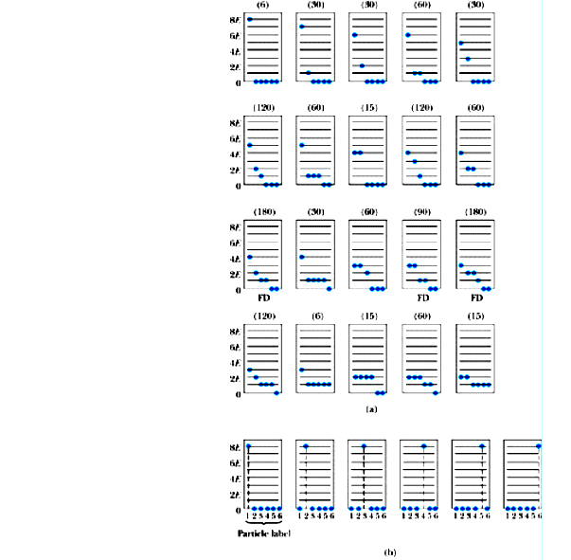
Underlying assumptions of Maxwell-Boltzmann statistics

particles are identical in terms of physical properties, but distinguishable in terms of position, path, or trajectory – i.e. classical physics particles, e.g. an ideal gas

- this is equivalent to saying the particle size is small with respect to the average distance between particles

equilibrium distribution is most probable way of distributing particles among the various allowed energy states subject to constraints of fixed particle number

Figure 10.1 (a) The 20 arrangements (states of a system) of six indistinguishable particles with a total energy of 8E. (b) The decomposition of the upper left-hand arrangement of part (a) into six distinguishable states for distinguishable particles.

statistical approach – small system for overview

say total energy is 8E distributed between six particles, 1 E is the smallest unit of energy – indivisible unit, we are not dealing with quantum mechanics, so particles can have zero energy

each arrangement of energies of six particles is called a state, each state has a certain number of microstates, e.g. 6 microstates for one particle at 8 E and five at 0E (top left corner Fig. 10.1

GOAL: want to know probability of finding a particle with a given energy

Number of microstates $N_{\text{MB}}=\frac{N!}{n_{1}!n_{2}!n_{3}!\text{.}\text{.}\text{.}}$

N total number of states, n_{i} number of particles in occupied states

6! / 5! 1! = 6 microstates as shown in Fig. 10.1 b (bottom row)

total of 1287 states, 20 states with certain number of microstates
Basic postulate of statistical mechanics: any individual microstate is as likely as any other individual microstate (just as in a lottery)

Sum the number of particles with that energy in each of the states above, weighted by the probability of realizing that state (arrangement)

Total of 1287 microstates, 6 distinguishable microstates for state #1

Probability of finding system in this state is ⁶/₁₂₈₇

to calculate average number of particles with E0,

# of such particles in each state time number of microstates divided by total number of microstates all summed up

5 (6/1287) + 4 (30/1287) + 4 (30/1287) + 3 (60/1287) + … = 2.307 (see Serway et al.)

so on average 2.307 particles have energy E0, the probability of finding such a particle by reaching randomly into a box with 6 particles is 2.307 / 6 = 0.385

38.5 % probability finding a particle with E0
25.6 % probability finding a particle with E1
16.7 % probability finding a particle with E2
9.78 % probability finding a particle with E3
5.43 % probability finding a particle with E4
2.72 % probability finding a particle with E5
1.17 % probability finding a particle with E6
0.388 % probability finding a particle with E7
0.0777 % probability finding a particle with E8
let’s plot that distribution – close to exponential decrease

so now you get an inkling that playing the lottery may give you a good feeling, but incredibly high odds are against you

Ma
Figure 10.2 The distribution function for an assembly of six distinguishable particles with a total energy of 8E. (looks similar to energy distribution of undistinguishable bosons who also can all be in one state, Bose-Einstein condensate)
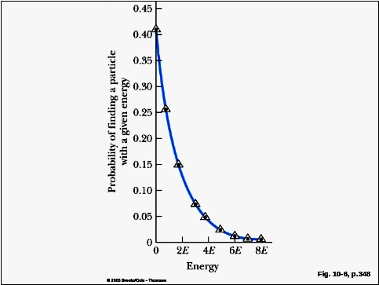

$$f_{\text{MB}}={\text{Ae}}^{{−E}/{k_{B}}T}$$

Maxwell-Boltzmann distribution (for classical particles)

probability of finding a particle with energy E_{i}, or probability that a state with energy E_{i} is occupied at the absolute temperature T

for E0 in example above it would just be 0.385

number of states with same energy E0 is called degeneracy or statistical weight. g_{i}

number of particles n_{i} with energy E_{i} is just statistical weight times probability that the state E_{i} is occupied

$n_{i}=g_{i}f_{\text{MB}}$= 0.385 times 6 for EO particles = 2/307

A is a normalization constant – determined by requirement that total number of particles (N) in system is constant

If bosons $n_{i}=g_{i}f_{\text{BE}}$ If fermions $n_{i}=g_{i}f_{\text{FD}}$

For large number of particles and available energy states smooth functions$n_{i}(E)=g_{i}(E)f_{\text{MB}}(E,T)$where $g_{i}(E)$is called density of states or the number of energy states per unit volume in the energy interval E+dE

Maxwell’s speed distribution for an ideal gas
Figure 10.4. The speed distribution of gas molecules at some temperature. The number of molecules in the range Δ v is equal to the area of the shaded rectangle, n(v) Δ v. The most probable speed, vmp, the average speed, v, and the root mean square speed, vrms, are indicated.

Good classical system, ideal gas of point particles (no internal
structure and no interaction between particles)

Maxwell’s equilibrium speed distribution for ideal gas, or
number of molecules with speeds between v and v + dv

Maxwell’s molecular energy distribution

one can derive

$$E=32\text{NkT}=32\text{RT}$$

$$EN=32\text{kT}=\text{ave}\text{arg}e_{{\text{molecualr}}_{\text{energy}}}$$

an ideal gas particle (i.e. classical particle that does not interact with anything) has 3 degrees of freedom, so in each one of these degrees of freedom there is just
$12\text{kT}$ equipartition theorem

The average energy per degree of freedom of any classical object that is a member of a system of such objects in thermal (thermodynamic) equilibrium at the absolute temperature T is $12\text{kT}$ this is a general classical physics result !

Degrees of freedom are not limited to linear velocity components – each variable that appears squared in the formula for the energy of a particular object represents a degree of freedom – just like

$$12m{\bar{v}}_{x}^{2}=12m{\bar{v}}_{x}^{2}=12m{\bar{v}}_{z}^{2}=12I_{x}{\bar{ω}}_{x}^{2}=12K(Δx)^{2}=12\text{kT}$$

ω angular velocity, I angular momentum for a rotation

K force constant, ∆x displacement in an harmonic oscillation

So a one dimensional harmonic oscillator has

$$E=12m{\bar{v}}_{x}^{2}+12K(Δx)^{2}=12\text{kT}+12\text{kT}=\text{kT}$$

even better, equipartition theorem is even valid for non-mechanical systems such as thermal fluctuations in electrical circuits

2.2. Application of Maxwell-Boltzmann statistics: ideal gas

applicable when average distance between particles, d. is large compared with quantum uncertainty in particle position

$\frac{ℏ}{2\sqrt{\text{mkT}}}≤Δx\text{<<}d$ then particles are distinguishable, wave properties of particles can be neglected, some algebra

$(\frac{N}{V})\frac{ℏ^{3}}{8\sqrt{(\text{mkT})^{3}}}\text{<<}1$ i.e. particle concentration (density) is low, particle mass is high (classical particle), temperature is high

Are Maxwell-Boltzmann statistics valid for hydrogen gas at standard temperature and pressure (abbreviated typically STP, 273 K, 1 atmosphere) ?

Under STP 1 mol H₂ gas = 6.02 10²³ molecules occupies 22.4 liter dm³

Mass of H₂ molecule 3.34 10⁻²⁷ kg,

h = 6.626 10⁻³⁴ Ws²

k = 1.381 10⁻²³ J/K = 8.617 10⁻⁵ eV/K

$(\frac{N}{V})\frac{ℏ^{3}}{8\sqrt{(\text{mkT})^{3}}}=8\text{.}\text{83}⋅{\text{10}}^{−8}\text{<<}1$ surprise
Are Maxwell-Boltzmann statistics valid for electrons in Silver?

Silver has a density of 10.5 g/cm-3 and molar weight 197.9 g. assuming one free electron per silver atom, density of free electrons is

$$\frac{\text{10}\text{.}5}{\text{197}\text{.}9}6\text{.}\text{02}⋅{\text{10}}^{\text{23}}{\text{electrons}}/{m^{3}}=5\text{.}\text{86}⋅{\text{10}}^{\text{28}}{\text{electrons}}/{m^{3}}$$

mass of electron 9.109 10⁻³¹ kg

assuming “room temperature” T = 300 K then kT = 4.14 10⁻²¹ J ≈ 25 meV

$(\frac{N}{V})\frac{ℏ^{3}}{8\sqrt{(\text{mkT})^{3}}}=4\text{.}\text{64}$ so Maxwell-Boltzmann statistic not applicable

two reasons, small mass of electron, density of electrons in silver about 2000 times higher than density of H₂ at STP

electrons are fermions, so Fermi-Dirac statistics is applicable
OK quantum mechanical “wavicals” at high density and low temperature are non classical
Figure 10.6: The distribution function for six indistinguishable particles with total energy 8E (bosons).
Looks “similar” to Maxwell-Boltzmann distribution function

Important bosons: photons – (coupling electromagnetic force between charges), phonons – the wavical of a sound wave in a solid, a quasi-particle that does not exist outside of the solid, α-particle and He atom

$f_{\text{BE}}=({\text{Be}}^{E/{k_{B}}T}−1)^{−1}$ but $f_{\text{MB}}={\text{Ae}}^{{−E}/{k_{B}}T}$
B = 1 for photons and phonons

for Bose-Einstein
distribution function
Since particles are indistinguishable, each of the 20 states are equally likely
To calculate average number of particles with energy E0 = 5 /20 + 4/20 + 4/20 + 3/20 + ... = 2.45
The probability of finding a particle with a given energy p(E) is average number of particles with that E devided by total number of particles = 6

p(0E) = 2.45 / 6 = 0.408
p(1E) = 0.258
p(2E) = 0.150
p(3E) = 0.075
p(4E) = 0.050
p(5E) = 0.025
p(6E) = 0.0167
p(7E) ≈ 0.00833
p(8E) ≈ 0.00833 but smaller than p(7E)

Figure 10.7: The distribution function for six indistinguishable particles with total energy 8E constrained so that no more than two particles occupy the same energy state (fermions).

Fermions all non-integer spin particles: electrons, protons, neutrons, their antiparticles, most atoms

Distinctly different shape in comparison to MB and BE distribution, there is a second inflection, the Fermi-Dirac distribution function levels off both at high and at low energy values

$f_{\text{BE}}=({\text{Ce}}^{E/{k_{B}}T}+1)^{−1}$ but $f_{\text{MB}}={\text{Ae}}^{{−E}/{k_{B}}T}$

In addition to particles being indistinguishable, there is at most only two in each state, one spin up one spin down, there are only three states that obey this constraint, marked as FD, each of these arrangements is equally likely, each of them has two fermions at E0, so
average number of particles with energy E0 = 2 /3 + 2/3 + 2/3 = 2
The probability of finding a particle with a given energy p(E) is average number of particles with that E divided by total number of particles = 6
Note non of these states has a particle with energies E5, E6, E7 or E8

p(0E) = 2.00 / 6 = 0.333
p(1E) = 0.278
p(2E) = 0.167
p(3E) = 0.167
p(4E) = 0.055
p(5E) = 0
p(6E) = 0
p(7E) = 0
p(8E) = 0
loosely speaking shells and sub-shells are filled by two fermions with opposite spin, that’s it, the result is frequently atoms = matter,

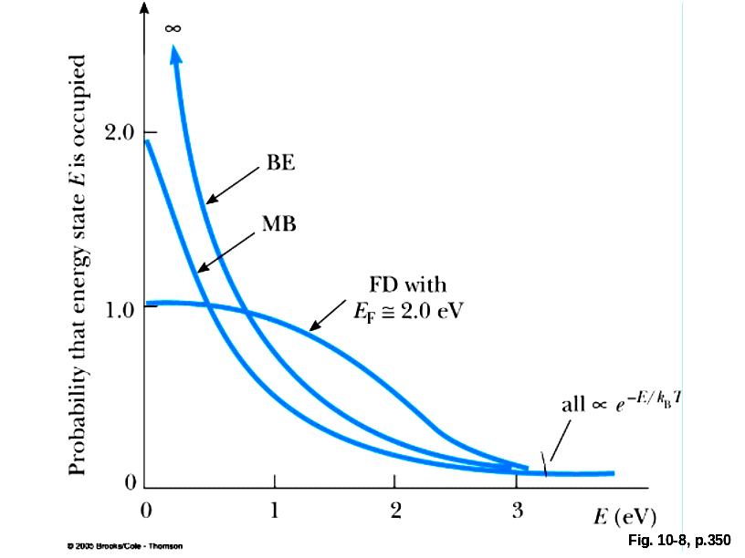
Figure 10.8: A comparison of Maxwell–Boltzmann, Bose–Einstein, and Fermi–Dirac distribution functions at 5000 K.
For high energies (and temperatures) the two quantum distribution functions converge to the Maxwell-Boltzmann distribution function (for the same constant pre-factor) BE is always higher than MB, which is always higher than FD

Term -1 in denominator for BE distribution expresses increased likelihood of multiple occupancy of an energy state, at very very low temperatures all wavefunctions overlap and one gets one superwave-function, in a sense the distinct atoms disappear and a superatom is created, predicted by Einstein in 1924, produced by Cornell+Wieman (1995 Nobel prize)
While MB distribution is for a finite number of particles, BE distribution if for an infinite number of particles, bosons such as photons are not conserved, can be created and destroyed

Term +1 in denominator for FD distribution is consequence of Pauli’s exclusion principle, for small energies FD approaches 1 (Fig, 10-8 not quite OK in this respect)

For FD distribution, since C depends strongly on temperature, defined by

$C=e^{{−E_{F}}/{k_{B}}T}$ where E_{F} is called Fermi energy

$f_{\text{FD}}=(e^{(E−E_{F})/{k_{B}}T}+1)^{−1}$

if E = E_{F} $e^{(E−E_{F})/{k_{B}}T}=e^{0}=1$

this means: the probability of finding an electron with an energy equal to the Fermi energy is exactly 0.5 at any temperature !!!

E_{F} has a weak dependency on T, that frequently gets neglected

for T = 0 all states below the Fermi level (energy) are occupied, all states above the Fermi level are empty

for T > 0 some states below the Fermi level are empty some states above the Fermi level are occupied
the higher the T, the more states above the Fermi level are occupied

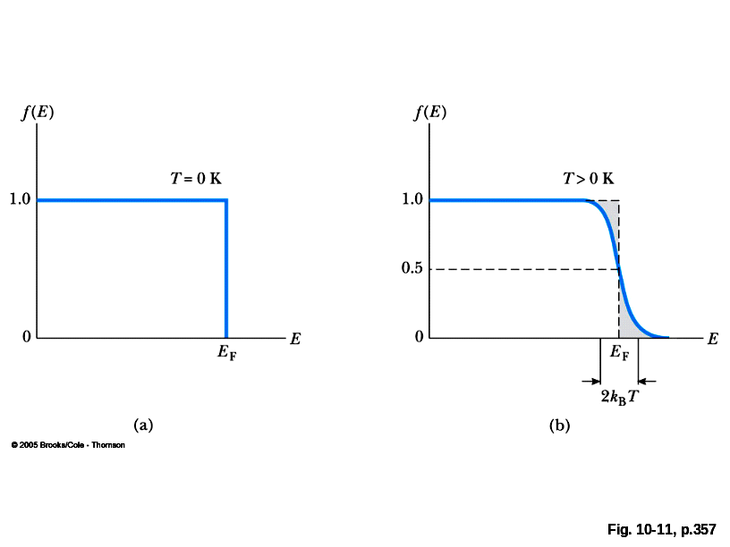
Figure 10.11: A comparison of the Fermi–Dirac distribution functions at (a) absolute zero (b) at some T > zero Kelvin

Satyendranath Bose (1894-1974)
Enrico Fermi (1901-1954)
Paul Adrien Maurice Dirac (1902-1984)
note that beards and long hair went out of fashion by the time the quantum distribution functions were developed ☺

2.4.1 Application of Bose-Einstein statistics: Blackbody Radiation

2.4.2 Application of Bose-Einstein statistics: Einstein’s Theory of Specific Heat

Figure 10.9: The dependence of specific heat on temperature for several solid elements.

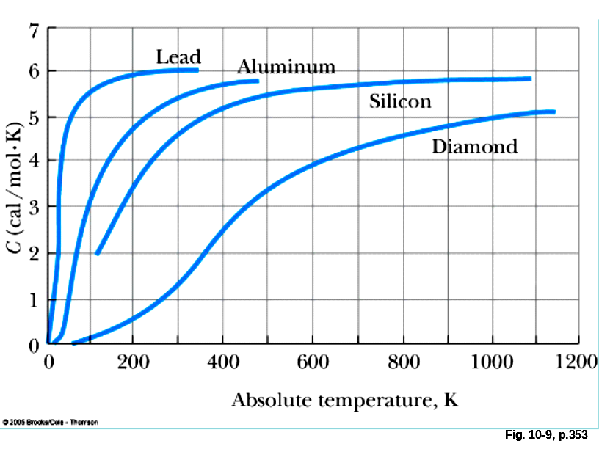

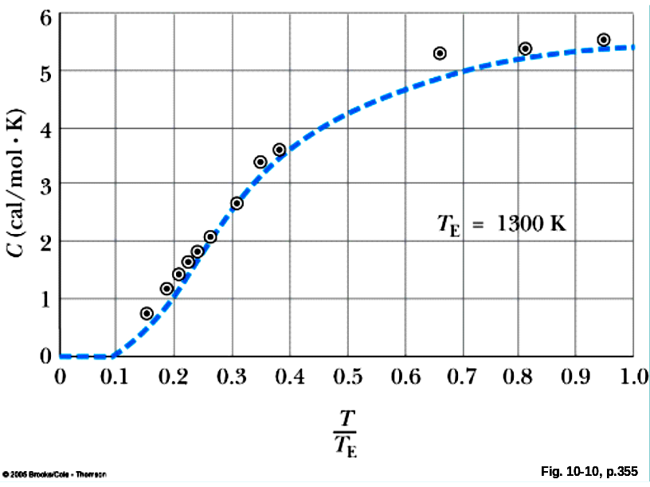
Figure 10.10: Einstein’s specific heat formula fitted to Weber’s experimental data for diamond. This figure is adapted from A. Einstein, Ann. Physik., 4(22):180, 1907.

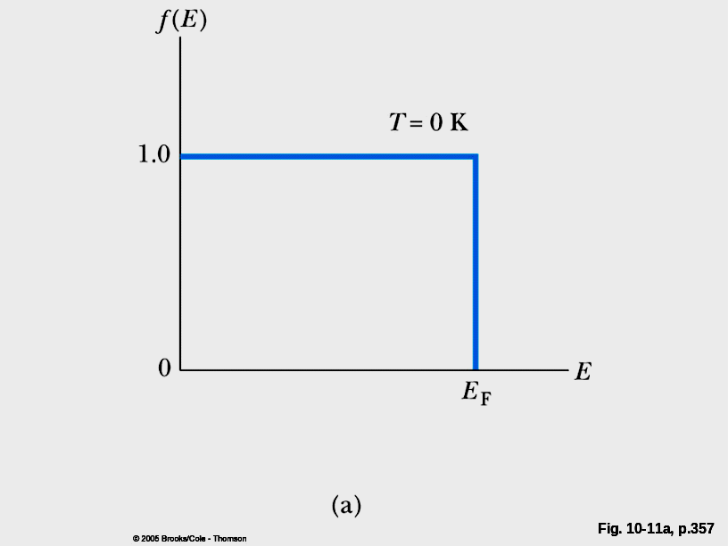
Figure 10.11a: A comparison of the Fermi–Dirac distribution functions at (a) absolute zero

Figure 10.11b: A comparison of the Fermi–Dirac distribution functions at (b) finite temperature.

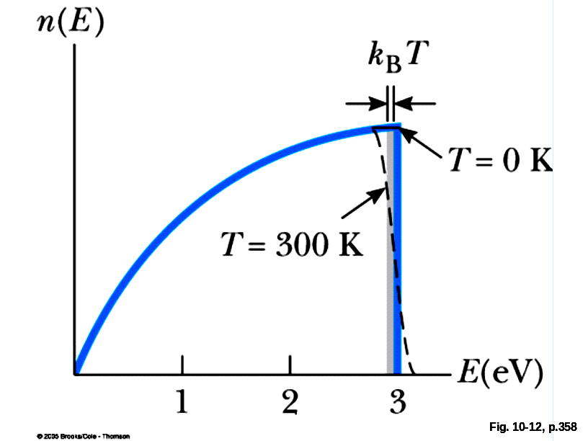
Figure 10.12: The number of electrons per unit volume with energy between E and E + dE. Note that n(E) = g(E)fFD(E).

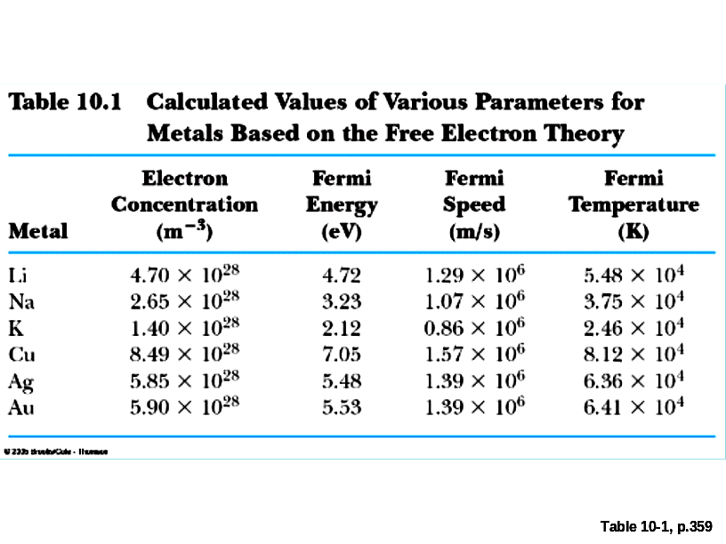

Figure P10.4 Tunneling energy levels. Allowed transitions are indicated by vertical arrows. The degeneracy of each level is indicated in parentheses.

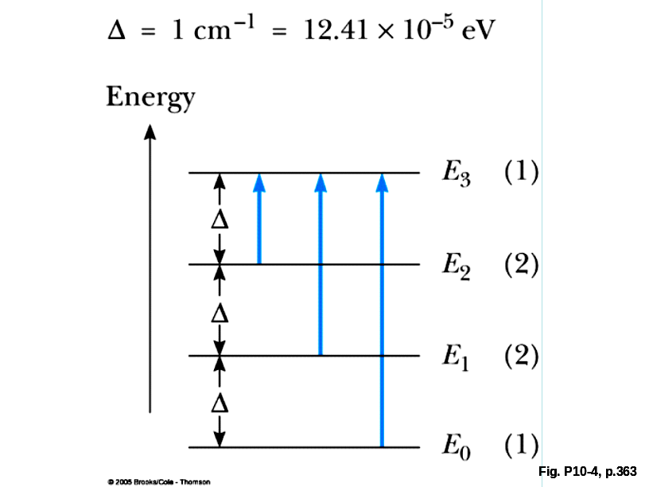

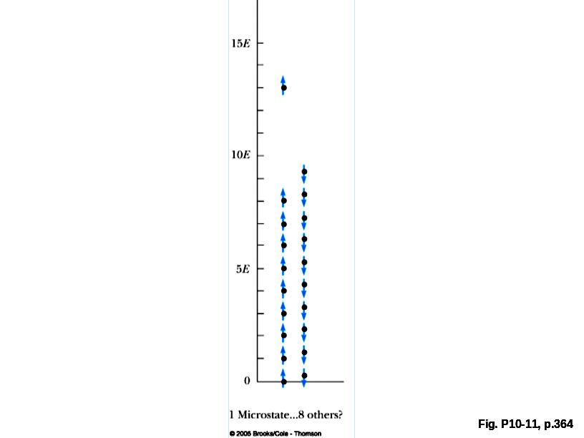
Figure P10.11: One of the nine equally probable microstates for 20 FD particles with a total energy of 94E.

