Chapter 8: Many Electron atoms

8.1. Stern-Gerlach experiment was designed to prove existence of space quantization (from1921 onwards with Ag atoms, 1927 repeated with hydrogen atoms)

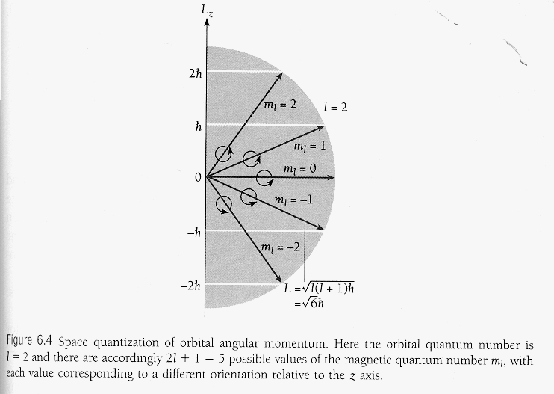

idea: put many hydrogen atoms in a particular state into an magnetic field and you get space quantization of the angular momentum,

then put many hydrogen atoms in a different particular state … and see what you get
for each l (orbital quantum number) there is always 2l + 1 different magnetic quantum numbers m_{l}
so m_{l} = 0, ±1, ±2, ±3 ±l

what happens in a magnetic field?

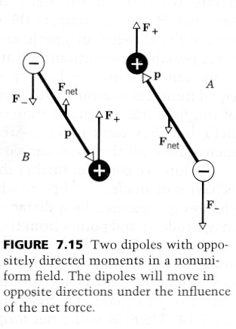
two possible scenarios, the magnetic field can either be homogenous or inhomogeneous
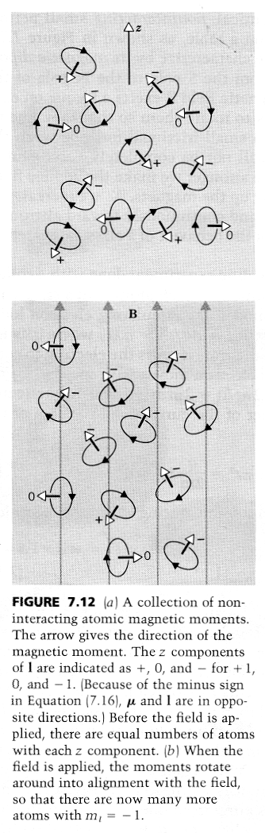
if the field is inhomogeneous, i.e. field lines, lines of force are not parallel to each other, there will be a torque on a moving magnetic dipoles, depending on the direction of that dipole there will be a sideway acceleration
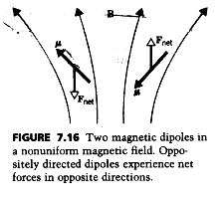
if m_{l} = 0, ±1, ±2, ±3 ±l we should always get an odd number of spots

e.g. for l =1 there is just m_{l} = 0 and ± 1, i.e. three spots

e.g. for l =0 there is just m_{l} = 0, i.e. no magnetic momentum, so there can only be one spot
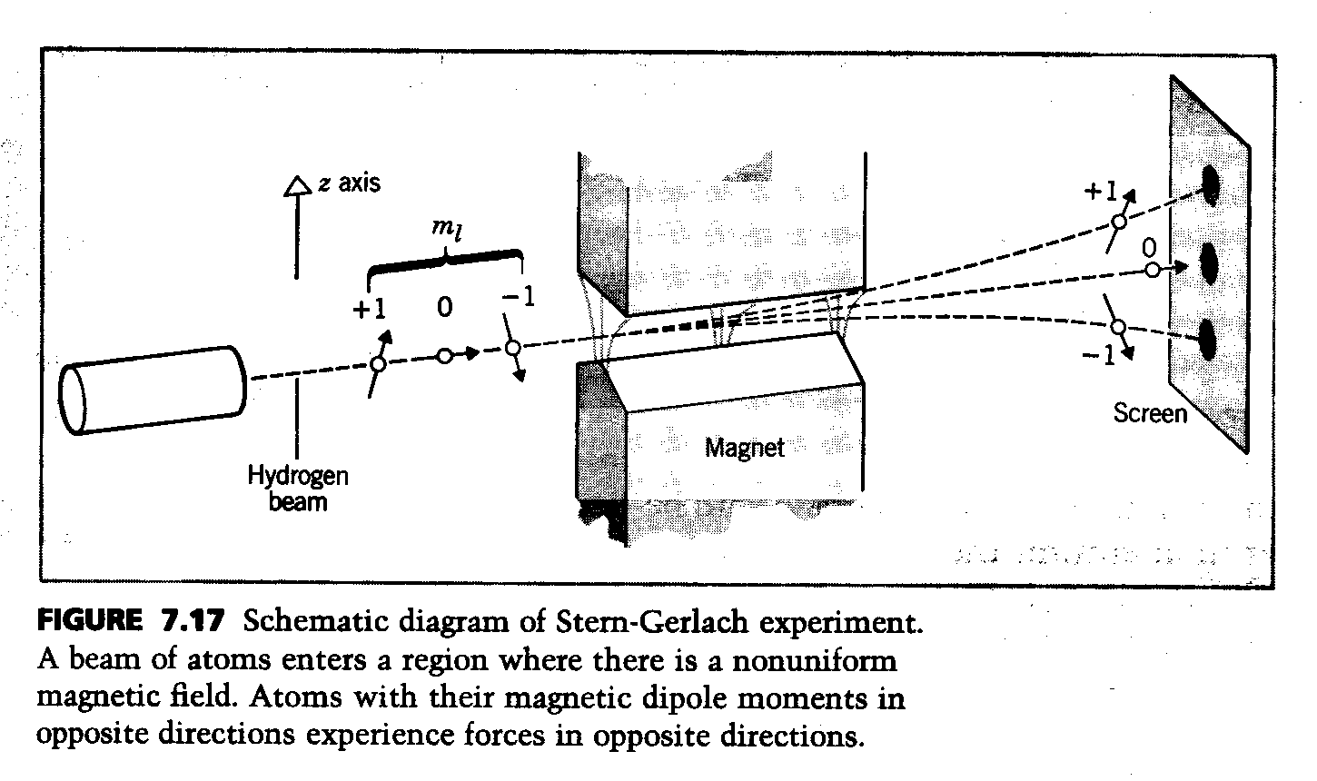

but what we do observe is that we always get an even number of spots, so space quantization that came out of Schrödinger equation may be wrong implying Schrödinger equation itself may be wrong???

or – things are really more complex and they assumptions we used to solve Schrödinger equation above, and Schrödinger used himself in 1925 were not quite correct – only a very good approximation?

so what went wrong?
total energy E = U+ KE, where KE = $\frac{p^{2}}{2m}$ non relativistic
but KE = $\sqrt{p^{2}c^{2}+m^{2}c^{4}}$ (if rest mass and 4 dimensional 4-D space time is taken into account)

using this starting point for the total energy, Paul Dirac in 1928 derived the basic equation wave functions of electrons in a 4-D space time have to obey: - relativistic invariance requited new operators = equivalent to electron spin, there shall also be anti-particles, positrons, found experimentally 1932 by Anderson,
there are always 4 wave functions, two for electrons with different spin, two for positrons with different spin
so Dirac said a particle with the mass and charge of an electron must have a spin = intrinsic angular momentum of magnitude $\sqrt{\frac{3}{4}ℏ}$ , just as it has mass and charge

also postulated by Goudsmith and Uhlenbeck, 1925
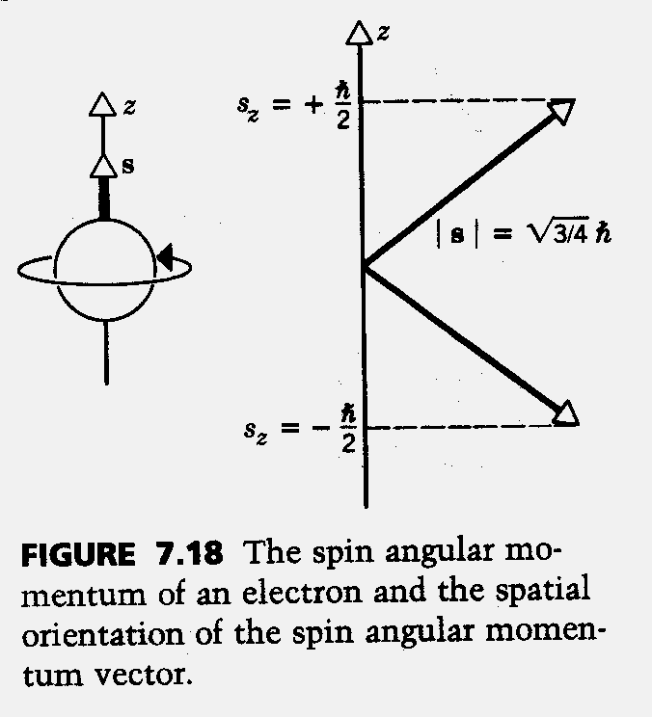
but spin is not to be taken literally

if electron where sphere of r = 5 10⁻¹⁷ m and rotating about axis through its center, it must have an angular momentum of
Jω= $\frac{2}{5}\text{mvr}$
now we know this angular momentum is only S = $\frac{\sqrt{3}}{2}ℏ$
so from
$$\frac{2}{5}{\text{mvr}}^{2}=\frac{\sqrt{3}}{2}ℏ$$

we can calculate v ≈ 5 10¹² ^{m} /_{s}
RIGHT !!

WRONG !

z-component of spin angular momentum is quantized by space quantization just as orbital angular momentum was, the two possible magnetic (intrinsic angular momentum) quantum numbers are ½ and -½

Again uncertainty principle requires that one component, (z component by convention) of the intrinsic angular momentum = spin be quantized, so we have an additional quantum number,
bringing the number of quantum numbers necessary to describe any atom up to four (in four dimensional space time)

so let’s get back to the Stern-Gerlach experiment and figure out what actually happens

two spots (lines) even if l = 0 as in the case of hydrogen atoms in the ground state, so there is m_{l} = 0 assume s is an angular momentum quantum number: by analogy: 2l + 1 was the number of different magnetic quantum numbers for any orbital quantum number l

so have 2s + 1 = 2 possible orientation of angular momentum vector that causes splitting if atom in magnetic field must apply, implies s = ¹/₂

for any l ≠ 0 , odd number of m_{l} when that is combined with s = ¹/₂ spin quantum number, with which a spin magnetic quantum number m_{s} = ± ¹/₂ is associated
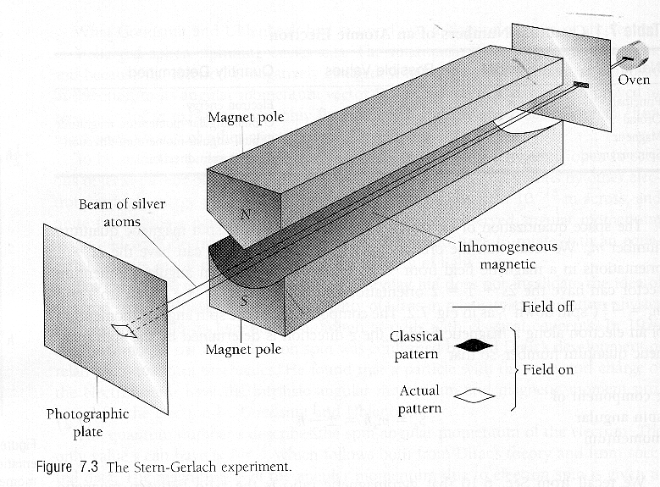
(i.e. intrinsic angular and magnetic momentum), we get an even number of spots, just as observed

intrinsic angular (spin) momentum behaves much like orbital angular momentum, but one important difference

we had magnitude of orbital angular momentum vector L = $\sqrt{l(l+1)}ℏ$, quantized z-component, L_{z} = = m_{l}$ℏ$with m_{l} =0, ± 1, ± 2, ± l magnetic quantum number and associated magnetic moment $μ_{L}=\frac{−e}{2m}L$
we also have magnitude of spin vector S = $\sqrt{s(s+1)}ℏ=\frac{\sqrt{3}}{2}ℏ$,
quantized z-component S_{z} = m_{s} $ℏ$ = $±\frac{1}{2}ℏ$ with quantum numbers m_{s} = $±\frac{1}{2}$ but $μ_{S}≈\frac{−e}{m}S$, i.e. the magnetic moment that is associated with the electron spin is (about) twice as large as that associated with the orbital angular momentum

note the difference: spin quantum number and m_{s} magnetic spin quantum number, while s = $\frac{1}{2}$ m_{s} = $±\frac{1}{2}$
we define a new constant $μ_{S,z−\text{component}}=±\frac{eℏ}{2m}=±μ_{B}$ as Bohr magnetron = 9.274 10⁻²⁴ ^{Ws}/_{T}

again, in the absence of a magnetic field we must space quantization in any direction we care to measure

electron spin and its pairing off in multi-electron is also the answer to the anomalous Zeeman effect
Wolfgang Pauli: How can one look happy when he is thinking about the anomalous Zeeman effect ?

electron spin and spin-orbit coupling is also the answer to the so called fine structure of the spectra, i.e. there are always two lines very close together

two equivalent points of view, electron goes around the nucleolus, nucleolus goes around the electron – there is no preferred frame in reference in physics!

considering proton goes around electron we have kind of “internal Zeeman effect”
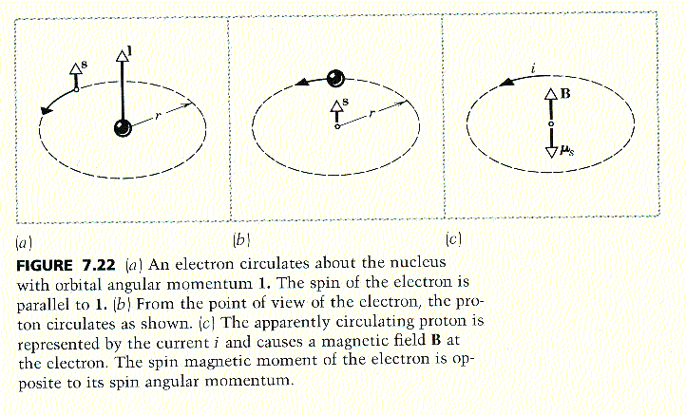

as in the case of normal Zeeman effect, there is a total energy difference, U_{m} = $±μ_{B}B$ also called spin-orbit coupling, all spectral lines split into two with
ΔU_{m} = $2μ_{B}B$
state with $s_{z}=\frac{1}{2}ℏ$ are shifted to higher energies by and amount Δ E = μ_{B}B with μ_{B} Bohr magnetron and B stands for the always present magnetic field due to the motion of the proton, directions of l and s are parallel

state with $s_{z}=−\frac{1}{2}ℏ$ are shifted to lower energies by and amount ΔE = μ_{B}B, with μ_{B} Bohr magnetron …

when directions of l and s are anti-parallel

energy difference can be shown to be $ΔE=({\text{mc}}^{2})α^{4}\frac{1}{n^{5}}=2μ_{B}B$
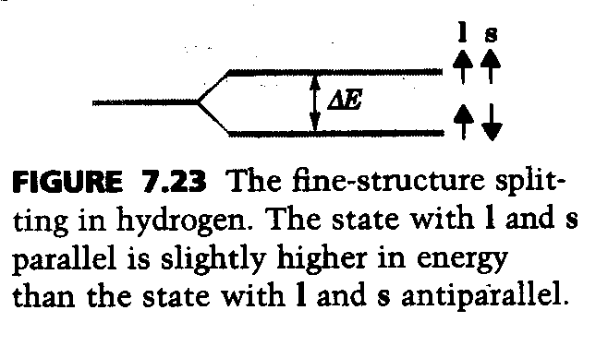
where α is called fine-structure constant $α=\frac{e^{2}}{4{\text{πε}}_{0}\text{hc}}$ is dimensionless and about $\frac{1}{\text{137}}$

8. 2. Schrödinger equation for two and more particles

particles frequently interact, if it is two electrons going around a nucleolus, the repel each other

such a Schrödinger equation can not be solved exactly (and analytically) similar to classical physics 3 (and more) body system with gravitational interaction has no analytical solution

(there is no general quantum theory of gravitation at present)

one more problem: electrons are identical to each other, so if there are two of them, one can not keep track of which is which

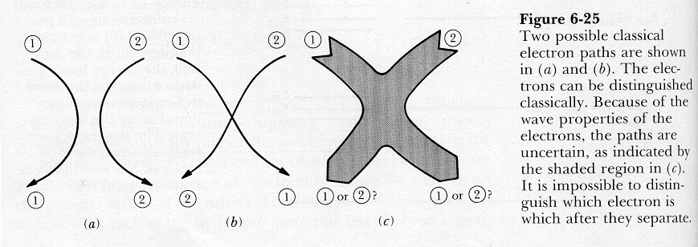

as there is no path the electrons follow, due to the uncertainty principle
time independent Schrödinger equation for two particles

$$\begin{aligned}−\frac{ℏ^{2}}{2m}\frac{∂^{2}}{∂x_{1^{2}}}ψ(x_{1},x_{2}) \\ −\frac{ℏ^{2}}{2m}\frac{∂^{2}}{∂x_{2^{2}}}ψ(x_{1},x_{2})+U(x_{1}x_{2}) \\ \end{aligned}ψ(x_{1},x_{2})=Eψ(x_{1},x_{2})$$
where x₁ and x₂ are the coordinates of the particles, is just like one particle in two dimensions

if it is electrons, they interact, potential energy function U will contain terms that depend on both x₁ and x₂, these terms can usually not be separated, so we can not do separation of variables, but we can use ideas of shielding to first describe a system where there is no interaction and then make the correction for the interaction

if it were two non-interacting particles

we could separate variables and have U(x₁,x₂) = U₁(x₁) U₂(x₂)

e.g. in a one dimensional finite square well we would have U = 0 inside the wall, then Schrödinger equation would be just of same form as for a single particle in a two-dimensional finite square well
simple solutions have form

$ψ_{\text{nm}}(x_{1}x_{2})=ψ(x_{1})ψ(x_{2})$,e.g. $ψ_{1,2}(x_{1}x_{2})=C\text{sin}\frac{{πx}_{1}}{L_{1}}\text{sin}\frac{{πx}_{2}}{L_{2}}$
probability of finding particle 1 in dx₁ and particle 2 in dx₂ is

$ψ_{\text{nm}}(x_{1}x_{2}){\text{dx}}_{1}{\text{dx}}_{2}=ψ(x_{1})^{2}{\text{dx}}_{1}⋅ψ(x_{2})^{2}{\text{dx}}_{2}$ as the particles do not interact in this scenario

if the particles were undistinguishable, e.g. if they were electrons we do not know which is in dx₁ and which is in dx₂

for identical particles, e.g. electrons, we must construct a wave function so that probability density is the same if we interchange the labels 1 and 2:

$$ψ_{\text{nm}}(x_{1},x_{2})=ψ_{\text{mn}}(x_{2},x_{1})^{2}$$

this equation can only be fulfilled if wave function is either symmetric

$ψ_{\text{nm}}(x_{1},x_{2})\text{=+}ψ_{\text{mn}}(x_{2},x_{1})$

or anti-symmetric

$$ψ_{\text{nm}}(x_{1},x_{2})=−ψ_{\text{mn}}(x_{2},x_{1})$$
now looking at the simple form solutions, they are neither symmetric nor anti-symmetric, so they can’t represent indistinguishable particles

we have to make linear combinations in order to get wave functions for indistinguishable particles

$ψ_{\text{nm}}(x_{1}x_{2})=C[ψ_{n}(x_{1})⋅ψ_{m}(x_{2})+ψ_{n}(x_{2})⋅ψ_{m}(x_{1})]$ symmetric

$$ψ_{\text{nm}}(x_{1}x_{2})=C[ψ_{n}(x_{1})⋅ψ_{m}(x_{2})−ψ_{n}(x_{2})⋅ψ_{m}(x_{1})]$$
anti-symmetric

if n = m anti-symmetric wave function = 0 for all x₁ and x₂

but symmetric wave function ≠ 0

in nature: a system (i.e. more than one) of electrons and other (non-integer spin) particles such as protons and neutrons can only have anti-symmetric wave functions (such particles are called fermions) !

if follows single particle wave functions

$$ψ_{n}(x_{1})\text{__}\text{and}\text{__}ψ_{m}(x_{2})$$

can not have the same quantum number, i.e. n ≠ m,
example of Pauli’s exclusion principle – it’s just a fact of nature can not be derived from any other principle

“no two electrons in an atom can have the same set of values for their four quantum numbers!”

another fact of nature: other particles such as photons, α-particles, deuterons, mesons, are also indistinguishable due to the uncertainty principle, but do not follow exclusion principle, have symmetric wave functions (and integer spin)- such particles are called bosons

so protons and neutrons have non-integer spin as well

and must, therefore, obey the exclusion principle when they are in the same system,

i.e. a nucleolus of an atom, the result is each of the constituents of the nucleolus must be in a different energy state, and indeed is

the observable result is the hyperfine structure of spectral lines
8.3. Periodic table total angular momentum of atoms

Dimitri Medeleev in 1869: ordered the then known 63 elements according to their known chemistry into 7 main columns (also called main groups), with their (relative) atomic mass increasing from the top to the bottom, putting these 7 columns together into a table and adding some 30 transition elements according to their relative atomic weight, he noticed that there is a gradual change in chemistry from one column to the next, that follows the increase in (relative) atomic mass pretty well along the rows

so in effect his scheme is a matrix with column and row vectors, there is a distinct periodicity of the chemical behavior in every of the row vectors as column vectors were made up from elements of similar chemical behavior
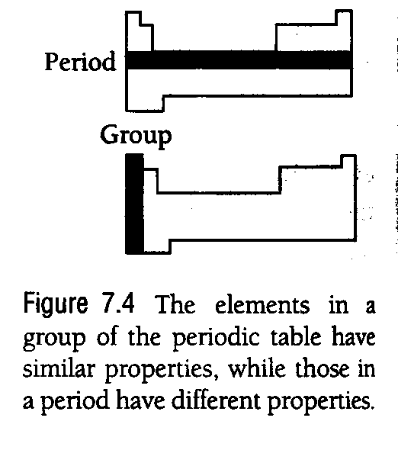
within columns (groups) there is a gradually increasing or decreasing intensity of the main chemical property, but from row to row there is periodicity, so whatever causes chemical behavior must be a periodic thing as well, there is also periodicity in most physical properties
in 1871, he predicted that the gaps in this matrix are undiscovered elements, some of them were indeed later found, a whole new column, consisting of the 6 inert (or noble) gasses – which do not react chemically with anything, i.e. have nearly identical chemical behaviors - was added at the end of the 18th century, this became the 8th column, group

the majority of the elements are metals

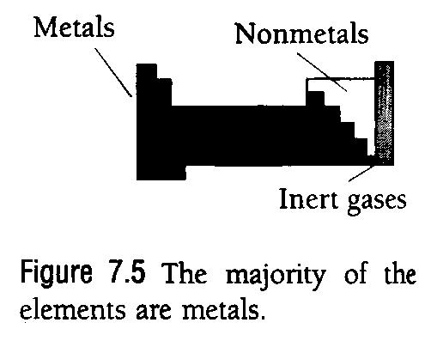
the most active naturally occurring metal (Cesium), which is also the largest atom, (the non-stable Francium atom is even more reactive)

the most active non-metal (Fluorine) are at “kind of opposite ends” in the matrix
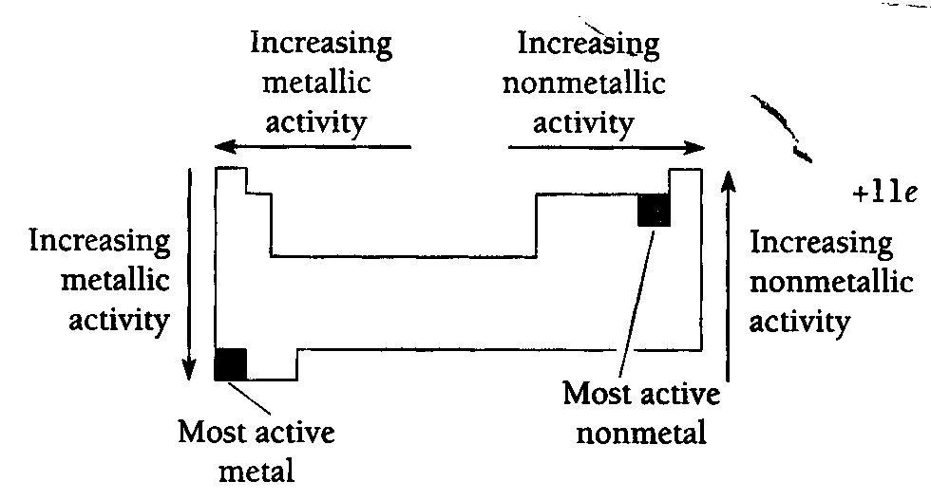

Transition elements

between these extremes in different chemical behavior there are gradual transitions and a region of atoms which are neither metals nor non-metals

there are 3 full sub-rows of 10 transition elements of similar chemical behavior (not considering Z = 104 to 109 which are non-stable transition elements)
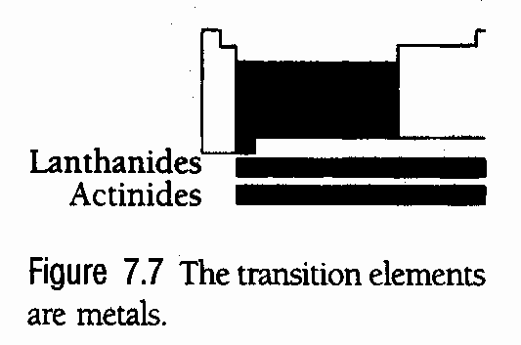
two sub-rows to 14 members each
of essentially identical chemical behavior, collectively called the rare earth, their natural place in the scheme next slide, sometimes depictions of their place in some books is misleading

Transition elements
now we give then all a number Z = number of protons in the nucleolus = number of electrons, so Z=1 is hydrogen, …
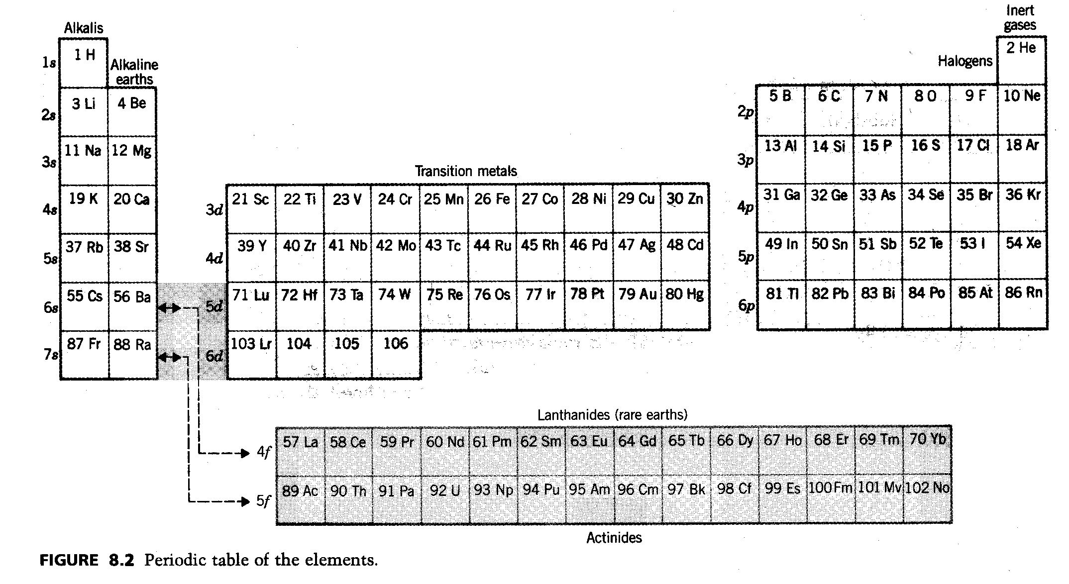

U, Z=92, is the last (heaviest) of the stable atoms
Tc, Z=43, and Pm, Z=61, do not exist in nature

do you notice the familiar notation, 1s, 2p, …at the beginning of each row ???

that’s right, the whole periodic scheme can be explained from quantum mechanics, i.e. Schrödinger’s model of the hydrogen atom, electron spin, Pauli’s exclusion principle, screening effects – nothing more is needed
Screening effects

for closed shells and sub-shells as in the inert gases, we get very tightly bound states because the electrons in these (sub-)shells experience a high attractive force due to a large positive charge

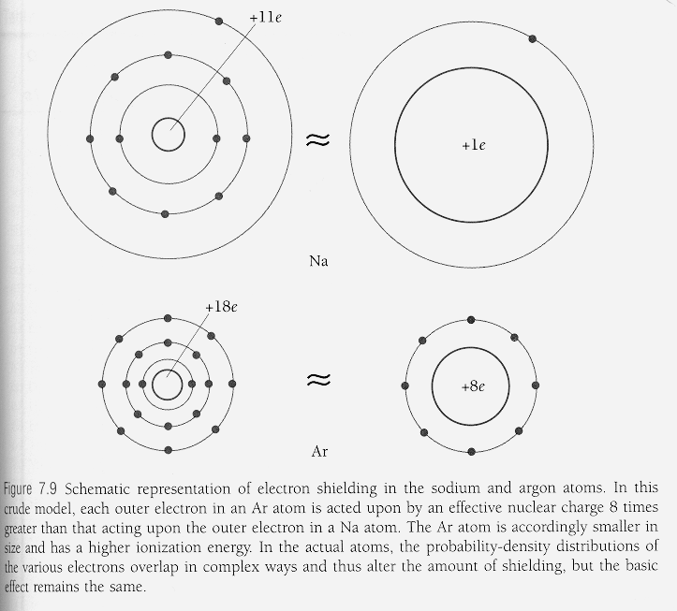

for a single electron in a (sub-)shell we get loosely bound states as the electron in effect experience only one positive charge

so the single outermost electron in Na reacts easily with some other atom, the whole group, column is called the alkali metals

if there is just one electron missing in an otherwise closed sub-shell, such as in group or column 7, the halogens, an electron gets easily captured from some other atom, so these elements, F, Cl, Br, I, react pretty fast, (Astatine is radioactive)
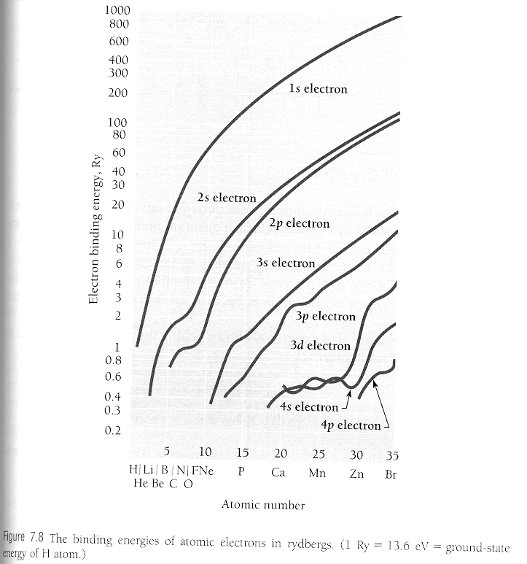

as usual, it’s not so simple, here you see how the binding energy really changes due to screening effects,

if there were no interaction between the electrons and screening, all of these curves would be smooth and equidistantly spaced

“screening coefficients” get introduced,

$$E_{n^{{\text{screen}}_{\text{corrected}}}}=−\frac{e^{2}}{8{\text{πε}}_{0}a_{0}}{\left\{n−D(l)\right\}}^{−2}$$

instead of $E_{n^{\text{Bohr}}}=−\frac{e^{2}}{8{\text{πε}}_{0}a_{0}}(\frac{1}{n^{2}})$

and are called Quantum defects, e.g. for Sodium,

Sub-shell | D(l)
s | 1.35 | Large screening effect
p | 0.86 | Medium screening effect
d | 0.01 | very small screening effect
f | ≈ 0 | almost no screening

different for every real atoms
Screening granted, How to build up atoms?

starting point a single proton, Z = 1, add an electron and make sure it has the lowest energy, i.e. you have to put it into its ground state, i.e. in an 1s state, and you get an hydrogen atom

next take two protons, Z = 2, add two electrons and make sure they have the lowest energy, i.e. you have to put then into their ground state, which is also the ground state of the two electron atom i.e. both into an 1 s state, they must have the configuration spin up and spin down, and you get helium

for larger nuclei you need to add neutrons in order to overcome the strong electric repulsion between the protons

atoms with the same number of protons (and electrons) but different numbers of neutrons are called isotopes,

effectively all chemistry and a lot of physical properties can be explained from the electronic structure of the involved atom alone

so all isotopes of an element have the same chemistry as they have the same electronic structure

that’s why it is so difficult to separate ²³⁵U from Uranium ore, one can’t do it by chemistry as one does with every other ore, that’s why the atom bomb “little boy” over Hiroshima came with a price tag $ 2 10⁹ (atom bomb “fat man” over Nagasaki was filled with Pu, partly from Heisenberg’s research reactor, partly from American sources)

so let’s look at the electronic structure
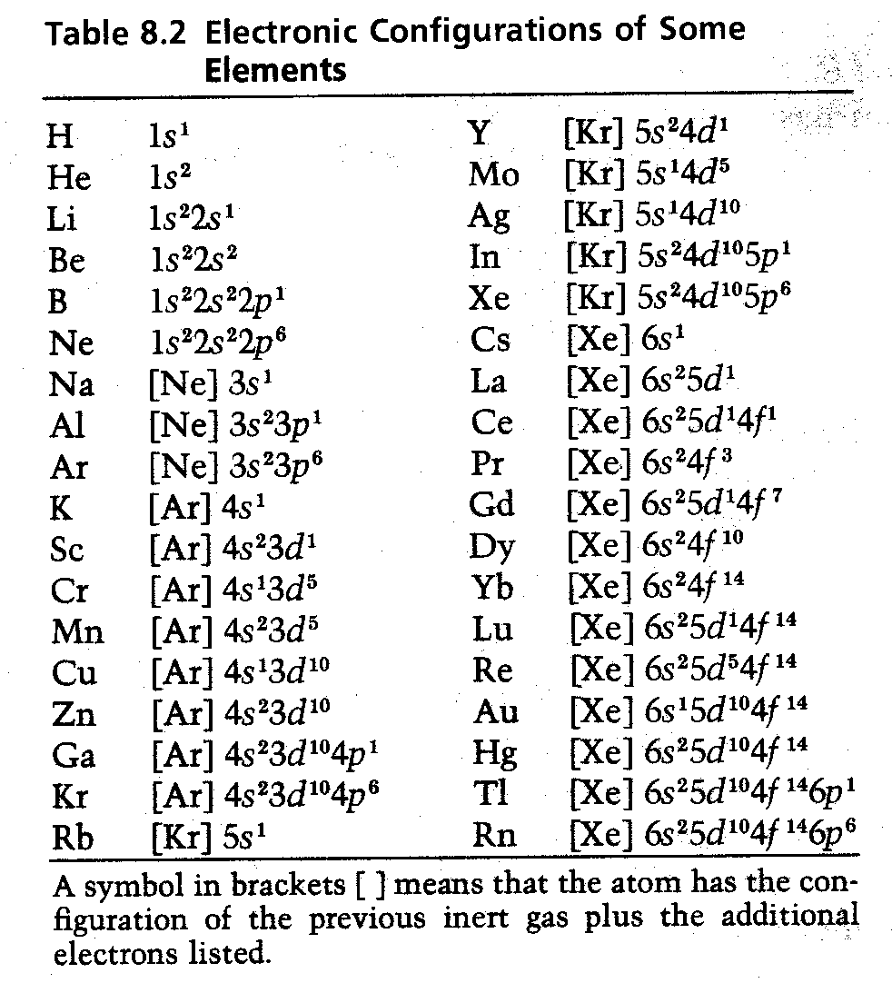

for increasing number of protons and electrons
shells (quantum number n) and sub-shells (quantum number l) get filled according to the lowest energy principle

1s < 2s < 2p < 3s < 3p < 4s ≈ 3d < 4p < 5s < 4d < 5p < 6s < 4f ≈ 5d < 6p < 7s < 6d ≈ 5f …

peculiarities of this order are due to “shielding effects”

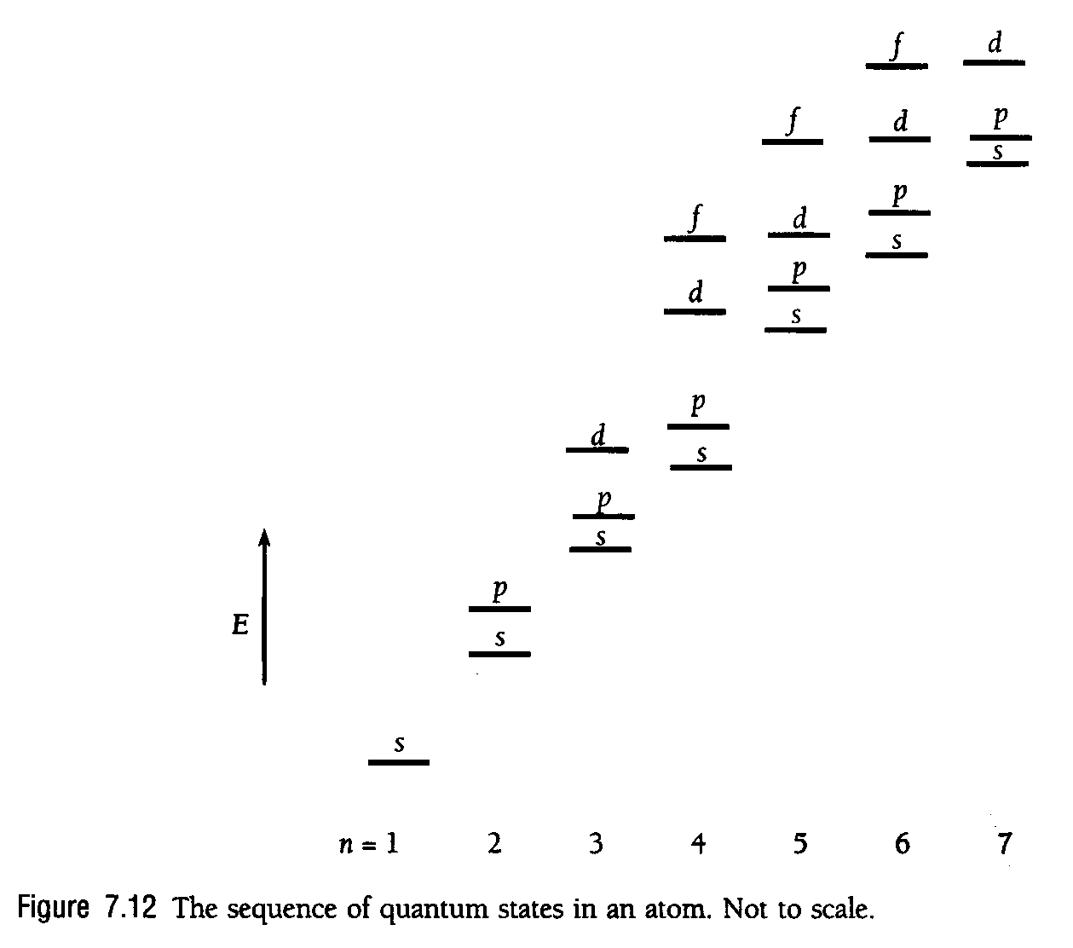
the outermost electrons determine the chemical behavior and most physical properties (except mass, …)

there is a difference in energy between shells and sub-shells, if a shell or sub-shell is full, i.e. closed, the chemical activity is very small as the new electron would need to go into a new shell, sub-shell with a higher energy,

inert gasses have therefore closed shells (or sub-shells)

capacity of every sub-shell is 2 (2l + 1), the inert gasses have full capacity shells (closed shells and sub-shells)

each s shell l = 0, m_{l} = 0 can contain 2 electrons, there are no sub-shells, so the K-shell (n=1) has two electrons, ∑2 electrons, ₂He is the 1st period inert gas

each p shell l = 1 can contain 2 electrons, there are three of them, as m_{l} = ± 1, 0, so the total capacity of these sub-shell is 6 electrons, so the whole L-shell (n=2) comprises these 6 electrons plus the 2 electrons from the 1s state, ∑8 electrons + ₂He = ₁₀Ne is the 2nd period inert gas

each d shell l = 2 can contain 2 electrons, there are five of them, as m_{l} = ±2, ± 1, 0, so the total capacity of these sub-shell is 10 electrons, so the whole M-shell (n=3) comprises these 10 electrons plus the 6 electrons from all of the p-shells, plus the 2 electrons from the s state, ∑18 + ₁₀Ne ? does not exist as an inert gas,

so what went wrong? 3 d sub-shell has slightly higher energy than 4s sub-shell, or lower binding energy, see fig. 7.8 above, so it does not get filled until the 4s sub-shell has been filled

this happens from ₂₀Ca onwards

the inert gas of the 3rd period is therefore ₁₈Ar, so it only has filled 3p, 3s, 2p, 2s, and 1s sub-shells, i.e. 8 + 8 +2 electrons, it is not a fully filled shell inert gas as the first two, ₂He and ₁₀Ne are

the inert gas of the 4th period is ₃₆Kr, its structure is [Ar]4s²3d¹⁰4p⁶ so it has also only a closed p sub-shell as outer electrons

let’s continue:

each f shell l = 3 can contain 2 electrons, there are seven of them, as m_{l} = ±3, ±2, ± 1, 0, so the total capacity of these sub-shell is 14 electrons, this explains why there are exactly 14 Lanthanides and 14 Actinides
as one can easily derive:

l = 0,1, 2, …. (n-1)
m_{l} = 0, ±1, ± 2, ± l
m_{s} = ± ¹/₂

N_{n} = $2\sum_{l=0}^{l=n−1}{(2l+1)}=2\left\{1+3+5+\text{.}\text{.}\text{.}+2(n−1)+1\right\}=2n⋅\frac{1}{2}\left\{1+2n−1\right\}=2n^{2}$

as there are n terms whose average value is ½{1+(2n-1)}

maximal number of electrons in a shell N_{n} = 2n²

so with n = 6 we get for the 6th period inert gas [Xe]4f¹⁴5d¹⁰6s² 6p⁶ , i.e. the 54 electrons of Kr + 14 + 10 + 2 + 6 = 86 which is
the radioactive inert gas Radon ₈₆Rn, which is the end of the last of the full periods,

so considering that the 14 4f states have to be added, this confirms N₆ = 2 6² for the last element in the 6th period ₈₆Rn

then there are two more elements where the 7s states get filled, this brings us up to Z = 88, then there come the 14 Actinides, ending with ₁₀₂No

then the 6 d states get filled, …but nothing beyond ${}_{\text{92}}^{\text{238}}{}U$ is stable, what follows is frequently called the transuranians
Hund’s rule

while filling up sub-shells, in general, electrons in a sub-shell remain unpaired, that is, have parallel spins wherever possible

ferromagnetism of Fe, Co Ni has its origin in Hund’s rule

there are five 3d orbitals,
Fe is [Ar]3d⁶4s² i.e. 4 unpaired, cancelled off spins
Co is [Ar]3d⁷4s² i.e. 3 unpaired, cancelled off spins
Ni is [Ar]3d⁸4s² i.e. 2 unpaired, cancelled off spins

origin of Hund’s rule is mutual repulsion of atomic electrons, the farther apart the electrons the lower the energy of the atom

electrons in the same sub-shell with the same spin quantum number m_{s} must have different m_{l} quantum numbers, i.e. possess wave functions with different spatial distribution of the probability density, i.e. are therefore ,ore separated in space that “spin paired off electrons; the as everywhere in nature the lower energy state is the more stable one

why are crystals of pure Cu, Ag and Au the best conductors of electricity in nature?

Cu is [Ar]3d¹⁰4s¹
Ag is [Kr]4d¹⁰5s¹
Au is [Xe]4f¹⁴d¹⁰4s¹

i.e. all of them have one outer electron that is given off easily to the interior of the crystal forming an electron gas, that atoms in these crystals are effectively positive ions with one excess positive charge, of course, there elements are in one column of the periodic table

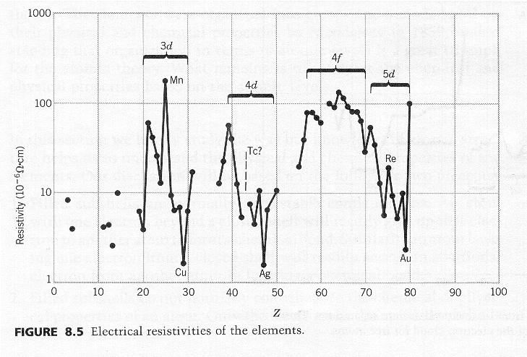
some more periodic physical properties

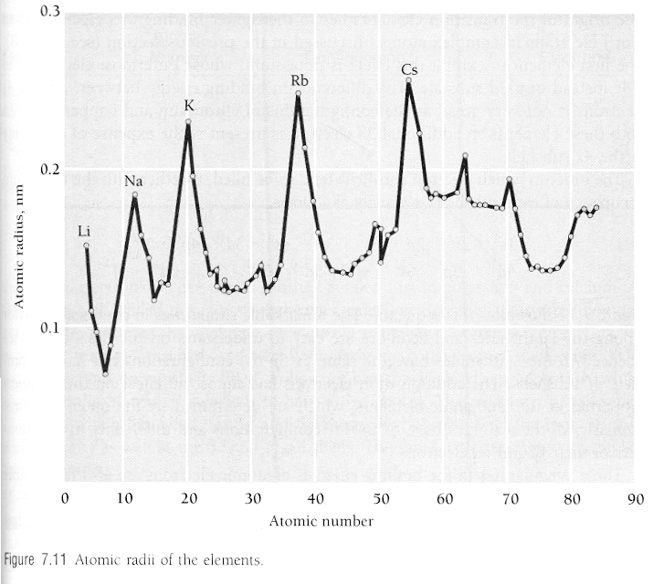
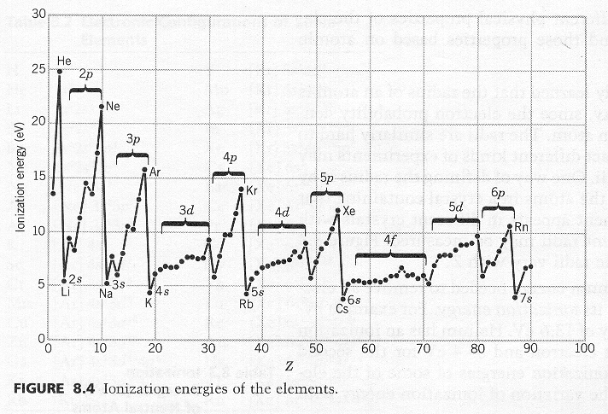

Similarities in spectra of one outer electron systems, e.g. Hydrogen and Sodium

H 1s¹
Na [Ne]3s¹

so we have a similar part of the full spectrum, the whole Hydrogen spectrum is a part of the Sodium spectrum with changes energy scales of course
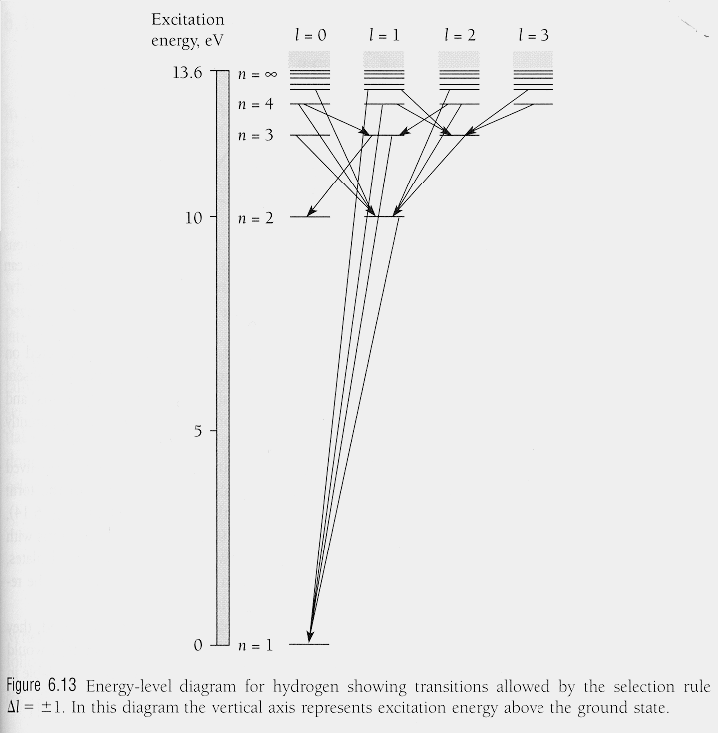
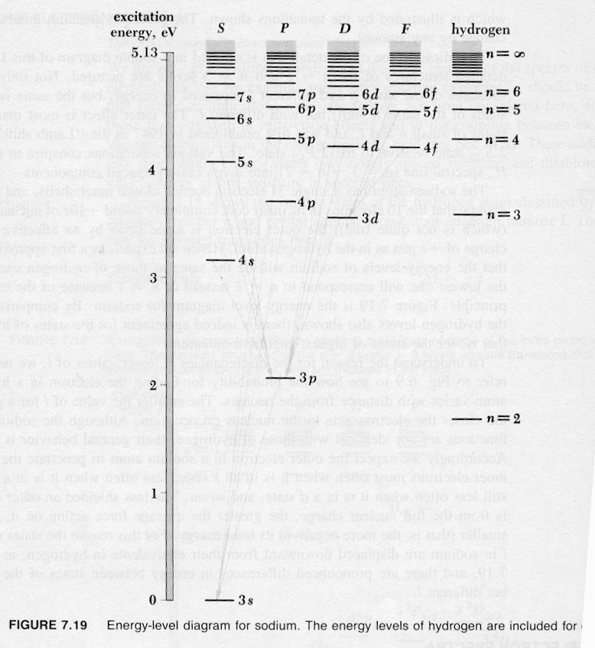

so everything that depends on the occupation of the outer electron states has to be periodic, is there something else that is not periodic?

8.4. X-ray spectra

there is “brems-radiation”, i.e. so called “white” radiation, a continuous spectrum and characteristic radiation

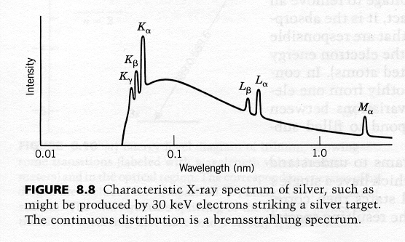

in order to produce characteristic X-rays one need to excite the atom so much that an inner electron gets kicked out, order of magnitude some 30 keV, easily done in modern scanning electron microscope, then one can identify the elements in the sample by their characteristic X-ray spectrum

note that X-ray spectra are much simpler than optical spectra because they reveal only the energy lever of the innermost electrons

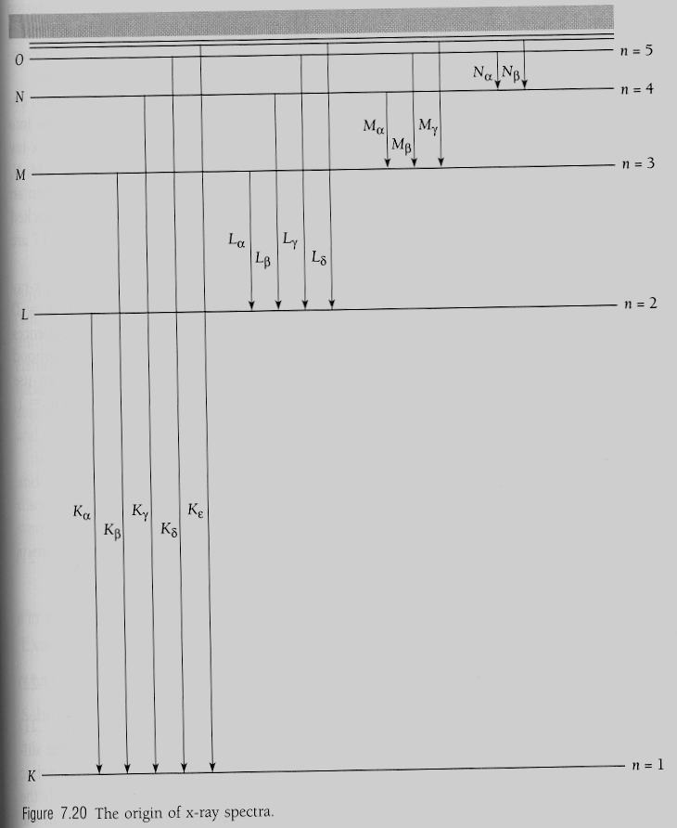

K_{α} originates from a transition from n = 2 to n = 1, actually it is a doublet, as electrons have spin and spin-orbit coupling results in these electrons having slightly different energies

there are more characteristic X-ray lines helping to identify a specific element, as the X-rays arise from transition between the innermost electrons, the modifications of the electronic structure of the elements due to chemical binging of the outermost electrons does not matter (much)
Moseley in 1913 got experimentally for the frequency of the characteristic radiation of some 60 elements

$\sqrt{f}≈A_{n}(Z−b)$ called Moseley’s law

where A_{n} and b are constants for each type of line

plotting square root of X-ray frequency versus Z, this ”law” is represented by a straight line analogously to
y = Ax - b
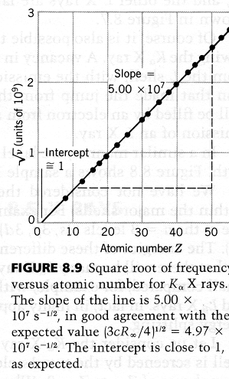

so called “Moseley plot” to derive empirical values for the constants A_{n} and b for different X-ray series

so why is slope 5 10⁷ Hz^{0.5} and intersection with “Z-axis” close to 1 ?

explanations based on Bohr model of atoms and idea of shielding

if one s electron in the K shell (n=1) has been kicked out of the atom by the energy provided by the electron beam, the electron that is going to jump down from the (n = 2) L-shell is shielded just by the remaining s electron, i.e. it experiences the full positive charge of the core minus one electron charge due to that remaining electron in the K shell

taking Bohr’s formulae

$\frac{1}{λ}=Z^{2}R(\frac{1}{n_{{\text{final}}^{2}}}−\frac{1}{n_{{\text{initial}}^{2}}})$
where R is Rydberg constant $R=\frac{{\text{me}}^{4}}{8h^{3}ε_{0^{2}}c}$ a reciprocal length

replacing Z with Z -1 due to shielding, and setting f_{final} = 1 as the whole is in the K shell and n_{intitial} = 2 as it comes form the L shell, we get

$$\frac{1}{λ}=(Z−1)^{2}R(\frac{1}{1^{2}}−\frac{1}{2^{2}})$$

as c = λ f, we multiply both sides with c and get
$$f=(Z−1)^{2}\text{Rc}(1−\frac{1}{4})$$
taking the square root, we get

$$\sqrt{f}=\sqrt{\text{Rc}(0\text{.}\text{75})}(Z−1)$$

so the slop of a Moseley plot for K_{α} is

$$\sqrt{\text{Rc}(0\text{.}\text{75})}=\sqrt{1\text{.}\text{0973732}⋅{\text{10}}^{7}m^{−1}⋅2\text{.}\text{99792458}⋅{\text{10}}^{8}{\text{ms}}^{−1}⋅0\text{.}\text{75}}$$
= 4.9673 10⁷$\sqrt{\text{Hz}}$

intersection close to 1 means the shielding effect is indeed about one electron, for Z = 1 we would have Z-1 = 0, i.e. no X-ray line with zero frequency

this good agreement between theory and experiment, 5 10⁷ $\sqrt{\text{Hz}}$ explanation shortly after Bohr’s series of papers helped to convince other scientist of its merits
for L series of characteristic X-rays

$$\sqrt{f}≈A_{n}(Z−b)$$

i.e. transitions from n = 3 to n = 2, the experimental result

$$f_{L}≈\text{cR}(\frac{1}{2^{2}}−\frac{1}{n^{2}})(Z−7\text{.}4)^{2}$$

reflecting the difference(and complexity) in the shielding idea

X-ray spectroscopy in 1913 gave meaning to the atomic number, which determined the place of the element in the periodic table

the (relative) atomic weight is only roughly right as indication of the place of an element in the periodic table, e.g. Z = 18 Argon, 39.948 g ;
but Z = 19 Potassium, 39.102 g, both behave very very differently in chemical reactions

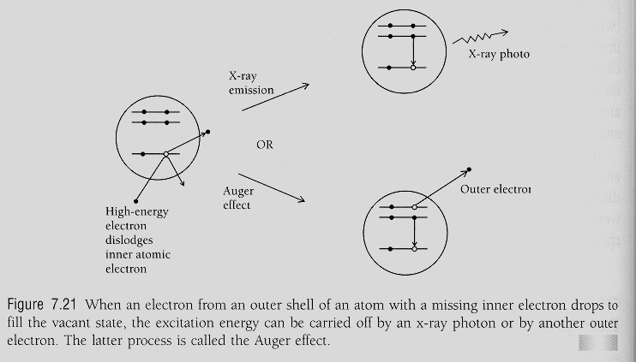

Auger effect is competitive de-excitation process to characteristic X-ray photon emission

an outer shell electron is ejected and takes away the excess energy and angular momentum that has to be removed so that another outer electron can jump down to the hole that resulted from the high energy excitation

in a (dirty) bulk material the ejected electron is quickly absorbed, but in (clean) ultra high vacuum it may emerge from a surface area, since it is an outer electron it carries information on the chemical environment at the surface, so it is a very valuable spectroscopic tool

