7.2. Schrödinger equation in spherical coordinates / Theory of the hydrogen atom

done first by Schrödinger himself, he discovered how naturally quantization occurs in wave mechanics: “It has its basis in the requirement that a certain spatial function be finite and single values.”

electron is considered to be a point charge that goes around the nucleus, which is also considered to be a point charge and assumed to be stationary, the great distance between electron and proton with respect to their actual size and the 1836 times larger mass of the proton makes these assumptions entirely feasible
potential energy is electrostatic potential energy U = $−\frac{e^{2}}{4{\text{πε}}_{0}r}$

U is a function of r rather than x, y, z, but r = $\sqrt{x^{2}+y^{2}+z^{2}}$

as our electrostatic potential function depends on r, so we can not substitute it directly into 3D Schrödinger equation that is valid for a wave function that depends on x,y,z

two alternatives: express U as a function of x,y,z or express Schrödinger equation in spherical polar coordinates, latter is by far easier, especially as we want to separate the variables later and get a physical interpretation in the form of quantum numbers on as we did for 3D infinite square well

so it is naturally to use spherical coordinates as it is a spherical problem
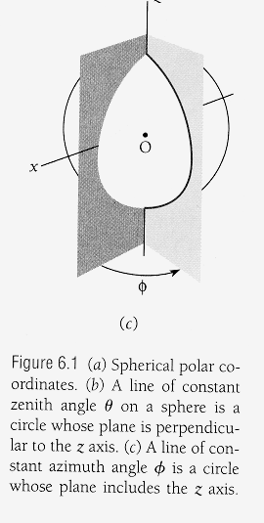
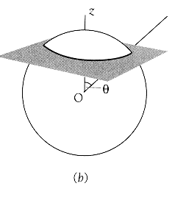
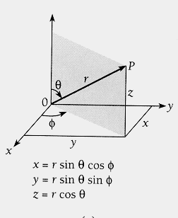

“kinds” of latitude,

angle θ is zenith angle = arc cos $\frac{z}{\sqrt{x^{2}+y^{2}+z^{2}}}$
angle φ is azimuth angle = arc tan $yx$ “kinds” of meridians longitude

Schrödinger equation in spherical polar coordinates

$$\frac{1}{r^{2}}\frac{∂}{∂r}(r^{2}\frac{∂ψ}{∂r})+\frac{1}{r^{2}\text{sin}θ}\frac{∂}{∂θ}(\text{sin}θ\frac{∂ψ}{∂θ})+\frac{1}{r^{2}{\text{sin}}^{2}θ}\frac{∂^{2}ψ}{∂φ^{2}}+\frac{2m}{ℏ^{2}}(E−U)ψ=0$$

now the potential energy function U = $−\frac{e^{2}}{4{\text{πε}}_{0}r}$can be substituted

and we multiply whole equation by r² sin²θ

$${\text{sin}}^{2}θ\frac{∂}{∂r}(r^{2}\frac{∂ψ}{∂r})+\text{sin}θ\frac{∂}{∂θ}(\text{sin}θ\frac{∂ψ}{∂θ})+\frac{∂^{2}ψ}{∂φ^{2}}+\frac{2m{\text{sin}}^{2}{θr}^{2}}{ℏ^{2}}(\frac{e^{2}}{4{\text{πε}}_{0}r}+E)ψ=0$$
this is the equation for the wave function of the hydrogen atom, it entirely describes how the electron moves in the electrostatic potential of the proton, (just as Newton’s second law described how classical objects move)

it has to be solved, by separation of variables, under the boundary conditions, as usual wave function must be normalizable, and it and its derivates must me continuous and single valued at each point r,θ,φ

when this equation is solved, there are three quantum numbers, just as we had 3 quantum numbers for the 3D infinite square well

Separation of variables

just as we did for Schrödinger equation for the 3D infinite square well in cartesian coordinates, it is possible because the wave function is the product of three different functions that just depend on one variable each

$$ψ(r,θ,φ)=R(r)⋅Θ(θ)⋅Φ(φ)$$

function R(r) describes how wave function $ψ$varies along the radius vector from the nucleus, with θ and φ constant

function Θ(θ) describes how wave function $ψ$varies with zentith angle with r and φ constant, fig. c above

function Φ(φ) describes how wave function $ψ$varies with azimuth angle with r and θ constant, fig. d above

because each of the functions depends only on one variable, we can thus use ordinary derivates instead of partial derivates

in effect

$$\frac{∂ψ}{∂r}=\text{ΘΦ}\frac{\text{dR}}{\text{dr}}$$

$$\frac{∂ψ}{∂θ}=RΦ\frac{dΘ}{dθ}$$

$\frac{∂ψ}{∂φ}=RΘ\frac{dΦ}{dφ}$ and analogously $\frac{∂^{2}ψ}{∂φ^{2}}=RΘ\frac{dΦ}{{dφ}^{2}}$, …..

if we substitute R, Θ, and Φ for $ψ$in Schrödinger equation and do some arrangements, introducing constants m_{l} and l(l+1) – which will later on turn out to be significant - we finally end up with

$$\frac{d^{2}Φ}{∂φ^{2}}+m_{l^{2}}Φ=0$$

$$\frac{1}{\text{sin}θ}\frac{d}{dθ}(\text{sin}θ\frac{dΘ}{dθ}+[l(l+1)−\frac{m_{l^{2}}}{{\text{sin}}^{2}θ}]Θ=0$$

$$\frac{1}{r^{2}}\frac{d}{\text{dr}}(r^{2}\frac{\text{dR}}{\text{dr}})+[\frac{2m}{ℏ^{2}}(\frac{e^{2}}{4{\text{πε}}_{0}r}+E)−\frac{l(l+1)}{r^{2}}]R=0$$
each of these equations is an ordinary differential equation for a dingle function of a single variable !!! Only the equation for R depends on the potential energy U(r) !!! – that is as far as Schrödinger equation can be simplified for the hydrogen atom

now we put physical meaning to m_{l} and l which turn out to be quantum numbers

note that we have only m_{l} in the first equation

l and m_{l} in the second equation

l and E in the third equation, E will again be total energy that
is quantized
first equation for azimuthal part Φ has simple solution

$Φ(φ)={\text{Ae}}^{{\text{im}}_{l}φ}$ as this is a component-wave function of the full wave function $ψ$, we know that it must have a ingle value at any given point in space

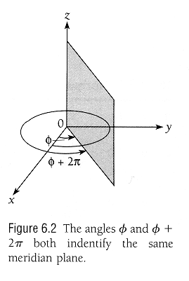
as it is only the function of an angle φ, we will have identical values of Φ for any φ and φ+2π

so it must be true that $Φ(φ)={\text{Ae}}^{{\text{im}}_{l}φ}={\text{Ae}}^{{\text{im}}_{l}(φ+2π)}$

which can only happen when m_{l} = 0 or a positive or negative integer, ± 1, ± 2, ± 3, ….

we call m_{l} magnetic quantum number

second equation for zenithal part Θ has a solution provided constant l is an integer, equal or greater than the absolute value of ⎢m_{l} ⎢

we express this requirement as a condition on m_{l}

m_{l} = 0, ± 1, ± 2, ± 3,
we call l orbital quantum number

solution to 3rd equation for radial R part requires two conditions

1. that E has one of the values E_{n} that are identical to energy levels that could be calculated from the Bohr formula!!!

$E_{n}=−\frac{{\text{me}}^{4}}{\text{32}π^{2}ε_{o^{2}}ℏ^{2}}(\frac{1}{n^{2}})=\frac{E_{1}}{n^{2}}$ n = 1, 2,3,

so the correct part of the Bohr model (which described may spectral lines correctly) is contained in Schrödinger model

we call n principal quantum number

the principal quantum number

2. n must be equal or greater than l + 1

we express this requirement as a condition on l

l = 0, 1, 2, 3, (n - 1)

Summary

Principal quantum number: n = 1, 2, 3, .. ∞

Orbital quantum number: l = 0, 1, 2, n-1)

magnetic quantum number: m_{l} = 0, ±1, ±2, ±3, ± l

(for n or n-1 or l = ∞ we will have classical physics again, correspondence principle)

just as Schrödinger said: ”requirement that a certain spatial function be finite and single values” results in a series of 3 (interrelated) quantum numbers in a natural way just by making physical sense of the mathematical boundary conditions

the three quantum numbers are interrelated because the spherical polar coordinates were interrelated
expressing dependency on the different
kinds of quantum numbers we can
rewrite

$ψ(r,θ,φ)=R_{n\text{.}l}⋅Θ_{l,m_{l}}⋅Φ_{m_{l}}$

