Chapter 13
Nuclear Structure and Physics
November 8th 1895, Konrad Wilhelm Röntgen, while working with his cathode-ray tube (wrapped in black paper) in the dark observed that a one side photosensitive screen, which happened to be by chance at the other corner of the laboratory partially facing the experiment, lit up each time he switched on the power. Some unknown (X) rays were emitted from his cathode ray tube,
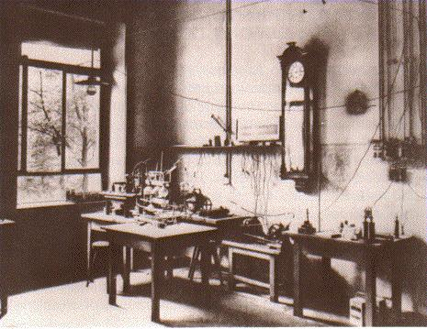
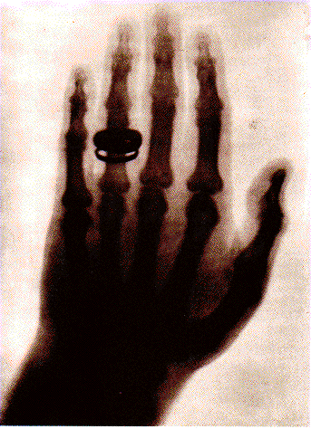
out of this discovery grows materials science, medical applications

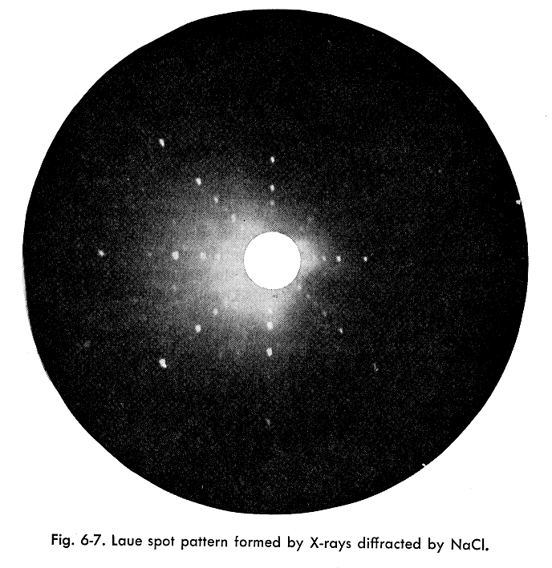

Röntgen had a paper out by New Years day 1896 and mailed it to his friends

January 20th 1896

Henri Poincaré describes Röntgen’s work at the weekly meeting of the French Academy of sciences, wonders “luminescent bodies may emit X-rays”
Henry Becquerel is present,

January 21st 1896
Becquerel starts experimenting, wrap a photographic plate in black paper lay minerals (e.g. K₂U0₂(SO₄)₂ that he know fluoresced when excited by sun light on top of it, expose to sunlight, develop the photographic plate weather or not to see if the plate was exposed by X-rays that penetrated the black paper
February 24th weekly meeting of the French Academy of sciences, he says I got it all wrapped up, the shapes of coins and grids left under the minerals (when those were exposed to the sun) were reproduced on the photographic plate
February 26th and 27th
set up for more experiments with double wrapped black paper, it was cloudy in Paris and he felt nothing would come out of the experiment, so everything goes into a drawer
March 1st 1896 (Sunday)
the doubly wrapped plates and the Uranium ore have been sitting in the drawer (in the dark), he develops the photographic plates anyway (he does not expect much as he thinks one need sunlight to make the mineral fluoresce, so he is thorough/careful/curious – a scientist - and he has to speak the next day at the French Academy, is unhappy that there wasn’t sun for his experiments,
and the plates were fogged although the sun didn’t cause the uranium mineral to fluoresce, and he realizes that (X or Y or whatever, he calls them U-rays) rays just come out of the mineral for no obvious particular reason
and he has indeed something of importance to say at the meeting next day …
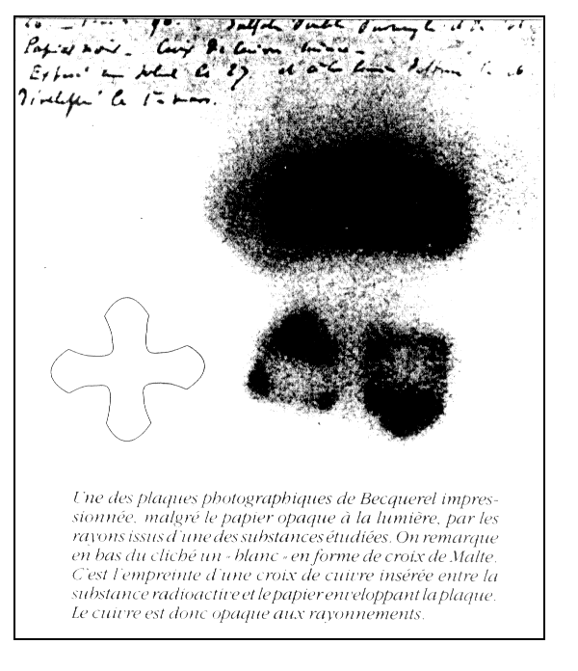

showed that his U-rays could be deflected by magnetic field and must therefore consist of charged particles, so it wasn’t the same thing as Röntgen’s X-rays
----------------------------
then comes Madam Curie, Pierre Curie, her daughter Irene Curie and Irene’s husband Frederic Joliot
Madam Curie the only scientist to win Nobel prizes in both Physics and Chemistry
one important result, with the discovery and isolation of sufficient amounts of radioactive material, Ra, Po, Th, U so that there was enough to go around for more experiments, so a new branch of physics is born Nuclear physics with radioactivity (M. Curie’s word) as a subfield
size of a nucleolus from scattering of α particles is 1 – 10 10¹⁵ m, 10⁻¹⁵ m = 1 femtometer = 1fm also called 1 fermi
NUCLEAR PHYSICS is quite different from atomic physics,

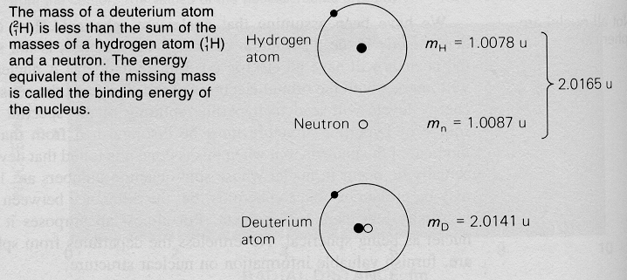
the simplest nucleolus is deuterium ${}_{1}^{1}{}H$ = D, one proton and one neutron,

we CANNOT simply solve the Schrödinger equation because we do not know the potential energy of interaction (it is an extremely messy problem, nothing like a central point charge, a single electron far far away and a simple Coulomb interaction)

from the stability of ⁴He it is clear that there must be other forces much stronger than electromagnetic force

electrostatic energy of two protons separated by 1 fm

$$U(r)=\frac{e^{2}}{4{\text{πε}}_{0}r}=\frac{(1\text{.}\text{602}⋅{\text{10}}^{−\text{19}}C)^{2}{\text{Nm}}^{2}}{4π⋅8\text{.}\text{854}⋅{\text{10}}^{−\text{12}}C^{2}{\text{10}}^{−\text{15}}m}≈2\text{.}{\text{3110}}^{−\text{13}}\text{Nm}$$
≈ 1.44 MeV so the same energy an electron would have if it were accelerated by a potential of 1.44 10⁶ V

what repulsive force does this correspond to?

$$F(r)=\frac{e^{2}}{4{\text{πε}}_{0}r^{2}}=\frac{(1\text{.}\text{602}⋅{\text{10}}^{−\text{19}}C)^{2}{\text{Nm}}^{2}}{4π⋅8\text{.}\text{854}⋅{\text{10}}^{−\text{12}}C^{2}({\text{10}}^{−\text{15}})^{2}m^{2}}≈2\text{.}\text{31}⋅{\text{10}}^{2}N$$
so what acceleration (from rest) would that imply (without relativistic corrections and not taking into account the decay of the electrostatic field with distance)

a = ^{F}/_{m} = $\frac{2\text{.}\text{31}⋅{\text{10}}^{2}{\text{kgms}}^{−2}}{1\text{.}\text{673}⋅{\text{10}}^{−\text{27}}\text{kg}}=1\text{.}\text{381}⋅{\text{10}}^{\text{29}}\frac{m}{s^{2}}$

a = $\sqrt{(1−v^{2}c^{2})^{3}}$ $\frac{F}{m}$ if from rest v = 0

such a high repulsive force, that an amount of (positive) energy in such a tiny space must be balanced by something which is at least as strong

gravitational force won’t do, although attractive, it’s about 10⁻³⁵ times smaller than repulsive electric force

NUCLEAR Force, we do not have any closed form equation for that force (as we had for forces of electricity and gravitation)

energy to remove a proton (or neutron) from ⁴He is ≈ 20 MeV

central problem of nuclear physics is determination of the characteristics of nuclear force

this kind of information comes mainly out of scattering experiments as pioneered by Rutherford

so far: the nuclear force between proton and neutron is measured to be the same, the charge of the proton does not matter much as the nuclear force is so much stronger
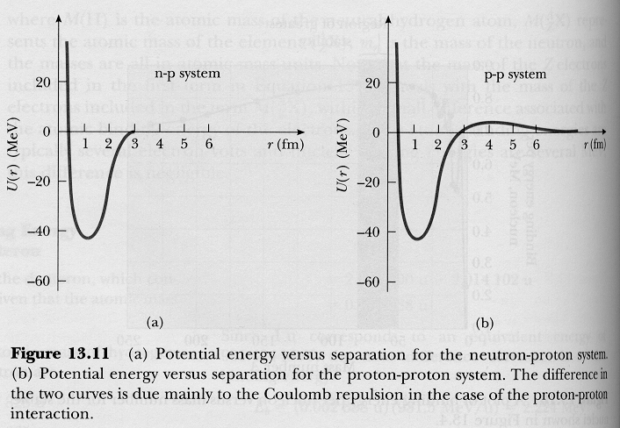
the potential energy curves for proton and neutron are very similar

the force is the stronger the closer the nuclei are together, potential energy function can be approximates as roughly a finite barrier square well of about 40 MeV depth and a few fm widths

in atomic physics we learned a great deal from Bohr/Schrödinger models of hydrogen atoms, where there was one central force provided by the proton, which is 1836 times heavier than electron so it basically stays at rest

all the other electrons in the elements (and their mutual interaction) beyond hydrogen we treated as an perturbation of the hydrogen atom model, idea of shielding, ---- that is NOT going to work,

it is the interaction between the nuclei that provides the nuclear force

meson theory of nuclear force

just as molecules are hold together by exchange of electrons

Yukawa 1935, it is a particle of intermediate (between electron and proton) mass = meson, these particles may be charges π⁺ π⁻
or neutral π (short: pion)
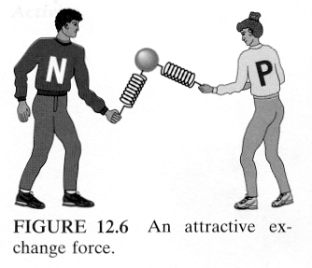
each nucleolus continually emits or absorbs pions, associated transfer of momentum = analog to action of a force, at very short distance force is repulsive, at slightly larger distance force is attractive, rough analogy
both are pulling over the strings at the ball and over the ball and strings on each other

fundamental problem: if this were so, kind of “stuff” constantly coming and going, why are protons and neutrons never found with other masses than usual?

again uncertainty principle limits the accuracy with which certain measurements can be made, results from wave-particle duality and tells us what is allowed in nature without violating energy-mass conservation principle
$$ΔE⋅Δt≥\frac{ℏ}{2}$$
if emission and absorption (including re-absorption is fast, we can never detect that a violation of the principle of conservation of mass and energy has occurred!!
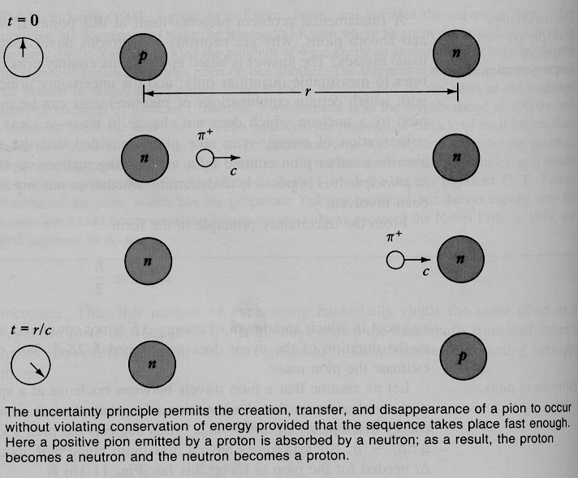
so rearranging: $ΔE≥\frac{ℏ}{2Δt}$ with $ΔE≈m_{π}c^{2}$

say pion travels between two nuclei with 99 % speed of light, nuclear forces have a maximum range of only about 1.7 fm = r , so time needed to go so far is Δt = ^{r}/_{0.99 c}

$$ΔE=m_{π}c^{2}≥\frac{ℏ}{2Δt}=\frac{ℏ⋅0\text{.}\text{99}c}{2r}$$

$$m_{π}≥\frac{ℏ⋅0\text{.}\text{99}c}{2{\text{rc}}^{2}}≈\frac{1\text{.}\text{05}⋅{\text{10}}^{−\text{34}}{\text{Ws}}^{2}⋅0\text{.}\text{495}}{1\text{.}7⋅{\text{10}}^{−\text{15}}m⋅3⋅{\text{10}}^{8}ms}=1\text{.}\text{02}⋅{\text{10}}^{−\text{28}}\text{kg}$$
mass of electron is: 0.9109 10⁻³⁰ kg
mass of proton is: 1.673 10⁻²⁷ kg

so the mass of the pion is indeed intermediate, at least two orders of magnitude larger than that of electron, approximately one order of magnitude smaller than mass of proton

free (but rapidly decaying) particles with 273 and 264 times mass of electron were indeed found in cosmic rays and are produced in modern particle accelerators, where there are particle energies of GeV
so in short, we can’t observe the pion in the nucleolus as this would violate the uncertainty principle, we can observe a free pion when we have broken up a nuclei by adding sufficient energy

so that is a bit of

“was die Welt im Innersten zusammen hält” Johan Wolfgang von Goethe, Faust I, loosely “what keeps the world together at the innermost level” in order to achieve this level of knowledge he makes a pact with the devil

nuclear constituents

protons and neutrons, but not electrons (as distinct particles)!

size of the nucleus is argument against electrons in the nucleus if one were to confine an electron to the size of a nucleolus, say 2.5 fm = Δx its momentum must according to the uncertainty principle be

$$Δp≥\frac{ℏ}{2Δx}=\frac{1\text{.}\text{055}⋅{\text{10}}^{−\text{34}}{\text{Ws}}^{2}}{5⋅{\text{10}}^{−\text{15}}m}≈1\text{.}1⋅{\text{10}}^{−\text{20}}\text{Ns}$$

it that is it’s uncertainty, momentum p itself must be at least of the order of Δp

no relativistic approximation

$$\text{KE}=\frac{p^{2}}{2m}=\frac{(1\text{.}1⋅{\text{10}}^{−\text{20}}\text{Ns})^{2}}{2⋅9\text{.}\text{109}⋅{\text{10}}^{−\text{31}}\text{kg}}≈6\text{.}\text{64}⋅{\text{10}}^{−\text{11}}\text{Nm}=\text{415}\text{MeV}$$

whow, that’s about a thousand times its rest mass (m₀ = 0.511 $\frac{\text{MeV}}{c^{2}}$) times c², so we have to calculate relativistically

$\text{KE}=(\frac{1}{\sqrt{1−v^{2}c^{2}}}−1)m_{0}c^{2}$

we really need to calculate relativistically, and get about 20 MeV for an electron confined to a nucleolus (and the electron sure were to move very fast)

but experimentally, electrons that result from β- decays have energies of 2 – 3 MeV only !!! experiment has the last word on this matter as usual so there are no electrons as such in the nucleolus

but same consideration for a proton, which is about 1836 times heavier than electron

$$\text{KE}=\frac{p^{2}}{2m}=\frac{(1\text{.}1⋅{\text{10}}^{−\text{20}}\text{Ns})^{2}}{2⋅1\text{.}\text{67}⋅{\text{10}}^{−\text{27}}\text{kg}}≈3\text{.}6⋅{\text{10}}^{−\text{14}}\text{Nm}=0\text{.}\text{23}\text{MeV}$$

completely reasonable, also KE << m₀ c² , justifying our non relativistic calculation, which is for the proton 938.272 3 $\frac{\text{MeV}}{c^{2}}$

proton and neutrons are fermions, have non-integer spin
and must, therefore, obey the exclusion principle when they are in the same system (confined space), i.e. a nucleolus of an atom, the result is each of the constituents of the nucleolus must be in a different energy state (including spin), and indeed is

observable result is the hyperfine structure of spectral lines

neutron and proton have magnetic moment associated with spin, is about 0.15 % of magnetic moment of electron, so the hyper in hyperfine comes from this fact

Nomenclature and binding energy

A is sum of protons and neutrons,
Z is number of protons also called atomic number, the principle number that defines the place of an element in the periodic table,
N is number of neutrons, so A = Z + N

there are atoms with the same Z, i.e. same number of protons but different N number of neutrons, i.e. A is different, they are called isotopes, e.g.

${}_{6}^{\text{11}}{}C,$${}_{6}^{\text{12}}{}C,$${}_{6}^{\text{13}}{}C,$${}_{6}^{\text{14}}{}C,$i.e. ${}_{Z}^{A=Z+N}{}C,$
98.9 % of carbon is ${}_{6}^{\text{12}}{}C,$ 1.1% ${}_{6}^{\text{13}}{}C,$
${}_{6}^{\text{14}}{}C,$is radioactive, constantly produces on earth by cosmic rays, gets incorporated in all organic (living) beings, when these beings die there is no exchange with sounding any more, so the level of ${}_{6}^{\text{14}}{}C,$in the “corpse” (literally or in the paper, cloths, …) does not get replenished, it decays over time (half live 5730 years) according to a physical law, basis of carbon dating

– that happens to be a time span we are particularly interested in as all recorded history is no older than some 6000 years)

if you look into periodic table of elements you find as atomic mass of relative atomic mass, e.g. C: 12.011
this number times u (atomic mass unit ≈ 1.66 10 ⁻²⁷ kg - defined per international convention) is the actual atomic mass of the “average” carbon atom (which does not exist as such as there is only a discrete isotopes (and mixture of them)

${}_{6}^{\text{11}}{}C,$${}_{6}^{\text{12}}{}C,$${}_{6}^{\text{13}}{}C,$${}_{6}^{\text{14}}{}C,$

so 12.011 u, mean value of the weight of all the C isotopes in their natural abundance, we define the standard for atomic mass unit

${}_{6}^{\text{12}}{}C,$has a weight of exactly 12 u, then u is 1.66054 10⁻²⁷ kg

mass of a proton is 1.0072765 u
mass of a neutron is 1.0086649 u
mass of an electron is 0.0005485799 u

so 6 proton + 6 neutron + 6 electron should have the mass of 12 times 1.66054 10⁻²⁷ kg, right what do you think? watch out, I am about to fool you

6 m_{p} + 6 m_{n} + 6 m_{e} = 12.098939 u = 2.0091 10⁻²⁶ kg ???

but ${}_{6}^{\text{12}}{}C,$weights only 12 u, per definition, i.e. 12 times 1.66054 10⁻²⁷ kg =1.9926 10⁻²⁶ kg
so how come there is a difference (of 1.6429 10 ⁻²⁸ kg)?

if the electrons went into the nucleolus we could say that amount of matter gets converted (lost, stashed away, negative mass) into binding energies (i.e. negative potential energies) which can of course be calculated from E = m c²

so in the example above, when a carbon “atom” were to be formed from the 18 particles making it up, a total binding energy of -1.4766 10⁻¹¹ Ws ≈ - 92.17 MeV get locked in and this is equivalent to a respective loss of mass (m = - 1.6429 10 ⁻²⁸ kg)

but the electron does not go into the nucleolus, it is only bound by some eV, so for a correct calculation of the nuclear binding energy we have to subtract the mass of 6 electrons from the mass of , further add the mass equivalent of a couple of eV binding energy for each of these electrons (as we are taking them off so to speak) we have to provide the energy necessary to do that

then we can compare the ”naked” nucleus o f with the sum of 6 proton and 6 electrons, the mass difference of the two of them is the binding energy in the nucleolus

– it’s not difficult it just needs combining different concepts, my calculation gives – 89.37 MeV instead of the – 92.17 MeV above,

so as the effect is not large, in some texts, e.g. Krane, it just gets neglected in the respective formulas – never mind, life may also be considered as an approximations

on the other hand, one needs about 90 MeV to take a carbon atom completely apart and then the total sum of the isolated particles will be just so much heavier than the atom (bizarre?, sure is!)

in addition, the free neutron won’t last long, within 10.6 min (on average) it will decay into a proton and an electron (and a neutrino which is almost massless )

so how much energy will be released if a neutron decays into a proton and an electron? calculate the mass difference, that will be the energy released

(1.0086649 – 1.0072765 – 0.0005485799) 1.66054 10⁻²⁷ c²= E

1.3947 10⁻³⁰ Ws = 0.7835 MeV, so the same energy an electron would have if it were accelerated by a electrostatic potential of 783,500 Volt

so there is a lot of energy in nuclear processes and radioactive processes

but, the masses of one electron and one proton (and one neutrino) do not exactly add up to be mass of a neutron, although a neutron decays into a proton and an electron (and a tiny tiny mass neutrino, that carries away angular momentum)

latest values for neutrinos http://cupp.oulu.fi/neutrino/nd-mass.html
m_{electron-neurino} < 2.2 eV (1998), µ < 1.8 10⁻¹⁰ µ_{B}

1 eV/c² ≈ 1.78 1 ⁻³⁶ kg mass equivalent

but neutrino masses are very very important for cosmology and the fate of the universe, as there are so many of them all over the place

let’s look at an “average” hydrogen atom

look in your periodic table, it’s relative atomic mass is 1.0080, so its actual mass is 1.0080 u

with the reasoning above this should be

1 proton, 1.0072765 u, plus one electron, 0.0005485799 u,

plus the mass equivalent of - 13.6 eV binding energy, i.e. minus 13.6 eV = 2.1787 10⁻¹⁸ Ws, that divided by c² is 2.4242 10⁻³⁵ kg, in units of u this is 1.4599 10⁻⁸ u is negligible for our sum

Do note the difference, since we do not change a nucleus, only bringing an electron and an proton together we have a very tiny contribution form the binding energy,
a couple of eV per electron plus/minus is typical for chemical processes, a couple of MeV plus/minus per nucleolus is typical for nuclear processes
back to our hydrogen atom

proton and electron added up is 1.007825 u – but that’s not what’s in the periodic table of elements, how come? see, Serway appendix A.2 our calculation is OK, because

there are also a stable hydrogen isotope called deuterium, consisting of a proton and a neuron in the core and an electron going around the nucleolus with a mass of 2.014102 u and a relative abundance of 0.015%

there is also a tiny amount of a radioactive hydrogen isotope called tritium, with mass 3.016049 u constantly decaying/constantly newly created by cosmic rays, (its half live is 12.33 years so it is no good for archeological dating)

so what’s in the periodic table of elements is the “average” relative mass of all the hydrogen atoms (on earth), each isotope has its own discrete weight and abundance

definition: relative atomic mass is the quotient of the absolute mass of the “average isotope” of an element and the 12th part of the carbon isotope ${}_{6}^{\text{12}}{}C,$

why do we have these “average” in the periodic table, just for convenience, remember it is a scheme for chemist, most of the times they use it to make chemical calculations that involve many many many atoms at once

definition: 1 mole of any substance contains Avogadro’s number of atoms, and weights as much as its relative atom mass (as tabulated in the periodic system of the elements) in gram
i.e. 1 mole of ${}_{6}^{\text{12}}{}C,$contains 6.022 10 ²³ ${}_{6}^{\text{12}}{}C,$atoms

and weights exactly 12.000000000000 … g per definition
i.e. 1 mole of C contains 6.022 10 ²³ C atoms and weights (as it occurs on earth) approximately 12.011 g, look at the periodic table

so what is given in the periodic table is relative atomic mass, to get real mass, multiply with u to get mass of an isotope, look at a different table

all atoms have less mass than the combined masses of all the particles they are composed of, in other words, all atoms have binding energies,

and that is very good for our existence as you will see

Binding energy per nucleon

remember, binding energy in general:
it’s the extra (positive) energy we gain when we construct a nucleolus out of ingredients,

or the (negative) energy we have to supply (that is need) to break a nucleolus apart into its ingredients

except for the light nuclei binding energy is order of magnitude 7-8 MeV (and except for ${}_{2}^{4}{}\text{He}$with 7.07 MeV)

for ${}_{\text{26}}^{\text{56}}{}\text{Fe}$ at its maximum 8.7901 ^{MeV}/_{nucleolus}

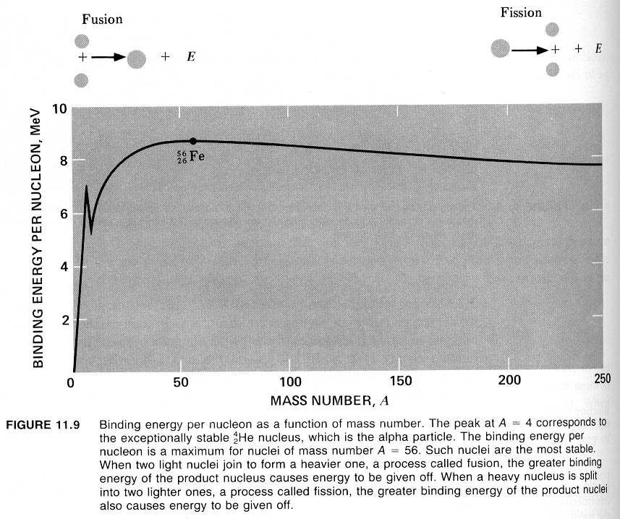

so if we were to fuse two (or more) nuclei lighter than Fe together (that result in one nucleolus that is still lighter than Fe) we would gain energy

e.g. H + neutron = D

2.0165 U
+ Binding energy (- a rather big number of eV ) = 2.0141 u
-0.0024 u time 931.48 ^{MeV}/_{u} ≈ 2.22 MeV out of one single atomic reaction
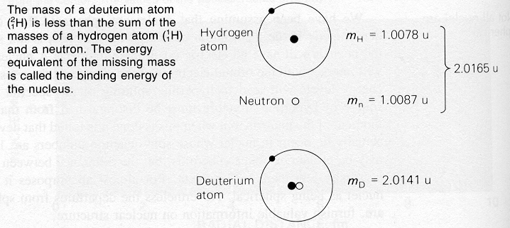
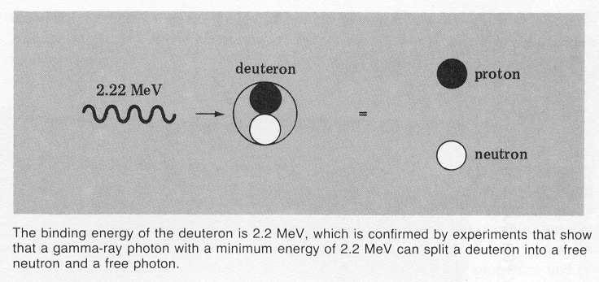
remember in chemical reactions, it is only a couple of eV than can be gained (or must be provided)
vice versa, if we hit a deuterium atom with a γ – ray of 2.22 MeV, it brakes apart
if we blow apart a nucleolus that is heavier than Fe (into two or more nuclei) that are still heavier than Fe) we would also gain energy,

e.g. if a ${}_{\text{92}}^{\text{235}}{}U$is broken into two smaller nuclei, binding energy difference per nucleolus is as large as about 0.8 MeV

giving a total energy difference of

0.8 ^{MeV}/_{nucleolus} times 235 nucleons = 188 MeV

in one atomic event !

as nuclear binding energies are so high, we better only try to fuse the lightest elements, e.g. H and its isotope Deuterium and split the heaviest, U or Pu in order to gain the most energy

distinction between energy gain by either fusion or fission on the basis of the place of Fe in the binding energy per nucleus graph is just because the curve of binding energy per nucleolus has its maximum at this very point

why is this graph so important for live on earth and our whole universe??
the fact that binding energies do exist means that nuclei more complex than the single proton can be stable,

this stability results in 83 stable elements, (and several more unstable), so that’s all the different forms of matter around us, including our own carbon based living bodies !

all the energy that “drives the world”, the evolution of the universe comes, directly or indirectly, from the fusion of protons and neutrons to form heavier nuclei

----------------------
our sun is not large (and old) enough to produce all the heavier atoms that are around in our environment including the constituents of our carbon based bodies, we and our heavier atom surrounding are believed to be all 3rd generation of “stardust”

problem: fusion goes only up to ${}_{\text{26}}^{\text{56}}{}\text{Fe}$where do all the heavier atoms come from, answer: neutron capture and β⁻decay
Nuclear shape and density

most nuclei are spherical symmetric, can be modeled as a cluster of tightly packed spheres, representing the nuclei themselves
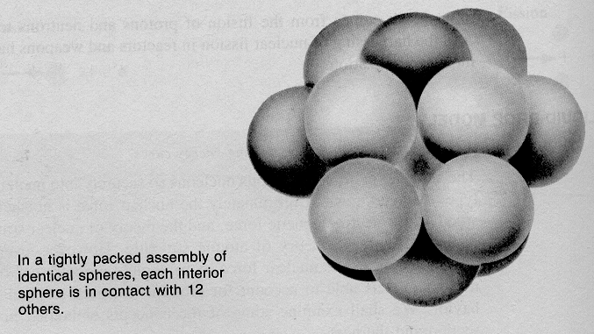

there is no sharp boundary of the protons and neutrons, we do not know how they really look like, so there is no sharp boundary for the nucleolus either

variety of experiments shows that all nuclei have about the same density, this fact is usually expressed by the radius (r) of a nucleus increasing linearly with the $\sqrt[3]{A}$

so r ≈ 1.2 fm $\sqrt[3]{A}$
calculating density of nuclei
assuming a nucleolus is a sphere, V = $\frac{4}{3}{πr}^{3}=\frac{4}{3}π⋅1\text{.}2⋅{\text{10}}^{−\text{15}}A$
its mass ≈ A u, where u is the atomic mass unit 1.6605402 10 ⁻²⁷ kg (per international convention)

$ρ=\frac{3⋅1\text{.}\text{66054}⋅{\text{10}}^{−\text{27}}⋅A}{4π⋅1\text{.}2⋅{\text{10}}^{−\text{15}}A}=2\text{.}\text{294}⋅{\text{10}}^{\text{17}}\text{kg}m^{3}≈2\text{.}3⋅{\text{10}}^{\text{14}}g{\text{cm}}^{3}$

how does this compare to average density of earth?

5.518 g cm⁻³ 14 orders of magnitude, this of course reflects that the earth and with it all atoms are mainly empty space, very diluted form of matter

Nuclear stability

about 260 stable nuclei in nature, the heaviest is ₈₃Bi, ${}_{\text{83}}^{\text{209}}{}\text{Bi}$as there is also radioactive ${}_{\text{83}}^{\text{211}}{}\text{Bi}$with a half life of about 2 minutes

light elements (A < 20) contain approximately equal number of neutrons and protons

heavy elements contain more neutrons than protons, the more protons you have the more neutrons are needed to keep the nucleus stable, there can be more neutrons than protons, e.g. ${}_{5}^{\text{11}}{}B$is stable, but never more protons than neutrons, e.g. ${}_{6}^{\text{11}}{}C$which decays within about 20 minute half life

there are certain “magic numbers”,

for Z or N, 2, 8, 20, 28, 50, 82, 126 they come out of quantum mechanics of the nucleus, so called shell model, similar ideas to periodic table of elements, closed shells and sub-shells, remember protons and neutrons have spin, are fermions, and have to obey Pauli’s exclusion principle, stable nuclei have configurations of minimum energy

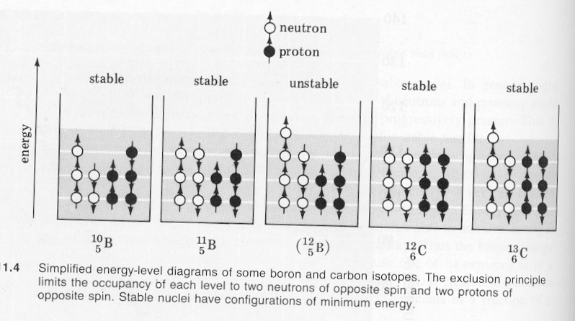
a simple transition between the energy levels in a nucleolus is accompanied by the emission of a γ-ray photon, as the energies are enormous in the nucleolus, the γ rays have also energies of MeV, γ rays may be considered to be part of radioactivity
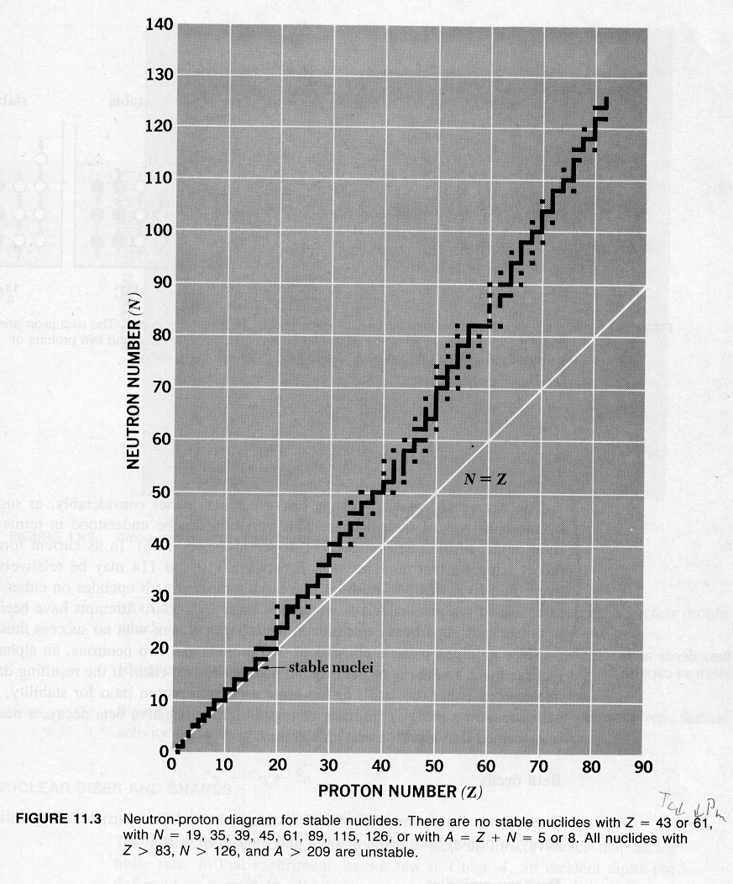
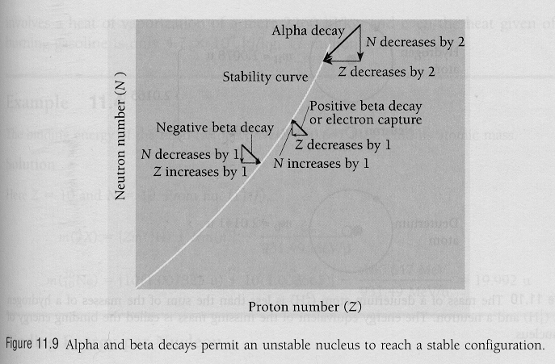
${}_{2}^{4}{}\text{He}$is particularly stable, that’s why it exist as α-particle

even-even nuclei are the most common (and stable), making up some of the elements that are most abandon on earth, ${}_{8}^{\text{16}}{}O$ , ${}_{\text{14}}^{\text{28}}{}\text{Si}$, there is a hell of a lot of ${}_{\text{26}}^{\text{56}}{}\text{Fe}$ in the core of the earth, the crust is pretty much ${}_{\text{14}}^{\text{28}}{}\text{Si}$ and ${}_{8}^{\text{16}}{}O$

in the relative abundance of elements on earth graph below you also see also evidence for the quantum mechanical shell structure of the nucleus, we do have so much Fe because it is at the peak of the curve binding energy per nucleolus over number of nuclei

remember all the core of the earth is made of molten iron, the spinning of the earth produces the magnetic moment we employ in our compasses for navigation

odd-odd nuclei the least common (and stable)

here are no stable nuclei for the “odds” Z = 43 (Tc) and 61 (Pm) and all the “stuff” beyond ${}_{\text{83}}^{\text{209}}{}\text{Bi}$is radioactive anyway, of them only ${}_{\text{92}}^{\text{235}}{}U$${}_{\text{92}}^{\text{238}}{}U$${}_{\text{94}}^{\text{238}}{}\text{Pu}$have technical importance for the production of electric energy

