37-6 Watching the electrons (matter waves)

testing our proposition: the electrons go either through hole 1 or hole 2
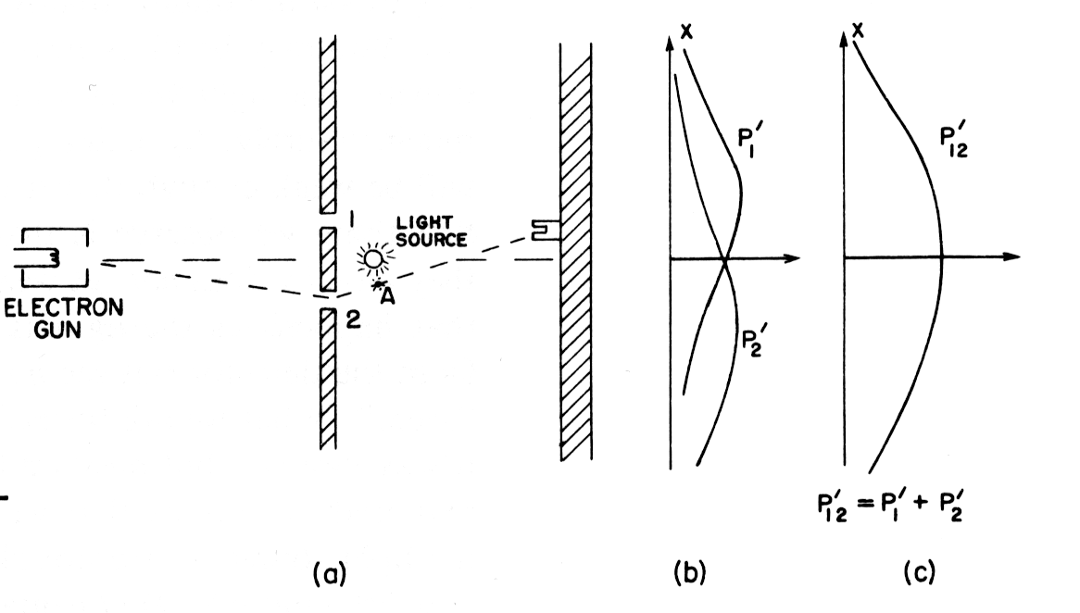

add a very strong light source behind walls between two holes, electrons will scatter light, some of that light will reach out eyes or a detector if we have different kinds of invisible electromagnetic radiation

If electron passes through hole 2, were to take the sketched path we “see” flash from vicinity of point A

perhaps we may see two flashed because the electron somehow divided while going to both holes at once? let’s do the experiment

RESULT: every time we hear a “click” from the detector at the backstop, we also see a flash of light either near hole 1 or near hole 2 – but never at both

so if we look at the electrons we find that they go either through hole 1 or 2 no matter where the backstop detector actually is

Proposition A: Each electron either goes through hole 1 or it goes through hole 2 is true (when we are looking with an experiment)

What’s wrong with the argument against proposition A? Why isn’t P₁₂ not just equal P₁ + P₂?

let’s keep track of the electrons while they are on their way experimentally

for each position of the detector (x location) we count number of electrons that arrive and also keep track through which hole they went through by watching the flashes

whenever there is a “click”, we put a count in Column 1 if we see the flash near hole 1, likewise if we seen a flash near hole 2, we record a count in Column 2

from number in Column 1 we will get probability P₁’ that an electron will arrive at the detector via hole 1, likewise for column 2, so we get the known P₁’ and P₂‘ curves as functions of x

surprise or no surprise, the result just look like blocking one hole or the other – the electrons come as we would expect them to come if they were classical particles (like bullets)

those we do see coming through hole 1 are distributed whether hole 2 is open or closed

since we watched each electron, there is definitely no complicated business like splitting apart and going through both holes or going first through hole 1 and then a somersault and then through hole 2

let’s look at the sum of the probabilities, i.e. lump together the entries in column 1 and column 2 – we just add the numbers, P₁₂’ = P₁’ + P₂’ = P₁ + P₂

now P₁₂’ no interference ≠ P₁₂ interference, so you can’t have interference and watch which hole the electrons go through at the same time

when we switch the light off, we have again interference P₁₂ is restored

Feynman himself: We must conclude that when we look at the electrons the distribution of them on the screen is different than when we do not look.

so the light must have changed the motion of the electrons, scattered them

turn the light source down, then there is less scattering, if light is dim enough – negligible effect on electron movement we get back interference ? NEW EXPERIMENT

result: the flash of light when it is scattered by an electron does not get weaker, it’s the same size flash, it is just fewer of them

we hear a click from the detector at the backstop and don’t see a flash of light because an electron “slipped by without being detected”

Feynman himself: What we are observing is that light also acts like electrons, we knew that is was “wavy” but now we find it is also “lumpy”. It always arrives – or is scattered – in lumps that we call “photons”. As we turn down the intensity of the light source we do not change the size of the photons, only the rate at which they are emitted. That explains why, when our source is dim, some electrons get by without being seen. There did not happen to be a photon around at the time the electron went through.

implication: the electrons we do see are always the disturbed ones, to check this out another experiment this time with a dim light and we count again

whenever we hear a click in the detector at the backstop, i.e. an electron arrives, we make a count;
column 1: those electrons seen close to hole 1,
column 2: those electrons seen close to hole 2 ,
column 3, click in the detector – but no flash, electron went through either (or both) hole(s) but we have not seen it

computing the probabilities, those seen close by hole 1 have distribution P₁’, those seen close by hole 2 have distribution P₂’ if I add these two probability up, those seen close by either hole have distribution P₁₂’ NO INTERFERENCE

but the rest – the one that were not seen - in column 3 have distribution P₁₂ INTERFERENCE !!!!
simple explanation, when we do not see the electron, no photon has disturbed it, so we have interference, when we see the electron it is so much disturbed that there is no interference anymore

now dimming down the light was something about the intensity, we did not change the “size of the photon” its E = hf and p = ^{h}/_{λ}
(remember there was a threshold effect in the photoelectric effect) let’s go more and more to “redder” light, from visible to infrared to or radio wave for which we need special detectors in experiments

first using more redder light, same result,

then at sufficiently red light, we can’t distinguish anymore if the scattering event happened close to hole 1 or 2, that is a direct result of the longer wavelength, it makes the electromagnetic wave more like a classical wave, i.e. spread out, so we only know there was an electron in some area but we do not know if it went through hole 1 or hole 2 with precisely this kind of long wavelength light, i.e. small momentum photon, we start to get some interference effects again, there is some distribution P₁₂ on top of P₁₂’

the redder we go the more interference we get, then the wavelength of the light is way to long that we could tell which hole the electron went through and eventually in the limit λ → infinity we get a nice P₁₂ INTERFERENVE distribution

summary, it was impossible to watch which hole the electron went through and not at the same time to disturb/destroy the interference pattern

Heisenberg: quantum mechanical laws are of such a nature that you can’t have your cake and eat it – more physical these emerging laws will only ever be mathematically consistent if there is some basic limitation in nature to explore it, the wave particle-duality shows up in experiments, there is a mathematical uncertainty when we describe the pilot wave of a particle by wave mathematics, if we put in physical interpretation into this mathematical limit we get a physical limitation

Heisenberg’s uncertainty principle rephrased by Feynman:

“It is impossible to design an apparatus to determine which hole the electron passes through, that will not at the same time disturb the electrons enough to destroy the interference pattern. If an apparatus is capable of determining which hole the electron goes through, it cannot be so delicate that it does not disturb the pattern in an essential way. No one has ever found (or even thought of) a way around the uncertainty principle.”

by the way this no one includes EINSTEIN, he could not debunk it, it seems to be "undebunkable"

if it were to be debunked, all of quantum mechanics collapsed due to mathematical inconsistencies – this would lead to incorrect predictions

--------------
back to proposition A: Is it true or not that the electron goes either through hole 1 or 2?

from experiment we have to conclude that there is a special way we have to think about these things

if you have an apparatus for watching the holes with light, then you can say through which hole the electron went trough, (and you get no interference)

but if you don’t have such an apparatus, if one does not try to measure through which hole it went, there is nothing in the experiment to disturb the electrons and one gets and interference pattern – then one may not say that an electron goes either through hole 1 or hole 2, if one does say that and make any prediction from this statement, one will make errors in the analysis.

Feynman: “This is the logical tightrope on which we must walk if we wish to describe nature successfully.
... one cannot design equipment in any way to determine which of two alternatives is taken …”

So if we leave nature alone, it takes two (or if it has more) alternatives (all alternatives)

all stuff has wave-particle duality
If nature is so weird that all objects are “wavicels” how about bullets?

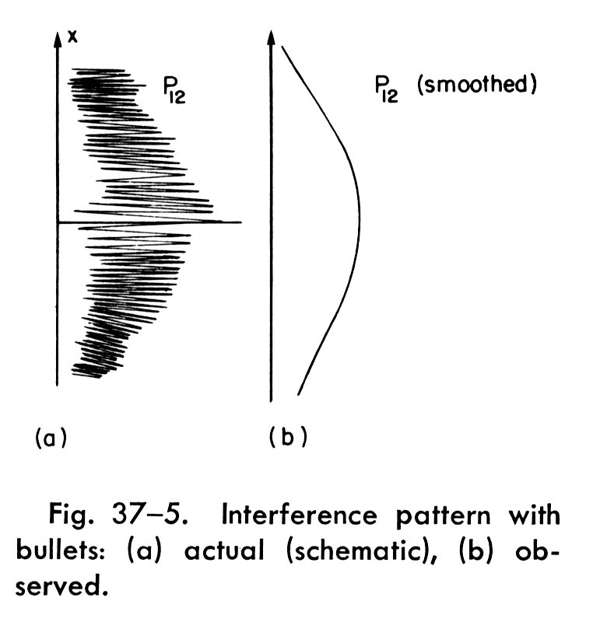
what looks to us as a smooth cure is in reality an interference pattern, our detectors are not fine enough to detect if, we just detect the averaged out effect
beating the uncertainty principle
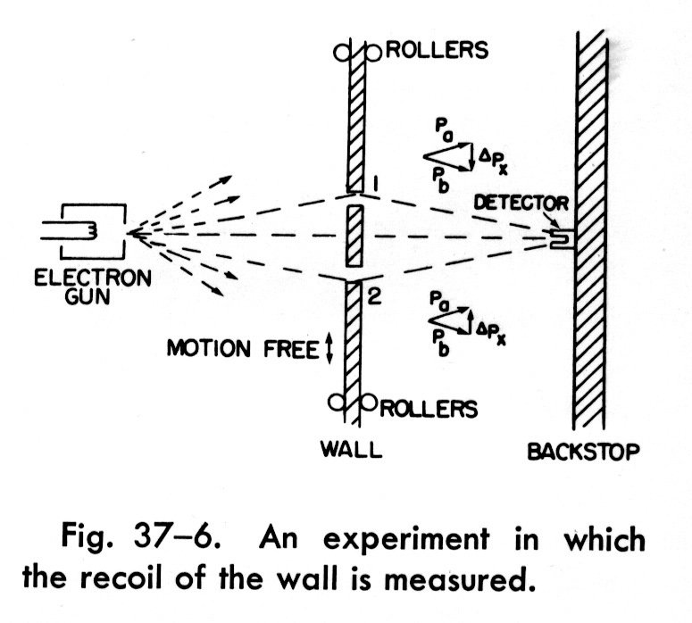

– no way, Feynman can’t come up with an apparatus, and neither could Einstein, look at the course page, assume: the wall is free to recoil up an down very very very delicately when an electron goes through

if it goes through hole 1, there should be an upward recoil – for which we watch out

in order to watch our for a change in momentum, we must know the momentum of the plate before the electron went through

now the uncertainty principle tells us that if we know the momentum of the plate before the kick by the electron precisely enough to measure a pretty small effect, we have a certain uncertainty in the position of the plate

if we do not precisely where the plate is, we do not know precisely where the holes in the plate are

so the plate “wiggles” all the time, our detector is set at for one electron exactly at the center of the diffraction pattern, but for the next electron it is a bit off the center, and for the next electron it is again a bit off the center in some way, and the interference pattern is lost
Feynman in the messenger lectures: It is impossible to design any apparatus whatsoever to determine trough which hole the electron passes that will not at the same time disturb the electron enough to destroy the interference pattern. No one has found a way around this. I am sure you are itching with inventions of methods of detecting which hole the electron went through, but if each one of them is analyses carefully you will find out that there is something the matter with it. … This is a basic characteristic of nature, and tells us something about everything. …

let us return to our proposition … electrons must of either through one hole or another, is it true or not? Physicists have a way of avoiding the pitfalls which exist. They make their rules of thinking as follows. If you have an apparatus which is capable of telling which hole the electron goes through (and you can have such an apparatus), then you can say that it either goes through one hole or the other. It does; it always is going through one hole or the other – when you look. But if you have no apparatus to determine through which hole the thing goes, then you cannot say that it either goes through one hole or the other. … To conclude that it goes either through one hole or the other when you are not looking is to produce an error in prediction. That is the logical tight-rope on which we have to walk if we wish to interpret nature.
This proposition that I am talking about is general. It is not just for two holes, but is a general proposition with can be stated this way. The probability of any event in an ideal experiment – that is just and experiment in which everything is specified as well as it can be – is the square of something, which in this case I have called ” φ “the probability amplitude. When an event can occur in several alternative ways, the probability amplitude, this “ φ “ number, is the sum of the “φ’s “ for each of the various alternatives. If an experiment is performed which is capable of determining which alternative is taken, the probability of the event is changed, it is then the sum of the probabilities for each alternative. That is, you lose the interference.
The question now is, how does it really work? What machinery is actually producing this thing? Nobody knows any machinery. Nobody can give you a deeper explanation of this phenomenon than I have given; that is, a description of it.

somebody has said it this way – ‘Nature herself does not even know which way the electron is going to go.’

… We look, and we see what we find, and we cannot say ahead of time successfully what it is going to look like. The most reasonable possibilities often turn our not to be the situation. If science is to progress, what we need is the ability to experiment, honesty in reporting results … – and finally – an intelligence to interpret the results… As long as you are only biased it does not make any difference, because it your bias is wrong a perpetual accumulation of experiments will perpetually annoy you until they cannot be discarded any longer. The can only be discarded if you are absolutely sure ahead of time of some precondition that science has to have. In fact it is necessary for the very existence of science that minds exist which do not allow that nature must satisfy some preconceived conditions, like those of our philosopher”

