The Feynman lectures on Physics, from chapter 37 Quantum Behavior,

37-1 Atomic mechanics

“Quantum mechanics is the description of the behavior of matter in all its details and, in particular, of the happenings on an atomic scale. Things on a very small scale behave like nothing that you have any direct experience about. They do not behave like waves, they do not behave like particles, …., or billiard balls … or like anything that you have ever seen.

There is one lucky break, however – electrons behave just like light. The quantum behavior of atomic object (electrons, protons, neutrons, photons and so on) is the same for all, they are all “particle waves”, or whatever you want to call them.

Because atomic behavior is so unlike ordinary experience, it is very difficult to get used to and it appears peculiar and mysterious to everyone, both to novices and to the experienced physicist. Even the experts do not understand it the way they would like to, and it is perfectly reasonable that they should not, because all of direct, human experience and human intuition applies to larger objects. We know how large objects will act, but things on a small scale just do not act that way. So we have to learn about them in a sort of abstract or imaginative fashion and not be connection with our direct experience.

We choose to examine a phenomenon which is impossible, absolutely impossible, to explain in any classical way, and which has in it the heart of quantum mechanics. In reality, it contains the only mystery. We cannot explain the mystery in the sense of “explaining” how it works. We will tell you how it works. In telling you how it works we will have told you about the basic peculiarities of all quantum mechanics.

37-2 An experiment with bullets

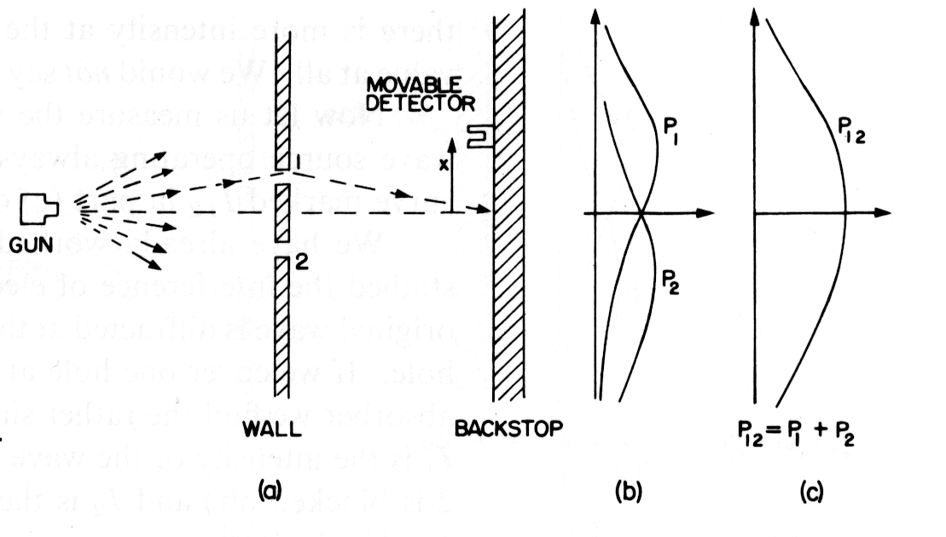
old machine gun that shoots of steam of bullets, fairly large spread of directions of bullets

armor plate wall with two hole, just about big enough to let a bullet trough,

backstop (thick wall of wood) which “absorbs” bullets, a “detector”, e.g., box containing sand where the bullets that passed trough one hole or the other get collected (so that they can later be counted/”detected”)

detector can be moved up and down (x), left to right, so that we can detect the number of bullets that arrive at any point at the backstop, for the following we just consider one dimension, x

experimental setup to answer: “What is the probability that a bullet which passes through either of the holes (if either of them is open and also both holes combined when both are open) in the wall will arrive at the backstop at the distance x from the center?”

Note we talk about probability, we have set up the experiment to answer a question about probability, not to answer the question where this one or that one bullet goes

probability means: chance that bullet will arrive at detector – we measure it by counting number of bullets that arrive at detector position x in a certain unit time interval and divide this number by total number of bullets that hit the backstop (or have been detected at all positions x combined) in the same unit time interval
or we assume that the gun always shoots at the same rate, i.e. identical number of bullets leave the gun, we don’t know how many as we are not measuring, but that does not matter as our probability that a bullet passes through either of the holes (and also both holes combined) in the wall will arrive at the backstop at the distance x from the center will be proportional to the number of bullets we count with the detector in the same standard time interval

idealized experiment: our bullets are indestructible- they cannot break into half

then we find that bullets arrive in identical lumps, always whole, never in parts

with a low rate of fire of the gun, (and one hole open) not much may be arriving at a particular position x of the detector, but if something arrives, it is always 1 whole bullet or two whole bullets, never 1.5 …the size of our identical lumps does not depend on the rate at which the gun fires, just as we did with the machine gun, we can reduce the flux of bullets by turning the machine gun to single fire and make an extra pause to make sure any one bullets is absorbed before the next enters the experimental apparatus.

if we have both or either one of the holes open and only one bullet in the apparatus at any one time and two detectors to detect these single bullets one at a time, we still would detect this bullet as a single lump in either one of the detector, never will there be a signal of the detection of the bullet from both detectors

result of the experiment: probabilities with hole 1 open only: we get P₁, with hole 2 open only:
with both holes open we get P₂, which happens to be P₁₂ = P₁ + P₂ (no mystery yet) i.e. probabilities just add up case is called no interference

37-3 An experiment with waves

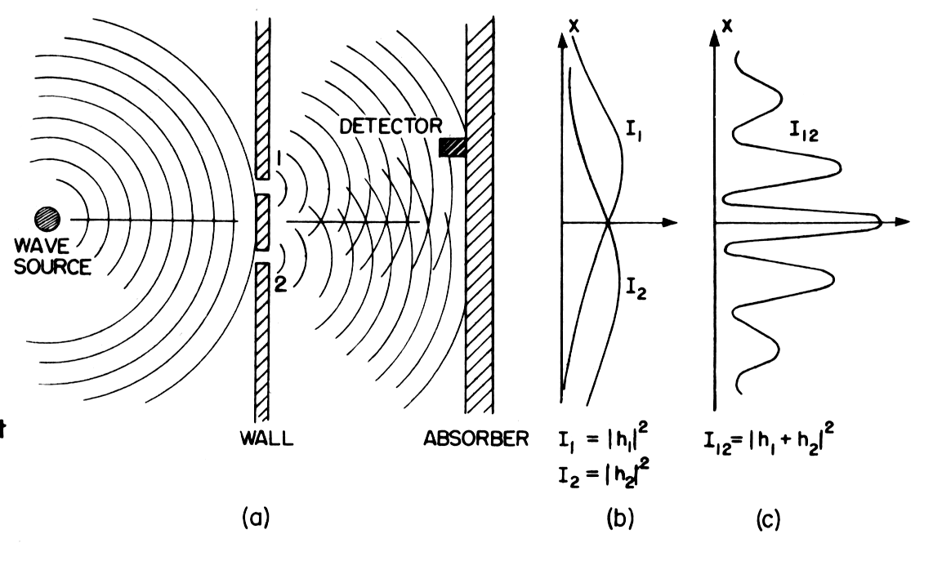
we take water waves, shallow trough, small circular object “wave source” is jiggled up and down makes circular waves, wall with two holes, beyond that wall (holes) is another wall which we call absorber (just as we had a bullet absorber) there is no reflection of the water waves, they (their energy get completely absorbed) it could be a gradual sand “beach
in front of that “beach” we place “detector” which can be moved back and forth in the x-direction, detector measures values of intensity of wave in dependence of positions x

intensity (and energy) is proportional to amplitude – height of the water waves – squared

detector can measure the height of the water waves, but must be calibrated in intensity, i.e. height squared in order to be proportional to intensity and energy flowing into detector

first observation: intensity/energy can have (measurably) any size, if source just moves a small amount, small amount of intensity/energy is transported, we would not say that wave intensity/energy comes in lumps

first intensity as a function of detector position x for hole 1 open only: I₁ looks pretty similar to P₁

second intensity as a function of detector position x for hole 2 open: I₂ looks pretty similar to P₂

third: intensity as a function of detector position x for hole 2 and hole 1 open simultaneously: I₁₂ looks not like P₁₂ we say interference happened

I₁₂ ≠ I₁ + I₂

at some x both waves are in phase, constructive interference, peak in I₁₂

from that it is straightforward to figure out, maxima arise at positions x where the distance x hole 1 is any integer number of wavelength longer/shorter than distance x to hole 2

at some other x, both waves are out of phase, destructive interference trough in I₁₂ no conceptual problem either, just the difference is any odd integer number of half-wavelengths longer/shorter,

NOW: mathematically: instantaneous height of water wave that came through hole we can write as real part of $\hat{h}={\hat{h}}_{1}e^{iωt}$
where ${\hat{h}}_{1}$is amplitude and in general a complex number

intensity is proportional to mean squared height, or if we use complex numbers ${\left|{\hat{h}}_{1}\right|}^{2}$

analogously for wave that comes through hole 2: $\hat{h}={\hat{h}}_{2}e^{iωt}$intensity ${\left|{\hat{h}}_{2}\right|}^{2}$

if both holes are open, we have wave heights adding as $({\hat{h}}_{1}+{\hat{h}}_{2})e^{iωt}$and intensities adding as ${\left|{\hat{h}}_{1}+{\hat{h}}_{2}\right|}^{2}={\left|{\hat{h}}_{1}\right|}^{2}+{\left|{\hat{h}}_{2}\right|}^{2}+2\left|{\hat{h}}_{1}\right|\left|{\hat{h}}_{2}\right|\text{cos}δ$where $δ$is phase difference between ${\hat{h}}_{1}$and ${\hat{h}}_{2}$

so we can say: I₁₂ = I₁ + I₂ + $\sqrt{I_{1}I_{2}}\text{cos}δ$ last term is interference term, summing up: intensity/energy can have any measurable value, intensity shows interference
37-4 An experiment with electrons (photons, nucleons, muons, atoms, "buckyballs") light and matter waves

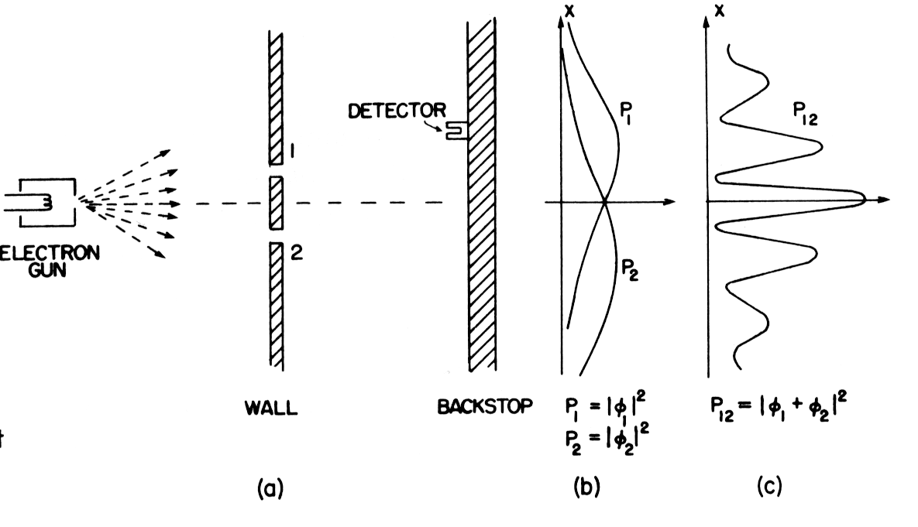

the machine gun is an electron gun, are electrons more like bullets or more like waves? (remember we run an electron microscope on the principle that electrons are a wave, remember that in the Compton experiment, X-ray photons scattered at electrons both entities behaved just like particles, …)

will electron come as lumps? will there be an interference pattern as there was one for the water wave?

detector is electron photomultiplier that is connected to a loudspeaker,

each time an electron is detected: there is a certain “click” noise, it is always the same noise of the same loudness,

as detector is moved to other x positions, there may be more or less click noises in the same time interval, but the “click” noise is the same, its loudness is the same

just as we did with the machine gun, we can reduce the flux of electrons by turning down the current in the electron emitting wire,

if we have both or either one of the holes open and only one electron in the apparatus at any one time and two detectors to detect these single electrons one at a time, we still would detect this electron singly at either one of the detector, never will there be a “click” noise from both detectors at the same time
so electrons come in the same kind of lumps just as bullets did !!

again we can go for the answer to the questions: What is the (relative) probability that an electron “lump” will arrive at the backstop by observing the rate of clicks holding the electron emission at the electron gun constant

what happens if we do experiments in one hole open only, then the other hole open only, then both holes open simultaneously?

again we have P₁ and P₂ but P₁₂ is not P₁ + P₂ as it was for bullets

we can replace the electrons with “buckyballs”, e.g. C₆₀ which is approximately 60 times 22061 times heavier than an electron, we still get the same result !

37-5 The interference of matter waves

analyzing curve of probability as a function of x when both holes are open

since they are lumps, the should come through either hole 1 or hole 2, so we have a “proposition”: each electron either goes through hole 1 or it goes through hole 2 what would be the consequence of this?

if our proposition is correct P₁₂ should be P₁ + P₂ but it is not, it looks like the interference result for water waves, how come?

our proposition they go through either hole can’t be true

THEY MAY SPLIT APART OR GO IN VERY COMPLICATED PATHS THROUGH BOTH HOLES ONE AFTER ANOTHER OR TROUGH BOTH AT ONCE, NOBODY KNOWS, NOBODY HAS AN EXPLANATION

we can try to determine this experimentally, but nature does not allow this one to figure out, is just don’t, if we build a mechanism that could detect if the electron goes through one hole or the other or both at once, the interference pattern is destroyed, we get P₁₂ = P₁ + P₂ as we did for bullets

Feynman himself:

“It is all quite mysterious. And the more you look at it the more mysterious it seems. Many ideas have been concocted to try to explain the curve for P₁₂ in terms of individual electrons going around in complicated ways through the holes. None of them has succeeded. None of them can get the right curve for P₁₂ in terms of P₁ and P₂.

Yet, surprisingly enough, the mathematics for relating P₁ and P₂ to P₁₂ is extremely simple. For P₁₂ is just like the curve I₁₂ …”

we take two complex numbers (functions)${\hat{φ}}_{1}$and ${\hat{φ}}_{2}$(which are functions of x).

The square of the absolute value of ${\hat{φ}}_{1}$gives the effect/probability when only hole 1 is open, i.e. P₁ = ${\left|{\hat{φ}}_{1}\right|}^{2}$

For hole 2 e do the same, square of the absolute value of ${\hat{φ}}_{2}$, that gives the effect/probability when only hole 2 is open, i.e. P₂ = ${\left|{\hat{φ}}_{2}\right|}^{2}$

and the combined effect/probability when both holes are open is P₁₂ = ${\left|{\hat{φ}}_{1}+{\hat{φ}}_{2}\right|}^{2}$

the mathematics is the same as we had for water waves, so we know how to describe the diffraction pattern

Feynman himself:
It is hard to see how one could get such a simple result form a complicated game of the electron going back and forth through the plate on some strange trajectory. We conclude the following: The electrons arrive in lumps, like particles, and the probability of arrival of these lumps is distributed like the distribution of intensity in a wave.”

for classical water waves, we defined intensity as the mean over time of the square of the wave amplitude, we used complex numbers in order to simplify the analysis BUT in Quantum Mechanics, the amplitudes must be represented by complex numbers (functions). Feynman himself: “The real part alone will not do. … that is really all there is to say”

