3. Particle nature of matter

3.1 atomic nature of matter

Democrit(us) 470-380 B.C.: there is only atoms and empty space, everything else is mere opinion (atoms are indivisible)

Dalton (chemist) 1802: chemical reactions involve same proportions of elements and compounds:
2 H₂ + 0₂ ↔ 2 H₂0, so there must be atoms and molecules
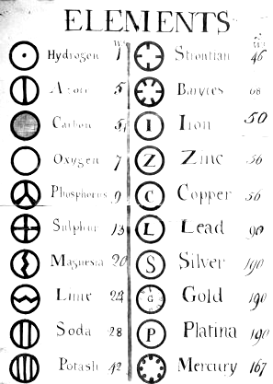

and then came the physicists, Faraday 1833, electrolysis, if 96 485 C is passed through molten NaCl, 23 g of Na deposit on the cathode and (½) 35.5 g of Cl₍₂₎ bubble off

why precisely that amount of charge?
we know today it’s 1 mol of electrons = Avogadro’s number, 6.0221 10²³ mol⁻¹, times electron charge, 1.602 10⁻¹⁹ C (1 mol ¹²C = 12 g), matter consists of molecules, molecules consist of atoms, one can “kind of pull off electrons from atoms, create ions, so they can not be indivisible

J.J. Thomson 1897, cathode rays are negatively charged particles (electrons) that are pulled out of matter, so atoms are definitely not indivisible

ratio ^{charge}/_{mass} measured for electron from balancing electric and magnetic fields, 3 orders of magnitude larger than for hydrogen ion from electrolysis (classical mechanics treatment, so charge of electron came out slightly to large)

particles had same properties as those from photoelectric effect (which was not understood at the time)

first model of atom by speculation: positive charges are distributed evenly throughout the volume of atom (assumed to be a sphere), negative charges (of 10³ times smaller mass, but same absolute value of charge) balances positive charges, also evenly distributed throughout the volume - called raisin (plum) pudding model of atom, 1898

determining charge of electron Millikan’s (American) oil drop experiments (1910-1913)
Lord Rutherford’s nuclear model

while Thomson’s model arose from speculation, Rutherford’s arose from experiments, 1911-1913

at the time fastest and heaviest particles readily available from naturally occurring radioactivity:

α-particles, two protons, two neutrons, 0.05 c,

E ≈ 5.5 MeV (compare with typical X-ray photon
1.25 10⁻² MeV
p ≈ 2 10⁻¹⁹ ^{kg m}/_{s} (compare with typical X-ray photon
6.7 10⁻²⁴ ^{kg m}/_{s})

in a sense the very first particle accelerator to probe the inner structure of atoms

alpha particles were scattered by thin metal foils only a few thousand atom layers thick at angles around 1°, effects of multiple scattering, most particles went straight through, indicating that atoms are pretty empty, but ≈ 1 in 5 10⁵ was scattered to angles of 180 °

Rutherford: “It was quite the most incredible event that has ever happened to me in my life. It was almost as incredible as if you fired a 15-inch shell at a piece of tissue paper and it came back and hit you… It was then that I had the idea of an atom with a minute massive center carrying a charge. I worked out mathematically what laws the scattering should obey … These deductions were later verified by Geiger and Marsden in a series of beautiful experiments.

explanation, all the positive charge there is in an atom is concentrated in a tiny core, if α particle heads straight for the core, electric repulsion becomes large and particle is scattered back,

all macroscopic physical effects taken care of in scattering formula (and assuming that only half of the mass of the core is made up of charged particles, the other half of mass is due to neutral particles) i.e. theory and careful analysis of data (experiments) led to the assignment of e.g. Z = 47 to Ag (which is correct !!!)

“If it is wheels within wheels, you look for the innermost wheel, but if it isn’t, you look for whatever the hell it is you find” Richard Philip Feynman, Nobel Laureate 1965 in Physics for Quantum Electrodynamics

1919 using more energetic α particles, 7.7 MeV on Al targets, predictions from scattering formula were not bore out in experiment, conclusion: α particles were touching/penetrating nucleus, from that by modeling → radius of nucleus of Al atom ≈ 10⁻¹⁴ m

by then it was known that atoms are of the size of 10⁻¹⁰ m, so they are mainly “empty space” inside

rather similar to our solar system, speculation planetary atom model

- electrons revolve around the core consisting partially of protons (much as the planets do around the sun)

- attractive force that keeps atoms together is electric between core and electrons, (much as gravity in case of planets and sun)

open question, how can a core partially consisting of same charge particles be stable at such a sort distance?
(answered by Chadwick, 1921, discovered the neutron and realized there is an even larger forces that the electric force acting over short distances to hold the core together)

more open questions:

- how can such an atom be stable? electrons in an orbit should radiate off energy as there is centripetal acceleration in circular motion, spiral down and crash into core pretty fast

- if two “planetary systems” were to “collide” and to come apart again, two new systems will be created with different orbits, if atoms “collide” and come apart again, e.g. in a molecule, they are just as before, same atoms, same orbits ect.

so there is a fundamental difference, a classical model can not be applicable on a small scale – quantum mechanics concepts are needed

- where do the spectral lines come from ?

partly answered by Bohr’s model which is a semiclassic/semiquantum mechanics system

Spectral lines

glowing solids, liquids, and high density (high pressure) gasses emit continuous (pseudo-)black body radiation (because atoms are close to each other), but low density (low pressure) gasses emit sharp and discrete lines when “exited” by e.g. a electrical discharge because atoms are far enough that they get “excited and relax” (nearly) independent of each other

each element has its specific set of spectral lines,

two types: emission and absorption spectroscopy have same wavelength and frequency, for each line in an absorption spectrum there is one line in a emission spectrum but not vice versa – explanation later by quantum mechanics, (not all of the emission lines are present in absorption spectra)

emission lines
example hydrogen H_{α} = 656.3 nm Balmer series (no.2) in the visible
H_{β} = 434.1 nm and UV
H_{γ} = 410.2 nm, ….

was explained empirically by

$\frac{1}{λ}=R⋅(\frac{1}{n_{{\text{series}}^{2}}}−\frac{1}{n_{i^{2}}})$

with R = Rydberg constant = 1.0973732 10⁷ m⁻¹

n_{series} = 1,2,3,4,5 (= n_{final}) (Balmer series is no 2)

n_{i} = n_{series} + 1 (or 2, or 3) …. (= n_{initial})

any acceptable theory of atom must yield this equation and an expression for R as a couple of other more fundamental constants!!

Bohr’s hydrogen atom model

1913 “half classical/half quantum mechanical” theory

positively charged core, electrons in stationary orbits of radius r₁, r₂, r₃, … circulating the core without radiating as result of Coulomb interaction, classical mechanics describes the motion of electrons in the orbits

radiation is only emitted when an electron “jumps” from an outer orbit, e.g. r₃ to a more inner orbit, e.g. r₂ or r₁

E_{initial} – E_{final} = Δ E = h f

determines the frequency of this radiation,

this frequency has nothing to do with the angular/orbital frequency of the atom, mechanics and dynamics of “jumps” are beyond classical physics

size of stable orbits is determined by a quantum condition,

angular momentum m$\left(\vec{r}×\vec{v}\right)$ = m r v = n ^{h}/_{2π} where n = 1,2,3 is quantum number

leads to energy quantization which provides basis for “jumps” of the electron resulting in radiation and exactly defined wavelengths/frequency

why energy quantization?
electric potential energy PE = q V = $\frac{−{\text{ke}}^{2}}{r}$(considered to be negative)

k: Coulomb constant ¹/_{4πε}

total energy of atom: E = KE + PE

KE = ¹/₂ mv² good enough as speed of electrons is
assumed to be not too high

E = KE + PE = ¹/₂ mv² - $\frac{{\text{ke}}^{2}}{r}$ (1)

in electron orbit:
Coulomb force $\frac{{\text{ke}}^{2}}{r^{2}}$ has to balance centripetal force $\frac{{\text{mv}}^{2}}{r}$

$\frac{{\text{ke}}^{2}}{r^{2}}$= $\frac{{\text{mv}}^{2}}{r}$

rearranging to get expression for KE under force balance condition

$\frac{{\text{mv}}^{2}}{2}$= $\frac{{\text{ke}}^{2}}{2r}$ (2)

(2) in (1)

E = $\frac{{\text{ke}}^{2}}{2r}$- $\frac{{\text{ke}}^{2}}{r}$= -$\frac{{\text{ke}}^{2}}{2r}$ total energy is negative, saying it is a bound electron-proton state, it takes energy to break it apart, take on of the particles to infinity and put it down there at rest

now we had: m r v = n ^{h}/_{2π} (1) where n = 1,2,3

so there is one radius for every quantum number (n) and there will be one energy state for every quantum number

resolve (1) for v = $\frac{\text{nh}}{2π\text{mr}}$
and square v² = $\frac{n^{2}h^{2}}{2^{2}π^{2}m^{2}r^{2}}$ (3)

and resolve (2) for v² = $\frac{{\text{ke}}^{2}}{\text{rm}}$ (4)

$\frac{n^{2}h^{2}}{2^{2}π^{2}m^{2}r^{2}}$= $\frac{{\text{ke}}^{2}}{\text{rm}}$ (3) = (4)

resolve for r = r(n) = $\frac{n^{2}h^{2}}{2^{2}π^{2}{\text{ke}}^{2}m}$

with quantum number n = 1,2,3,

gives a series (n) of radii for stable orbits of electron

between which electron can “jump”

n = 1 is smallest and most stable orbit as it has lowest total energy, special name is Bohr radius

a₀ = $\frac{h^{2}}{4π^{2}{\text{ke}}^{2}m}$= 0.0529 nm

right size range for an atom, 0.1 nm!!! first triumph for Bohr {and Planck (h) and Einstein (light is quantized E = h f)}

quantization of orbits r, i.e. there is r₁, r₂ r₃,

r₁ = a₀

r₂ = 2² a₀

r_{n} = n² a₀

with E = E(r) = -$\frac{{\text{ke}}^{2}}{2r}$ we get by replacing r with r_{n} = n² a₀

E_{n} = -$\frac{{\text{ke}}^{2}}{2a_{0}}(\frac{1}{n^{2}})$ n = 1, 2, 3

i.e. quantization of energy

inserting numerical values: E_{n} = -$\frac{\text{13}\text{.}6}{n^{2}}⋅\text{eV}$ n = 1, 2, 3, …

E₁ = - 13.6 eV ground state

E₂ = -3.4 eV 1. excited state

E₃ = -1.51 eV 2. excited state

E∞ = 0 from the view point of the electron

so the electron is so far way that it is no longer
under the influence of the proton,
as Coulomb force ranges to infinity, the electron must be at r = infinity

energy needed to do that must be +13.6 eV = - E₁
= -(- 13.6 eV) called (complete) ionization energy,

quantization of energy, on the other hand, leads to discrete and well defined spectral lines

E_{initial} - E_{final} = hf

(E₃ – E₂ ) $\frac{1}{h}$ = f

f = (-1.51- [- 3.4] ) eV $\frac{1}{6\text{.}\text{625}⋅{\text{10}}^{−\text{34}}⋅6\text{.}\text{242}⋅{\text{10}}^{\text{18}}\text{eV}⋅s}$= 4.568 10¹⁴ Hz

λ = ^{c} / _{f} = 656,3 nm = the known H$α$ as calculated by the empirical formula !

$\frac{1}{λ}=R(\frac{1}{n_{{\text{final}}^{2}}}−\frac{1}{n_{{\text{initial}}^{2}}})$
so let’s figure out what R really is

f = $\frac{E_{\text{initial}}−E_{\text{final}}}{h}=\frac{{\text{ke}}^{2}}{2a_{0}h}(\frac{1}{n_{{\text{finanl}}^{2}}}−\frac{1}{n_{{\text{initial}}^{2}}})$

again c = λ f
comparison with empirical formula yields R = $\frac{{\text{ke}}^{2}}{2a_{0}\text{hc}}$

Bohr’s theory is as well consistent with experiments on He⁺, Li ⁺⁺, Be⁺⁺⁺ , i.e. ions that have one electron left
(there were some “strange lines” in the spectrum of the sun that could be explained by electronic transitions within these ions)

modifications r_{n} = n² $\frac{a_{0}}{Z}$

E_{n} = -$\frac{{\text{ke}}^{2}}{2a_{0}}(\frac{Z^{2}}{n^{2}})$ n = 1, 2, 3

where Z is the charge of the nucleus

explanation why not all emission lines are present in absorption spectra, atom is usually in its ground state, n = 1, so absorption of the photon with the right ΔE = E_{n} – E₁ results in it going into an exited state, so the spectral lines of the first series are observed

emission, on the other hand, arises from exited states and the electron may jump to the n = 3, n = 2, and n = 1 state

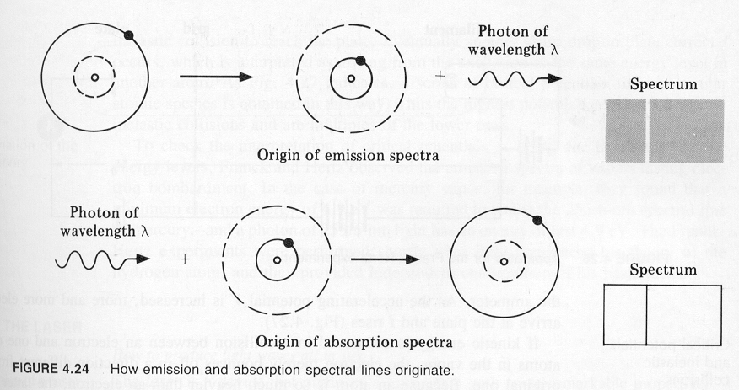
(in dependence by how much energy it was exited by in the first place)

Summary Bohr’s atom:

orbits, angular momentum, energy are quantized

next step: electronic shell theory !

solutions for very complex problems: several electrons orbiting a nucleus, for each of them there in a stationary orbit with quantized angular momentum and energy, the whole system has minimal total energy

several electrons in a shell with a slightly different orbit 0 essentially correct !

the outermost electron shell determines the chemistry of an atom, i.e. if it is going to be a cation or an anion in a salt,
(there is a couple of chemically similar elements, Fe, Co,
Ni, and the two groups of rare earth elements [derived from
chemical experiments],
within each of these groups, there is the same number of outer
shell electrons according to Bohr, and this is a good explanation
for there chemical similarity)

next step: correspondence principle !!!

lim [quantum physics] = [classical physics]
n → ∞

what is the quantum number of an H atom of 1 cm radius?
(even 10000000000000000000000 km radius must correspond to a quantum number)

r_{n} = $\frac{n^{2}h^{2}}{4π^{2}{\text{mke}}^{2}}$ = 1 cm

n = 738 ? 13747 ? 3885993 ?

what is its energy level
E_{n} = - $\frac{\text{13}\text{.}6}{n^{2}}\text{eV}$

- 2.487 10⁻⁵ eV - 7.1968 10⁻⁸ eV - 9.0061 10⁻¹³ eV

how much more energy will it take to remove the electron completely, i.e. ionize the H atom?

conclusion: it is already “pretty much” ionized, so it’s “almost” two separated electrical charges with a simple Coulomb force between them, i.e. a classical physics (macroscopic) object

from correspondence principle comes actually the condition that angular momentum comes only in multiples of ^{h}/_{2π}

in the outermost orbits, the radiation that arises from transitions between these orbits must be the same as predicted by Maxwell’s equations, i.e. be of the same frequency as the frequency of the electron in that orbit

so Bohr derived quantum concept independently from Planck (from blackbody radiation) and Einstein (from photoelectric effect) (and – of course - got the same value for h)

correspondence principle is to guide all further developments in quantum mechanics

Frank-Hertz experiment confirmed energy level in atoms independently from spectroscopy (mercury atoms can only accept discrete amounts of energy - that allow internal transitions of the electrons - from bombarding electrons)

