2. Quantum theory of light

in the 1900s, unsolved problem with classical statistical mechanics (the works of Maxwell, Clausius, Boltzmann, Gibbs (American!) – calculating intensity of radiation at a given wavelength emerging from a heated cavity - deeper questions is what it light, is it a wave (Maxwell) or is it a stream of particles/corpuscles (Newton)

Solution by Max Planck: Annalen der Physik IV, Folge 4, 553-563 (1901) “On the distribution law of energy in the normal spectrum”
Approaching form a new angle what light may be, setting the scene for Einstein)

Maxwell: from theory light is just as any other electromagnetic wave a disturbance traveling through space

Heinrich Hertz electromagnetic waves produced by electrical oscillations travel trough space, behave just as light waves (reflect, refract, focuses, polarize, interfere) in every other aspect, (60 cm wavelength)!

After that daring scientists speculated: results from extremely high frequency electric oscillators in matter. What are these oscillators, nobody knew, Planck called them resonators – assumption was the frequency of the light wave is equal of the frequency of the oscillators

highest electrical oscillation produced 5 10⁸ Hz, but visible (500 nm) light has frequency 6 10¹⁴ so it is extrapolated that the same physics should apply over 6 more orders of magnitude, this is indeed a very daring proposition!

Blackbody radiation

Observation: quite independent of the material, shape one gets graph Fig. 2.3

Challenge: Why is that so? predict the radiation intensity at a given wavelength and temperature

Kirchhoff’s theorem: e_{f} = J(f,T) A_{f}

body in thermal equilibrium with radiation, pretty much like a hot liquid in a container, same temperature everywhere as liquid (radiation) and container (cavity walls) have exchanged energy many times, stationary state

e_{f} power emitted per unit area

A_{f} fraction of incident power absorbed per unit area and frequency

J(f,T) universal function, same for all bodies regardless of material, shape,…

Black body

A_{f} = 1 for all f - appears pitch black

e_{f} = J(f,T) only a function of temperature and frequency, perfect radiator (power)

Stefan’s law e_{total} = $\int{e_{f}⋅\text{df}}={σT}^{4}$

σ = 5.67 10⁻⁸ Wm⁻²K⁻⁴

Non ideal black body behavior is accounted for by coefficient a, e_{total} = ${aσT}^{4}$ (total power, area under curve)

Wien’s displacement law:

spectral energy density, u(f,T), energy per unit volume per unit frequency,

u(f,T) = ⁴/_{c} J(f,T) = ⁴/_{c} e_{f}

Wien’s law: $u(f,T)={\text{Af}}^{3}e^{−\frac{βf}{T}}$ A, β constants, to
be determined by
experiments – no theoretical
justification

Confirmed in near to mid infrared (1- 4 μm) by Paschen, at medium λ (high f)

Lummer and Pringsheim up to 18 μm, Rubens and Kurlbaum up to 60 μm, Wien’s law does not hold in the far infrared

Planck one afternoon in the fall of 1900 after talking to Rubens:
u(f,T) ~ T for large λ (low f) + $u(f,T)∝e^{−\frac{1}{T}}$ for small λ (high f), there must be a formula that fits both sets of experimental observations

$E=\frac{8π\text{ch}}{λ^{5}}⋅\frac{1}{e^{\frac{\text{ch}}{k\text{λϑ}}}−1}$ from Planck’s 1901 paper,

download in translation: http://www.physics.pdx.edu/~pmoeck/pdf/planck-paper.pdf

$u(f,T)=\frac{8π{\text{hf}}^{3}}{c^{3}}(\frac{1}{e^{\frac{\text{hf}}{k_{B}T}}−1})$ as given in text books

at high frequency, $\frac{\text{hf}}{k_{B}T}\text{>>}1$ $\frac{1}{e^{\frac{\text{hf}}{k_{B}T}}−1}$ ≈ $\frac{1}{e^{\frac{\text{hf}}{k_{B}T}}}$
i.e. fits Wien’s law $u(f,T)∝e^{−\frac{1}{T}}$

at low frequency, $\frac{\text{hf}}{k_{B}T}\text{<<}1$ $\frac{1}{e^{\frac{\text{hf}}{k_{B}T}}−1}$≈ $\frac{k_{B}T}{\text{hf}}$,
i.e. fits u(f,T) ~ T

now there is meaning in the constant of Wien’s displacement law, Wien’s law does not look too bad either, we can calculate an approximation for these constants A and β, and the new formula fits everywhere

from experimental data (Rubens at al.), values for h = 6.55 10⁻²⁷ erg sec, k_{B} = 1.346 10^{-16 erg}/_{grad} (Boltzmann’s constant)

today's best values are

h = 6.6260755(40) 10⁻³⁴ Js
k = 1.380658(12) 10^{-23 J}/_{K}

i.e. Planck’s curve fitting results where too low by only ≈ 1.15% and 2.51%, respectively.

Quantum of Energy

Planck assumed walls of cavity are made up of billions of resonators, all vibrating at different frequency, emitted radiation has to be at different frequencies giving a curve analogous to Fig. 2.3

Now classical mechanics says: oscillator can have any value of frequency and energy, changes its amplitude by any incremental amount when energy is radiated off –resulting in Wien’s law

Planck: total energy of resonator with frequency f is always an integral multiple of an energy quantum hf

(it’s kind of like saying: you can not sip your wine at will, you have to drink it in units of glasses that are defined by the size of particular glass used)

E_{resonator} = n hf n = 1,2, ….usually a very high number

Emission when resonator drops one energy level ΔE = h f = one quantum of energy

it’s like a bank with $ 1 000 000, can only give out physically money in multiples of 1 cent, = one quantum of money

Planck’s law also avoids the ULTRAVIOLET CATASTPOPY inherent in Rayleigh-Jeans Law, which works well for low frequencies

Another great triumph of Planck’s formula: quantifying Stefan’s constant

e_{total} = $\int{e_{f}⋅\text{df}}={σT}^{4}$ σ = 5.67 10⁻⁸ Wm⁻²K⁻⁴

finding a physical meaning for σ

e_{total} = $\frac{c}{4}\int{u(λ,T)⋅dλ}=\int_{0}^{∞}{\frac{2π{\text{hc}}^{2}}{λ^{5}(e^{\frac{\text{hc}}{{λk}_{B}T}}−1)}}dλ=\frac{2{πk}_{B^{4}}T^{4}}{c^{2}h^{3}}\int_{0}^{∞}{\frac{x^{3}}{e^{x}−1}\text{dx}}$

where we substituted x = $\frac{\text{hc}}{{λk}_{B}T}$

now $\int_{0}^{∞}{\frac{x^{3}}{e^{x}−1}\text{dx}=\frac{π^{4}}{\text{15}}}$

e_{total} = $\frac{2π^{5}k_{B^{4}}}{\text{15}c^{2}h^{3}}⋅T^{4}$ and have the meaning of σ

that’s how nature is - there are only a very few fundamental constants, all the other constants are derived from these fundamental constants

Photoelectric effect and Light quantization

facts about photoelectric effect:

ultraviolet light, short wavelength, high frequency, i.e. high energy (E = h f)
impacting on a metal surface lead to the ejection of electrons (photoelectrons) from that metal with a range of velocities, kinetic energy ½ m v² (nonrelativistic)

There is a maximal kinetic energy KE_{max} (velocity) of photoelectrons which does not depend on the intensity (I) of the exciting light, but KE_{max} ~ f

KE_{max} easily measured

KE_{max =} ½ m v_{max}² = e V_{stop} (independent of intensity, I)

Photocurrent ~ I - to be expected classically

Linear relationship of KE_{max} to f - very strange, hinting at Planck’s relation E = h f - not explained classically

There is a threshold frequency f₀ for emitting electrons below which there is no photocurrent (threshold energy called work function (Φ) associated with binding energy of electrons in metal, easily explained classical)

There is no time lag between start of illumination with f > f₀ light (smaller 10⁻⁹) not explained classically

Explanations 1905 “A heuristic point of view about the generation and transformation of light”, Ann. Physik, 17:132 by A. Einstein

light itself is quantizes, not only energy,

so light is not only a wave in Maxwell’s sense but also is made of “discrete light particles = corpuscles = photons” each carrying one quantum of energy E = 1 hf (Planck-Einstein relation)

when such a photon strikes an electron it gives is 1 hf energy directly to the electron

so KE_{max} = hf – Φ

explains independence of KE_{max} on intensity (I)

for f > f₀ higher intensity means more photocurrent

light with f < f₀ has not enough energy (1 hf) to overcome work function Φ (order of magnitude 4 - 6 eV) , no electrons ejected, no photocurrent

at f = f₀ KE must be zero

f₀ = $\frac{Φ}{h}$

prediction for further experiments:

KE_{max} = hf – Φ

KE_{max} ~ f , slope of a graph KE_{max} = eV_{stop} (= y) versus f (= x) shall yield h Planck’s constant

(as y = hx + A general linear equation)

Intersection of line with (-y) shall yield -Φ

Millikan (American) didn’t belief any of this and did experiments for next 11 year but concluded Einstein is indeed right, derived h with precision of 0.5% (better than Planck’s first estimate)- another trend in physics, constants get defined more precisely

(only after experimental verification by Millikan got Einstein’s explanation accepted and secured him Nobel prize in 1921)
Compton Effect

1906 Einstein: a photon moves with c all the time, is never at rest, carries a relativistic momentum

$\vec{p}$= ^{E}/_{c} = ^{hf}/_{c} = ^{h}/_{λ} [^{kg m}/_{s} = ^{Js}/_{m} = Ns]

in Einstein’s own words: if a bundle of radiation causes a molecule to emit or absorb an energy packet hf, then momentum of quantity ^{hf}/_{c} is transformed to the molecule, directed along the line of motion of the bundle for absorption and opposite the bundle for emission

Debye/Compton (American) 1923 use this idea for explanation of scattering of X-ray photons by electrons

X-rays

When a beam of electrons is slowed down, e.g. by hitting a metal target, it produces electromagnetic radiation in the range of 0.1 nm wavelength (f ≈ 3 10¹⁸ Hz) ,

this radiation is very high in energy E = h f (≈ 2 10⁻¹⁵ J = 1,25 10⁴ eV so it’s the same energy an electron would have if it were accelerated by an electrical force going through a potential of 12,500 V) and has a momentum of
6.7 10⁻²⁴ ^{kg m}/_{s}
as an electron has rest mass of 9,108 10⁻³¹ kg this is a rather large momentum, so if an X-ray photon is hitting an electron at rest it will knock it about quite a bit so that the effect can be measured – this makes X-rays also dangerous to living organisms

visible light, 550 nm, ≈ 5.45 10¹⁴ Hz, ≈ 3.6 10⁻¹⁹ J ≈ 2.25 eV (as you may have guessed from the work function of the photoelectric effect, p ≈ 1.2 10⁻²⁷ ^{kg m}/_{s} does not produce a strong effect

we return to X-rays when we discuss: “Applied Modern Physics”

--------------------------------------------------------------------------
classical prediction based on Maxwell’s wave theory of light:

- incident wave of f₀ should accelerate electron in direction of propagation of wave, electron should start oscillating and reradiate wave of frequency f’ smaller than f₀
f’ should depend on intensity of wave (we had something like it for the photoelectric effect, hinting on classical premise the energy is not quantisized) don’t take fig. 2.23 in textbook literary it’s wrong so it can’t be shown correctly

experimental result: shift of f = Δ f = f₀ - f’ of X-ray photon is independent on intensity (we had something like this for the photoelectric effect, hinting at energy quantization)

so we have to expect that speed of light, Planck’s constant and rest mass of electron will be in the formula that explains effect

experimental result λ’ – λ₀ = $\frac{h}{m_{e}c}(1−\text{cos}Θ)$

θ scattering angle of photon

idea conservation of momentum

components of momentum have to be resolved in x and y as scattered photon and electron head off in different directions

for x-component: p_{pho} + 0 = p_{pho}’ cos θ + p_{ele} cos φ

for y-component: 0 + 0 = p_{pho}’ sin θ - p_{ele} sin φ

replace p_{pho} with ^{hf}/_{c} , rearrange, multiply by c

p_{ele} c cos φ = hf – hf’ cos θ
p_{ele} c sin φ = hf’ sin θ

each equation squared, adding the two of them together
(with cos ² φ + sin ² φ = 1)

p_{ele}² c² = (hf)² – 2(hf)(hf’) cos θ + (hf’) ² (1)

on the other hand: p_{ele}² c² = KE² + 2 KE m_{0ele}c²

with KE = hf – hf’

p_{ele}² c² = hf² - 2(hf)(hf’) + (hf’)² + 2 m_{0ele}c² (hf-hf’) (2)

must be equal to (1) so

- 2(hf)(hf’) cos θ = - 2(hf)(hf’) + 2 m_{0ele}c² (hf-hf’)

2(hf)(hf’) - 2(hf)(hf’) cos θ = 2 m_{0ele}c² (hf-hf’)

2 m_{0ele}c² (hf-hf’) = 2(hf)(hf’) (1- cos θ) (3)

change from frequency to wavelength (c = λ f) in steps
by dividing (3) by 2h²c²

$\frac{m_{0\text{ele}}c}{h}(\frac{f}{c}−\frac{f'}{c})=\frac{f}{c}⋅\frac{f'}{c}(1−\text{cos}θ)$

$\frac{m_{0\text{ele}}c}{h}(\frac{1}{λ}−\frac{1}{λ'})=\frac{1−\text{cos}θ}{\text{λλ}'}$

$(λ'−λ)=\frac{h}{m_{0\text{ele}}c}(1−\text{cos}θ)$ and a Nobel prize for Compton

duality of wave and particle properties for photons

photon has no mass, but momentum $\vec{p}$= ^{E}/_{c} = ^{hf}/_{c} = ^{h}/_{λ}

that momentum is capable of “pushing” electrons around just as if it were the cue ball in an billiard game

its “impact” energy is capable of “knocking” electrons out of a metal just if it were some kind of bullet

so when sufficiently energetic photons interacts with matter it looks as if they were a particle, (less energetic photons give no photoelectric effect, both less and more energetic photons behave just like waves in other experiments)

one more strange thing:

as p = m c, photon also appears to have mass m = ^{p}/_{c} = ^{hf}/_{λ} (but it can’t have real mass otherwise it could not rush around at the speed of light)

is “appearing” mass also subject to gravity?

General relativity, Einstein 1916, yes it is, there is actually no force of gravity in Newton’s sense, all there is is curved space time around any massive object, light is moving in straight lines in this curved space time, so gets deflected and we can model this effect by assuming there is gravity acting on it !!!

strange how can a particle have wave properties f, λ, c, how can a wave have particle properties, E, p, m
we can’t comprehend because our perception is based on classical physics
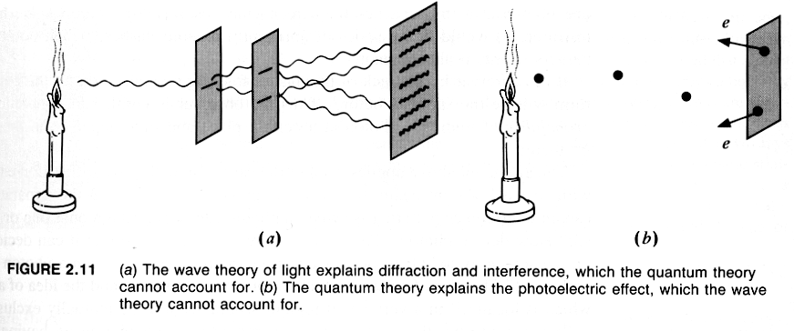
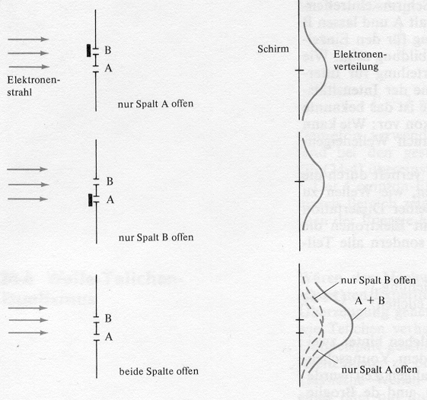

really ?

you are not supposed to translate the German in this graph, just assume it is either light or electrons, we will discuss this experiment in detail at the end of this session, after “applied modern physics” – it is the epitome of the quantum weirdness

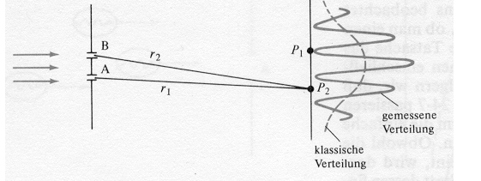

well, that’s looks more like it for light, it is Young’s famous 1808 experiment that proved that light is a wave, but wait a minute – we just get the same result for electrons – that’s strange

----------------------------------------------------------------
so is light kind of a wave that consist of particles, or is it kind of particles that are guided/piloted by a wave ?

light as an electromagnetic wave: electric (E) and magnetic (B) field vectors (FV) are producing each other in close vicinity, (E) and (B) are perpendicular to each other and oscillate while traveling a distance called wavelength (λ) from magnitude +FV_{max} to – FV_{max} and back to +FV_{max}. So the average FV is zero, how can such a wave have some effect on matter ???

How can sunlight produce a sunburn on human skin if the average effect, i.e. FV, is zero???

answer: FV are not physically relevant entities, after all, they are only models, and B can be considered to be the effect of a moving charge + relativity, i.e. does not really exist, to do something, burn human skin energy is needed, the longer one is exposed to this energy so larger the effect

hence, we have to consider the intensity of the wave per unit area (I) (which has unit energy per area (W m⁻²) as the physically significant parameter for interactions with matter

I = ε₀ c average (FV²) over both one λ and f cycle
- that is a physically significant

I in a particle description the intensity is energy divided by area

I = N hf/_{area} where N is the number of photons

both descriptions of I must give same value for intensity

N = $\frac{ε_{0}c⋅\text{area}}{\text{hf}}{\text{averageFV}}^{2}$ (over both λ and f cycle)

if N is large, one observes a full blown interference pattern and one would describe it by the wave theory

if N is medium, one observes a fuzzy interference pattern (and may not sure how to describe it properly)

if N is small, one observes a certain statistical distribution of individual photons arriving at the screen that appear at first random, but from with (with more and more N) first a fuzzy and much later (with even more N) a full blown interference pattern arises!

so the probability of finding a certain particle on the screen at (x,y,z) depends on the average FV² at this place, i.e. the square of the wave-function, intensity of the electromagnetic wave is of physical significance

individual photons are guided/piloted by a “probability wave” which is proportional to the intensity of the electromagnetic wave

modern physics concludes: light is both particle and wave at the same time when we are not looking at it / messing about with it, an alternative view is we do not know what it is, it may at any one time either be a particle or a wave – and we have no way of knowing between experiments

if we do make an experiment, either its wave properties or its particle properties (or aspects of both) show up, depending on the experiment (in a consistent manner), so we make a consistent theory describing the results of these experiments (with aspects from both models if necessary)

we just consider the particle and the wave models to be complementary to each other, after all they are only models and we don’t really know what light is

The problem then becomes, it seems to me, not to decide between the two theories of X-rays, but to find … one theory which possesses the capacity of both. Sir William Henry Bragg

Mosely and Darwin talking about X-rays: ” Since the rays are reflected they must be some kind of a pulse with an extended wave front, yet after reflection they retain their corpuscular character. Thus the energy of X-rays appears to show the contrary properties of extension over a wave front and concentration at a point”

my simplified analogy (all analogies are wrong but make some point):
particle and wave descriptions are like sides of one and the same coin, an experiment is tossing a coin and either heads or tails shows up – we need heads and tails to describe the coin, one of it does not give a complete description of a coin

“The ultimate origin lies in the fact (or philosophical principle) that we are compelled to use the words of common language when we wish to describe a phenomenon, not by logical or mathematical analysis, but by a picture appealing to our imagination. Common language has grown by everyday experience and can never surpass these limits. Classical physics has restricted itself to the use of concepts of this kind,; by analyzing visible motions it has developed two ways of representing them by elementary processes: moving particle and waves. There is no other way of giving a pictorial description of motions – we have to apply it even in the region of atomic processes, where classical physics breaks down.

Every process can be interpreted either in terms of corpuscles or in terms of waves, but, on the other hand, it is beyond our power to produce proof that it is actually corpuscles or waves with which we are dealing, for we cannot simultaneously determine all the other properties which are distinctive of a corpuscle or of a wave, as the case may be. We can therefore say that the wave and the corpuscular description are only to be regarded as complementary ways of viewing one and the same objective process, a process which only in definite limiting cases admits of complete pictorial interpretation ..

Max Born, Atomic Physics, 1946

