Modern Physics, PHY 311, 2003 2nd third test answers

1a. When two “planetary model atoms” according to Rutherford’s hypothesis collide, stick together for a while, and come apart again, will they be just the same as before or will they be different? (2 Points)

no they will be different

1b. What would happen in this scenario with real atoms, will they be just the same as before or will they be different? (2 Points)

they will be just as before, same energy levels, same atoms, same constituent particles

2. The figure below shows some of Millikan’s original data for the stopping potential versus incident photon frequency for the photo-electric effect of sodium. Use these data to find (a) the work function of sodium, (b) the ratio ^{h}/_{e} , (c) and the threshold frequency f₀, you may work graphically if you like as rounded results will be accepted if correct approach is taken, but be careful reading the origins of the y and x axes correctly (4 points)
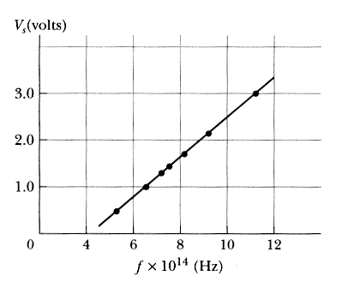
the intersection of the linear function with the V = y axis will be the work function Φ divided by the elemental charge, e ; intersection is at V = - 1.65 V multiplied by e and taken care of the – sign it is 1.65 eV, the negative sign is understood as being energy one must put into the system
the ratio ^{h}/_{e} is the slope of the function: 4.1355 10 ⁻¹⁵ Vs per definition, from the slope of the graph the accuracy will be much less, I guess something close to 4 10 ⁻¹⁵ Vs is the value everybody should get

the threshold frequency is the functions value at V = y = 0: directly from the graph 4.1 10¹⁴ Hz

3. What radically new idea(s) did Planck introduce in his famous 1901 paper “On the distribution of energy in the normal spectrum” (that is by many regarded as the starting point of modern physics and from which you should have read crucial passages as homework) 2 point, but be careful choosing too many answers results in point(s) taken off

there is no ether

the core of atoms is made of an equal number of electrons and protons

light is quantized, i.e. the energy of 1 photon is 1 h f

energy is quantized, i.e. E = h f 

angular momentum is quantized, i.e. m_{ele} v r = n ^{h} / _{2π}

photons have mass but no momentum

photon have momentum but no mass

photons have both momentum and mass

photons have neither momentum nor mass

light is a classical wave

X-rays sometimes behave like a classical wave and sometimes like a classical particle

light is a classical particle

4. Calculate the frequencies of the first three lines in the Lyman series for hydrogen, Hint: n_{final} = 1 (n_{initial} = 2, 3, 4) (4 points)

λ(n_{initial})⁻¹ = R $(\frac{1}{n_{{\text{final}}^{2}}}−\frac{1}{n_{{\text{initial}}^{2}}})$ where R = 1.0973732 10⁷ m⁻¹
f = ^{c}/_{λ}

f₁ = 2.4674 10¹⁵ Hz

f₂ = 2.9243 10¹⁵ Hz

f₃ = 3.0842 10¹⁵ Hz

5. What radically new idea(s) did Einstein introduce in his famous 1905 paper : “A heuristic point of view about the generation and transformation of light”, that gave the correct explanation of the photo-electric effect 2 point, but be careful choosing too many answers results in point(s) taken off

there is no ether

the core of atoms is made of a different number of electrons and protons

light is quantized, i.e. the energy of 1 photon is 1 h f 

energy is quantized, i.e. E = h f

angular momentum is quantized, i.e. m_{ele} v r = n ^{h} / _{2π}

photons have mass but no momentum

photons have momentum but no mass

photons have both momentum and mass

photons have neither momentum nor mass

light is a classical wave

X-rays sometimes behave like a classical wave and sometimes like a classical particle

light is a classical particle

6. Using the so called Faraday (96 485 C) and Avogadro’s number (6.022 10 ²³ mol⁻¹) calculate the value of the elemental charge (1 point) , explain your reasoning (1 point, so total of 2 points). Hint: Other textbooks have the concept of a Faraday constant = 96 485 C mol⁻¹

there are 96485 C per mol and one mole is 6.022 10 ²³ particles, so the charge of one Faraday divided by the number of particles in a mol give the charge of one particle

1.6022 10⁻¹⁹ C which must be the elemental charge per definition

7. What did Rutherford and his co-workers prove: 1 point, but be careful choosing too many answers results in point(s) taken off

there is no ether

the core of atoms is made of a different number of electrons and protons

the core of atoms is made of protons only

light is quantized, i.e. the energy of 1 photon is 1 h f

energy is quantized, i.e. E = h f

angular momentum is quantized, i.e. m_{ele} v r = n ^{h} / _{2π}

photons have mass but no momentum

photons have momentum but no mass

photons have both momentum and mass

photons have neither momentum nor mass

light is a classical wave

X-rays sometimes behave like a classical wave and sometimes like a classical particle

light is a classical particle

none of the above as he really did prove that: there is a massive positively charges core in an atom (1 point) all the positive charge is in that core, about half of the mass of the core of atoms is made of protons the other half is made up by some neutral particle (2 points) 

8a) In fantasy land, your personal flying saucer reaches a nearby star in 5 years Earth time, but only 1 day of your time. What was your relative velocity in units of c? 1 point

0.85

0.915

0.985

0.99999985 $Δt'={γΔt}_{0}$

1.00000005

8b) In fantasy land, one flying saucer is chasing a second one, From the earth’s point of view the first is traveling at 0.8c and from this travelers perspective the second is traveling at 0.6 c. What is the speed of the second as viewed from the Earth? 1 point

1.4 c

c

0.95 c $u=\frac{u'+v}{1+u'\frac{v}{c^{2}}}$
0.6 c

0.2 c

8c. In fantasy land, where massive flying saucers are rushing around pretty fast which of the following quantities for an electron conserved are conserved ? 4 points

rest mass 

charge 

total relativistic energy 

potential energy

kinetic energy

linear momentum 

quantized angular momentum 

none of these

or all of these

9. E² = p²c² + (mc²)² follows from E = γ m c² and p = γ m v

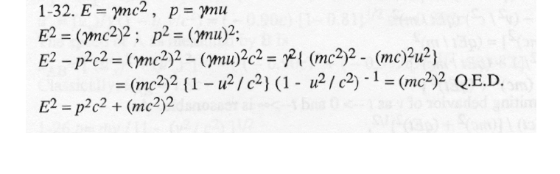
E² - p²c² = $\frac{1}{1−\frac{v^{2}}{c^{2}}}\left\{({\text{mc}}^{2})^{2}(1−\frac{v^{2}}{c^{2}})\right\}$

