Improving Vaccine Access Presentation
PAH 510 Global Health Systems
Karen Spalding
(Note Website Links on Page 3)

Current Vaccine Coverage Worldwide 2014

- A birth dose of the Hepatitis B vaccine was introduced nationwide in 96 countries by the end of 2014. Global coverage is estimated at about 38%.
80% coverage in the Western Pacific but only 10% in the African Region (WHO, 2015).
- Haemophilus influenzae type b (Hib) vaccine was introduced in 192 countries this was up from 189 countries in 2013.
China and Thailand still have not introduced a vaccine containing Hib.
Global coverage of 3 doses of a vaccine containing Hib is around 56% reaching 90% in the Americas but only 21% in the Western Pacific and 30% in Southeastern Asia.
- Pneumococcal vaccine was introduced to 14 more countries than in 2013.
83% coverage in the American, 50% in the African Region but only 2% in Western Pacific Region.

Lacking Coverage

- 18.7 million children worldwide did not receive DTP3 vaccine
More than 60% of these children live in ten countries: Democratic Republic of the Congo, Ethiopia, India, Indonesia, Iraq, Nigeria, Pakistan, Philippines, Uganda and South Africa
- 20.1 million children under 2 worldwide did not receive the first dose of the measles vaccine
More than 60% live in the following ten countries: Afghanistan, Bangladesh, Democratic Republic of the Congo, Ethiopia, Indonesia, India, Iraq, Nigeria, Pakistan, and the United States

Discussion Questions
- Who should be in charge of improving access?
Do more developed countries have an obligation to help improve access elsewhere?
- Are current methods what we should stick to?
- What ideas could be exported from more developed nations?
- Does competition need to be improved in vaccine markets?
- Where does education and culture play a role?
- Should we focus on NGOs or Governments?

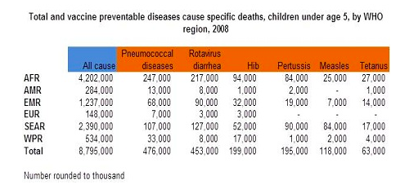
Chart from WHO Estimates of disease burden and cost effectiveness http://www.who.int/immunization/monitoring_surveillance/burden/estimates/en/

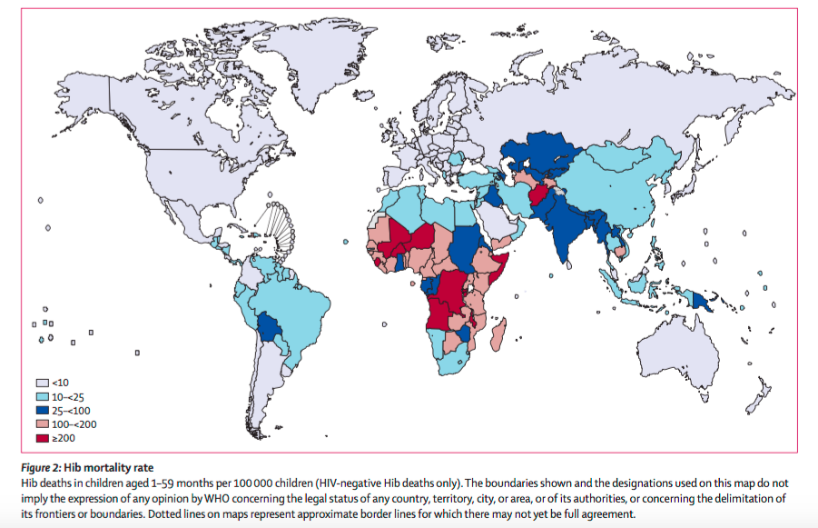
Haemophilus influenza type b is the leading cause of childhood bacterial meningitis, pneumonia, and other serious infections. Hib disease can be almost completely eliminated through vaccination. http://www.who.int/immunization/diseases/hib/GBD_Hib.pdf?ua=1

Below is the access link to the global immunization data from July 2015. It is a PDF format from the WHO showing percentage of coverage when it comes to a wide variety of vaccines as well as improvements over the years
Global Immunization Data (July 2015) http://www.who.int/immunization/monitoring_surveillance/Global_Immunization_Data.pdf?ua=1
I am also including some links to websites that are just short readings to orient the class on what is going on and being done when it comes to improving vaccine access and usage worldwide.
Website links:
http://www.gavi.org/Library/News/GAVI-features/2016/African-Ministers-pledge-to-improve-access-to-vaccines/
http://www.path.org/power-of-vaccines/improving-delivery.php

