Readings:
I would like to discuss the role of implementation frameworks in assisting with implementing HCBS waiver policies.

Please familiarize yourself with:
- ***So helpful please at least look at the tables!***(P. Nilsen, 2015) – This publication is super helpful for thinking about the many approaches to implementation! It is not aging or HCBS specific, so should be helpful for everyone.
- CMS Person-centered System Implementation Slides regarding HCBS waiver implementation from a CMS webinar
- Revisit from Health Policy:
  - (Berman, 1980)
Not required, but helpful:
- Useful for understanding how the policy implementation research fits in with other implementation science literature:
  - (Per Nilsen, Ståhl, Roback, & Cairney, 2013)
- May not discuss, but there’s a tool for comparing implementation theories and determining their relevance for the situation!
  - (Birken et al., 2018)
Complexity Theory
Complexity theory provides a framework to describe Complex Adaptive Systems (CASs). A complex adaptive system is dynamic – in constant flux, massively entangled – having large numbers of interdependent parts, emergent – self-organizing, and robust – able to self-alter in response to feedback (Zimmerman, Lindberg, & Plsek, 2009).
Why Complexity Matters
Implementing services via the Home and Community-Based Services waivers is an inherently complex process. Waivers must be approved by the Federal secretary of Health and Human Services, invoking politics at the national level, while also relying on approvals and political leadership from state level policymakers. After approval, the implementation of waiver-based services is by-design less programmed or prescribed than the implementation of non-waiver-based Medicaid services. Because the services are unique to each state, they have the possibility to be highly context-specific, and to be customized to fit the particular needs of a community. Complexity theory then is essential for analyzing such a system.
‘A system may need to be studied as a complete and interacting whole rather than as an assembly of distinct and separate elements’. In other words, breaking the process down into a system’s constituent parts (including the actions of individuals within it) may undermine explanation (Cairney, 2012).
Identifying where on the Stacey diagram a policy implementation approach falls can inform frameworks and criteria for both the process of implementation and evaluation (P. Nilsen, 2015).

Stacey Matrix Applied to Policymaking
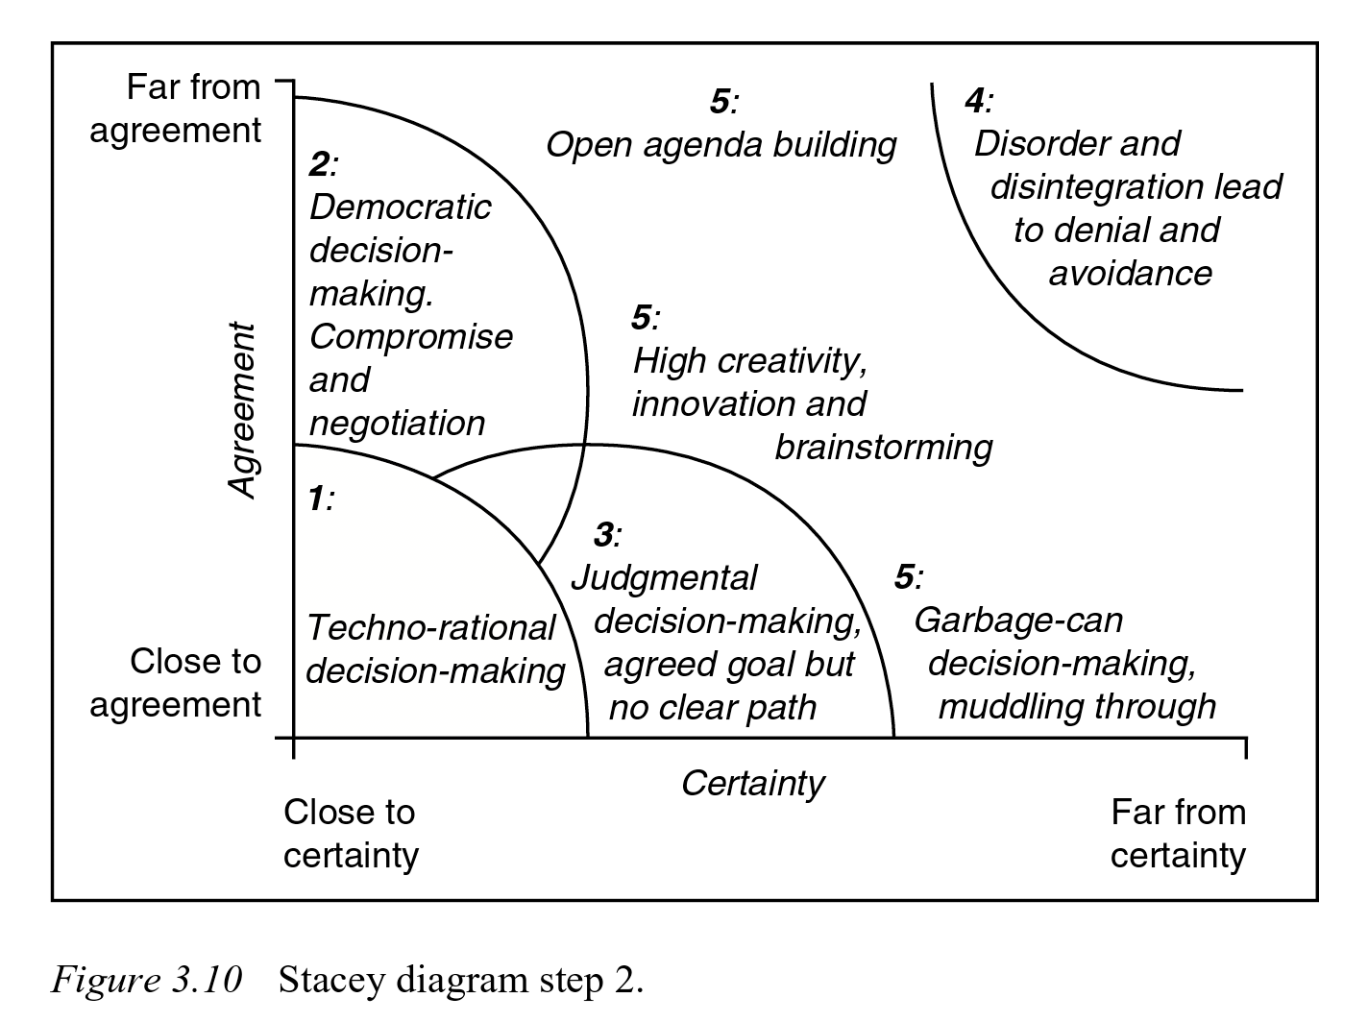
(Geyer & Rihani, 2012)

Questions
- Given the many frameworks laid out by Nilsen et al., should CMS be recommending specific frameworks for the process of implementing the various waivers?
- Do some waivers lend themselves more towards one process or determinants framework than another? Is that possible?
- Given the unique and complex nature of HCBS waivers, how should we approach evaluating their implementation?

Works Cited

Berman, P. (1980). Thinking About Programmed and Adaptive Implementation: Matching Strategies to Situations. In H. Ingram & D. Mann (Eds.), Why Policies Succeed or Fail (pp. 205–227). Sage Publications.
Birken, S. A., Rohweder, C. L., Powell, B. J., Shea, C. M., Scott, J., Leeman, J., … Presseau, J. (2018). T-CaST: an implementation theory comparison and selection tool. Implementation Science, 13(1), 143. https://doi.org/10.1186/s13012-018-0836-4
Cairney, P. (2012). Complexity Theory in Political Science and Public Policy. Political Studies Review, 10(3), 346–358. https://doi.org/10.1111/j.1478-9302.2012.00270.x
Geyer, R., & Rihani, S. (2012). Complexity and public policy: A new approach to 21st century politics, policy and society. Routledge.
Nilsen, P. (2015). Making sense of implementation theories, models and frameworks. Implement Sci, 10(1), 53. https://doi.org/10.1186/s13012-015-0242-0
Nilsen, Per, Ståhl, C., Roback, K., & Cairney, P. (2013). Never the twain shall meet? - a comparison of implementation science and policy implementation research. Implementation Science, 8(1), 63. https://doi.org/10.1186/1748-5908-8-63
Zimmerman, B., Lindberg, C., & Plsek, P. (2009). A complexity science primer: What is complexity science and why should I learn about it [Primer].

