Lab 6: Idrisi Advanced Classifiers
This lab provided an introduction to the capabilities of Idrisi software package in terms of advanced classification schemes. The various exercises performed include the following topics:
- Bayes’ Theorem and Maximum Likelihood Classification
- Soft Classifiers I: Bayclass Soft Classifier
- Hardeners
- Soft Classifiers II: Dempster-Shafer Soft Classifier and BELCLASS
- Dempster-Shafer and Classification Uncertainty

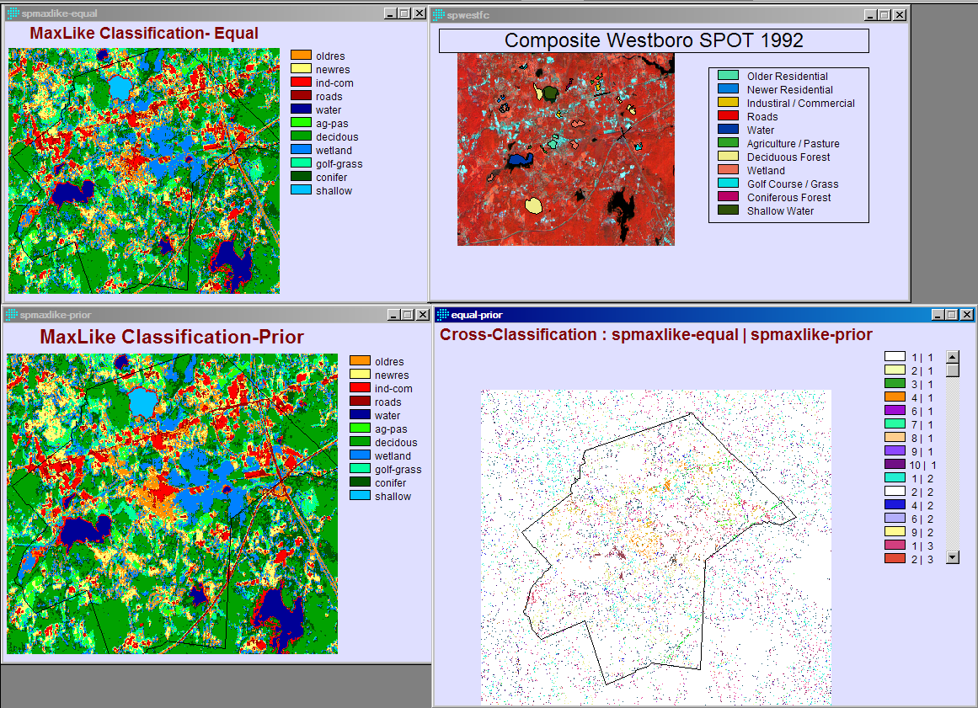
Figure 1: Exercise 5-1 MaxLike Classification

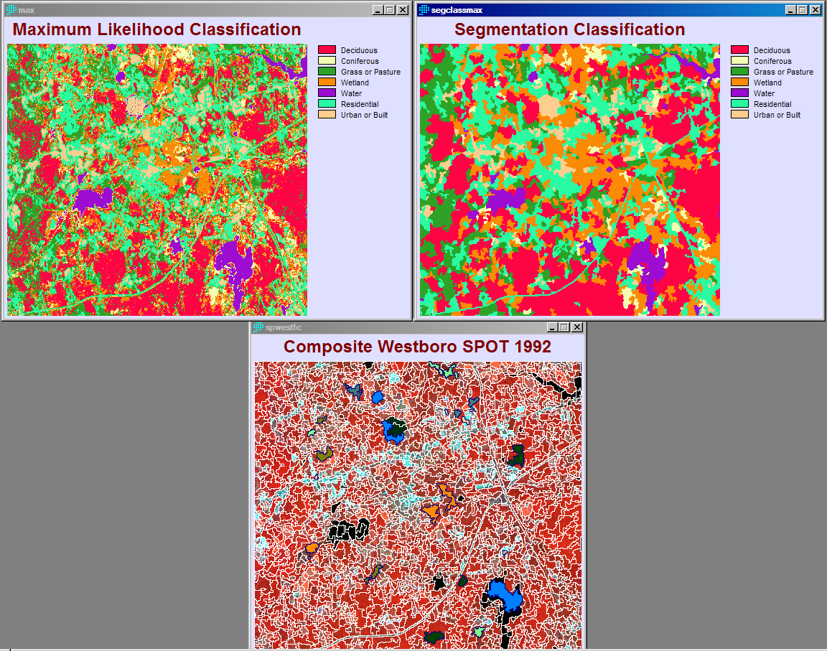
Figure 2: Exercise 5-2 Segmentation Classification

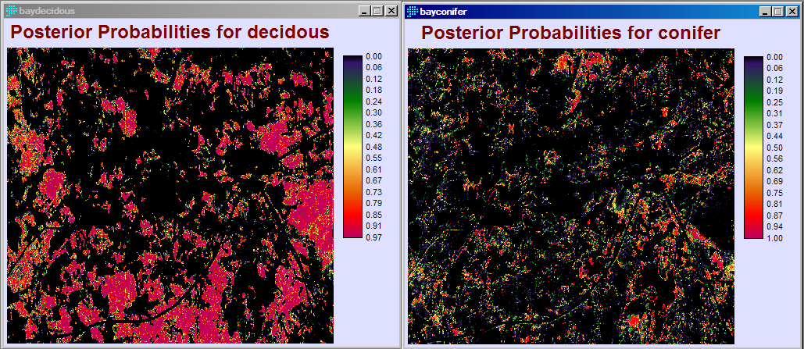
Figure 3: Exercise 5-3 BAYCLASS Method Conifer vs Deciduous Classification

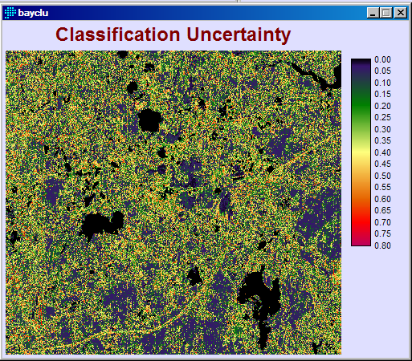
Figure 4: Ex 5-3 Bayclass Uncertainty

Average values extracted from BAYCLU based on SPMAXLIKE-EQUAL

Category Average Legend
1 0.343203 oldres
2 0.282645 newres
3 0.066097 ind-com
4 0.336280 roads
5 0.000002 water
6 0.294644 ag-pas
7 0.189668 decidous
8 0.149133 wetland
9 0.219302 golf-grass
10 0.301683 conifer
11 0.004251 shallow
Table 1: Exercise 5-3 Bayclass uncertainty by class
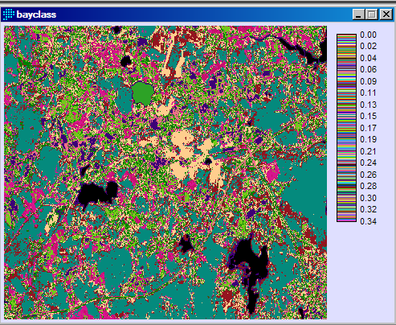
Figure 5: Exercise 5-3 Avg Bayclu Values based on spmaxlike-equal
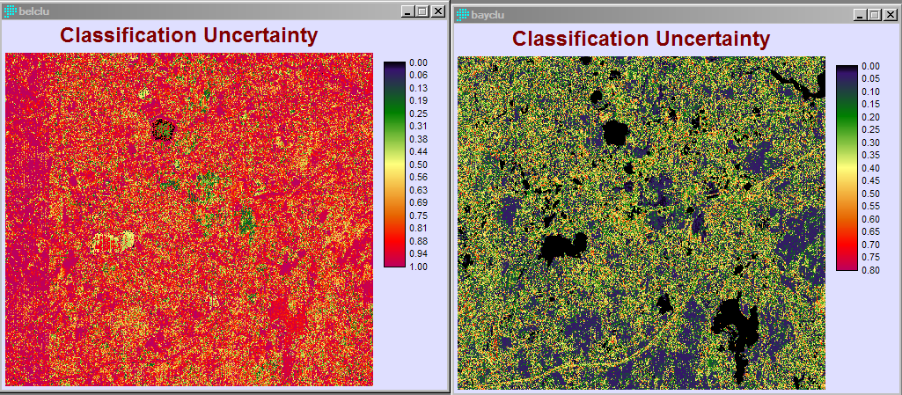
Figure 8: Exercise 5-5 Comparison of bayclass and belclass uncertainty

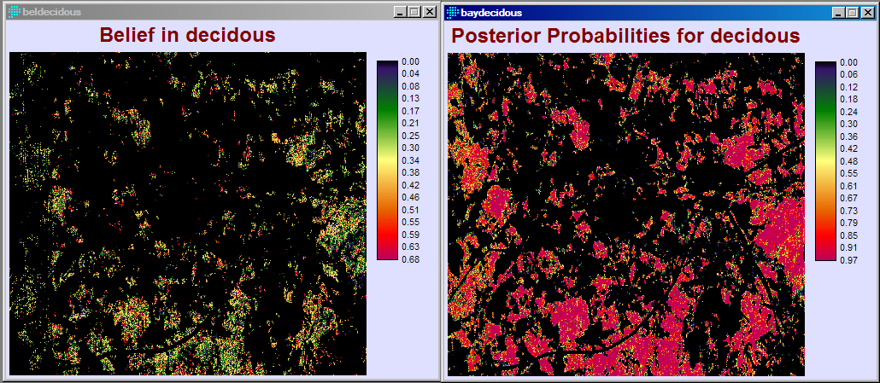
Figure 9: Comparison of deciduous results (bel vs bayclass)

