Idrisi Advanced Classifiers
This lab provided an introduction to the capabilities of Idrisi’s Andes software package in terms of advanced classification schemes. The various exercises performed include the following topics:
- Bayes’ Theorem and Maximum Likelihood Classification
- Soft Classifiers I: Bayclass Soft Classifier
- Hardeners
- Soft Classifiers II: Dempster-Shafer Soft Classifier and BELCLASS
- Dempster-Shafer and Classification Uncertainty
As a guide for this lab the IDRISI tutorial manual was used. The same dataset will be used for all five exercises in this lab. The study area is the region of Westborough, Massachusetts. According to the tutorial this region has undergone significant change in terms of high-tech development. The purpose of these exercises is to evaluate the trends that have accompanied this change.
Exercise 5-1 Bayes’ Theorem and Maximum Likelihood Classification:
In this exercise the Maximum Likelihood procedure, the most common procedure in remote sensing, was used. This approach is based on Bayes’ Theorem which states that there is a relationship between evidence, prior knowledge, and the likelihood that a specific hypothesis is true. In this example case our hypotheses are aimed towards identifying what type of change has dominated the various locations in the study region. Our prior knowledge is based upon landuse assessments conducted, by the state of MA, in the years 1978, 1985 coupled with landuse inventories based on aerial photos from the year 1992. Based on the ’78 and ’85 assessments, the frequency of change from one class to another was determined using CROSSTAB and applied to the ’85 landcover classes as a base, called prior distributions. This yielded a set of probability maps that will be used to indicate the extent to which the classes will continue to change up to ’92. The MAXLIKE operation within Idrisi was then performed, yielding the results shown in figure 1 below. The image in the lower left corner of the figure displays the classification results using those prior distributions discussed above. The image in the upper left of figure 1 shows the classification using equal likelihood, this assumes that there is no prior knowledge of the change occurring so each is equally probable. In order to evaluate the level of change, training sites must be identified so that the classification scheme has a reference point to start at; these sites are indicated in the image in the upper right of figure 1. The image in the lower right of figure 1 indicates the difference between using the equal vs prior likelihoods. This image demonstrates the disagreement between the two choices and gives an indication as to what types of land change may be most probable when including the prior knowledge.
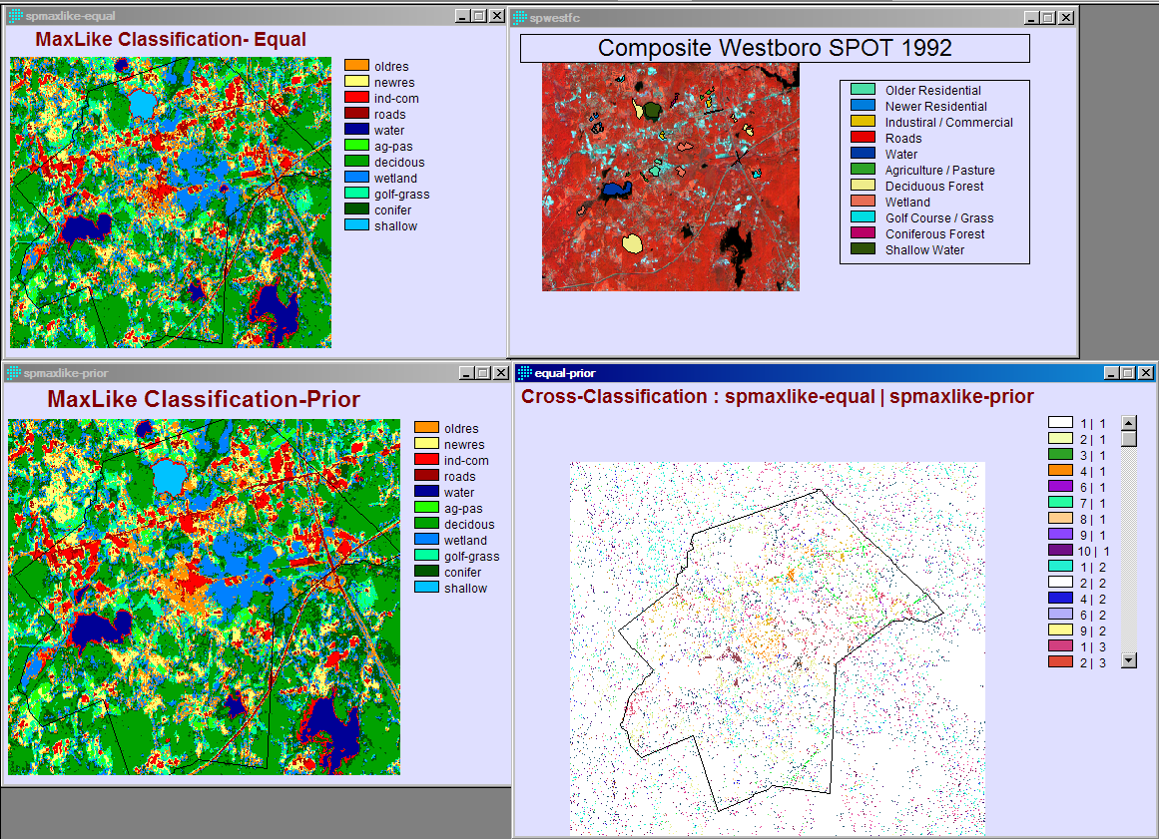
Figure 1: Exercise 5-1 MaxLike Classification
The following display is the maximum likelihood classification for change detections around the area of Westborough, Massachusetts. This area has undergone significant development in recent years as can be seen in the NEWRES (Newer Residential) demarcations both within and around the boundary of the town.
The Maximum Likelihood Classification is based on Bayes’ Theorem which expresses the relationship between evidence, prior knowledge, and the likelihood that a specific hypothesis is true.

Exercise 5-2 In this exercise, three basic steps were used to supply an introduction of image segmentation for classification. The first step involves generalizing the imagery to a specific level. The second involves identifying training sites within the generalized results. The final step is the classification itself based on the training sites and a previously classified image.
For the first step individual pixels are grouped together if they exhibit spectral similarity, this process uses a moving window to evaluate similarity and divide segments based on a threshold similarity value. In this exercise three threshold values were used: 0, 30, and 50, with 0 yielding the most homogeneous, therefore smallest, segments. Using the threshold value of 30 for further classification, training sites were then identified based on tutorial guidance. These training sites are displayed in the bottom image in figure 2 below. For this area a total of five different classes were identified: wetland, residential, urban/built, coniferous, and deciduous. A total of 21 training sites were identified and chosen for further classification. The final step of classification was then performed resulting in the image on the upper right of figure 2. For comparison, the upper left image is the result of the MaxLike classification performed in exercise 1. As demonstrated in comparison of the two images, the results of the segmentation classifier are a bit more generalized in appearance, with fewer small unconnected pixels.
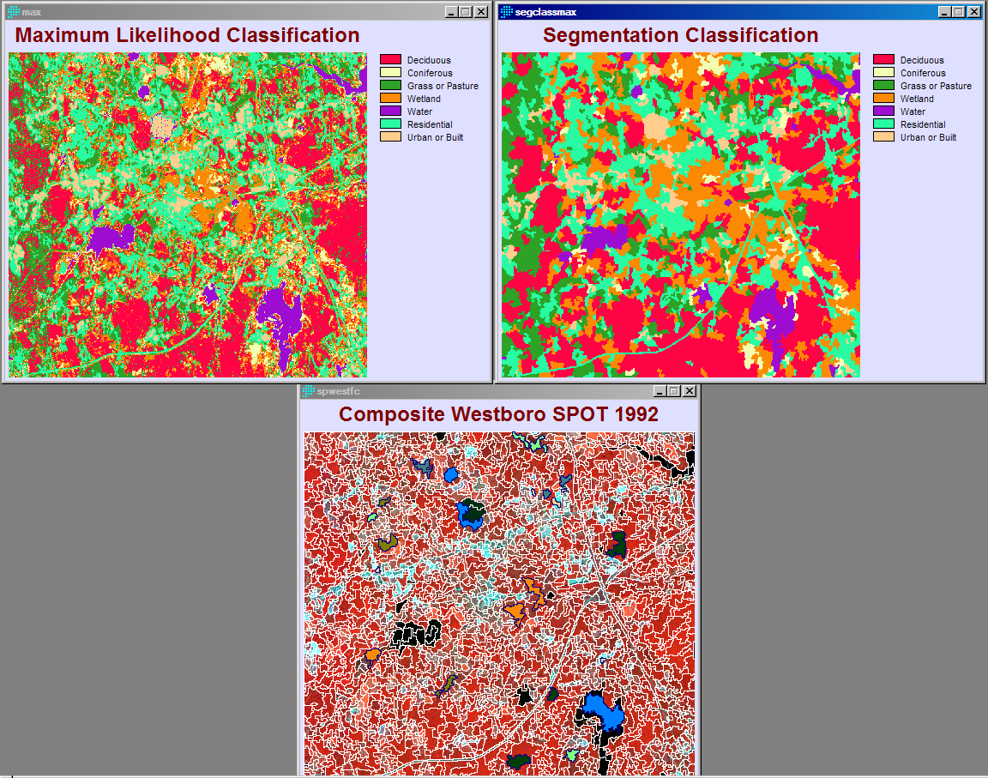
Figure 2: Exercise 5-2 Segmentation Classification
Exercise 5-3 Soft Classifiers I: BAYCLASS
This exercise provides an introduction to soft classification, a process that allows for class membership within a pixel to be on a percentage scale rather than a binary scale. Specifically, the BAYCLASS module within Idrisi is demonstrated here. The output from the first step of this module provides the user with posterior probability maps wherein values represent the probability that a pixel belongs to each class. Figure 3 below shows the probability of each pixel belonging to either the conifer or deciduous class. The bar scale on the right of each image indicates the overall probability that the pixel is classified as belonging to that class. Figure 4 reveals the overall uncertainty in classifying each pixel, as this figure demonstrates, the majority of the study area can be classified to one particular class with relative certainty (note that much of the region is covered in either black or blue tones indicating a high level of certainty and a much smaller portion of the study area is covered by red tones indicating high uncertainty). The BAYCLASS module also supplies an output identifying the average uncertainty associated with each individual class, these values are displayed in table 1 below. These values, along with the classification image displayed in figure 5 are based on the equal likelihood classification performed in exercise 5-1.

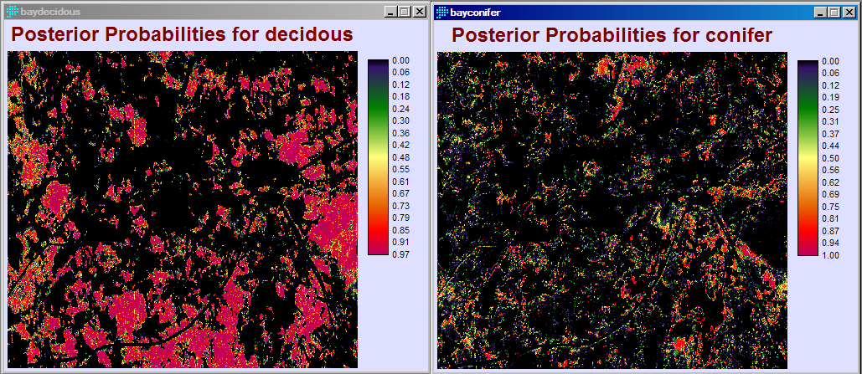
Figure 3: Exercise 5-3 BAYCLASS Method Conifer vs Deciduous Classification

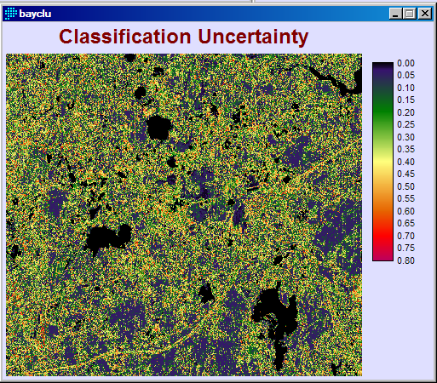
Figure 4: Ex 5-3 Bayclass Uncertainty

Average values extracted from BAYCLU based on SPMAXLIKE-EQUAL

Category Average Legend
1 0.343203 oldres
2 0.282645 newres
3 0.066097 ind-com
4 0.336280 roads
5 0.000002 water
6 0.294644 ag-pas
7 0.189668 decidous
8 0.149133 wetland
9 0.219302 golf-grass
10 0.301683 conifer
11 0.004251 shallow
Table 1: Exercise 5-3 Bayclass uncertainty by class
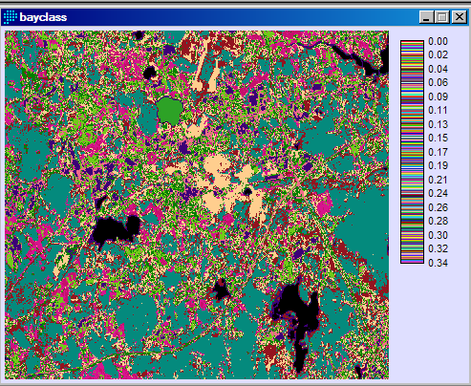
Figure 5: Exercise 5-3 Avg Bayclu Values based on spmaxlike-equal
Exercise 5-4 Hardeners
This exercise introduces hardeners, modules that force a pixel to be classified via a relatively simple decision logic, resulting in each pixel being assigned to a single class. The exercise presented here allowed for four levels of certainty when assigning a class, therefore resulting in four output images that have varying ranges of certainty when assigning a class. This option is intended to follow a previous classification scheme such as BAYCLASS and is oriented at transforming mere probabilities into qualitative outputs. Figures 6 and 7 below display the results of the HARDEN module. Figure 6 displays the top two certainty levels and figure 7 displays the lower two certainty levels.

Exercise 5-5 Soft Classifiers II: Dempster-Shafer Theory and BELCLASS
This exercise introduces the user to a third soft classifier called BELCLASS, based on a variation of the Bayesian probability theory known as the Dempster-Shafer theory. In theory, the BELCLASS module allows for other landuse types to exist beyond the pre-determined classes. This generally results in a much higher uncertainty when compared to BAYCLASS results. This difference can be observed in figure 8 below, a much higher overall uncertainty is obtained via BELCLASS, displayed on the left in comparison to the uncertainty resulting from BAYCLASS, displayed on the right.
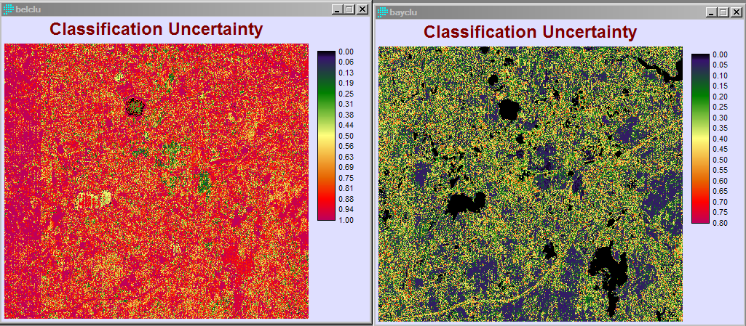
Figure 8: Exercise 5-5 Comparison of bayclass and belclass uncertainty
If the user looks at a particular class group, for example the deciduous forest class, the uncertainty of classifying a pixel within this group is noticeably different. The advantage to using a classification scheme with high uncertainty is that it allows for the result to account for varying levels of misrepresentation. In truth, the environment is extremely complex, limiting a classification scheme to under a dozen classes does not allow for a module to fully capture the complexity present in the real world. When a scheme such as BAYCLASS makes a determination to classify a pixel as conifer or deciduous it does not take into account the fact that the pixel may be an entirely different forested land class that has not been included. A module like BELCLASS allows for additional unidentified classes to exist and takes this into account when assigning classification.
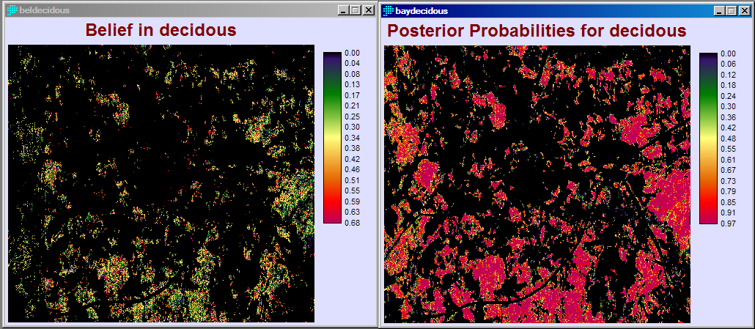
Figure 9: Comparison of deciduous results (bel vs bayclass)

