Life in the Universe
Lecture 29 Sept 2010
Hazel Owens, Sereane Bowstring, Eric Voyles, Kelly Anderson, Sara Marvin
Asteroids:
Definition: A rocky or metallic object in orbit around the sun. Includes Main Belt asteroid, (NEA) Near Earth Asteroids (planet-crossing), and the Trojan asteroids.
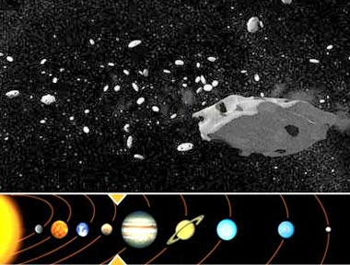 http://www.ukspaceagency.bis.gov.uk/8030.aspx
Main belt: It is thought that this material “should’ve” formed a planet between Mars and Jupiter, based on models, but that Jupiter’s gravity prevented it from forming. Which resulted in this asteroid belt. The amount of material that makes up the main asteroid belt is quite small, all the asteroids added together is less than the total mass of the moon. And this material is spread across a LARGE area. The idea of “dodging asteroids” during space travel is not a realistic image of the main asteroid belt.
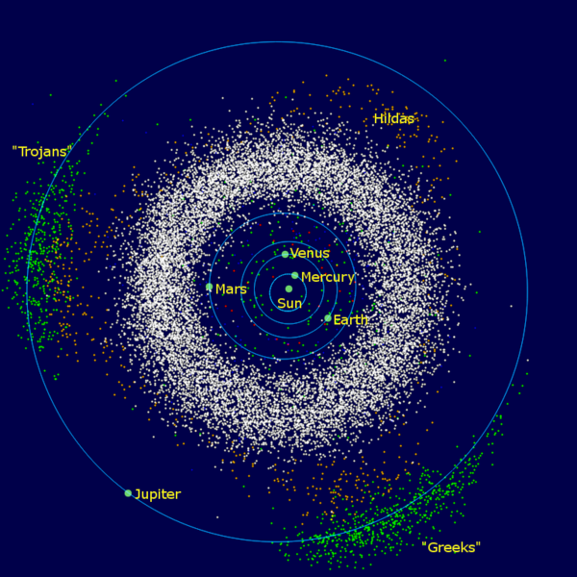
http://en.wikipedia.org/wiki/Asteroid
Near-Earth crossing: most likely what caused some of the major extinctions in the past. Their elliptical orbits cross Earth’s path, but this happens very rarely.
Trojan asteroids: caught from main belt asteroids and caught by Jupiter. Small pockets of asteroids that follow or lead Jupiter around the sun. 2 main clusters.
Lagrangian points- gravitational belt that keeps the clusters that lead and follow in orbit.
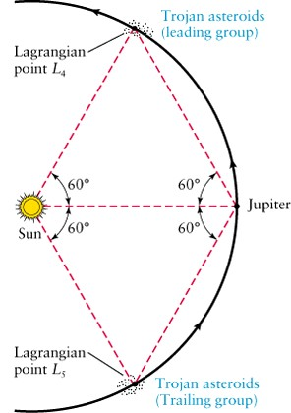
http://www.daviddarling.info/encyclopedia/T/Trojan.html

Major asteroids:
Ceres: exists in the main asteroid belt. It is the largest asteroid and was the first to be discovered. It is less than 1000 km wide (930 km) and approximately half the size of Pluto, but makes up ¼ of all the mass in the asteroid belt. It has a lot of known surface water ice. Has a density of 2.12 g/cm^3. The density of water is 1, the density of rock is about 3, so this means there may be a significant amount of water in addition to the known surface water ice. Could have more water than earth.
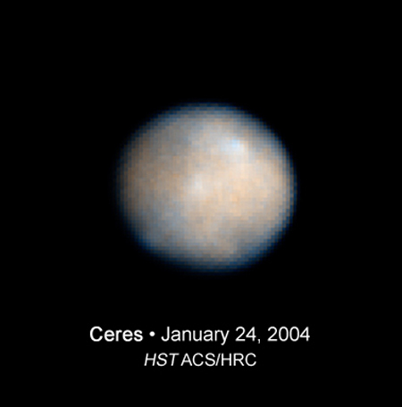
http://www.space.com/php/multimedia/imagedisplay/img_display.php?pic=070620_hubble_ceres_02.jpg&cap=This+Hubble+Space+Telescope+image+of+Ceres+shows+the+most+massive+asteroid+in+the+asteroid+belt,+a+region+between+Mars+and+Jupiter.+The+images+are+helping+astronomers+plan+for+the+Dawn+spacecraft's+tour+of+these+hefty+asteroids.+Credit:+NASA,+ESA,+J.+Parker+(Southwest+Research+Institute),+L.+McFadden+(University+of+Maryland)
Pallas- is the second largest asteroid
Vesta- the third largest asteroid

Kuiper Belt – In same plane of our solar system, a region of space beyond Neptune that is populated by larger (KBOs) and smaller objects are the less than 200 year comets. Many objects are substantially dark with less than 30 % albedo. This belt is where a lot of additional potential planets, such as, Pluto come from.
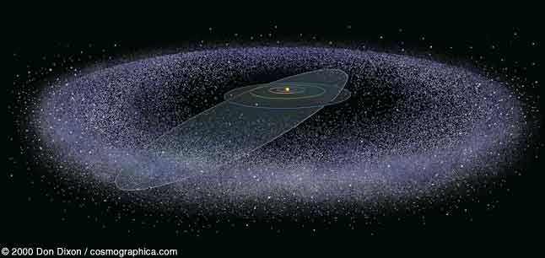
http://scienceblogs.com/startswithabang/2010/03/disrespecting_the_rules.php

KBO’s – Kuiper belt objects – prograde revolution around the sun ( same as other planets). Also known as transneptunians. A lot of the KBO’s have a tilted orbit compared to the rest. Should have formed in to a Jovian planet but lacked the sufficient ice core. There was not enough ice or dust to grow big enough, fast enough.

Comets – An icy object in orbit around the sun. Shows a gas cloud (coma) around the core when close to the sun which is what creates the tail. Solar wind is responsible for creating tail. The direction of the wind is what keeps the tail pointing away from the sun. A comets origin is an icy material that never turned in to a larger object. Almost like the icy version of an asteroid that are also survivors of planetary “sweep up process” also not formed due to orbital resonance.

Haley’s Comet – a potato shaped comet that is roughly 8 miles long, made of dust and ice that is really dark, carbonaceous looking that potentially could have been a source of amino acids and organic compounds for Earth.
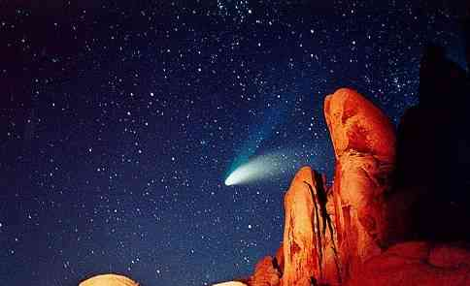
http://www.eskimo.com/~recall/bleed/0411.htm

Oort Cloud – another cloud that derives comets like Kuiper Belt. A spherical orb of icy objects that produce one time comets.

