Notes from Life of the Universe Lecture 9/27/2010
- Planets
  - There is not a solid definition of a “planet.” The following is a list of some working, possible definitions. These are debatable.
    - The classic 9.
      - This definition allows for only the nine planets Mercury, Venus, Earth, Mars, Saturn, Jupiter, Uranus, Neptune and, until recently, Pluto to be characterized as planets. Some scientist argue that this is “too few” and that there are many other objects in the sky that have planet like characteristics.
    - An object in orbit around the sun that is large, self-gravitating and is shaped into an orb.
      - This definition allows for thousands of objects in the sky to be planets as there are many large objects in our solar system that revolve around the sun.
    - Same definition as ii but bigger than Pluto.
      - This gives us about 10 planets. This possible definition was proposed when the “tenth planet” was discovered in 2003. It was bigger than Pluto and it had a moon. It was named UB313 or Xena and the moon’s name was EL 61 Gabrielle. It is a large Kuiper Belt object and it is bigger than Pluto. This discovery raised even more questions about the definition of a planet and the confusion allowed scientists to also question the legitimacy of Pluto’s status as a planet. Eventually, Pluto was deplanetized
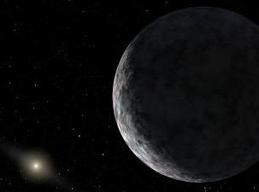
. Image and information about UB313 and EL 61 from: http://www.humansfuture.org/space_the_tenth_planet.php.htm
  - The following is a list of the terrestrial planets or planets of the inner-solar system (planets inside the asteroid belt) and what we know about them
    - Mercury:
      - The planet closest to the Sun
      - About the same size as earth’s moon.
      - Surface is similar to the earth’s moon.
    - Venus
      - Venus and Earth are roughly the same size. And made out of the same components.
      - Venus’s lack of liquid water makes it completely inhabitable.
      - The clouds are made of sulfuric acid.
    - Earth:
      - The only inner-solar planet with its own moon.
      - The only inner-solar planet with mostly liquid water.
      - The perfect distance from the sun to sustain life.
      - Earth means “terra” or dirt.
    - Mars:
      - The only other planet in our solar system that holds the possibility of containing life.
      - It was at one point producing a magnetic field.
      - In 1996, scientists from the Johnson space center discovered a meteorite from Mars showed compelling evidence that there may be life on Mars. This is still debated.
  - The following is a list of planets in the outer solar system (planets outside the asteroid belt). They are called the “Jovian plants.” Also called gas ginats. The outer atmosphere of these planets is think and dense.
    - Saturn:
      - Rings made of ice, dust and rock particles. These rings were discovered by Galileo
      - Contains a moon that sprays liquid water.
      - Also contains a moon named Titan that has a nitrogen atmosphere. The surface of this moon is -300 degrees.
    - Jupiter:
      - The biggest planet in our solar system.
      - Contains many moons in it’s gravitational pull. These moons are also called Galilean Sattilites because they were also discovered by Galileo. The names of some of these moons are Ganymede, Callisto, Io and Europa. Europa is the same size as the earth’s moon, may have liquid oceans and is a possible candidate for containing life.
    - Uranus:
      - Not well studied.
      - Two moons.
      - Blue.
      - Pretty.
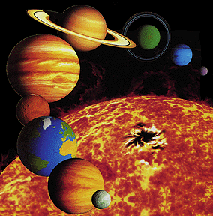
Image from: http://starchild.gsfc.nasa.gov/docs/StarChild/solar_system_level1/solar_system.html

