Gothic Cathedral
Reims, located in Champagne, France. (Another example of Gothic architecture that you might recognize is Notre Dame-Paris.)

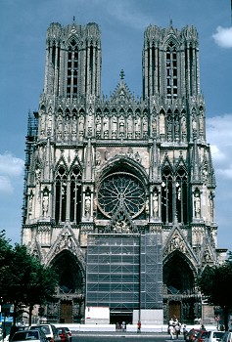

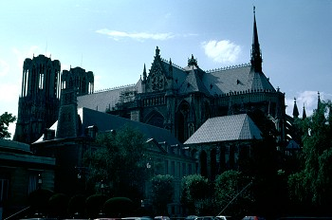

Romanesque Cathedral
Durham Cathedral located in Durham, England.

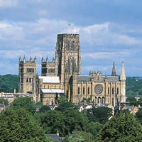

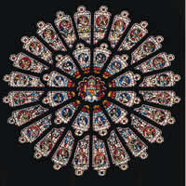
The Rose Window

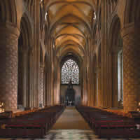
The Nave!

Comparison of Layouts for Romanesque (left) and Gothic (right) Cathedrals

