Gatewood & Field (2001) Ch 7-9 Job Analysis

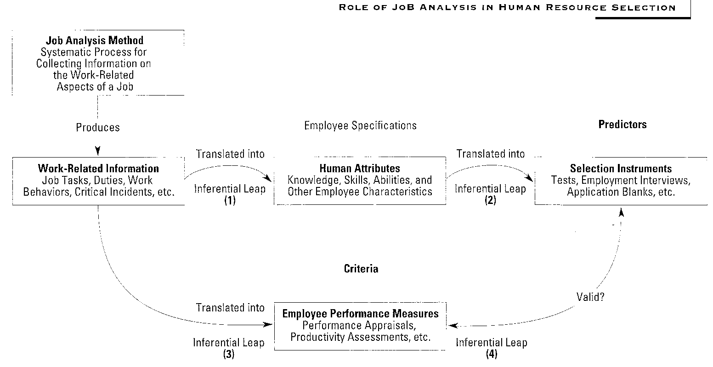

LEGAL ISSUES IN JA
Griggs v Duke Power 1971—MQs must be job related→JA
Albermarle Paper Co v Moody→criticized lack of a JA
also supported EEOC guidelines
Legal Recommendations
do JA
record in writing; describe process in detail
collect info from variety of qualified sources; incumbents, mgrs, job analysts
adequate sample size & diversity in sample
specify tasks & activities
most important used in selection
specify competencies for entry level performer
specify KSA & link to tasks
examine adverse impact

ORGANIZING THE JA
Who performs the JA-analysts, incumbents, mgrs
How to manage project (org & political issues)
Needed resources
Choosing jobs to be studied
representativeness of the job
criticality of the job
# of apps for job
stability/obsolescence of job content
evidence of adverse impact
entry level?
does job serve as a link to higher-level jobs—promotion related
are their current performance dieficiencies
is job physically demanding

Review Relevant Literature
previous JA, ONET, other orgs JA
Selecting Job Agents
analysts—consultants best if not going to be used freq (cost effective)
incumbents—at least 6 mo on job
mgrs—may be widely dispersed, supervise many jobs; expensive to get together a lot of them
Experts give better info

JA METHODS
work v worker orientations
JA Interviews
STRUCTURED! clear obj
collect job info, clarify/verify prev info, as part of selec process
focus on tasks, ksa
task statements—what, to whom/what, producing what, using tools, materials, procs, equip
limitations→lack of standard/struct, expensive/time consuming, need to verify info
JA Questionnaires
e.g PAQ, Job Element Inventory
task analysis inventories
lg list of task statements & rating scales (freq, imp for new hires to have, diff, criticality)
often user dev—rev docs, interview, make init scale, sme rate, revise scale, re-rate, pilot
important esp for content valid
Adv/Disadv
A-econ lg scale survey, quantify job chara
D-dev time/costly, motiv of sme, item quality
PAQ
~200 item worker-oriented survey—gen work beh, work cond, job chara
filled out by trained job analyst OR sme under guidance of trained job analyst
meas→info input, mental processes, work output, relat wi others, job context, other job chara
broken down into several dimensions eg decision making, clerical, phys
Adv→complicated, high reading level, trn on it
Disad→worker oriented, masks diffs between jobs
SME Workshops
ident & rate job tasks, ident & rate KSAs, linkage, rate relevance to job content (content valid)
Others→worker diaries, technical conferences, direct obs, work participation
Recommendations
diff methods for diff purposes

Critical-Incidents Technique
gather info on specific good/bad beh that have occurred
not indiv oriented inferences
Steps 1-select method group indiv or survey 2-select sme 3-gen crit incid (single specific beh, obs, brief context, conseq)
4-defind job dimensions (card sort into CIs themes, then resort by theme)
Adv→very rich source of beh, can use on beh rating scales as anchors, also info for SJTs
Disadv→may not be full scopr of job tasks, labor intensive

Fleishman Job Analysis Survey (F-JAS)
worker orient; survey of 52 abilities eg visual discrim
4 categories→cog, psychomotor, phys, sensory/percept
can apply to whole job, a job dimension, specific tasks
steps: 1- determine level of analysis 2- select sme 3-rate abilities 4-analyze results 5-select tests
Adv→straightforward & easy to adopt; ident ksa after task analysis; esp good for crit valid study; NOT content valid

Functional Job Analysis (FJA)
2 types of task info→what a worker does as task performed, how task is performed
NOT what gets done
can be done by job analyst obs & interview & generate task statements ; sme generate task statements
use Worker Functions Scale to rate abilities for tasks
use Scale of Worker Instructions to rate autonomy/structure
use Scales of Gen Educ Dev to rate educ/know needed for task
Identify KSA
Adv→comprehensive, logical, quantative JA tech
Disadv→time consuming, labor intensive, laborious, need trn (expensive)

Job Element Method
worker oriented—identify superior workers
Job Elements→wide variety of chara describing superior performers
consist of worker chara KSA
elements can have subelements (maybe context specific)
STEPS→select sme panel & dev job elements & subelements,
rate (imp to superior perf, critical of error, do min perf have, should new hire have)
analyze data
amplify sub element dimensions

generates a list of elements & KSA for each one & subelements, & job tasks that illus chara tied to examples

can be difficult, esp generating job elements & subelements
doesn’t specify tasks so hard to show elements job related

Task Analysis (task-ksa) Approach to Finding Selection Measures
1-ident & rate job tasks (what to whom/what why/how)
2-specify ksa
3-rate importance of ksa
4-ident Os
5-link ksao to job tasks
6-dev content areas of sel measures
are KSAOs→rated as important, necess for new hires, necess for import task
rate relative importance of KSAO
pick sel meas

PAQ Approach to Finding Selection Measures
conduct JA with PAQ
identify major components of work with PAQ analysis
identify KSAO from PAQ analysis
choose sel meas

