Gatewood & Feild (2001) Ch 2—Legal Issues in Selection

-EEOC LAWS & EXECUTIVE ORDERS
-Title VII CRA of 1962
-no discrim based on race, color, religion, gender or nat origin; 1978 include preg, ch birth
-doesn’t apply to private clubs, religious org, Indian reservations
-usually must file charge within 180 days of violation

-CRA 1991
-incr burden of proof for plaintiffs—gather data, prove test discrim
-makes it more costly to bring suit; used to be Orgs burden to prove no discrim
-plaintiff must identify which part of selection system is discriminatory
-also allows for compensatory & punitive damages
-prohibited race norming
-estab Glass Ceiling Commission

-Executive Order 11246
-for federal contractors
-same prohibitions as Title VII
-requires AA plans
-OFCCP enforces

-Age Discrim in Employ Act of 1967 (ADEA)
-prohib discrim of >40yo

-The Rehabilitation Act of 1973
-for Fed gov & federal contractors
-prohib discrim in employ & AA toward disabled

-Americans with Disabilities Act of 1990 (ADA)
-disability→a)phys or mental impair that substantially impacts at least 1 major life activities
b) has a record of the impairment; c) is regarded as impaired
-specifically excludes: GLBTs, sexual deviants, compulsive gamblers, kleptos, pyros, druggies
-prohib selection devices that discrim against disabled UNLESS job related & business necessity
-must help indiv decide if they need testing accommodations
-also can’t ask about disability in interview; just can you perform work task
-med exams (if job related) only after offer of employ; drug testing not included
-reasonable accomm→changes in work processes or environ; no undue hardship for org, eg. ramps
-NOT REQUIRED→create job for disabled, prefs for disabled, shadow Ee

-Immigration Reform & Control act of 1986
-can’t knowingly hire illegal aliens
-no disparate tx of foreigners; adverse impact not covered

-Constitutional Amendments & CRAs of 1866 & 1871
-5th (federal) & 14th (states) prohibit disparate tx for all citizens
-CRA 1866→same right to make & enforce contracts as whites; usually just race based law
-CRA 1871→applies to states (not Fed or priv orgs)
-broad bases for discrim—ethnicity, gender, religion, age, sex pref, citizenship, phys attributes
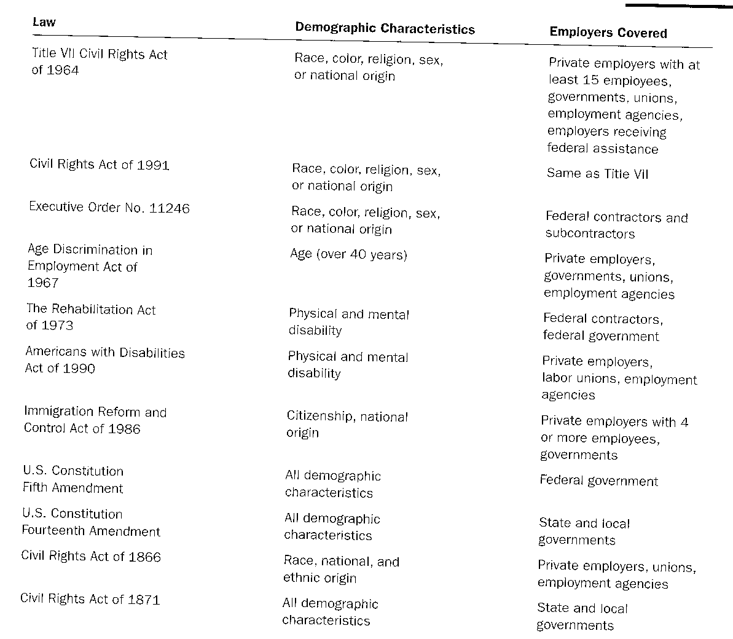

-EMPLOYMENT DISCRIMINATION
-types
-disparate Tx→obvious discrim against a protected group, eg. no hire women
-disparate impact→adverse impact from universally applied selection system
-evidence
-plaintiff must present a prima facie case then org can rebut, eg. adverse impact; plaintiff can rebut org
-disparate tx→protected class, was qualified for job, was rejected, org kept looking to fill job
-McDonnel Douglas rule
-disparate impact→prima facie case (adverse impact stats)—Org rebut—plaintiff rebut
-Org rebut→job related (valid), business necessity (safety of workers/customers), bfoq (no one of a gender, religious order, can do job)
-stats→can compare to labor market (geography & skill level); 4/5 ths rule
-UNIFORM GUIDELINES
-4/5ths rule for adverse impact
-with very small samples may not apply
-Defense of selection program (EEOC only concerned with adverse impact systems)
-job related (validity), business necessity, bfoq
-Selection Requirements
-can’t select on skills easily trained
-cutoff scores
-least stringent—score above which all apps considered equally acceptable
-can make groups of equivalent scores
-can rank order & do top-down selection
-Record Keeping
-demographic chara of apps & hires (for all groups that constitute 2% of labor market)
-both for entry level & promotion
-if have >100 Ees must keep records for adverse impact of total selection system & sub-parts

-AA programs
-written plan to seek & remove barriers to minority employ
-must be specific
-done in 3 conditions: Fed contractor, court order/consent decree, voluntary
-voluntary→temporary, no perm adverse impact against whites, correct a demonstrated maj/min imbalance
-tend to affect attitudes & perceptions of current Ees about new hire abilities

-SELECTION COURT CASES
-Griggs v Duke Power 1971
-job relatedness
-plaintiff must show adverse impact, then Org has burden
-1970 EEOC guidelines given deference in proving validity

-US v Georgia Power 1973
-reaffirmed job relatedness & necessity to follow EEOC guidelines

-Spurlock v United Airlines 1972
-job related of selection instruments other than tests (college degree, 500 hrs flight time)
-when job requires much skill & risks great, org has lighter burden to show job relatedness

-Connecticut v Teal 1982
-discrim in multistep select system even though total system had no adverse impact
-Org must ensure each part of select system no discrim

