Professional, Interactive Data Visualization for Everyone

David Gerbing

School of Business

Portland State University

The purpose of lessR is to simplify the process of obtaining professional-quality data visualizations at no cost and with minimal effort. The most recent version of lessR, Version 4.5, simplifies most of the entire visualization workflow into just three intuitive, accessible functions that share a common syntax: Chart(), X(), and XY(). Using lessR requires no programming; just a few simple function calls, so a lack of R experience is not a roadblock.

Anyone with a computer can download both R and its environment for analysis, RStudio, from the free resources. Then download lessR to immediately enter function calls into the R console, in response to the R prompt >, to create high-level, modern, interactive visualizations. You can work on your computer with unlimited access or work in the cloud with a free account for a reasonable amount of processing. Find complete instructions at the same website I developed for my students, though there is little more to learn than provided in this brief overview.

Data. Begin a data analysis by reading the standard rectangular data file common to all analysis systems, stored somewhere on your computer network or on the web, into R. Store the data within an R analysis as an object of whatever name you choose, but usually keep it simple, d, which serves as the default data name for the analysis functions. To use the lessR Read() function, enter a path name to a file on your computer system, or on the web, enclosed in quotes, such as:
d <- Read("https://dgerbing.github.io/data/Employee.xlsx")
The file name can refer to an Excel sheet, as in this example, a text file, or many other data formats. If you leave the quotation marks empty, Read("") lets you browse for your file. Read() detects the file type automatically and imports it appropriately.

Chart(). Once the data is loaded, the heart of the lessR workflow consists of the three visualization functions. The first, Chart(), visualizes grouped data from a summary table computed (aggregated) across the groups. For example, count the number of people in each department of a company. Simply enter:
Chart(Dept)
This single instruction produces a clean, professional bar chart that visually and numerically summarizes the data in an easy-to-read table.
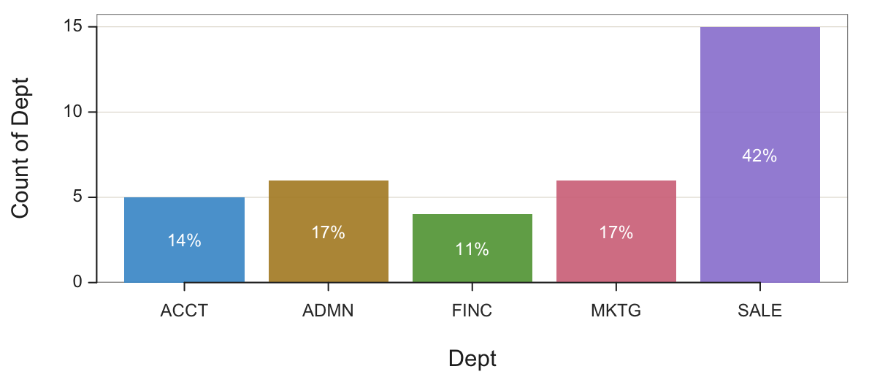
Across the three primary lessR visualization functions, the argument type specifies the type of plot for the chosen function. For Chart(), the default value is "bar" for a bar chart. Other possibilities include "radar", "pie", "bubble", "treemap", and "icicle". By default, the numerical values plotted are the counts for each grouping. Further, use the argument y to analyze a numerical variable in your data, specifying the data transformation with the argument stat.

For example, create a multi-level pie chart called a sunburst chart, a multi-level pie chart. Here, show the relative sizes of the average salaries by gender within each department:
Chart(Dept, by=Gender, y=Salary, stat=”mean”, type=”pie”)

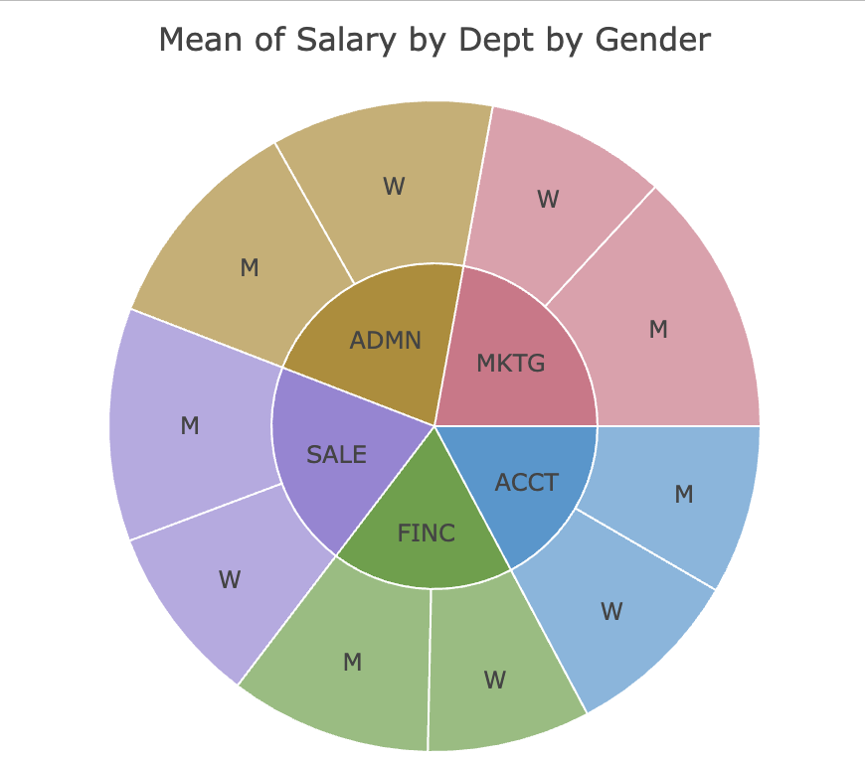
Extend the analysis to more levels for analysis with the R function c(), such as specifying by=c(Gender, Plan). Or create a separate chart for each group using the argument facet in place of by.

X(). The second primary tool, X(), visualizes the distribution of a single numerical variable. An initial step in working with a dataset is answering questions such as: What does the distribution look like? Are there outliers? What is typical? For example, to create a smooth, clean histogram, drawn using an enhanced approach that intelligently selects the number of bins, formatting, and displays key summary statistics, simply enter:
X(Salary)
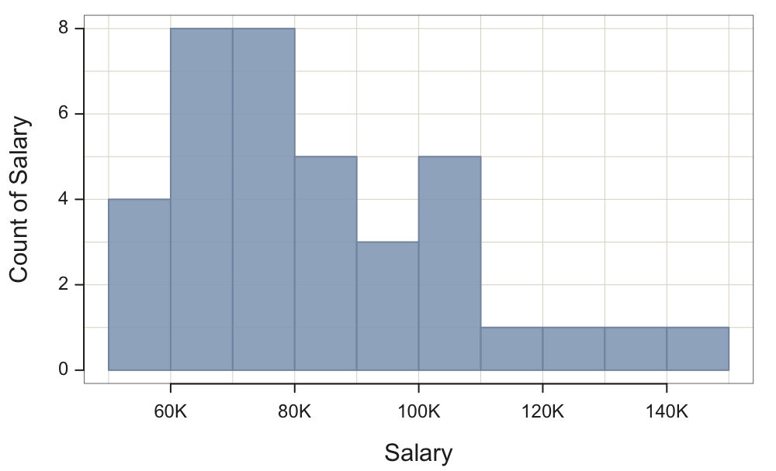
Other visualizations of distributions, set by the type argument, include "density" for a smooth curve and "vbs" for an integrated violin, box, and 1-dimensional scatter plot, also called a strip plot. If you include a grouping variable, such as Gender, lessR produces overlapping distributions if you specify a by variable or separate distributions if you specify a facet variable. For example, to see a separate plot of the distribution of Salary for men and women, with any outliers identified by red points, enter:
X(Salary, facet=Gender, type=”vbs”)
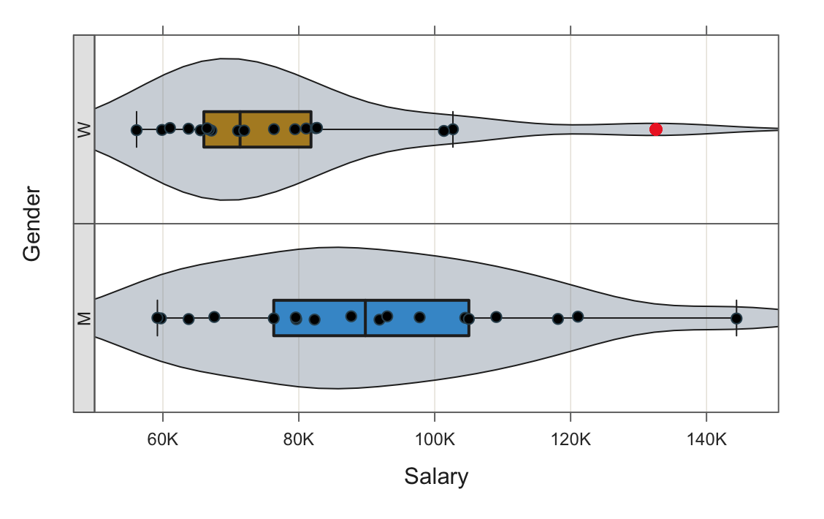

XY(). The third core lessR function, XY(), creates visualizations of relationships between two (or three) variables. One of the most common questions in any analysis is whether one variable predicts, influences, or correlates with another. The default type of XY() plot is the scatterplot, so view the scatter plot with the best-fitting line with:
XY(Years, Salary, fit=”lm”)
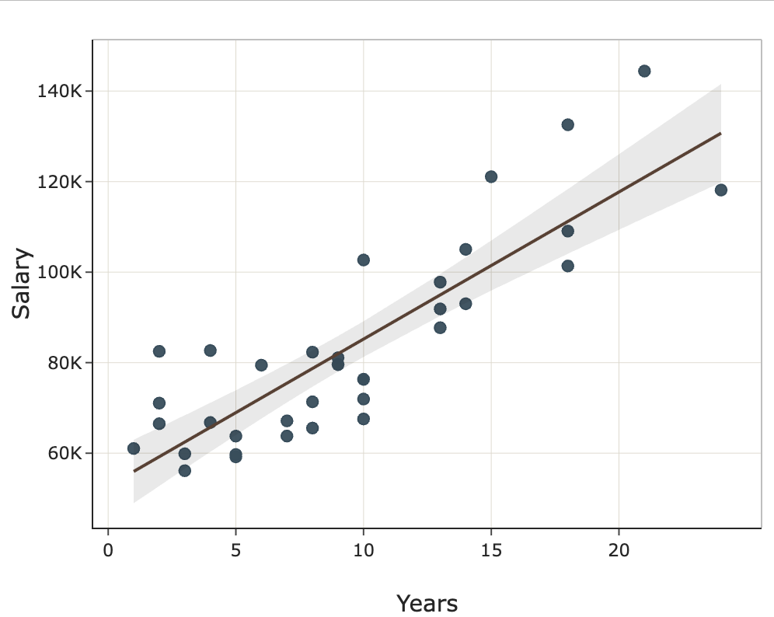
The output also includes the correlation coefficient and other statistics.

Add a grouping variable to automatically color and organize the relationships according to that variable. Here, add a by variable to produce overlapping scatter plots.
XY(Years, Salary, by=Gender, fit=”lm”)
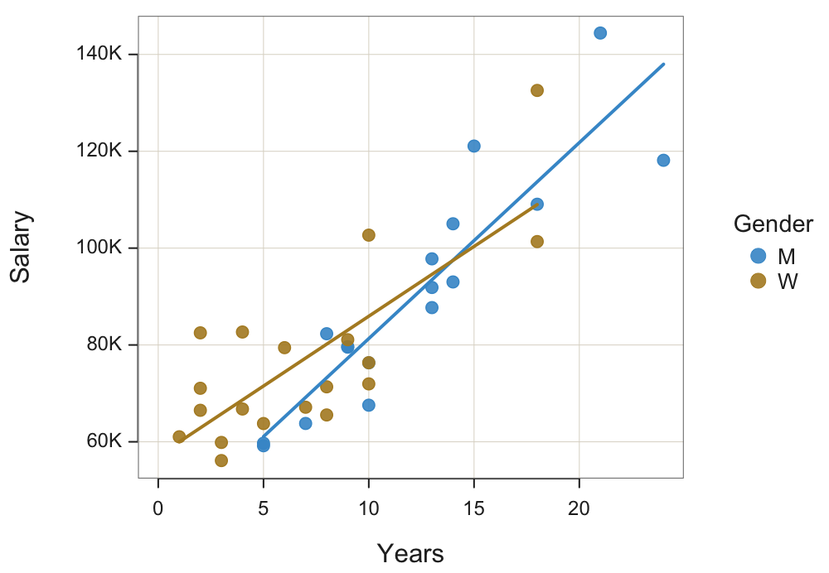
One of the strengths of the lessR design is that each of the three functions behaves consistently, accepts similar inputs, and produces meaningful, readable summaries.

Interactivity. Each function -- Chart(), X(), and XY() -- produces mostly interactive, browser-friendly (Plotly) graphics by default. Hover over points to see underlying values, zoom in or out, isolate categories, or view tooltips that contain rich numerical information. Some specific plots are not interactive but otherwise fully detailed. Some visualizations appear in both forms. Within RStudio, the interactive plots appear in the Viewer Window, and the standard plots appear in the Plots Window.

Summary. The combination of ease of use with a unified experience across the three functions, meaningful defaults, and powerful interactivity makes lessR particularly well-suited for education, business analytics, and general research. lessR handles many of the complex details automatically, without having to learn a complicated software environment or purchase expensive software. The simplicity of the interface does not limit its power, and many more straightforward options such as custom colors are available, such as for using the fill parameter to color the interior of plotted objects and the color parameter for the color of a line segment, either by itself or as the edge of a region such as a bar or point. Other analyses are also available, such as a simply obtained comprehensive regression analysis with function Regression(), a t-test between groups with function ttest(), and an analysis of variance between many groups with ANOVA().

