Template: Regression Analysis

Scatterplot/Correlation Matrix

Estimated Model

Hypothesis Test of a Single Slope Coefficient
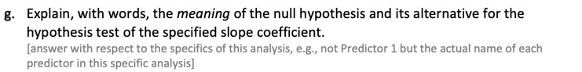



Confidence Interval of a Slope Coefficient

Model Fit

Potential Model Revision [if multiple predictor variables]

Prediction Intervals

Conclusion

