ISQA 523 – Winter 2022

Homework Week 4

Directions

It is OK to work together on the Homework. Of course, make sure that everyone working together on an assignment is learning the material. Each person still turns in their own homework even if exactly the same as that of other group members. Learning this material well enough to do the homework problems is how you succeed in this course.

Short-Answer Problems
These concepts can appear on the short-answer part of the tests. As part of this homework, answer the following questions, usually just several sentences that include the definition.
- K-means cluster analysis minimizes the cluster inertia for each cluster. What is cluster inertia?
- A cluster should demonstrate cohesion and separation.
a. What are these concepts?
b. What fit index simultaneously assesses these two concepts? How is it interpreted?
- What is the Pythagorean theorem so important to cluster analysis?
- What is a cluster centroid and how is it computed?
- Why is it good practice to investigate multiple initial configurations of centroids when pursuing a K-means cluster analysis?
- a. What is the distinction between supervised learning and unsupervised learning?
b. How can unsupervised learning be a preliminary step to supervised learning?
- Express in words the calculation of Euclidean distance between two points calculated over p features. [Write the formula if you wish, but do describe verbally.]
- Why is it important to standardize (or otherwise normalize) the data before pursuing a K-Means cluster analysis?
- Briefly describe the statistical procedure to assess the best number of clusters for a given data set. Explain specifically of the importance in terms of K-Means.
- What is the distinction between a parameter of a model, and a hyper-parameter? Give an example of each.
- Your company supplies almost 1200 products to retail locations. You wish to develop an inventory strategy for your warehouse based on type of product. You analyze two features for each product, Net Revenue and the Number of Customers during the last year who purchased the product. The resulting cluster analysis solution follows.
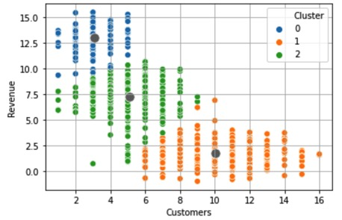
- Interpret each of the three clusters. [one or two sentences each]
- What inventory strategy do you recommend for each group of products? [a few sentences each]
- Hyper-parameter search: The fit analysis across different solutions of the 1200 products depending on the specified number of clusters yielded the following:
nc | 2 | 3 | 4 | 5 | 6 | 7 | 8 | 9 | 10
Inertia | 668.6 | 419.6 | 269.1 | 218.4 | 174.6 | 154.3 | 137.4 | 122.0 | 112.0
Silhouette | 0.623 | 0.587 | 0.509 | 0.459 | 0.441 | 0.426 | 0.407 | 0.417 | 0.406
Justify the 3-cluster solution from these indices. Specify how you balance Silhouette and Inertia.
- To do develop a targeted advertising campaign, a large-scale grocery chain did a cluster analysis of its customers according to their purchases at a given location. What are some likely clusters do you think such an analysis might uncover?
- You are tasked with analyzing drivers who transport materials to various points in your supply chain. Because drivers are driving company trucks, you can collect real-time information regarding their driving habits for each trip. One analysis is of the variables (a) distance driven in miles and (b) percentage of the time the driver was driving over 5mph of the speed limit. The resulting 4-cluster solution of several hundred trips by different drivers is shown below.
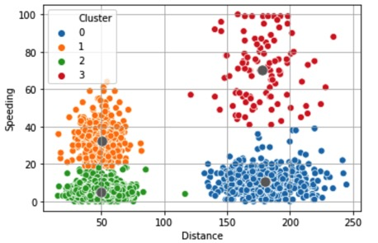
- Interpret each of the four clusters. [one or two sentences each]
- What additional variable would be useful in this analysis to make the results actionable?

- For the above 4-cluster solution, the fit analysis across number of clusters yielded the following values of Inertia. Justify the four-cluster solution from this hyper-parameter tuning.

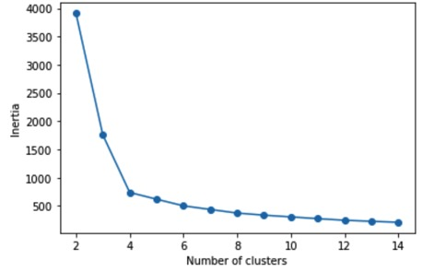

- For the above 4-cluster solution, the fit analysis across number of clusters yielded the following values of the Silhouette index. Justify the four-cluster solution from this hyper-parameter tuning.

