Sophomore Inquiry (SINQ) Course – Winter, 2014 (“Interpreting the Past” Cluster)

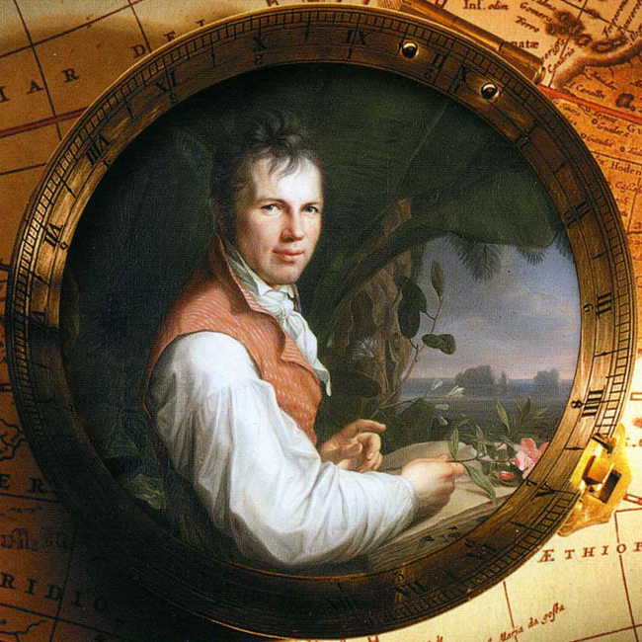 | Origins of Sustainable Environmentalism: In the Footsteps of Alexander von Humboldt – Explorer, Scientist, Human Rights Advocate  William B. Fischer, Ph.D. (Department of World Languages & Literatures)  CRN 44078 UNST 236A 001 • 4 credits • TR 14:00-15:15 • Cramer Hall 103  (with Mentored Inquiry Workshops & field trips)  for more information: William B. Fischer • 503 725-5285 • fischerw@pdx.edu  web.pdx.edu/~fischerw (links: “Personal Info” & “Humboldt Project Website”)
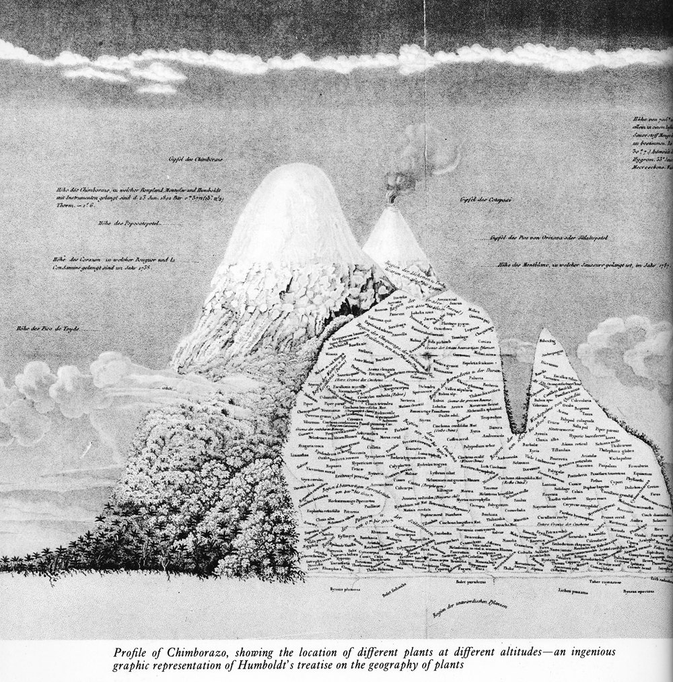 | Subject of inquiry  The explorations, scientific research, sociological studies, and ethical thought of Alexander von Humboldt (1769-1859) established the principle of interconnectedness – of our planet, its life forms, its natural resources, and its societies. Humboldt was probably the most famous cultural figure of Nineteenth-Century Europe, and was widely known in the United States. After a century of obscurity, he is being rediscovered and recognized as both a heroic explorer and a giant in many fields of endeavor: climate research, plant and animal geography, environmental studies, anthropology, linguistics, and social justice. Humboldt’s work was a major factor in not only modern sustainable environmentalism, but also how the United States developed as an ecology and a society. Counties, towns, schools, universities, geographical features, biological species and, of course the Humboldt Current and the Humboldt Penguin, commemorate his name.
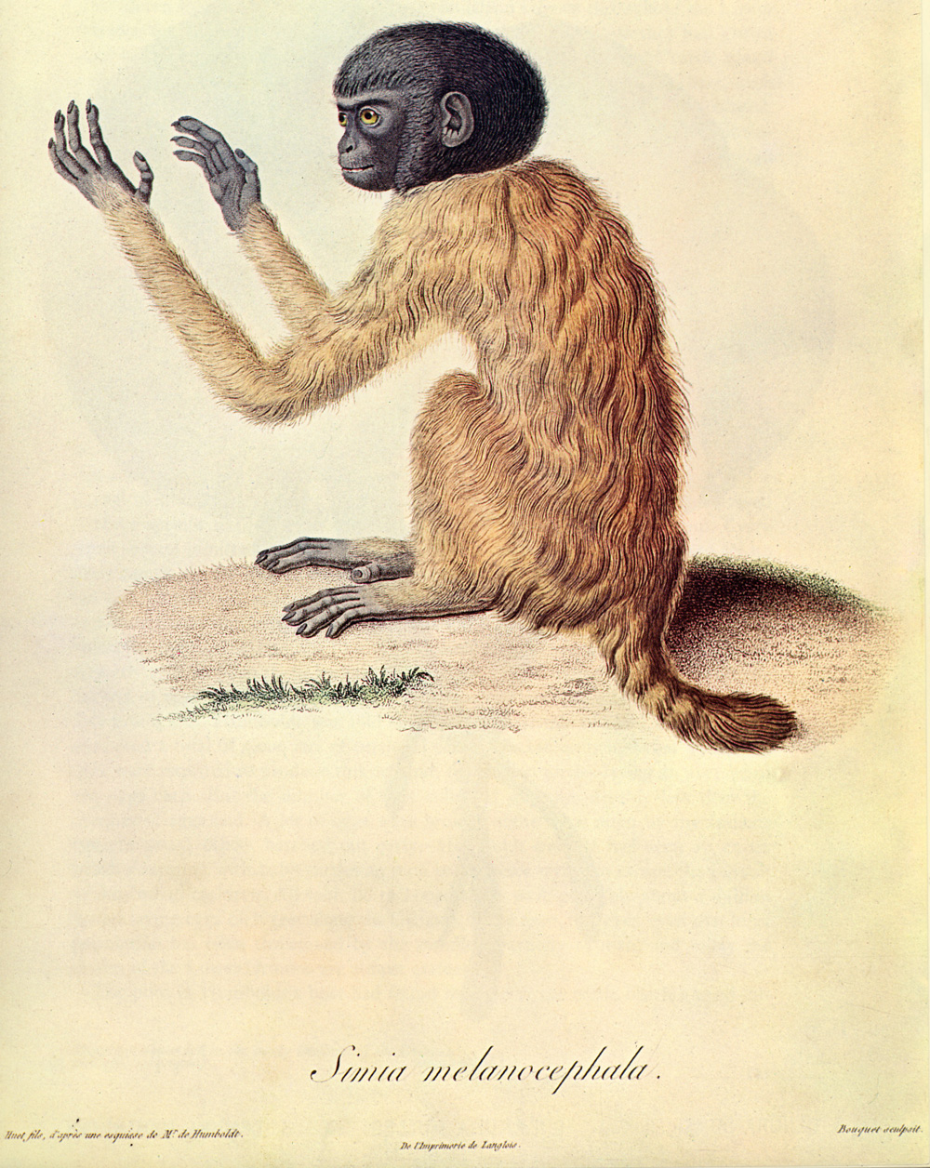 | Course goals  • Trace the origins of sustainable environmentalism in the Nineteenth Century.  • Follow an explorer and scientist of the Nineteenth Century whose work covered the range of the sciences and extended into the social sciences and humanities.  • Relate Humboldt’s work and world to our world, especially environmentalism.  • See how knowledge (including our own) is mediated by modes of perception and communication.  • Understand that history and human development are process, not product, and not perfection.  • Learn by helping others to learn: create Humboldt-related learning modules (“Earth Day with Alex”) for K-12 schools named for him (US, Latin America, Europe)  Method: combination of academic study, hands-on (“experiential”) learning, service learning, and carefully structured team-based learning with individual responsibility.  Campus-Wide Learning Outcomes addressed: Sustainability, Creative and Critical Thinking, Internationalization, Engagement, Communication (including quantitative), Diversity
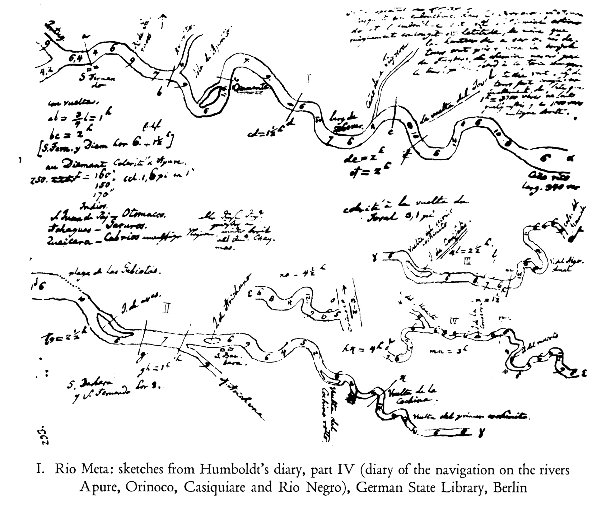 | Units of inquiry & exploration  Leaving Home • Loading the Boats • The Lands, Then and Now • The Animals (and the People) • The Plants • Rocks & Soil • Weather & Water • Stars & Numbers • The Societies & the Outlooks • Languages, Races, Peoples  Selected activities  Inventory of Skills (experiences, interests, communicating, presenting) • Replicate Humboldt’s Research Activities (make your own sextant from a CD and some Lego blocks) • Create a Learning Module • Writing / Speaking in Various Modes (reflective, descriptive, narrative) • In-depth Study of a Humboldt Contemporary • In-depth Study of a Humboldt-named Species (the penguin? the squid? the rare plant on Oahu?) • Learn about a Humboldt-named school • Plan a Humboldt-Themed Learning Garden • maybe swamp (SINQ!) a canoe (appreciate what Humboldt endured, practice numeracy skills)

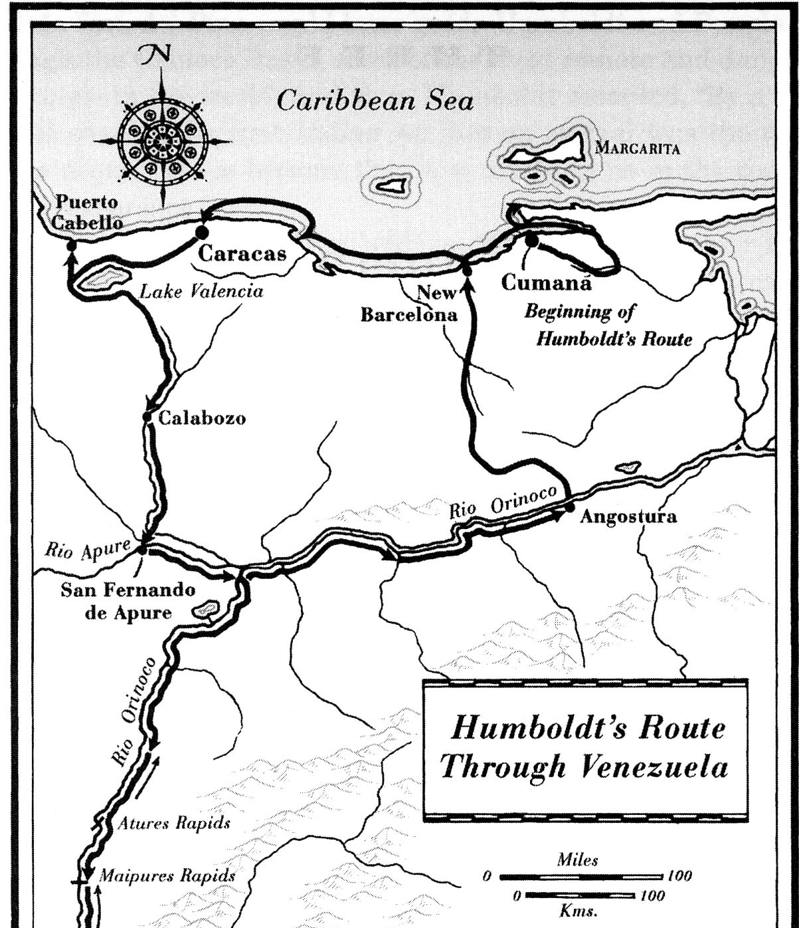 | This SINQ course combines a rigorous scholarly approach with engaged learning that should appeal to participants with varied interests and learning styles. We will use original sources and a recent biography to follow Humboldt’s travels through Central and South America in the early 19th Century. We will see how his explorations and research had an immense effect on both scientists and the general public, in America as well as Europe. We will examine the later impact of Humboldt on land and water use in the American West. And we will see how his work relates to the visual arts, philosophy, and literature.  Required Texts (all available both as print and e-books):  Helferich, Gerard. Humboldt’s Cosmos: Alexander von Humboldt and the Latin American Journey That Changed the Way We See the World.  Humboldt, Alexander. Jaguars and Eels. Translated by Jason Wilson. London: Penguin, 1995/2007.  Stegner, Wallace. Beyond the Hundredth Meridian: John Wesley Powell and the Second Opening of the West
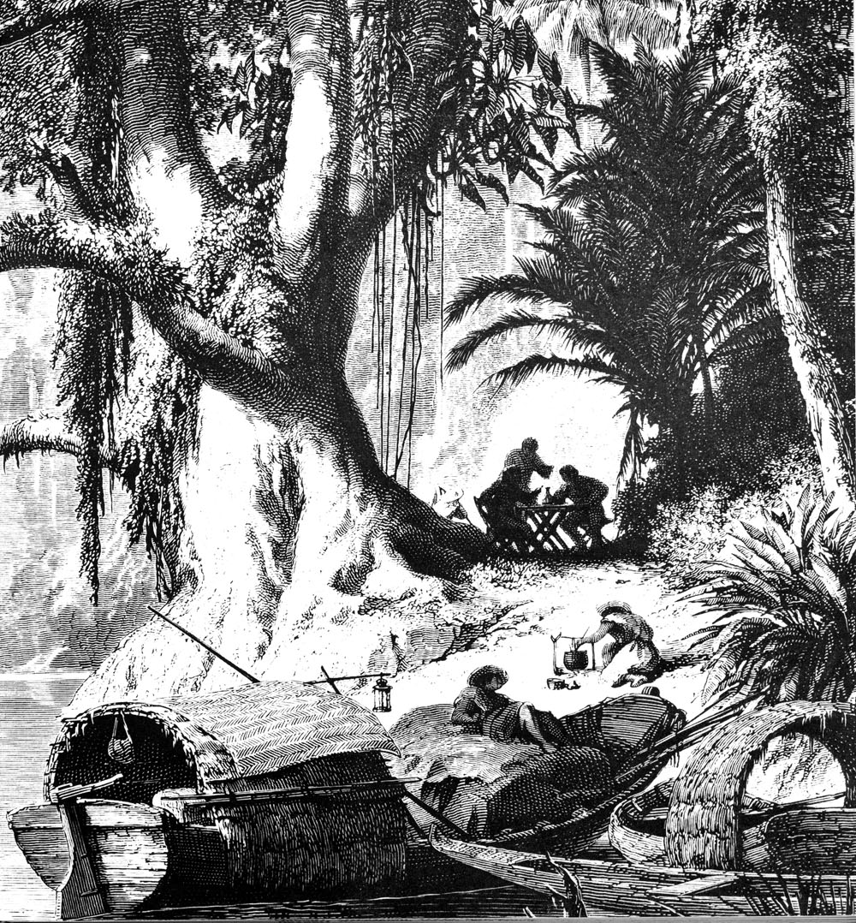 | But we will also take a “hands-on” approach. We will replicate some of Humboldt’s experiences in his travels and activities in his research. We may get a little wet as we see how many students or instructors, or boxes of scientific instruments and specimens, it takes to load a canoe close to SINQing (unless someone in the group has the math skills to figure that out for us – or, better, teach us to do that for ourselves). We’ll learn how to use scientific instruments like those that Humboldt worked with. You may find yourself building a sextant from household items and learning how to determine your latitude by “shooting the sun”. We’ll try our hands at mapping, at sketching, at writing in the forms that Humboldt used: careful description of life-forms, narration of our travels, expression of ecological vision, advocacy of equity.  For a list of schools worldwide that are named for Humboldt, go to:  http://web.pdx.edu/~fischerw/proj_pub/humboldt_project/index.html
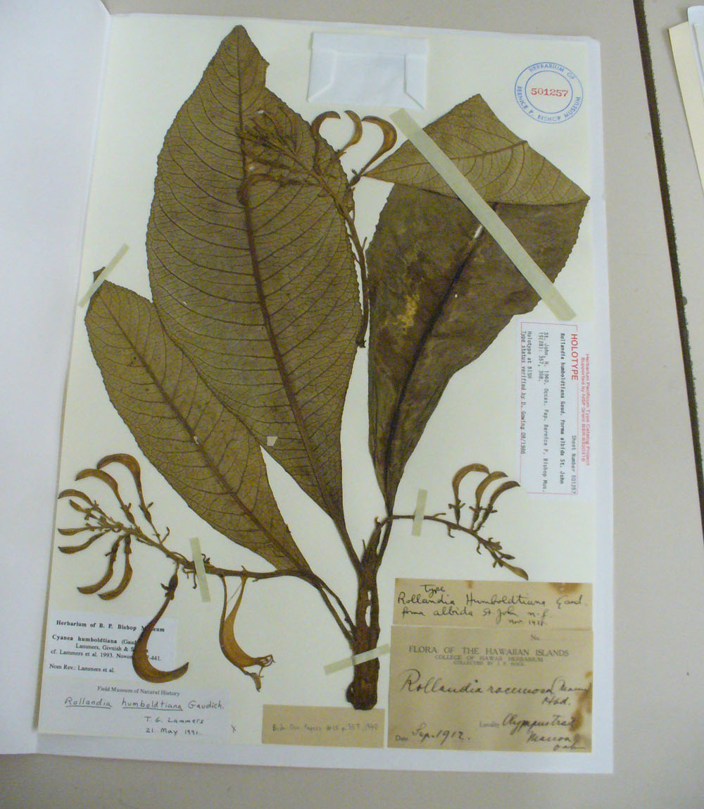 | “Hands-on” will have another meaning, and we’ll give another twist to “inquiry”. The best way to learn something is to teach it, and PSU means “let knowledge serve the city” (or the country, or the world). So we will help others learn: the learners at the many schools in North, Central, and South America that are named for Humboldt. We will create model learning modules that will help those young learners improve their learning by inquiring about the person whose life and work caused his name to be given to their schools. An example: kits (“Humboldt expedition boxes”) of materials about sustainability that would help Portland’s own Humboldt Elementary School, or the elementary, middle and high schools named for him in Nevada, Illinois, Nebraska, New York – or Montreal, Mexico, and Mannheim – celebrate “Earth Day with Alex” this next April, maybe with their own Humboldt-themed learning gardens, or projects that explore Cyanea humboldtiana, a Humboldt-named species in Hawaii that is on the Endangered Species list.  For a list of species that are named for Humboldt, go to:  http://web.pdx.edu/~fischerw/proj_pub/humboldt_project/index.html
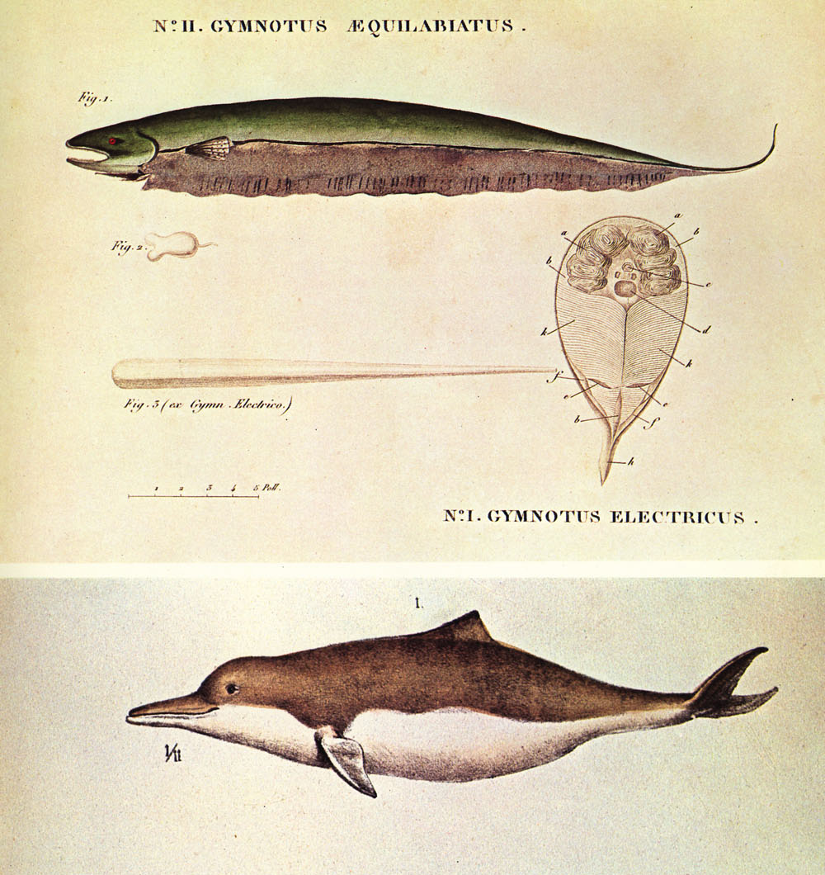 | Beyond the usual “academic” skills and motivation, what you’ll need for this course (or may acquire by taking it) are: willingness to work in groups as well as alone, and to offer the many skills you may have that might not emerge in a more conventional course. Can you draw, take high-quality photographs, or handle graphics software? interact well with younger learners? create a garden? find North during the day? organize a team? plan a grant proposal? perform an indigenous folksong, dance, or craft? help us with statistics, geometry, or trigonometry? steer a canoe? handle some Spanish, French, German, an indigenous American language, or maybe even Latin or Greek? contribute a knowledge of edible plants, environmentally sound food supply, or biological classification? offer some knowledge of environmentalism? go up a climbing wall with one hand while measuring atmosphere pressure with a barometer in the other? read a vernier scale? We’ll find out your talents early on, because we’ll need them. Humboldt had most of that skill set, and a whole lot more. We’ll be OK if we can field a group that can do most of that collectively.

