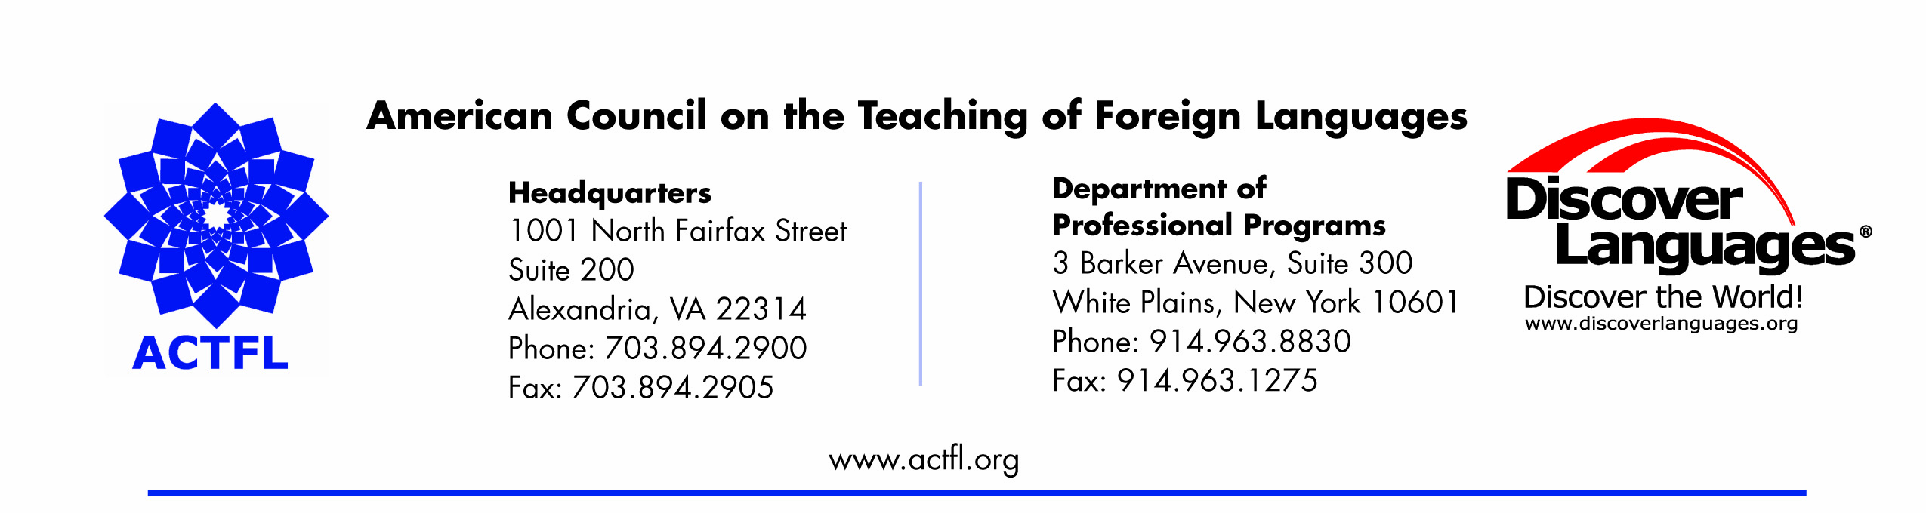
April 30, 2009

Fationa Aliaj
9410 NW 28th CT
Vancouver, WA 98665
H: 360-571-3173
W: 503-725-3528
CL 503-866-7855
e-mail: aliaj@pdx.edu
Language: Albanian

Dear Fationa Aliaj:

Congratulations! You have successfully completed the ACTFL/ILR OPI Tester Training and Qualification Process and have been recommended for qualification in Albanian without reservation. You are one of a very select group of individuals who has demonstrated the ability to administer oral proficiency interviews, and reliability rate according to the ILR Language Descriptors for Speaking.

You are to be commended for a job well done!
- The interviews show completion of all tasks required for the level
- The interviews show a variety of topics, structure and organization

Please follow the feedback below from the ACTFL ILR Review Board:
- Always avoid sensitive topics
- Must demonstrate ability to test a at variety of levels
- The “Can do” and “cannot do” statements need to be improved
- The rating rationale needs to be improved
- Explain the leap of faith in terms of the language elicited in the warm-up
- The plus rating needs to be explained clearly and justified more fully with respect to the term “partial”

We look forward to receiving your signed documents and to welcoming you to the network of Qualified ACTFL/ILR OPI testers.

Sincerely,

Lori Haims Yesenia Olivares
Training and Certification Manager Tester Quality Assurance Coordinator

Please do the following:
- Send the signed Tester Agreement and the Acknowledgement form the attention of Yesenia Olivares
- Make sure that the address above and the phone numbers below are correct:

If your contact information has changed, please notify me immediately.

Thank you!

