Portland State University
Department of Foreign Languages & Literatures

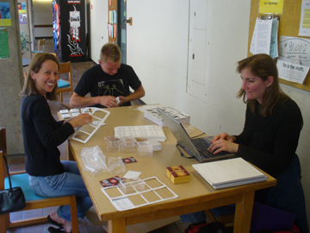 | Methods of  Content-Based Instruction  for  Language Teaching | 

FL 410 CRN 64501 / FL 510 CRN 64502 • Spring Quarter 2010
Tuesdays & Thursdays 4:00 - 5:50 pm
William B. Fischer, Ph.D. • fischerw@pdx.edu • x5285 • web.pdx.edu/~fischerw

What is CBI?
“a philosophical orientation, a methodological system, a syllabus design for a single course, …a framework for an entire program of instruction. CBI implies the total integration of language learning and content learning. It represents a significant departure from traditional foreign language teaching methods in that language proficiency is achieved by shifting the focus of instruction from the learning of language per se to the learning of language through the study of subject matter.”
Stryker & Leaver, Content-Based Instruction in Foreign Language Education, p. 5
“Children learn a language better when they use it to learn something else.” [and maybe adults?]
Curtain & Pesola, Languages and Children: Making the Match

Features of the course:
Seminar-Workshop format
Quick review of basic concepts of language learning and teaching
Survey of CBI courses described in two CBI methods textbooks (one FL, one ESL)
CBI, Team-Based Learning, Problem-Solving Learning, Community-Based Learning
Close study of two PSU CBI-based language courses / projects (“SpeakEasy” student-run business, “Humboldt Project” for K-12 outreach in multiple subject areas)
Language immersion programs in Portland Public Schools
Development of individual classroom lessons, thematic units, course outline
Reflective writing, possibly development of grant proposals

Texts (don’t order yet – details during first week of course):
Content-Based Instruction in Foreign Language Education. Edited by Stephen B. Stryker and Betty Lou Leaver. Washington, DC.: Georgetown UP, 1997 (or newer edition)
and/or
Content-based College ESL Instruction. Loretta F. Kasper et al. Mahwah, New Jersey: Lawrence Erlbaum Associates, 2000.
10-20 journal articles • work samples from earlier versions of course • grant proposals

