FL399 003 CRN 45075 • MWF 15:15-16:20 BHB220 • William B. Fischer, Ph.D.
Reason and Revolution  The Western Enlightenment  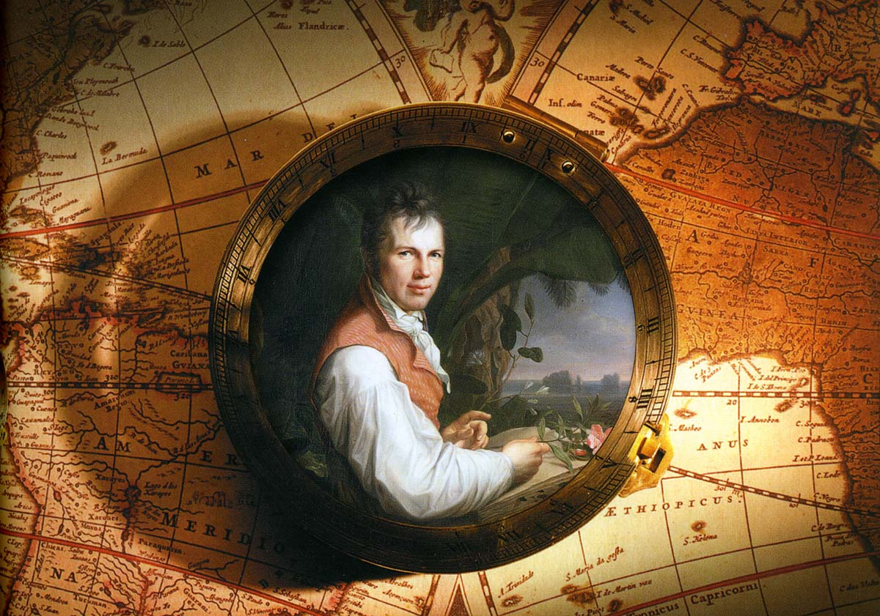 | 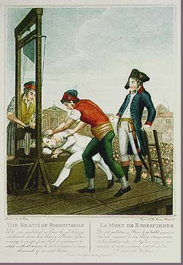
It made our world what it is today, like it or not…
It brought about the division of church and state, religion and science.
It inspired modern democracy… and the authoritarian state.
It championed the Rights of Man… and sometimes the freedom of women.
It opposed slavery… but sometimes supported imperialism and colonialism.
It showed Thomas Jefferson at his best… but trapped him in contradictions – as it will you too!
It produced monumental works of political thought, science, technology, philosophy, literature, art, architecture, and music – along with the dime and the dollar, the guillotine, a couple of major wars, and some new countries, including the one you live in.
readings in core texts of our culture • exploration of the Enlightenment in science and technology, social science, and the arts • job-shadowing Thomas Jefferson in Paris during the French Revolution, and Wilhelm von Humboldt as he explores the Americas • short papers and reports (fact-finding, personal reflection, position-taking) • group project involving community-based and service learning
FL399 is a new course, jointly sponsored by the FLL French and German sections, but open to anyone eligible for 300-level credit. It is conducted in English, but it counts for credit toward the major in French and German, and also in other language areas. Participants with French or German language interests will have the opportunity to use and develop their language skills.
More information: fischerw@pdx.edu • 725-5285 • 451-D NH

