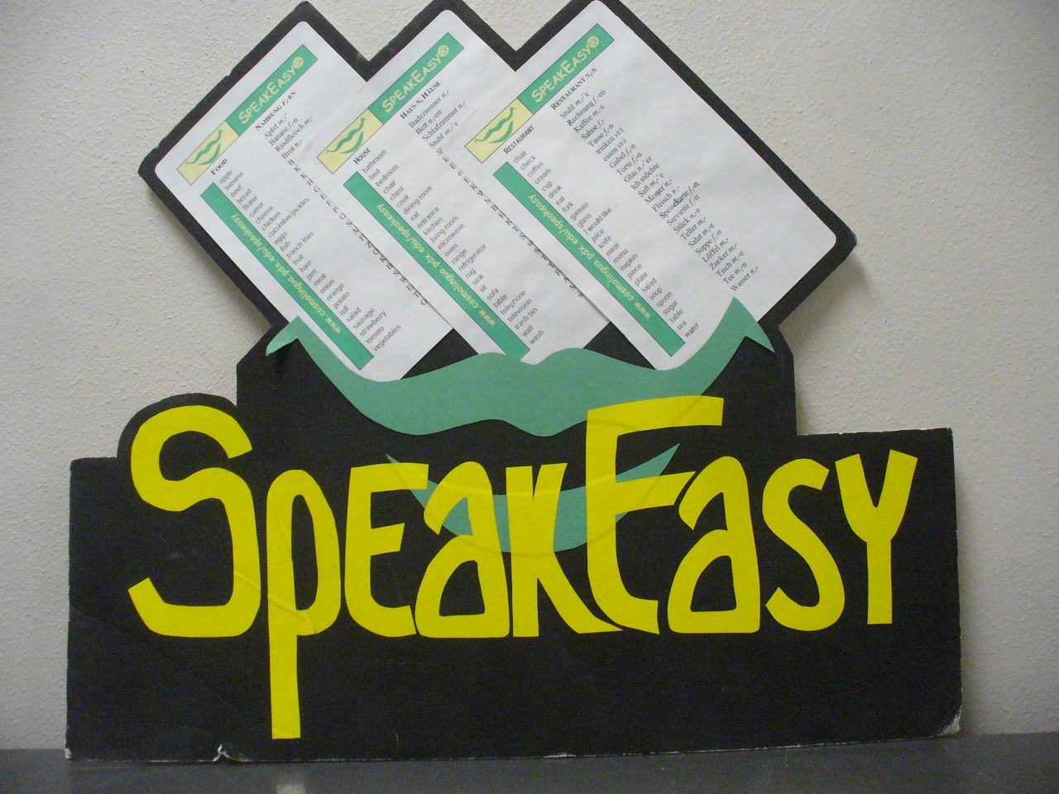
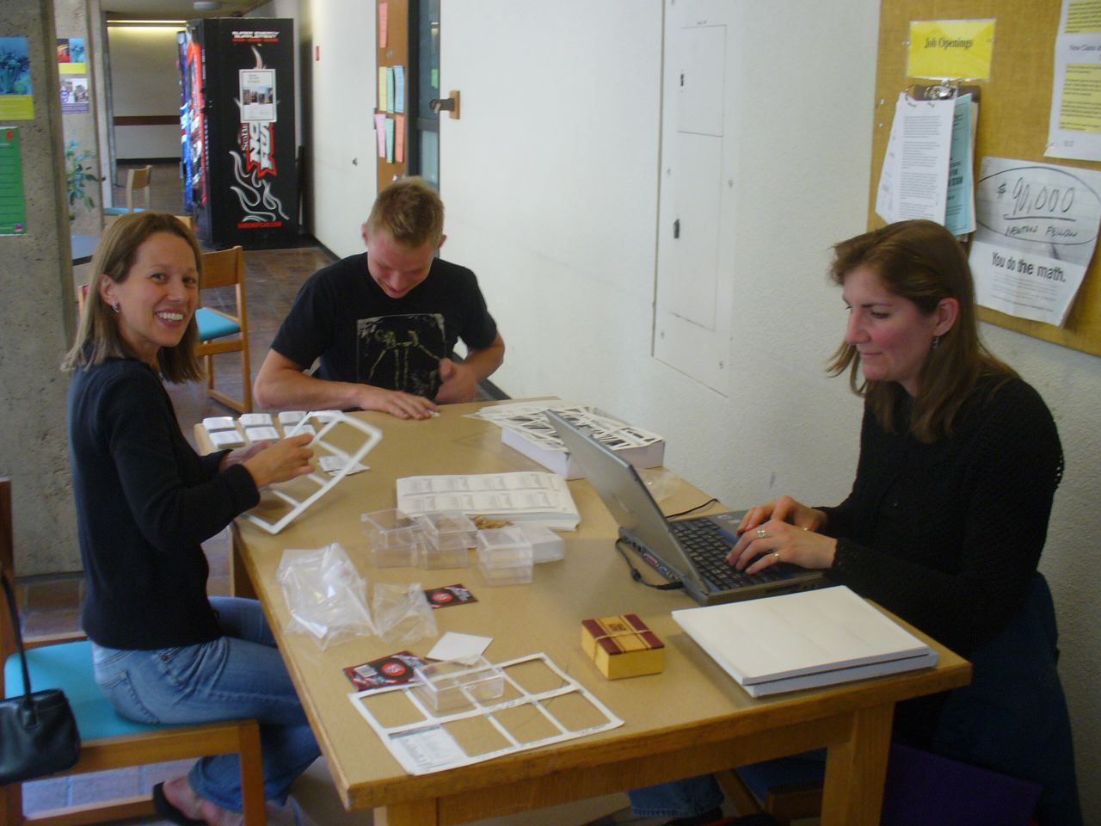
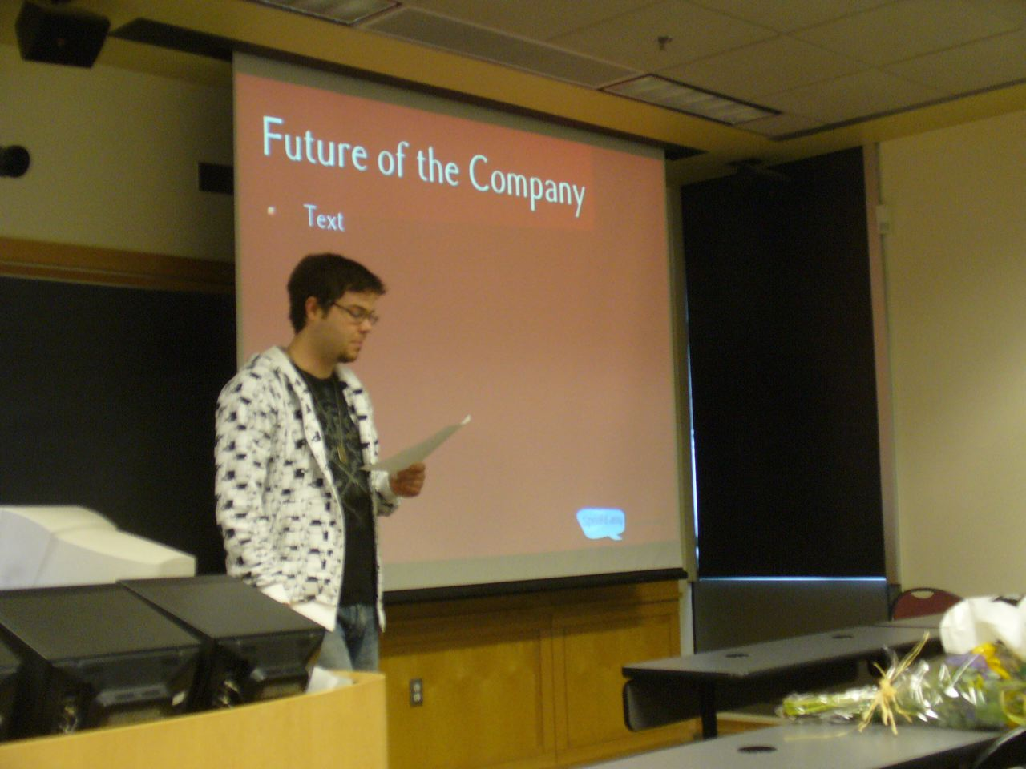
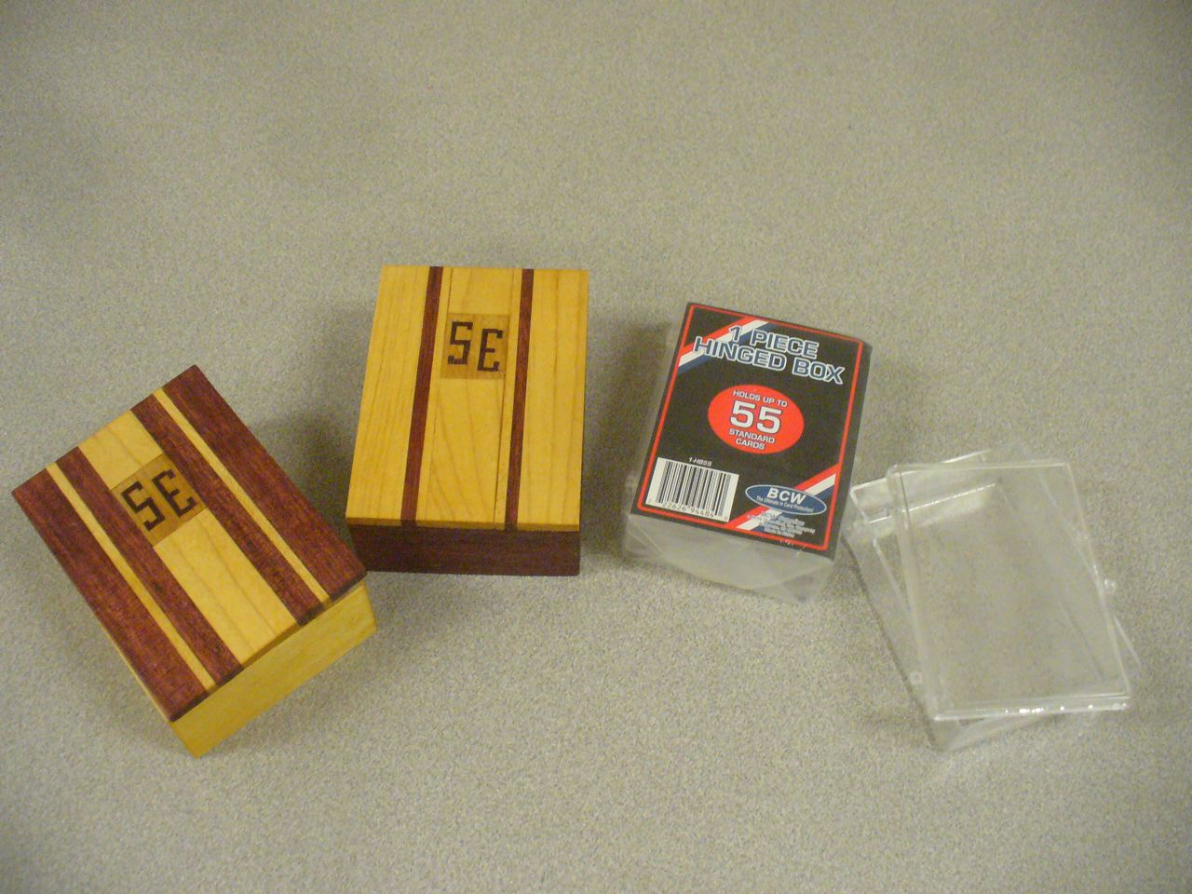
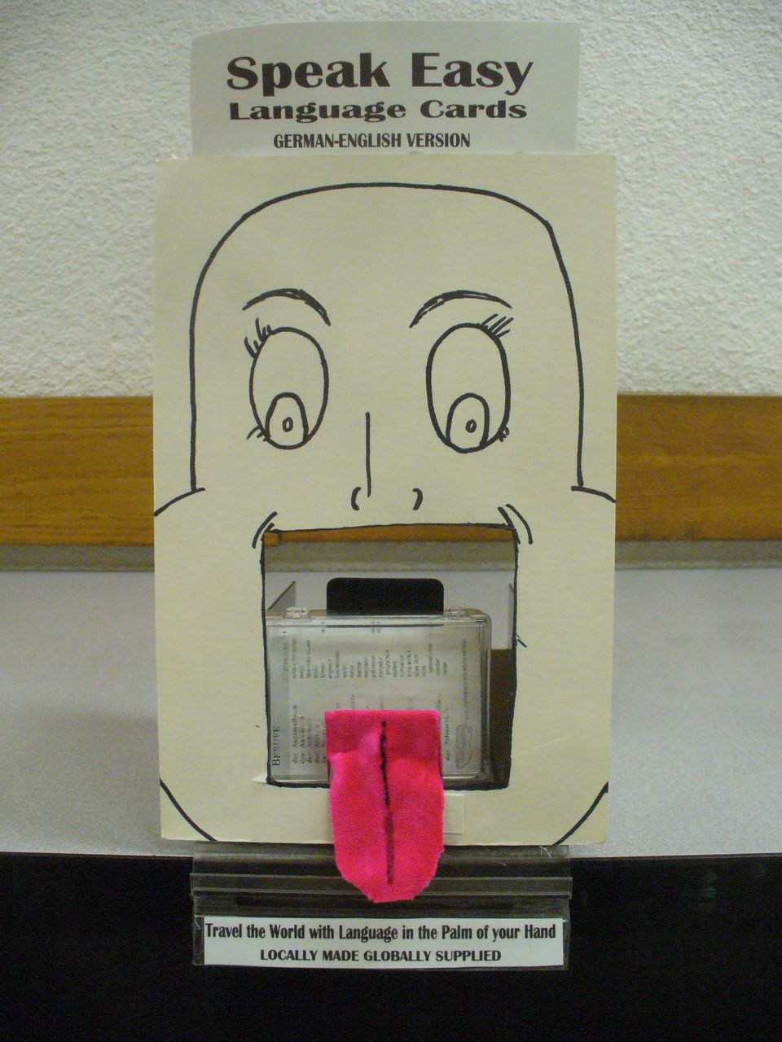
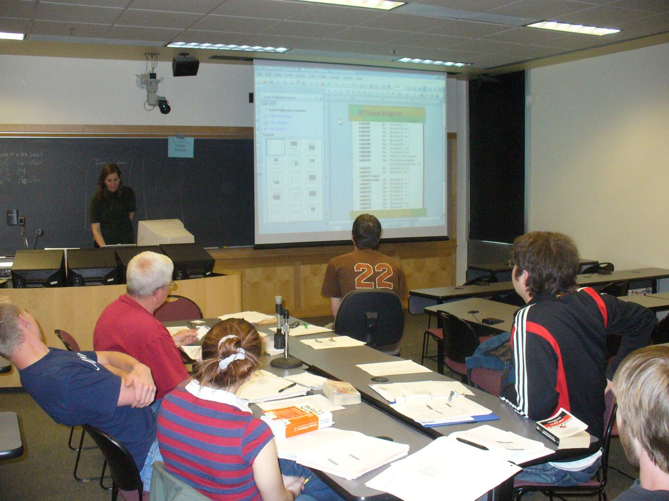
FR 399: French Business Simulation
Practice and improve your French in a real-life business setting!
Come join the brand new French version of SpeakEasyTM, an innovative course that combines language learning with hands-on experience in a student-run startup company!

WINTER TERM 2010, MWF 14:00-15:05
CRN 44825
For more info or to enroll in the course, contact Maggie Elliott: melliott@pdx.edu

Why take it?

- Practical opportunities to use and improve your French both in and outside of class
- Student-centered, team-based learning
- Innovative, creative atmosphere
- Hands-on experience working in a student-run company
- Focus on PSU goals of internationalization, engagement and sustainability
- Your “real world” skills will help the company grow and improve
- Great way to add to your resume!

What is it?
FR 399 is an innovative immersion language class and small business simulation, working in partnership with GER320/415/515. In the course, students will work to develop, produce and market competitive language products. The primary goals of this course are: 1) to improve French skills by using them to carry out “real world” activities; 2) to explore careers related to French and to develop skills for them; 3) to further the goals of SpeakEasyTM and its expansion to French.

