Homework 3: Atmospheric Rivers and the Lake Oroville, CA Dam Crisis of February 2017

Name:
Score: / 18

Background Assignment Begins on Page 5 There are 12 questions total, including bonus.
On February 7, 2017 the main spillway at the Lake Oroville Dam in CA developed major structural issues and became inoperable. Without a usable spillway, the ability of Dam operators to safely drain water from the reservoir became limited.
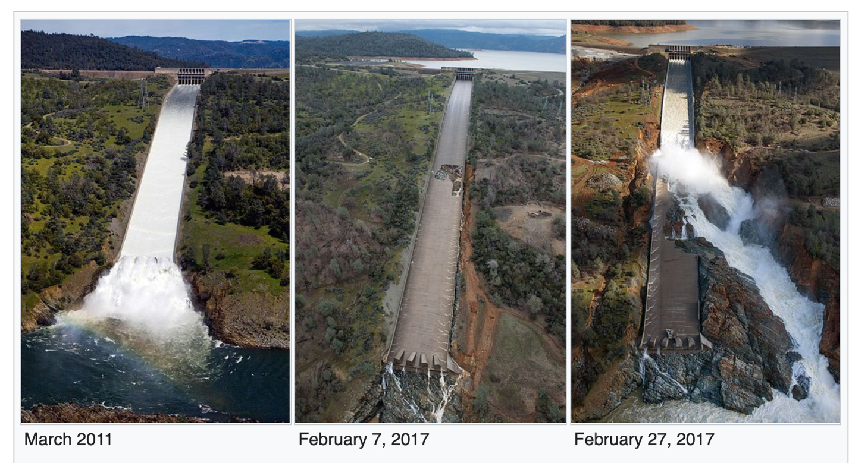
The above three pictures show the main spillway and where it drains into the Feather River. The middle shows the sinkhole that developed in the spillway on February 7, 2017.

Lake Oroville is the second largest reservoir in CA and is impounded by the tallest dam in the US!

During the period February 6-10, 2017 the Feather River Watershed received over 10 inches of precipitation, caused by two nearly overlapping atmospheric rivers (ARs):
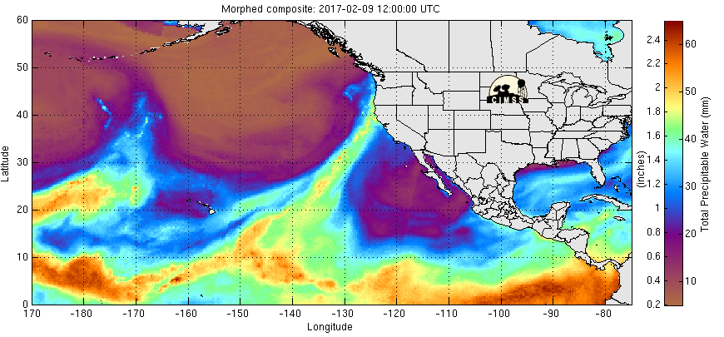
This picture shows the second AR making landfall in Northern CA near 12 UTC on 9 Feb, 2017 by its IWV (mm - same variable as “Total Precipitable Water”) from microwave satellite sensors.
Note that there are areas within the AR where IWV exceeds 50 mm. This is a value not typically seen outside the tropics.

The largescale weather pattern, its extratropical cyclones, fronts and atmospheric river pathways (green arrows) are summarized on the below schematic produced by the California-Nevada River Forecast Center:

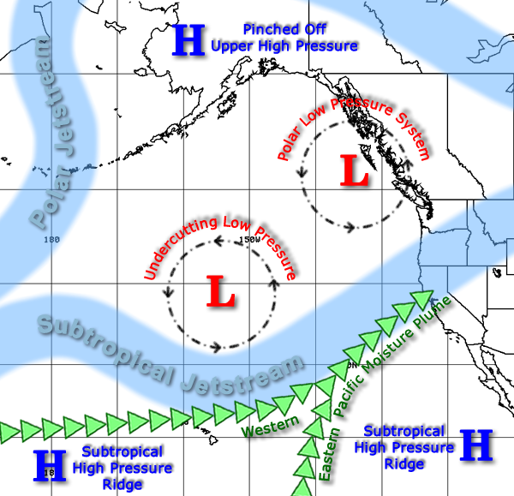

Potential for Dangerous Weather:
The Feather River Watershed is shown in the image below. This entire watershed drains into Lake Oroville behind the dam. The watershed encompasses more than 2 million acres and is a very rugged part of the northern Sierra Nevada mountains. Elevations in the watershed range from approximately 1000 feet to approximately 10,000 feet. The spillway failure coinciding with this powerful AR posed a critical emergency management scenario for the operators of Lake Oroville Dam. When the spillway failed, the level of the reservoir was 848 feet. This is the maximum safe operations level in the wintertime, when extra ‘flood capacity’ space must be kept in the reservoir to prevent floods from reaching the lower Feather River. More than 200,000 residents live downstream of the dam. These residents are in harm’s way if the dam is no longer able to control the amount of water spilling into the river from the reservoir. When the reservoir level is at 848 feet, the available room to store additional water is 750,000 acre-feet (a measure of volume). This means that if all the precipitation falling on the Feather River Watershed were to run-off into the reservoir, just 4.3 inches of precipitation would fill the available room and the reservoir would be over capacity.

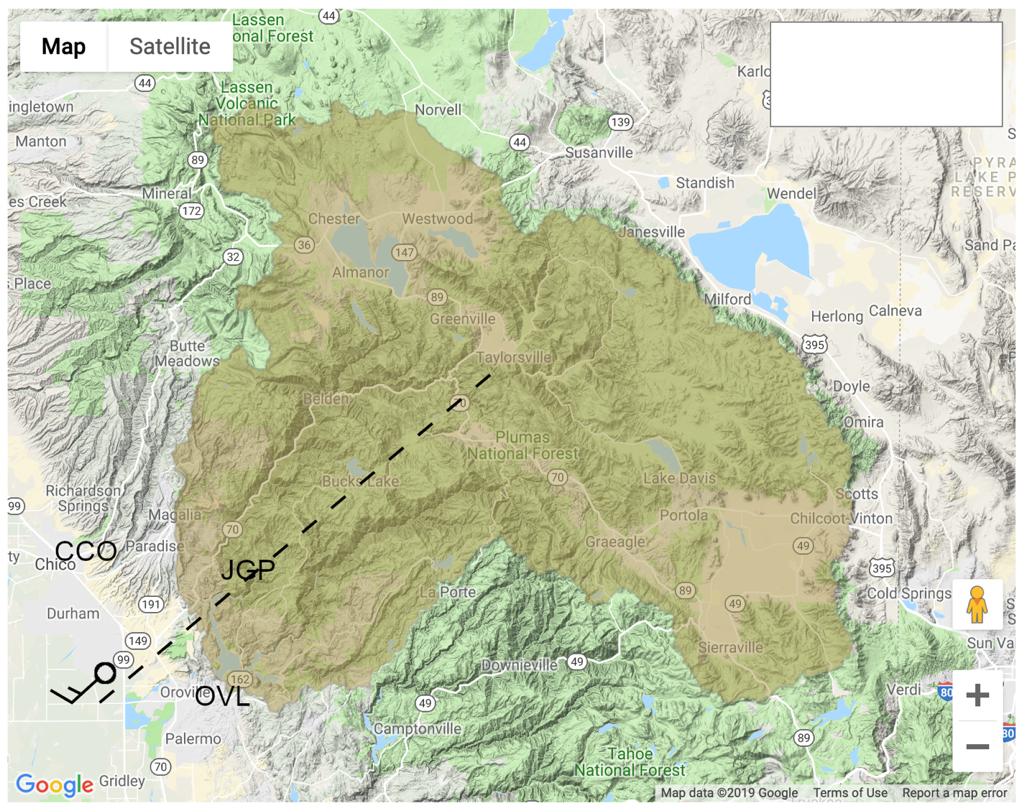
Map of the Feather River Watershed with Lake Oroville and the measurement locations you will use in this assignment. Brown shading shows boundaries of watershed, the reservoir is next to the HWY ‘162’ sign near the SW corner of the watershed. The “upslope” wind for the local mountain range flows along the dashed line from SW to NE. A hypothetical upslope wind barb with speed = 15 knots is depicted just to the south of the town of Durham. See Table 1 for a list of helpful parameters about the Watershed. See Table 2 for a list of instruments and their measured variables.

Table 1
Parameter | Value | Definition
Lake Orovile Flood Space | 750,000 ac-ft | The volume of extra space held in reserve for potential floods created by heavy rain the watershed.
$$A_{W}$$ | 2,048,000 ac | The surface area of the watershed (brown shading)
$$z_{elev}^{top}$$ | 3,000 m | Highest elevation terrain in watershed
$$z_{elev}^{95}$$ | 2,100 m | 95% of the watershed surface is below this elevation. If the rain-snow transition altitude is $z_{elev}^{95}$, $F_{R}=0.95$
$$z_{elev}^{50}$$ | 1,400 m | 50% of the watershed surface is below this elevation. If the rain-snow transition altitude is $z_{elev}^{95}$, $F_{R}=0.5$
$$α_{up}$$ | 225 deg | Upslope wind direction. 225 degrees is directly from the southwest. The hypothetical barb in the watershed map shows wind moving from this direction.

Table 2
Instrument | Location | Measurement
915 MHz wind profiling radar | CCO | Horizontal wind speed and direction (kt) profiles every hour and every 100 m vertically
FMCW precipitation profiling radar | OVL | Vertical location of rain-snow transition (m) if raining
GPS receiver | OVL | IWV (cm)
Hygrometer | OVL | Water vapor mixing ratio (g kg⁻¹)
Rain-gauge | JGP | Accumulated precipitation (inch)

Helpful Formulas:
- $BUF=IWV*\left|u_{ctl}\right|*cos⁡(δ_{wind}- δ_{up})$; Bulk Upslope Flux (AR strength)
- $R_{MAX}=P_{r}*A_{W}*F_{R}$; Maximum potential runoff from watershed. P_{r} is the accumulated rain.

How to Find Wind Direction:
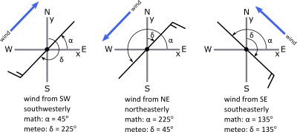
In Meteorology, δ = N = 0º refers to wind blowing from the North (from top of y axis). Directions increase clockwise from there: E = 90º, S = 180º, W = 270º.
Assignment:
- (2 points) Based on our definition of severe weather and the background section above, was the failure of the Oroville Spillway necessary to make this a severe weather event? Why or why not?

Part 1: Analyze the wind-profiling radar during the event to pick out the most problematic periods during this AR.

- Examine Figures 1a and 1b. The top panel of Figure 1a shows a sounding, every hour, of the horizontal winds measured by the 915 MHz radar at Chico, CA. Each horizontal wind measurement is shown using a wind barb, in standard notation, where the speed is in knots (kt). The x-axis is time, increasing from right to left beginning 00 UTC on Feb 6 and ending 00 UTC on Feb 8. The top panel of Figure 1b shows the same information beginning 00 UTC on Feb 8 and ending 00 UTC on Feb 9. Note that you could look at the contiguous time period 00 UTC on Feb 6 through 00 UTC on Feb 10 by placing Fig 1b next to Fig 1a and to its’ left. The middle panels of Fig 1a and Fig 1b show the controlling layer wind speed (kt): $\left|u_{ctl}\right|$, every hour, in brown bars. Note that an IWV measurement is usually also provided at CCO, but for this event the measurement was missing for the duration, so it will not appear in the middle panels. The lower panels of Fig 1a and Fig 1b show measurements from OVL of the water vapor mixing ratio in g kg⁻¹ and IWV in cm in light blue and dark blue, respectively. Each IWV and mixing ratio has its’ own scale located on opposite y-axes. You can assume that all weather conditions at CCO and OVL are identical. Note that if any hour from any figure in this assignment appears to be blank, this means the data was not collected because of an instrument issue.

- (3 points) Based on the definition we gave for an atmospheric river, identify the time the atmospheric river arrived in the Oroville area, identify the break period between the first and second AR, and identify the time of arrival of the second AR. You can use the following thresholds for moisture content and low-level movement of moisture: IWV must exceed 2.0 cm while controlling layer wind exceeds 30 kt. Write your answer in date / time (UTC)

  - AR1 arrival:
  - Interlude period between ARs:
  - AR2 arrival:

- (3 points) Based on our discussion of low-level jets and our definition of the term “jet”, use figures 1a and 1b to identify the periods when low-level jets are present over the CCO radar. You can exclude any periods where controlling layer wind speed does not exceed 30 kt. Write your answer in the same format as in question 3.

- (2 points) When did the strongest low-level jet occur? What non-meteorological event was also occurring during this time that made this timing especially dangerous?

- (3 points) Based on our discussion of the relationship between BUF and precipitation during ARs (July 24 lecture) and the formula for BUF given above, when do you expect the heaviest precipitation to occur in the Feather River Watershed? List the three 6 hour periods during which you expect the heaviest rain. Write your answer in the same format as question 3. Hint: cos (45 deg) = cos (-45 deg) = 0.7.

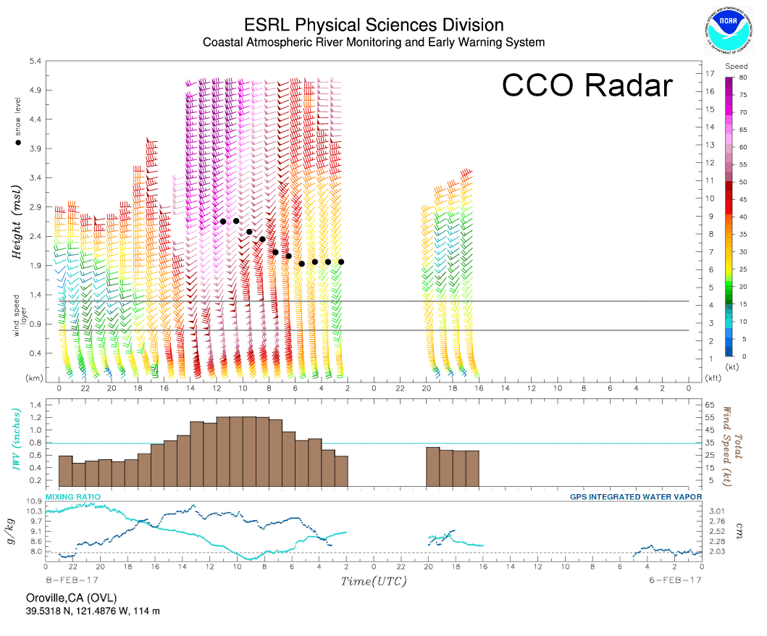
Figure 1a: Top displays the vertical profile of horizontal wind (kt), measured every hour by the 915 MHz wind profiling radar at CCO. The wind barbs are in standard station model notation. The vertical boundaries of the orographic controlling layer for the local mountains is shown by horizontal lines near 1 km altitude. You can ignore the black dots. Middle panel shows the average wind speed in the orographic controlling layer. The bottom panel shows the water vapor mixing ratio (humidity) in g kg⁻¹ and IWV in cm measured at the OVL site. This figure shows the period 00 UTC on 6 Feb, 2017 to 00 UTC on 8 Feb, 2017. Note that time increases from right to left!

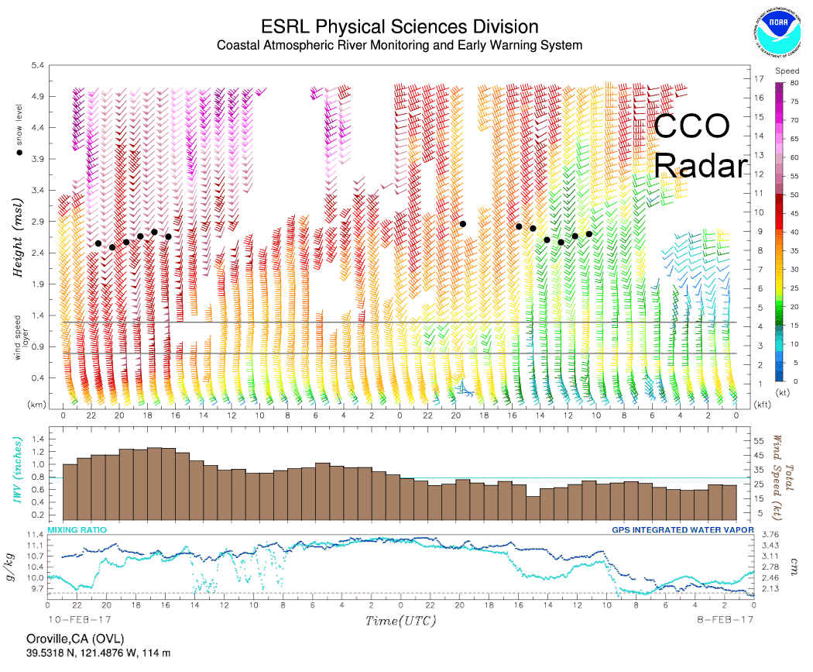
Figure 1b: Top displays the vertical profile of horizontal wind (kt), measured every hour by the 915 MHz wind profiling radar at CCO. The wind barbs are in standard station model notation. The vertical boundaries of the orographic controlling layer for the local mountains is shown by horizontal lines near 1 km altitude. You can ignore the black dots. Middle panel shows the average wind speed in the orographic controlling layer. The bottom panel shows the water vapor mixing ratio (humidity) in g kg⁻¹ and IWV in cm measured at the OVL site. This figure shows the period 00 UTC on 8 Feb, 2017 to 00 UTC on 10 Feb, 2017. Note that time increases from right to left!

Part 2: Analyze the precipitation that occurred and the rain-snow transition elevation to evaluate the risk of exceeding the flood space in Lake Oroville.

- Examine Figure 2. The figure shows the accumulated precipitation (inches) at JGP. The JGP gauge measures precipitation every hour. The location of JGP is shown on the watershed map. You can assume that the precipitation at JGP is representative of the precipitation everywhere in the watershed. Its elevation is approximately 750 m above mean sea level (MSL). Note that the time axis in this figure shows time in local standard time. To translate to UTC, add 8 hours to the value on the x-axis of Figure 2. You will need to do this to compare the rain-gauge measurement to the other measurements!

- Now examine Figures 3a and 3b. Each shows the time-altitude graph of the doppler speed of falling hydrometeors sensed by the precipitation radar at OVL. Falling hydrometeors speed up considerably after melting from snow to rain. Thus, the transition altitude from slowly falling hydrometeors to fast falling hydrometeors is approximately the altitude of transition from rain to snow. The exact location of the rain-snow transition (“snow level”) is shown by black dots. The measurement is impossible if rain is not falling, so there are several missing data periods. Just like with any storm, ARs include periods of light or no rain interspersed with heavy rain. This type of radar is also known as a “snow level radar”. Note time increases from left to right in this figure. This is the opposite direction compared to Figures 1a and 1b. Figure 3a covers the period 00 UTC on 6 Feb, 2017 to 00 UTC on 8 Feb, 2017 and Figure 3b covers the period 00 UTC on 8 Feb, 2017 to 00 UTC on 10 Feb, 2017.

- (4 points) Use Figure 2 to find the 3 six-hour periods (in UTC) of heaviest precipitation. Write down the time boundaries of each period and the accumulation in inches during each period.

- (Bonus: 2 points) Are the periods from question 9 approximately the same as what you wrote down for question 6? If not, what factors does BUF not take into account that may have caused a difference in precipitation in the watershed compared to what you expected?
- (1 point) Use figures 3a and 3b to determine when the largest change in F_{R}, the fraction of the watershed receiving liquid precipitation, will occur. Write the time down in date / time (UTC).

- (Bonus: 2 points) Which periods from question 9 will pose the greatest danger based on the situation at Lake Oroville? Use the equation for maximum potential watershed runoff (R_{MAX}) and the available storage space at the time of spillway damage to inform your answer. Write a sentence or two supporting your logic.

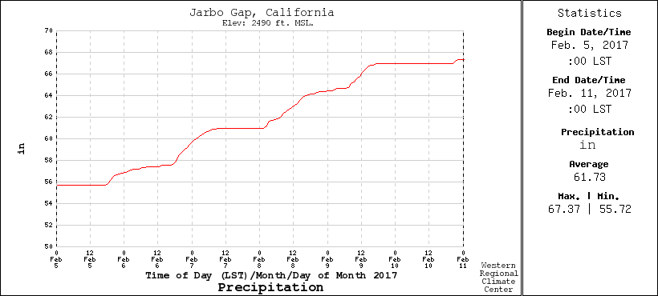
Figure 2: Accumulated precipitation (inches) at the JGP rain-gauge during the period 00 LST on 5 Feb, 2017 through 00 LST on 11 Feb, 2017.

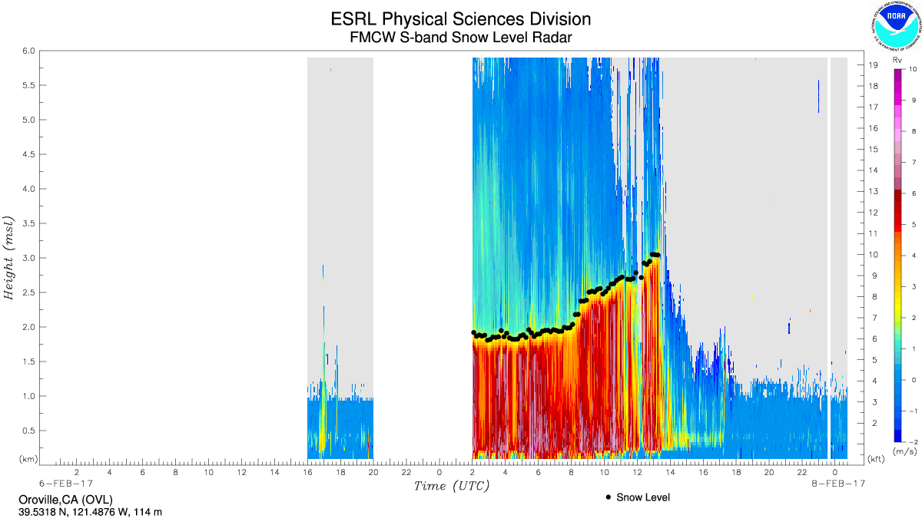
Figure 3a: Snow-level radar figure from OVL during the period 00 UTC on 6 Feb, 2017 to 00 UTC on 8 Feb, 2017. Note time increases from left to right in this figure. This is opposite from Figures 1a and 1b.

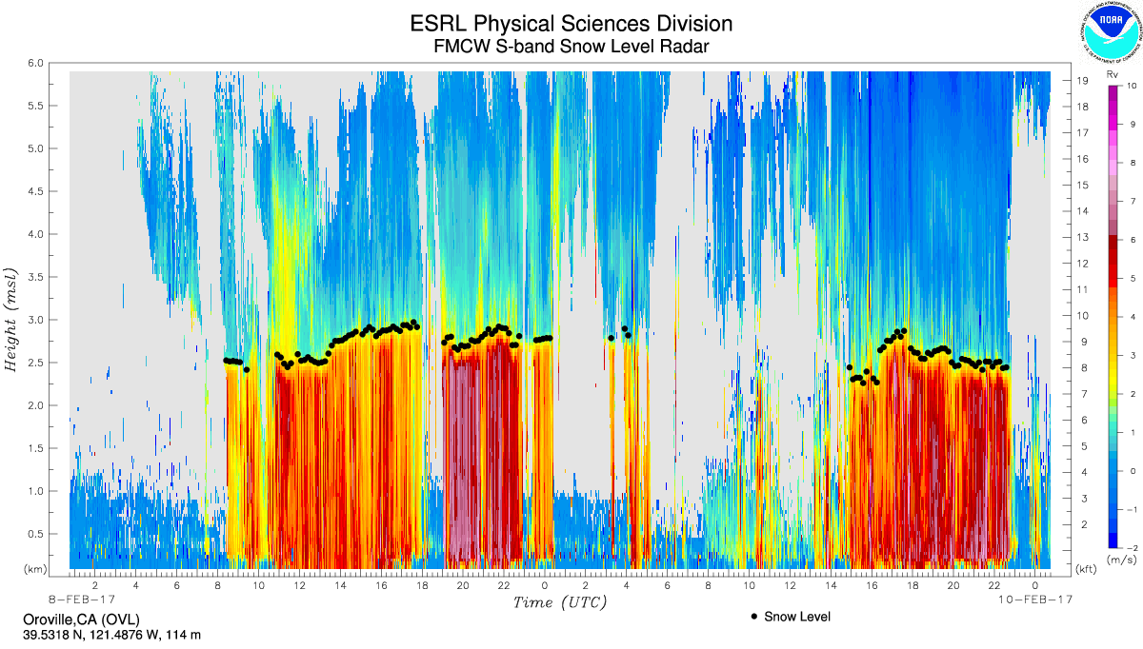
Figure 3b: Snow-level radar figure from OVL during the period 00 UTC on 8 Feb, 2017 to 00 UTC on 10 Feb, 2017. Note time increases from left to right in this figure. This is opposite from Figures 1a and 1b.

