Data Analysis Tool for Microsoft Excel
Before you begin your work, make sure that you have the Analysis ToolPak loaded on your machine. This is an Add-In in Excel. You must have the Data Analysis Tool for this lab and future lab assignments. If you do not have your original Excel CD, then you may have to use the campus or public library’s computers. You may need to access your Excel software disk to add this feature. If the disk is required, you will be prompted to insert it as you follow the steps below.
For Excel 2010:
To see if the ToolPak has already been loaded on your machine, click on the Data tab, Data Analysis should be on the far right side of the ribbon. If not then follow these steps.
1) Select the drop down menu on the top toolbar, then select More Commands.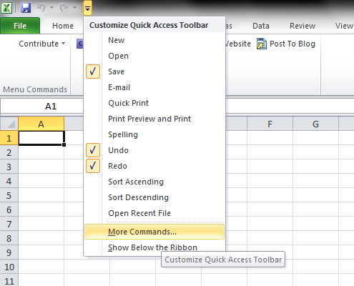
2) Select Add-Ins, select Analysis ToolPak, then select Go…
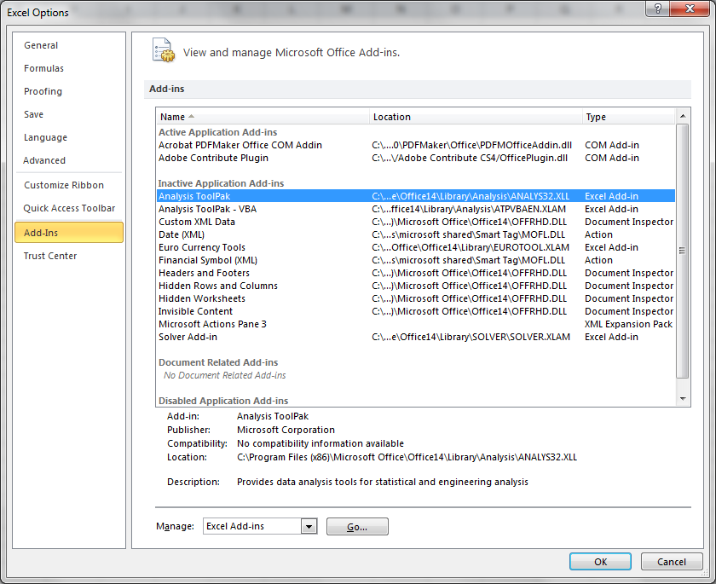

3) Check both the Analysis ToolPak and the Analysis ToolPak – VBA, then select OK.
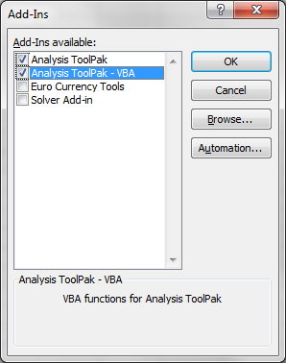
You should now see the Data Analysis Tool under the Data Tab.

For Excel 2007:
To see if the ToolPak has already been loaded on your machine, click on the Data tab, Data Analysis should be on the far right side of the ribbon. If not, follow these steps.
1) Select the Office Button in the top left, then select Excel Options.
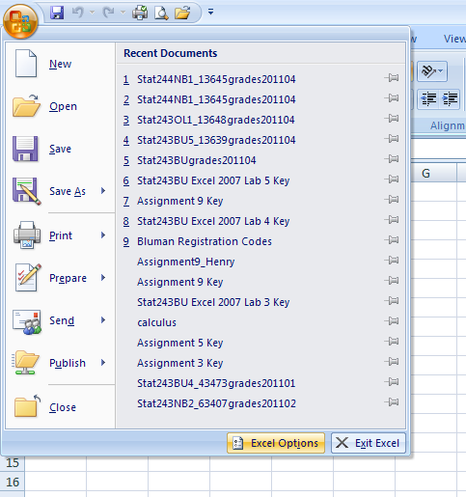
2) Select Add-Ins, select Analysis ToolPak, then select Go…
3) Check both the Analysis ToolPak and the Analysis ToolPak – VBA, then select OK.
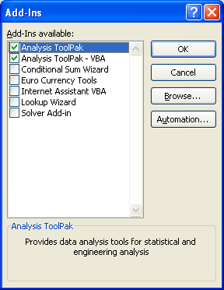
You should now see the Data Analysis Tool under the Data Tab.

For Excel 2003:
To see if the ToolPak has already been loaded on your machine, click on Tools in the menu bar, and see if Data Analysis is listed. If not follow the following steps.
1) Click on Tools, and select Add-Ins.
2) In the Add-Ins dialog box, check Analysis Tool-Pak., as well as Analysis TookPak-VBA.
3) Click on OK. The ToolPak will be loaded, and when you click on Tools you should now see Data Analysis listed at the bottom of the menu.)


