January 9, 2010

The Terrorist Mind: An Update

By Sarah Kershaw
WHAT MOVES PEOPLE TO KILL THEMSELVES AND INNOCENT BYSTANDERS?
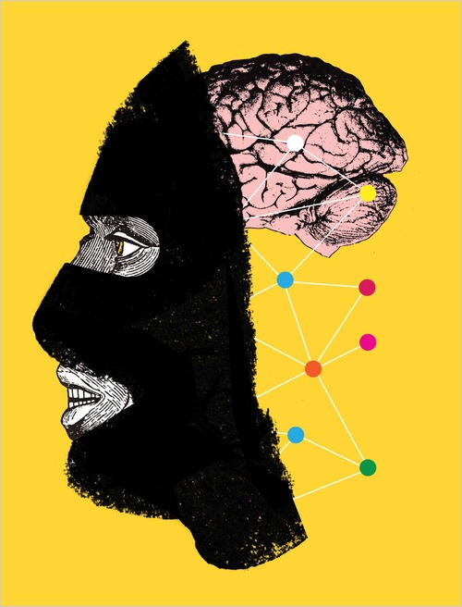
This mystery of the mind became an issue again in recent weeks as a suicide bomber in Afghanistan — a double agent — killed seven C.I.A. officers; a man plowed a truck full of explosives into a crowded playground in Pakistan, and a Nigerian man tried to blow himself up on a plane bound for Detroit on Christmas Day.
Until recently, the psychology of terrorism had been largely theoretical. Finding actual subjects to study was daunting. But access to terrorists has increased and a nascent science is taking shape.
More former terrorists are speaking publicly about their experiences. Tens of thousands of terrorists are in “de-radicalization” programs around the globe, and they are being interviewed, counseled and subjected to psychological testing, offering the chance to collect real data on the subject.
Terrorist propaganda has flooded the Internet and the thinking of sympathizers is widely available. There are entire cable television channels operated by extremists, and researchers have access to the writings and “farewell tapes” of the growing number of suicide bombers as well as the transcripts of terrorism trials.
The new research has its limits. The accounts of the extremists — generally militant Islamists — are difficult to verify. And researchers often differ over the path to radicalization. Some boil it down to religion, others to politics and power, others to an array of psychological and social influences.
But even if the motivations for terror can be wildly idiosyncratic, a range of patterns have been identified.
1. THE PATH TO VIOLENCE
Despite the lack of a single terrorist profile, researchers have largely agreed on the risk factors for involvement. They include what Jerrold M. Post, a professor of psychiatry, political psychology and international affairs at George Washington University, calls “generational transmission” of extremist beliefs, which begins early in life; a strong sense of victimization and alienation; the belief that moral violations by the enemy justify violence in pursuit of a “higher moral condition;” the belief that the terrorists’ ethnic, religious or nationalist group is special and in danger of extinction, and that they lack the political power to effect change without violence.
Research has also shown that some terrorists have a criminal mentality and had previous lives as criminals. Paradoxically, anxiety about death plays a significant role in the indoctrination of terrorists and suicide bombers — unconscious fear of mortality, of leaving no legacy, according to new research.
Many researchers agree that while there is rarely a moment of epiphany, there is typically a trigger of some kind to accelerate radicalization — for example, the politically related killing of a friend or relative.
Ervin Staub, professor emeritus of psychology at the University of Massachusetts who is finishing a book on what drives terrorism and conflict, has identified three types of terrorists. “Idealists” identify with the suffering of some group. “Respondents” react to the experience of their own group. (Perhaps they were raised in a refugee camp or saw relatives killed; they may also be responding to unrelated individual trauma, like child abuse.) Finally, “lost souls” are adrift, isolated and perhaps ostracized, and find purpose with a radical group. Dr. Post said the lost souls are “ripe for the plucking” by recruiters.
Clark McCauley, a professor of psychology at Bryn Mawr College, sees four general trajectories: “revolutionaries,” who are involved in the same cause over time; “wanderers,” who are involved with one extremist group after another, whatever their causes; “converts,” who suddenly break with their past to join an extreme movement; and “compliants,” whose involvement occurs through persuasion by friends, relatives and lovers.
2. LIFE IN THE GROUP
The collective, not the individual, identity has drawn the most attention in recent years. Only in rare cases, like those of the Unabomber, Ted Kaczynski, and the Washington sniper, John Allen Muhammad, have individuals acted on their own, with no connection to a group. (The Unabomber was diagnosed with paranoid schizophrenia, while most terrorist groups weed out the mentally unstable, experts say; they even prefer to select those with higher status for the suicide missions. in the belief that sending those with the most to lose will raise the credibility of their cause.) Most researchers agree that justification for extremist action, whether through religious or secular doctrine, is either developed or greatly intensified by group dynamics.
The Internet has come to play a huge role in increasing the number of jihadi groups, many of them offshoots of larger networks or inspired by Al Qaeda. Dr. Post said the Internet has given rise to what he calls a “virtual community of hatred.”
Marc Sageman, a psychiatrist, former C.I.A. operations officer and Al Qaeda scholar, and others say personality theory does no good in explaining terrorism — and that only an understanding of the group’s impact on the individual illuminates the causes of the phenomenon.
One theory holds that when people are in groups they are more likely to make risky decisions because the risk is perceived as shared and therefore is less frightening. As the group becomes more radical, so does the individual, who is also likely to feel enormous social pressure to agree with the group consensus.
At the same time, the group may provide camaraderie and a sense of significance. The group can become extremely cohesive under isolation and threat. Counterterrorism rhetoric like former President George W. Bush’s description of a planned tactic against Al Qaeda — “to smoke them out and get them running and bring them to justice” — often serves to unify the group. So do invasions and escalations of campaigns against them, which can draw more sympathizers to the group. Most terrorist groups crumble quickly because of internal strife, many experts say. But groups that go underground and are cut off from competing groups and outside opinions develop the most intense bond. With a charismatic leader, an individual’s identity and morality will be subordinated to that of the group.
3. MORAL QUESTIONS
A play by Albert Camus, “The Just,” is sometimes cited in explanations of the moral complexities of terrorism. It tells the true story of the assassination by a revolutionary group in 1905 of a grand duke in Russia. The assassin planned to kill the duke while he was riding alone in a carriage but the duke’s niece and nephew accompanied him. So the assassin went back and killed him when he was alone, having drawn from what John Horgan, director of International Center for the Study of Terrorism at Pennsylvania State University, calls the “internal limits” of terrorists.
For a book published last year, Dr. Horgan collected the accounts of 29 former terrorists, many of them defectors from groups like the Irish Republican Army and Al Qaeda. He found that terrorists must inherently believe that violence against the enemy is not immoral, but that they also have internal limits, which they often do not learn until they are deeply embedded in a group.
Some terrorists who accepted killing off-duty soldiers abhorred the killing of animals. Some are comfortable with only a limited number of casualties. When a key I.R.A. bombing instructor was ordered to shoot a police officer whose mother was a widow, he said he felt he “would have to pay for it.” He went into hiding when the I.R.A. killed a pregnant officer and he overheard his mentor say, “We might get two for the price of one.”
Some interviewed by Dr. Horgan told of becoming disillusioned when other group members stole or robbed banks. It was the stealing that bothered them, not the killing.
David C. Rapoport, professor emeritus of political science at the University of California, Los Angeles, and a longtime expert on terrorism and morality, said that the final common pathway is a moral calculus, driven by the conclusion that the terrorists’ enemies have “done something so bad, so terrible that they can’t get away with it.” Moral quandaries have often splintered groups, or caused them to disband.
If your objective is to create a world in which innocents (the members of your persecuted group) prevail, but you have to kill innocents to get there, you are in essence destroying your own dream, Dr. Rapoport said. Nevertheless, he said, many terrorists believe “the pathway to paradise is straight through hell." And to kill or in any way violate their own personal moral codes, many terrorists must believe they will achieve a higher moral condition for the group or society as a whole.
4. THE SUICIDE BOMBERS
Once a terrorist, it is often difficult to turn back. This is particularly true for prospective suicide bombers. Once assigned to their fatal missions, they become known as “walking martyrs.” Backing down would create too much shame or humiliation.

Fathali M Moghaddam, a professor of psychology at Georgetown University, describes a “staircase to terrorism,” as a way to understand the process of radicalization. The stairs narrow toward the top. It becomes harder to turn back with each step. As with killing, there are varying interpretations among Muslims of Islamic doctrine on suicide. The Koran prohibits suicide, religious scholars say. But some Muslim groups insist that by classifying the bombers as martyrs, their self-destruction becomes permissible because it is a form of self-sacrifice, and because it is honorable to die in battle against infidels. Much new research also ascribes the phenomenon to other motives that are more personal or temporal, including a desire for honor, dedication to a leader, vengeance, peer pressure (first identified as a motivation among the Japanese Kamikaze fighter pilots), and the material support that a terrorist group promises to extend to a martyr’s family after his death.
Arie W. Kruglanski, a professor of psychology at the University of Maryland, College Park, who has studied videotapes of suicide bombers’ final words and interviews with their mothers, argues that the overarching motivation of suicide bombers is the quest for personal significance, the desperate longing for a meaningful life that appears only to come with death.
5. LEAVING TERRORISM
Dr. Horgan has led much of the research into what is known as disengagement — a terrorist’s departure from the organization. He has concluded that terrorists can disengage from violence without abandoning their radical views, and he has also found that some leave after becoming intensely disillusioned with the reality of life in terrorist movements.
The reasons terrorists leave the life provides great insight into how their minds work, and their beliefs may be more subject to change than previously thought, Dr. Horgan said.
Recruits are often promised an exciting, glamorous adventure and a chance to change the world. But what they often find, Dr. Horgan said, is that the groups they join are rife with jealousies and personal competition. Also, the life, is boring. You end up in a safe house drinking tea. For those who maintain an existence outside the group, the pressure of living a double life can be exhausting. Some may, as they grow older, find that their own priorities change — for example, they may want to start a family. They may see that the group’s goals appear unattainable and they may find, as the group becomes more extreme, that they have reached their internal moral limits.
In one case, a former Al Qaeda recruit told Dr. Horgan that when he arrived to fight in Afghanistan, he was dismayed to find that children and the elderly were being forced into battles. The man’s “image of this all-seeing, all-powerful, all-noble movement was receiving its first hard knock,” Dr. Horgan said.

