4 Levels of measurement

Definition of Sampling Error
Definition of Statistical Significance
Nominal (Discrete) – Names are assigned to categories.

Ordinal – Categories can be ranked (1st, 2nd, 3rd).

Interval – Differences can be meaningfully compared, but no 0 on the scale.

Ratio – Meaningful ratios between pairs of numbers
The variation that is caused by chance and measuring problems.
A result is called 'statistically significant' if it is unlikely to have occurred by chance.
Experimental Data vs. Non-Experimental Data
Definition of Spurious Relationships
experimental controls vs. statistical controls
When looking at reported findings we should verify this distinction:
▪ How the data was collected, by observation or through experimental design?
▪ Remember the experimental design could be good but if poorly implemented our data may be less reliable
▪ Beware of spurious relationships = a relationship that is not causal
Spurious relationships = a relationship that is not causal
Experimental Control – A research method where variables are isolated in order to make a conclusion. For example, using a control group in a research study.

Statistical Control – Using statistical methods to “control for” variables, such as multiple regression.
Statistical terminology for describing relationships:
o independent vs. statistically related
Statistical terminology for describing relationships:
o monotonic vs. non-monotonic,
Statistical terminology for describing relationships:
o interactive vs. additive
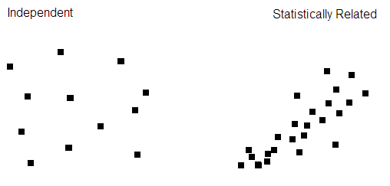
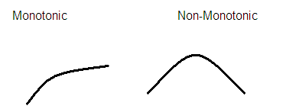
Additive – When independent variable are completely separate from the other independent variables. Whatever the effects of the different independent variables are, they just add up or accumulate in a simple way. We call this additive effects, i.e. no interaction.

Interactive - The effect of one independent variable(s) on the dependent variable depends on the value of another independent variable(s). For example, drug interactions. One drug may do X, and another may do Y, but together, they do Z (not X+Y)
Describe the T-Test for Difference in Means
How do you interpret a T-Test for difference in Means from SPSS?
Terminology for Describing Statistical Relationships
The t-test for the difference in means is an hypothesis test that tests the null hypothesis that the means for both groups are equal, versus the alternative hypothesis that the means are not equal (2-tail) or that the mean for one of the groups is larger than the mean for the other group (1-tail).

To interpret the t-test results, all you need to find on the output is the p-value for the test. To do an hypothesis test at a specific alpha (significance) level, just compare the p-value on the output (labeled as a “Sig.” value on the SPSS output) to the chosen alpha level. Alternatively, you could just report the p-value, rather than reporting whether the result is statistically significant or not at an arbitrary alpha level(s).
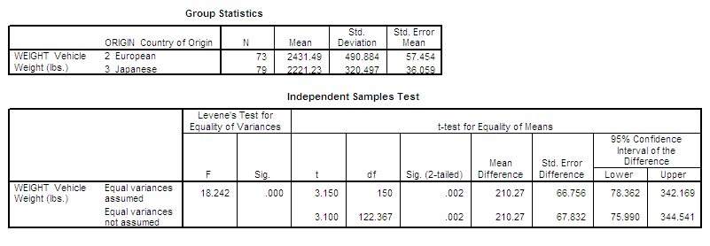
The p-value for the hypothesis test for the difference in means is in the column labeled “Sig. (2-tailed)” in the “t-test for Equality of Means” section, and in the second row (labeled “Equal variances not assumed”). In this case, the p-value for a 2-tailed test is .002 (.001 for a 1-tailed test), meaning that the differences in means is significant.
o independent vs. statistically related
o strong vs. weak
o positive vs. negative
o linear vs. non-linear, General Linear Model
o monotonic vs. non-monotonic
o interactive vs. additive
Statistical Interaction exercise
When would you use each statistical Tests For Simple Tables:

Chi-Square for Crosstabulation, T-Test for Difference in Means, Analysis of Variance (ANOVA) for Difference in Three or More Means
Controlling for a Third Variable in Crosstabulation and Comparison of Means Tables
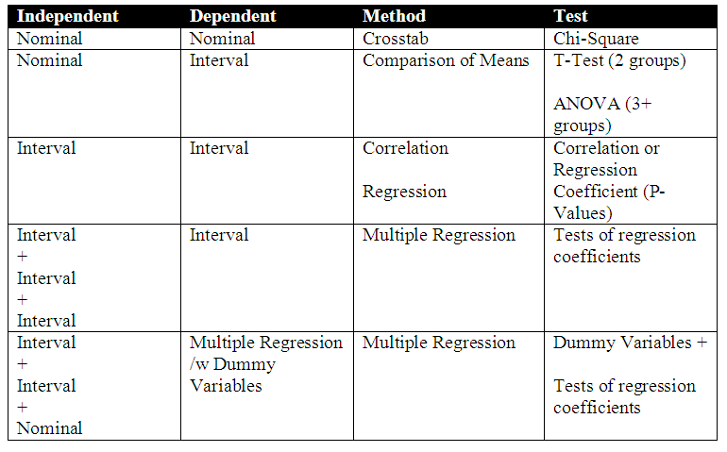
Help on Crosstabulation, Controlling for a Third Variable, and other Analytic Methods, Using the Bowling Alone data
What are the “rules” for crosstab tables?
Describe the chi-squared statistic
1. Make the dependent variable the row variable.
2. Make the independent variable the column variable.
3. Calculate column percents.
4. Compare percentages across the columns.
Describe the concept of correlation
Interpret a pearson correlation
When would you use a rank-order (gamma) correlation
(not done often in the real-world, as peearson correlations do it just as well).

You would use this when your data is Ordinal.
How would you estimate correlation from a scattergram?
o correlation analysis: how to apply in an example like the Portland City Auditor’s 1987 PPB “Patrol Staffing and Deployment Practices” audit
Causal Model Example
Estimate should be between -1 and 1.

Make it positive if it is going “up” from left-to-right, negative if it is going “down”.

If it has a good “fit” to a line, and the slope is steep, make it a bigger absolute number. Otherwise a smaller absolute number.
Got this using correlations:
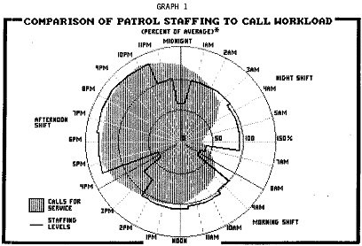
Example: Model whereby federal for local transit agency money leads to increased wages and therefore higher costs, lower productivity and therefore higher costs, and higher costs directly due to graft. In this model, there are 3 formulas, with 1-2 independent variables, plus lots of “control” variables that are not shown.When running the regression coefficiencts from multiple regression, we can just insert the results of the formulas right onto the chart, like this:
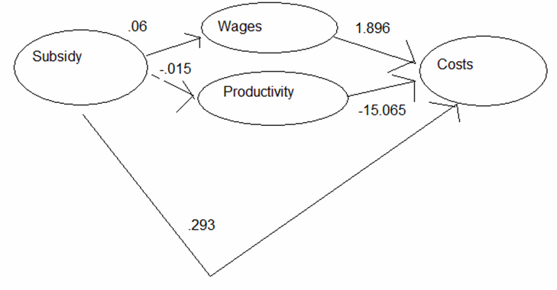
Describe an ANOVA test
Describe a Chi-Square Test
Describe a T-Test for Difference in Means
The ANOVA test is a test of the null hypothesis that the means of all of the groups are equal, versus the alternative hypothesis that the means are not all equal. The type of ANOVA test we are doing is the simplest ANOVA test, and it is just a generalization of the t-test of difference in means of two groups to the situation in which we have three or more groups. You can think of the two-group situation, in which we apply the t-test for the difference in two means, as a specific case of the more general ANOVA test. (Techie Tidbit: If you square the t-statistic in that special case you will get the F-statistic used in ANOVA.) This type of ANOVA test is called a "One-Way ANOVA", since there is one independent variable. The term "Analysis of Variance" confuses people; when you hear this term, try thinking to yourself "Analysis of Means" instead, and that may help you keep clear that the ANOVA test is a test of the difference in means.
The Chi-Square test is a test of the null hypothesis that the two variables are not related, versus the alternative hypothesis that the two variables are related.
The t-test for the difference in means is a test of the null hypothesis that the means for the two groups are equal, versus the alternative hypothesis that the means for the two groups are not equal (two-tail test) or that the mean for one group is higher than for the other group (one-tail test). Note: The t-test for difference in means can be directional (one-tail) or non-directional (two-tail), whereas the Chi-Square test and the ANOVA test are always non-directional.
How would you interpret a chi-square statistic?
What is the formula for a simple regression coefficient?
How do you read regression SPSS output?
A chi-squared statistic is a test of the null hypothesis that the independent variable is not related to the dependent variable. The resulting p-values for chi-squared tests of relevant demographic variables may be examined and used as a macro-level indicator as-to whether an observed relationship could be due to chance/error. You could compare the statistic to commonly-used significance levels (.05) to determine whether a relationship was statistically significant.

(note that this significance does not denote whether the relationship is important or the strength of such a relationship):
y = a + bx

Regression Equation. A line is defined by the equation Y=a+bx. The Y variable can be expressed in terms of a
- Constant / intercept (a)
- slope / regression coefficient (b)

Example:
Main = $50 + .03•Miles

Where:
• Main = maintenance costs for the past year in $
• Miles = miles driven during the past year
• Data are for cars in a city motor pool

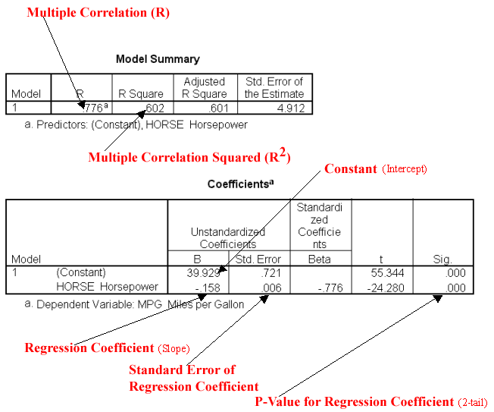
When would you use regression?

When would you not use regression? How would you critique it?
How would you interpret multiple regression output?
How do you conduct a confidence interval for a regression coefficient?
We can estimate the least squares line, but does using the resulting equation make sense?

For Prediction, use it if it predicts well.

For Explanatory (Causal Analysis) Purposes, we need:
• Sensible Model Specification:
• Variables included
• Linearity
• Causal Direction
• Reasonable Measures
Read left-to-right, “controlling for…”

Example:

Income = 5668 + 432·Educ +281·Seniority

Where:
- Income = annual income in $
- Educ = years of education
- Seniority = years of seniority on the job
- Data are for a sample of workers
You multiply the standard error times your z value (e.g., 1.96).

Computer Output: b = 22 se(b) = 10 n = 3000

Example: In constructing a 95% CI for B, you would take the standard error of (10)(1.96)=19.6

B = 22 +/- 19.6
When would you use a dummy variable?

How many dummy variables do you need?
Predictive power/accuracy:
o R,
o R2,
o % var. explained,
o SE of estimate
What are the components of total variation in a regression model?
When you have a nominal-level variable that you want to include as an an independent variable in a regression.

You need 1 less than the total number of categories. For example, if you have 10 categories, you need 9 dummy variables. The other variable is your reference variable, which is what you are comparing the output to on the equation.
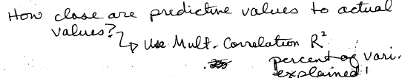
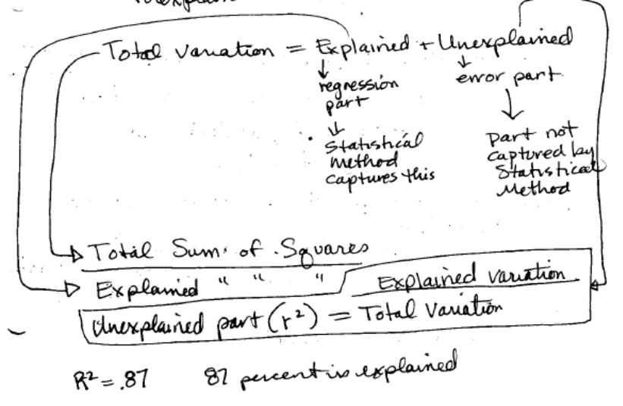
Describe R²
Describe R
How could you critique how any model (such as a multiple regression equation) is specificed?
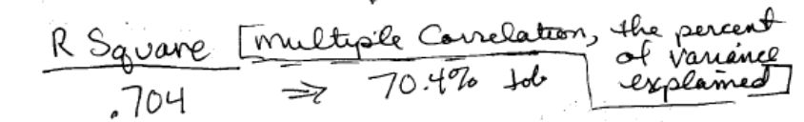
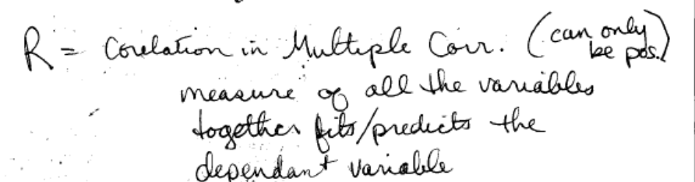

? I believe that R is the Pearson correlation coefficient.
What was left out?

What was included?

Did they get the direction of causality mixed up?

Are there logical errors (e.g, date of birth and age).

How good are the variables they used as measures of the variables you want?
Multicollinearity
3 Components of a Time Series
How do you make a trend component of a time series work better for predictive value?
Are independent variables correlated?

Can be logical (date of birth & age)

Or due to some other relationship.
3 Components of a Time Series
- Trend
- Cycle (seasonal component)
- Random component

The trend component can help make a forecast. But the random component makes it more difficult! Therefore, if you could get rid of the random component, then your forecast would be better! This is done using smoothing techniques.
→ A 3-period moving average provides some smoothing. A 5-period moving average provides even more smoothing!
- With time-series historical data, you can compute a centered moving average, using past and future time-series data.
- But with data up-to the current, you can only computer a non-centered moving average based on past data, used for indicating a change of trends (especially using two moving averages of different periods).

Can regression be used for forecasting?
What is stepwise multiple regression?
What are two methods of forecasting?
Can regression be used in forecasting? YES!
- Regression is used a lot, and can work very well, for forecasting.
- It can be this simple: We can just fit a line to the time series.

You would still need to address cycles through the use of dummy variables. For example, if your observations are for 4 quarters, then you would create 3 dummy variables and compare to the 4th (reference category).

The computer selects the independent variables to include in the model using an algorithm.
1) Forecasting by analyzing the series itself, perhaps by using regression to represent the trend and cycles

2) Forecasting by predicting the series using other variables that are logically related, perhaps by using multiple regression
What are the options for using moving averages when working with time-series data?
- With time-series historical data, you can compute a centered moving average

- But with data up-to the current, you can only computer a non-centered moving average based on past data, used for indicating a change of trends (especially using two moving averages of different periods).

