“Quantum-classical hybrid” interpretations of Quantum Numbers

we make connections to the Bohr model wherever possible

– but, be very carefully

no definitive values for r , φ, θ can be given, there is no paths the electron could follow, but only probabilities for finding the electron at various locations – because “the movements of the electron” and the electron itself is described by a wave function

this wave function is time independent, remember we solved the time independent Schrödinger equation, so kind of “the electron in the hydrogen atom does not change with time”, if it is in one particular quantum state

different locations have different probabilities of finding the particle there, as usual

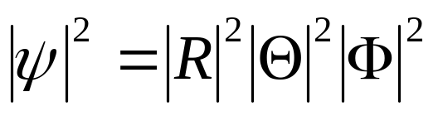

so we can look at the component wave functions R, Θ, and Φ and their squares to get some semi-classical insight into the inner workings of this atom, put some meaning to the quantum numbers that are connected with these component functions and some meaning to the interconnection between the quantum numbers that result
Principal Quantum Number – determines energy level in a first approximation

according to Bohr’s semi-quantum mechanical model
(which has two classical particles, J.J. Thompson’s electron and Lord Rutherford’s core proton), the electron goes around the proton only in certain orbits, at certain distances, where its angular momentum is a multiple of 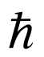 and, thus, its energy has a constant and time independent value

– all other possible orbits are instable and do, therefore, not exist in an atom (and other atoms) that is stable

so Bohr arrived at a quantum number and this explained many (but not all) features in emission and absorption spectra (and he derived the correspondence principle)
so there are energy levels 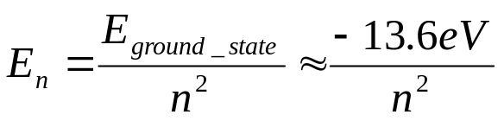
n is the characteristic quantum number (principal quantum number) of these energy levels, in both Schrödinger’s and Bohr’s model

the whole theory of planetary motion with all moons and satellites can also be worked out from Schrödinger’s equation (in the relativistic formulation by Paul Dirac) and yields also conservation and quantization of energy and angular momentum for very very large quantum numbers) it is a solution for large quantum numbers, an example of the correspondence principle at work
so in summary, both energy (a scalar) and angular momentum (a vector) are quantized and conserved
what is actually angular momentum?
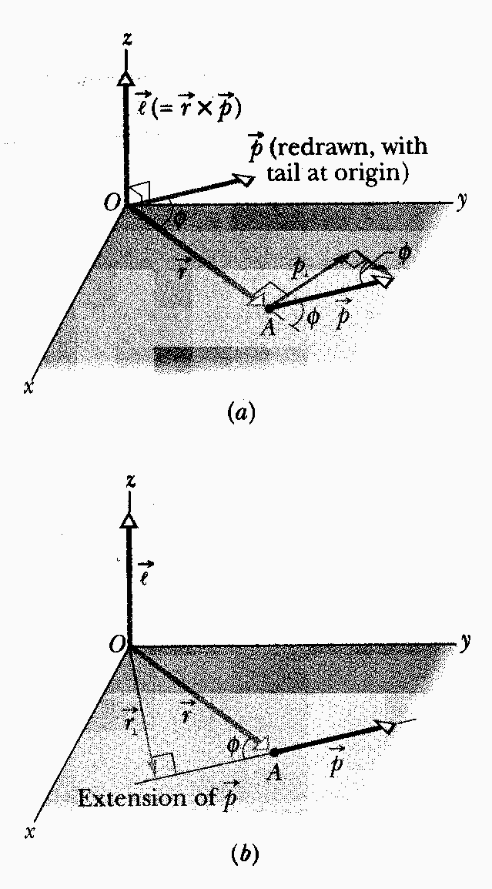
anything moving around any arbitrarily chosen axis has angular momentum

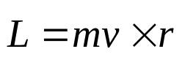

vectors v and r are always in a plane,
vector L is always perpendicular to that plane

magnitude of L vector, due to cross product, is mv r sin (v,r), i.e. an area

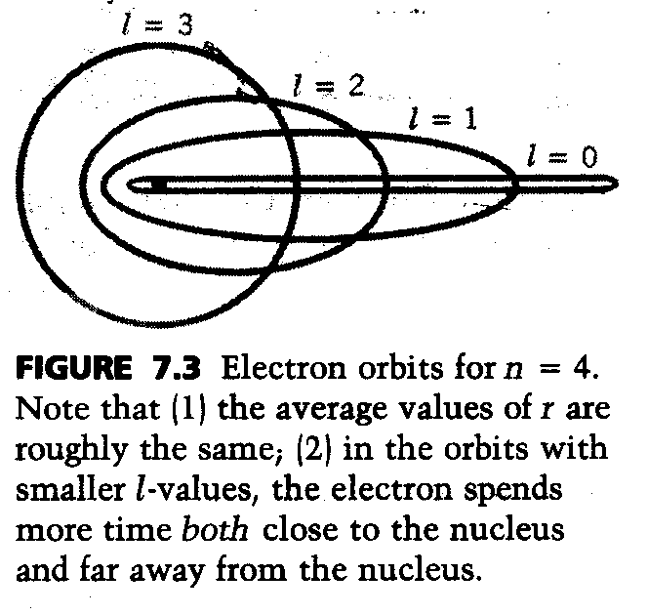
very very importantly, angular momentum in nature is always conserved
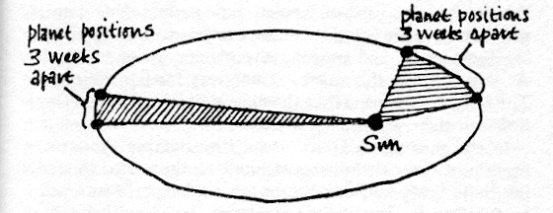
Drawing by R.P. Feynman, Nature of Physical Law, representing Kepler’s 2nd law, a planet going around the sun sweeps out equal areas in equal time, consequence if it is further away from the sun, radius vector is larger it goes slower, if it is closer it goes faster, which is nothing else than angular momentum is conserved

which is nothing else than conservation of angular momentum,
for highest angular momentum quantum number (l), i.e. highest angular momentum 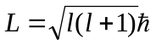 that goes with any principal quantum number (n) we have circles, then we have ellipses, for l = 0 we have a completely flattened ellipse that goes through the nucleus, this will be later called an s state

Orbital Quantum Number – magnitude of angular momentum

differential equation for radial part R(r) of wave function 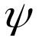

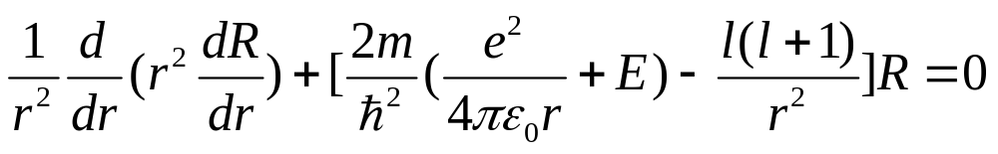

it is only about the radial aspect of the electron’s “motion”, of motion towards or away from the proton

E = total energy is in the equation, so it must consist of three parts, radial kinetic energy (although it is not “moving” racially), orbital kinetic energy – because it is “moving” in an orbit !!!, and potential energy

that potential energy being electrostatic:

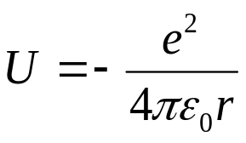 is negative as it is about bound states

so we can write
E = KE_{radial} + KE_{orbital} -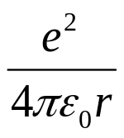 and put this into the differential equation above, and do some rearrangements

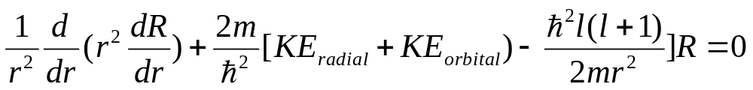
under (the entire realistic condition) that the last two terms in the square brackets cancel each other out for special cases), we have what we want for our interpretation, a differential equation for R(r) that involves functions of radius vector r only, i.e. we would have R(r) and KE(r)

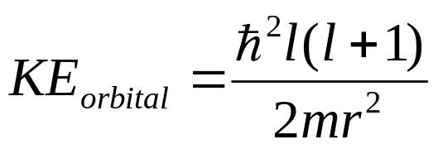

we have two classical (non relativistic) equations that are also valid for KE_{orbital} and angular momentum (L)

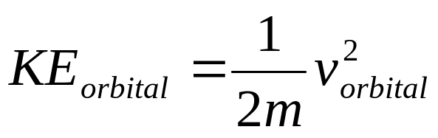

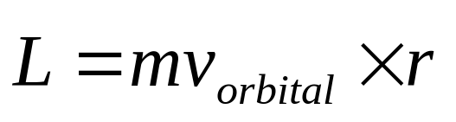 (orbital also tangential as we consider a circle, orbital velocity and r are perpendicular to each other reducing the vector product to v r sin α, and we obtain for the magnitude of the angular momentum vector )

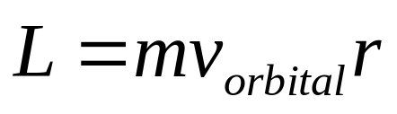

so we can rewrite

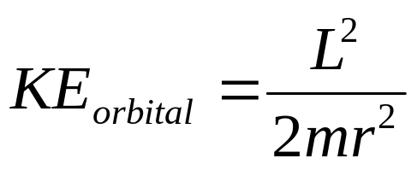

comparing this with

we get

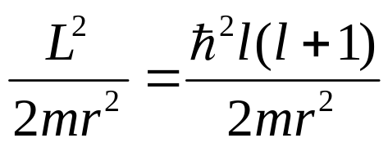

and resolve for magnitude of angular momentum

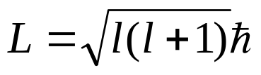

remembering that there was a restriction on orbital quantum number l set by the principal quantum number in the form of

l = 0,1,2, (n-1)

so the magnitude of the angular momentum vector can only be a multiple of

l = 0 → L = 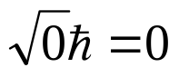 no angular momentum whatsoever

l = 1 → L = 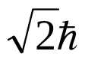

l = 2 → L = 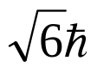

so its analogous to Bohr’s model, Bohr postulated angular momentum is quantized, i.e. multiples of and progressed from there to the quantization of energy with one quantum number n

as for the comparison to an classical system:
earth going around sun has orbital angular momentum about 2.7 10⁴⁰ Ws² which makes the square root factor about 2.7135 10⁷⁴ which is also roughly the orbital quantum number, surely the earth is not a quantum mechanical object

designation of angular momentum states – it is just a nomenclature/convention
s corresponds to l = 0 from sharp (all before Schrödinger)
p corresponds to l = 1 from principle
d corresponds to l = 2 from diffuse
f corresponds to l = 3 from fundamental
g corresponds to l = 4
h corresponds to l = 5
i corresponds to l = 6
combination of principal and orbital quantum number is widely used, e.g. 1s means n = 1 and l = 0, 4d means n = 4 and l = 2 in chemistry and spectroscopy

s states do not have angular momentum, so there isn’t anything “like an orbit” related to then, these wave functions must be entirely radially, i.e. completely spherically symmetric

Magnetic Quantum Number – quantization of one angular momentum component only

there is no preferred axis in the atom, nevertheless we consider z axis of spherical polar coordinate system sometimes as special for models

vector L is perpendicular to plane where rotational motion takes place, sign (sense) of the vector is given by right hand rule

an electron revolving around the proton is a minute current loop, magnetism is caused by moving charges, so there must be a magnetic moment associated with the electron’s orbital movement (and angular momentum and orbital quantum number) as the charge of the electron is negative, both vectors are anti-parallel
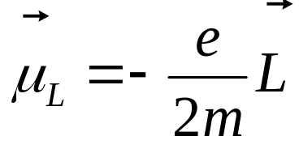 note that I used an index because there will be another (quite analogous) magnetic moment of the electron, called magnetic spin moment 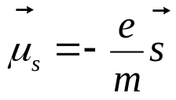

if there were a magnetic field (flux density B),
there were an interaction resulting in an alignment of this magnetic momentum

magnetic quantum number now specified the direction of L by determining the component of L in a possible field, we assume the field is in the z-axis direction, then

L_{z} = m_{l} 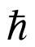 where m_{l} = 0, ±1, ±2, …±l
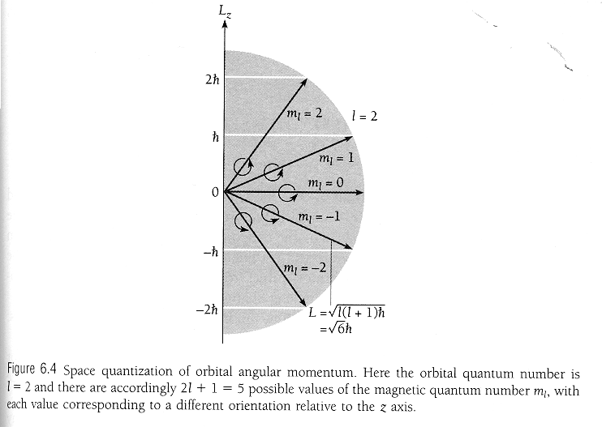

magnitude of L_{z} component is always smaller than L, so there must be L_{x} and L_{y} components as well

number of possible orientations of angular momentum vector (L) = 2 l + 1
Fig. 6.4 above indicates that L can never be aligned exactly parallel or anti-parallel to z axis = axis of hypothetical magnetic field

reason for space quantization is Heisenberg’s uncertainty principle

for this situation
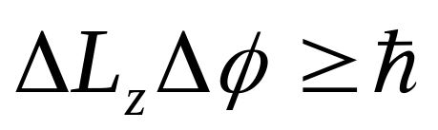

neither of them can be zero, z does not depend on φ, but x and y do, so the uncertainly in φ translates into an uncertainty in x and y

Result: L vector does not point in any specific direction in space, i.e. is not fixed, but is constantly precessing about the z-axis, allowing the electron to move in different planes all the time,

we can only know one of the components of L, the other two are on average zero, but L_{z} is always m_{l}
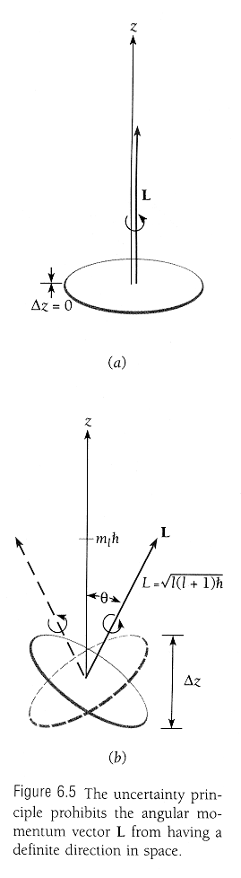
the angular momentum vector of an hydrogen atom with a certain m_{l} that finds itself in a magnetic field will assume certain directions – phenomenon called space quantization

in absence of magnetic field or any other reference line such as the bond line of two atoms, direction of Z-axis is arbitrary, so component of L vector in any direction we choose must be m_{l} , electron can move in all possible planes, can change planes any time

– remember we do not no anything about a possible path the electron is taking, we can only apply or mathematical framework to get probabilities of finding the electron at a certain place in space in dependence of the quantum number set, average (expectation) values of r, θ, φ, …

What we can learn from probability (density) calculations

probability density

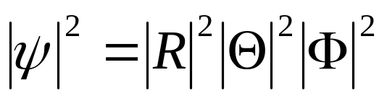

very nice thing, we do know all functions in their normalized forms!
to calculate actual probability of finding particle in small volume element dV we need to calculate

P (r,θ,φ) dV =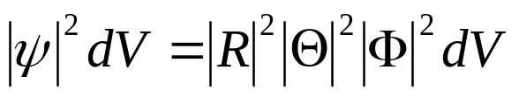

with dV = (dr) (r dθ) (r sin θ dφ) = r² sin θ dr dθ dφ

if there is an electron in a particular state, somewhere in the atom

P (r,θ,φ) dV =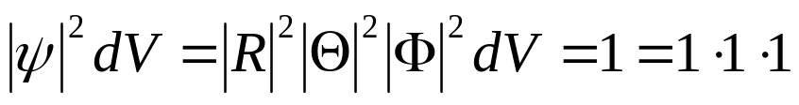

since all three component wave functions are normalized and are also each for one variable only we can calculate probability densities and probabilities for each of these functions independently

let’s start with azimuthal wave functions:

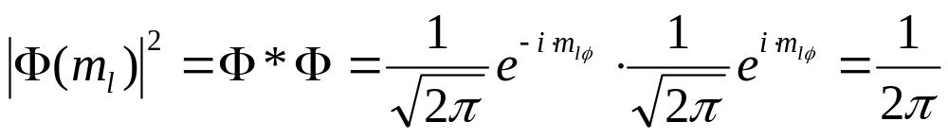
change i to –i wherever you find it and you get the conjugate complex function
so azimuthal probability density is a constant that does not depend on φ at all for all magnetic quantum numbers

we can further calculate actual probability of finding electron in small angle element dφ = φ₂-φ₁
we need to calculate

P (φ) dφ =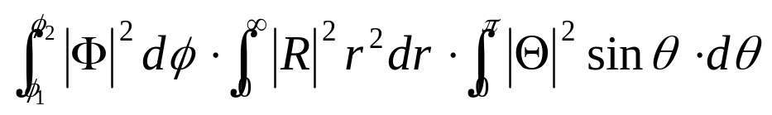

which simplifies to
P_{φ}(φ) dφ =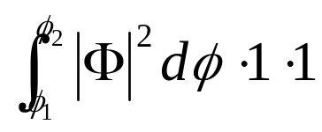 since R and Θ are both
normalized

so probability density and actual probability of finding the electron is always symmetric about z-axis regardless of the magnetic quantum state it is in,

that’s similar to the Bohr model,

in a sense: Bohr model + consequences of Heisenberg’s uncertainty principle = close to the truth = Schrödinger’s analysis
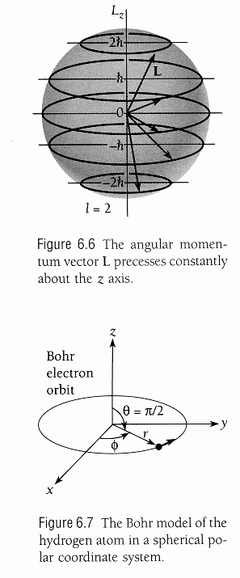

t

probability density and probabilities for radial wave function

for each quantum state with different n an l, there is a different function R wave functions, so the probabilities

P_{r}(r) dr = 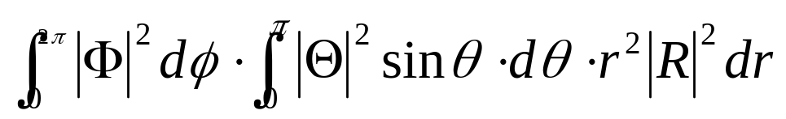

P_{r}(r) = 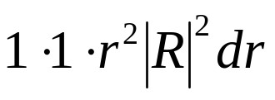

will be rather different for different quantum states as well
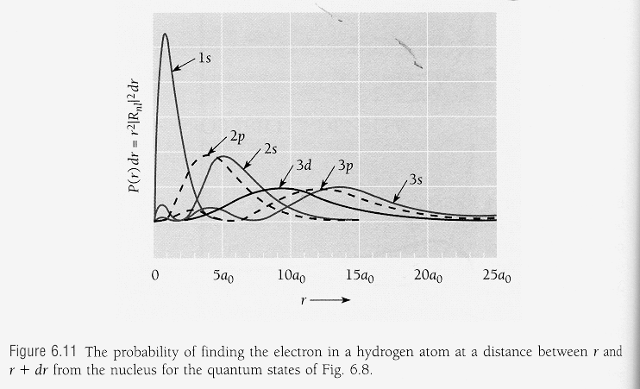
what is the most probably value of r for a 1s electron? Just as Bohr predicted: a₀
Is this also the average value? No - for that we need to calculate expectation values

Example: verify that the average value of ¹/_{r} for a 1s electron in the hydrogen atom is a₀⁻¹

Hint: average value = expectation value, which we would measure on average on a great number of particles, so we need to calculate expectation values – not probabilities
we need full 1s wave function 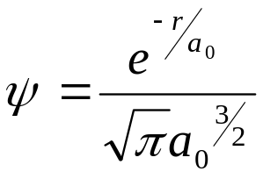
calculate expectation value 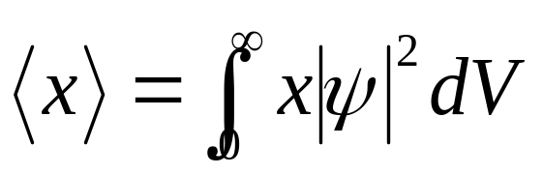
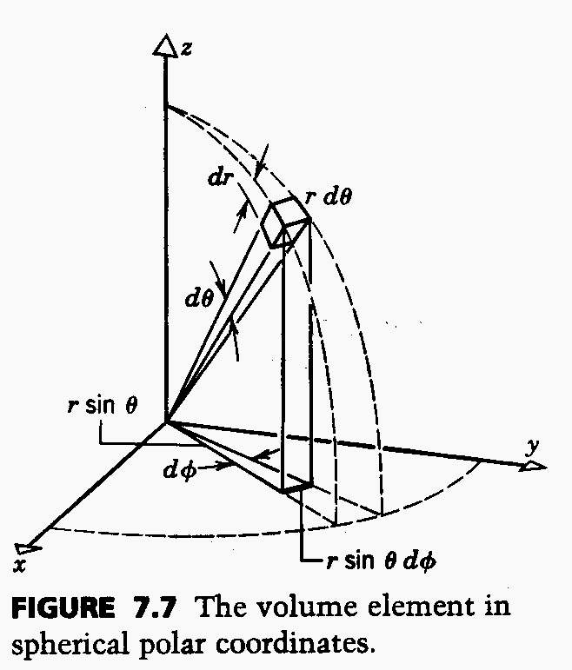 where dV = r² sin θ dr dθ dφ

i.e. we will have to solve the product of 3 integrals

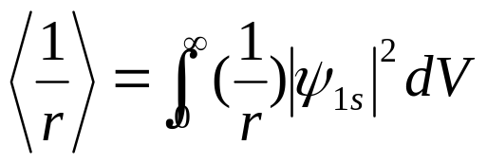

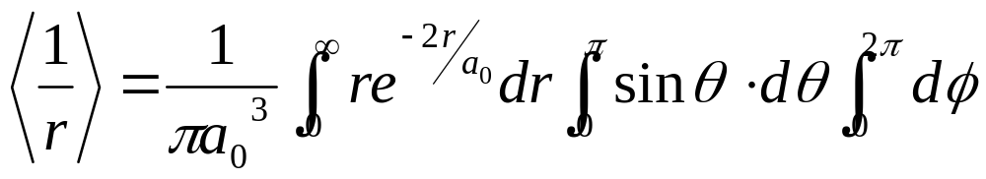

integrals only:

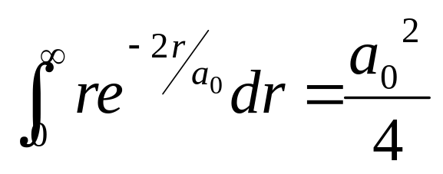
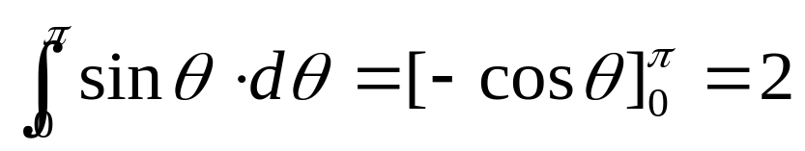

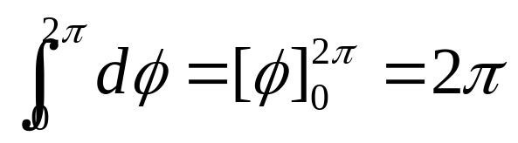

→ 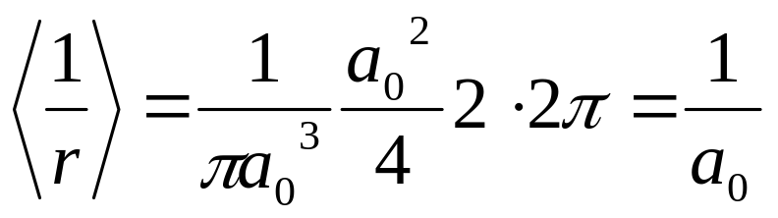

this must of course be as the energy is proportional to ¹/_{r}

Example: Prove that the most likely radial distance from the center of the nucleolus in the n = 2, l = 1 state is 4 a₀. What would the Bohr model predict?

What to do? calculate the radial probability density for this state and find its maximum How does one find the maximum?: one differentiates with respect to r and sets this derivate zero, resolves this derivate for the unknown, (there is no minimum in this function)

Solution: pick R(r) for n =2, l=1

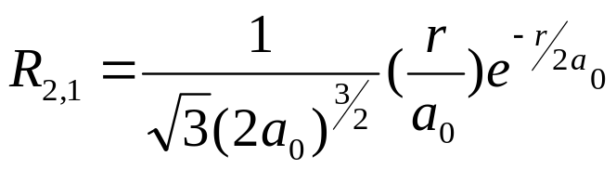
this is enough, as the respective functions Θ(θ) and Φ(φ) are normalized, so

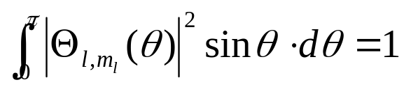 and 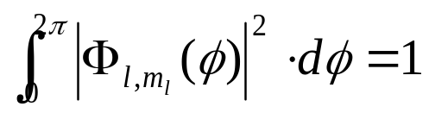

what remains for radial probability density:

P(r)= r² ⎢R _{2,1} (r)⎢²

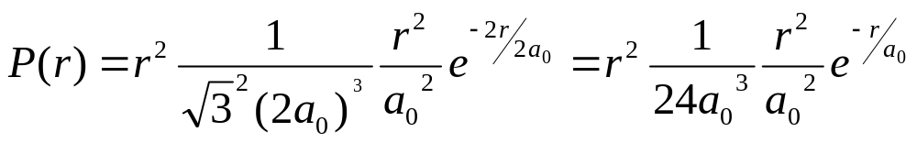
First derivate with respect to r gives maximum in probability density

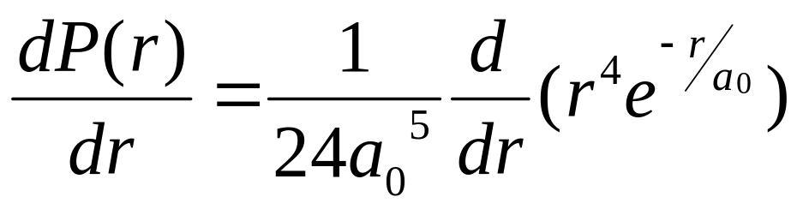

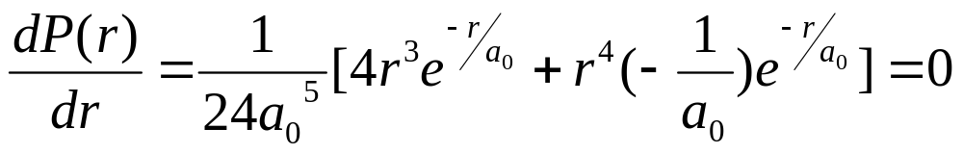

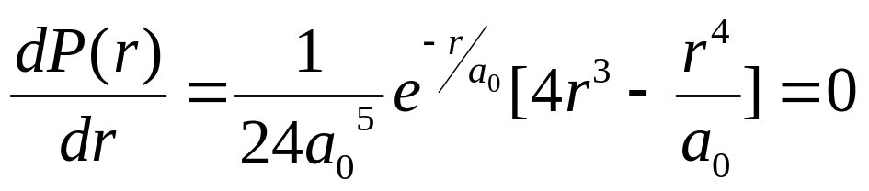

so content of straight bracket must be zero

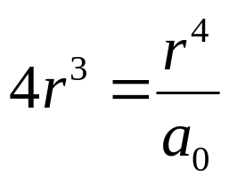 → r = 4 a₀

from Bohr equation: r_{n} = n a₀
Angular Variation of Probability Density

function Θ = varies with zenith angle θ for all quantum numbers l and m_{l} except l = m_{l} = 0, which are s states

Θ² for s states is constant ¹/_{2 ,} as Φ² also constant, probability density 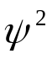 of s states is spherical symmetric, same value in all directions of r for a given value of r, but other states do have angular preferences

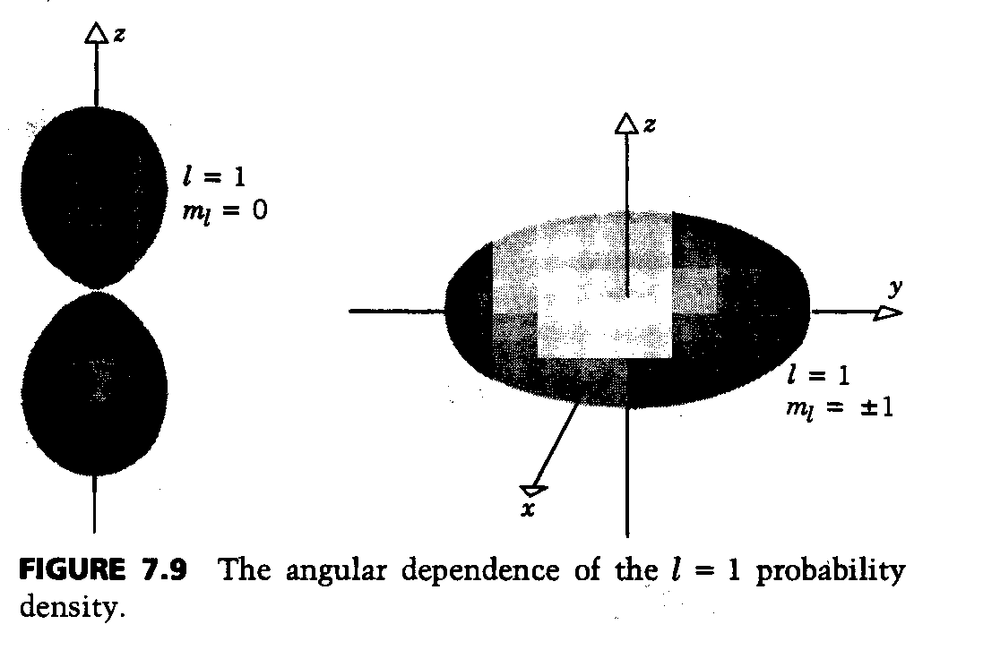
l = 1, m_{l} = ± 1 is a doughnut

as is independent of φ, we can rotate these images in our mind around the (vertical) axis (in the paper plane) indicated

pronounced lobe pattern are frequently important for chemistry and structural crystallography
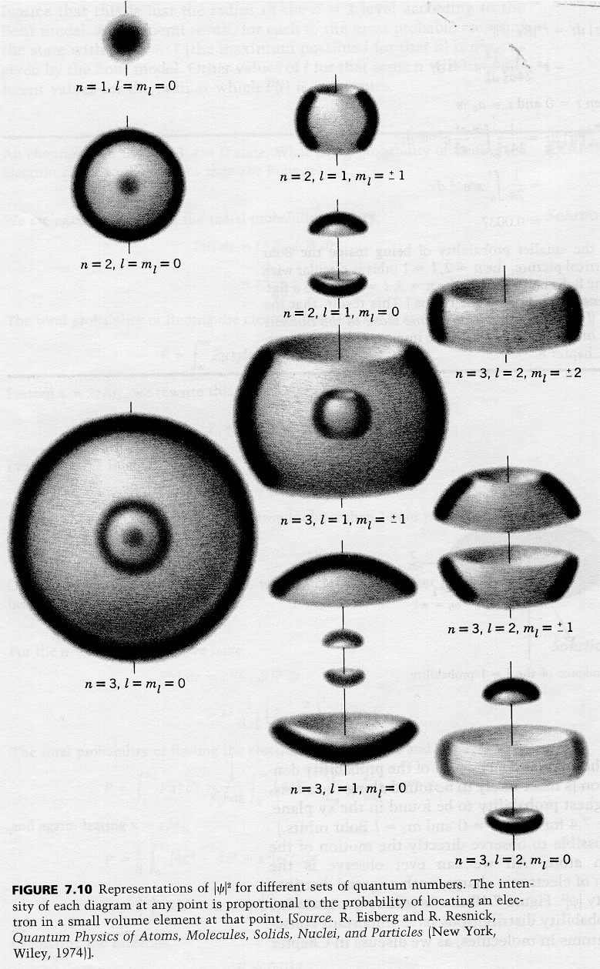
2p state (m_{l} = ±1) looks like a doughnut in equatorial plane centered at nucleolus, most probable distance of such an electron from center of nucleolus is 4a₀ – just as Bohr predicted

3d state (m_{l} = ±2), 4f state (m_{l} = ±3) , … also follow Bohr’s prediction r^{n} = n₂ a₀

So Bohr model is right in one of several possible states in each energy level

the angular momentum of these states is the highest possible, they therefore represent circles, remember

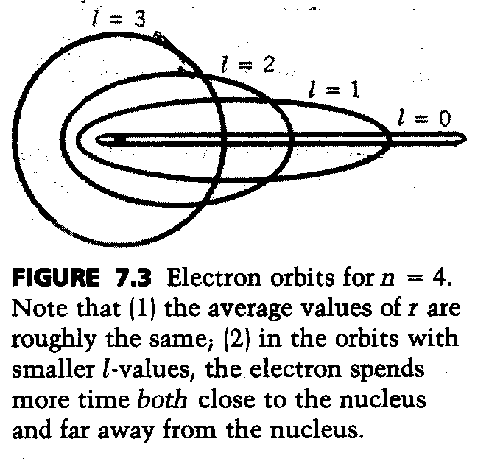

just as Bohr assumed

remember that angular momentum is always conserved, same as Kepler’s 2nd law: vector cross product refers to an area, this area is constant, i.e. cross product p x r is constant, so the other electron orbits are ellipses
Transitions between states and selection rules (may also be covered at the end of chapter 5)

energy levels revealed when system makes transitions,

either to a higher energy state as a result of excitation (absorption of energy)

or to a lower energy state as a result of relaxation (de-excitation, emission of energy , if it is an electron this is usually electromagnetic radiation)

form classical physics: if a charge q is accelerated, it radiated electromagnetic radiation, remember that’s how X-rays are produced, if a charge oscillates, the radiation is of the same frequency as the oscillation

if we have charged particle (charge q), we define charge density

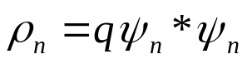 this quantity is time independent, stationary
state, i.e. does not radiate, quantum
mechanical explanation of Bohr’s postulate,
let’s say n is the ground state

with this wave function 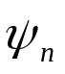goes a certain (eigen-value) energy E_{n} , as long as the charged particle is in this energy state it does not radiate, it does neither lose nor gain energy
say it gained just the right amount of energy to go to an excited state, this means eigen-value (energy) and wave function eigen-function change

let’s now consider how the particle returns to the ground state

only if a transition form one wave function (m) to another wave function (n) is made, the energy changes ΔE = E_{m} –E_{n} from one definitive value (excited stationary state, e.g. m) to the other definitive value (relaxed stationary state, e.g. n), E_{m} > E_{n}

as wave function for a particle that can make a transition, we need time dependent wave function Ψ(x,t), as it is two different states m and n, we have a superposition

Ψ_{m,n}(x,t) = a Ψ_{m}(x,t) + b Ψ_{n}(x,t)

initially say a = 1, b = 0, electron in excited state, m

while in transition a < 1, b <1, electron is oscillating
between states

finally a = 0, b = 1, electron in relaxed state, n

we can calculate frequency of this oscillation

expectation value that a particle can be in a transition is
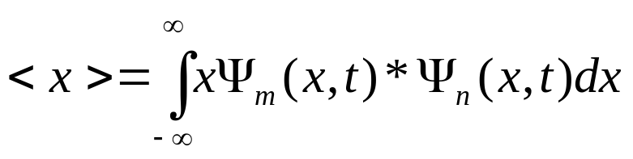
if this expectation value = 0 because the integral is zero, there is no transition possible

multiplied with the charge q, we have a dipole moment

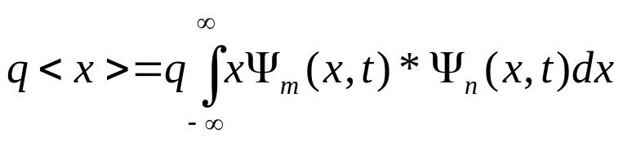 that radiates
q<x> = (2 q a b cos (ω_{mn} t) 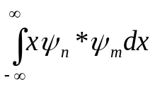) + constant

which we can interpret as the expectation value is oscillating due to cos function, the frequency of this oscillation

is the difference of the eigenvalues of the functions divided by h-bar
ω_{mn} = 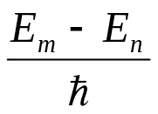= 2π f in other words, ΔE = h f

absence of a transition because the integral is zero is usually described as a selection rule

for harmonic oscillator: Δn = ± 1, so there is no transition between n = 4 and n = 2, it is always one hf that is emitted or absorbed, just as Plank had to assume in order to make his radiation formula fit the experimental data

for infinite square well Δn = 1, 3, 5 but not 2, 4 ,6
since, e.g. 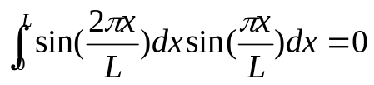
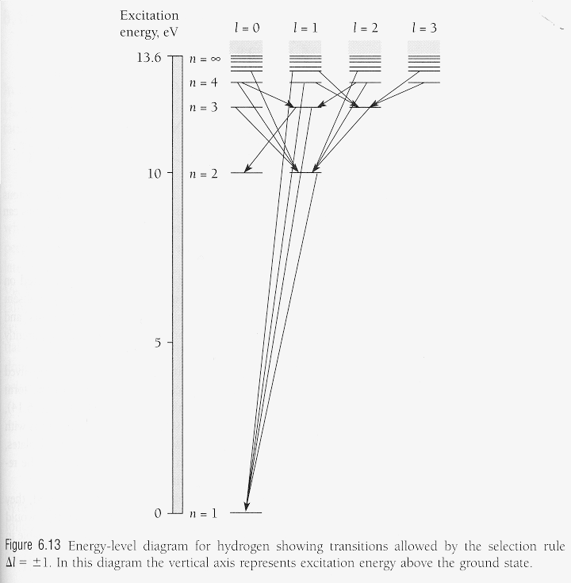

What causes a radiative transition? answer in “Quantum Electrodynamics”

- all electric an magnetic fields in nature constantly fluctuate, even when there is no field, these fluctuations are there, called “vacuum fluctuations” – analogous to zero point vibrations of harmonic oscillator – and help trigger transitions between energy states in an atom, radiation is indeed emitted as a single photon, as assumed by Bohr

experimental confirmation of these vacuum fluctuations is
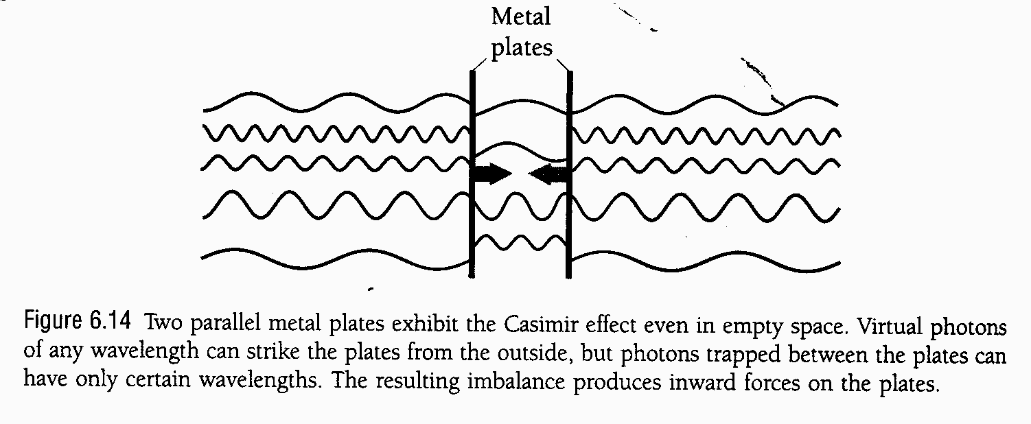

Normal Zeeman effect

remember there is an magnetic moment associated with the angular momentum

in a magnetic field, flux density B, the angular momentum tends to align itself by assuming special z-component with respect to the z-direction, so that

L_{z} = m_{l} 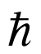

due to magnetic moment, we have magnetic potential energy
U_{m} =^{e}/_{2m} L B cos θ
θ
from graph we see

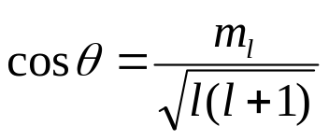
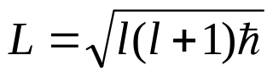
so U_{m} becomes 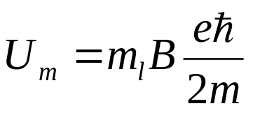
where 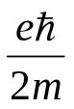 is called Bohr magnetron = 9.274 10⁻²⁴ Ws/T

in a magnetic field, the energy of a particular atomic state depends on the value of m_{l} as well as on the value of n

a state of n breaks up into several sub-states when in B whom’s energies are slightly above and slightly below than the n-dependent energy state without a magnetic field

phenomenon is know as Zeeman splitting of the spectral lines, when atom radiates in magnetic field, spacing of the lines depends on magnetic energy,, only variable, is magnetic flux density, B – experimental evidence for space quantization, 1896, could not be explained by Bohr model, 1913

changes in m_{l} are restricted to 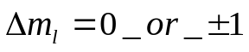by selection rules, so for every spectral line we have without magnetic field, we now have two additional lines

energy difference between two additional spectral lines (with B) and normal spectral line (without B) is ± 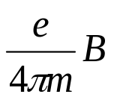

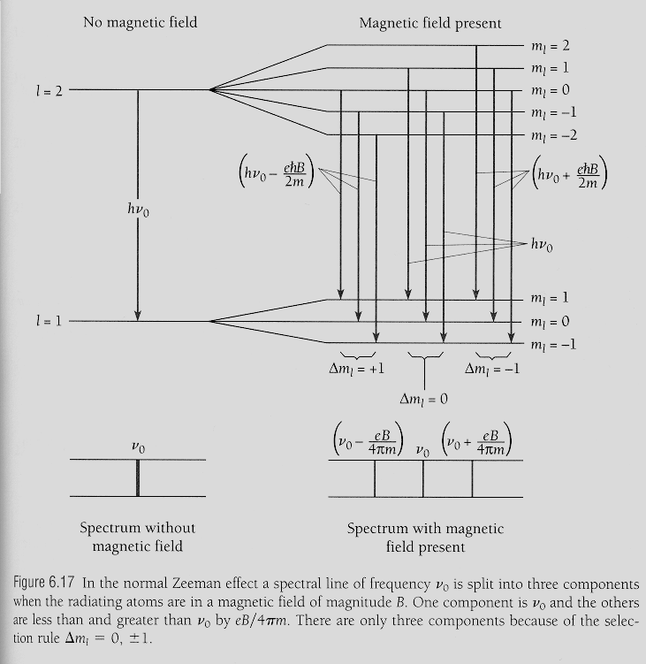
there is also anomalous Zeeman splitting,
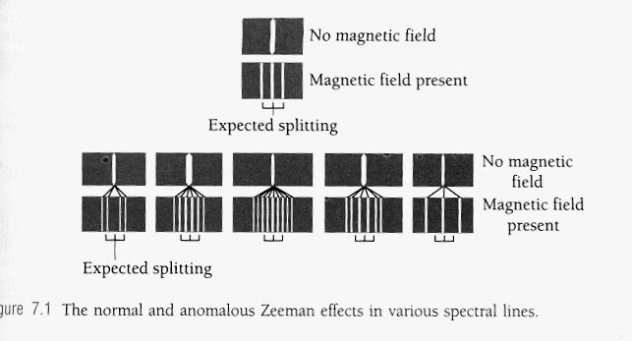
explanation next chapter as it needs spin, only atoms with “paired off” spin can show normal Zeeman splitting, all other shoe anomalous behavior, did you notice that we have only 3 quantum numbers for four-dimensional space time existence?

