Chapter 6: Tunneling Phenomena

the case of the semiconductor quantum dot is quite general

all waves spread out, go around corners, ensure that there are no sharp shadows in nature, …

... so real waves and matter waves can penetrate everywhere and their amplitude may approach zero at infinity but will be everywhere else finite (however small), if Ψ ≠ 0, Ψ² ≠ 0

penetrating into all kind of barriers, although with rapidly decaying amplitude, is one of the distinctive feature that separates wave phenomena from particle phenomena

barrier penetration can be explained from Heisenberg’s uncertainty principle:

If we were to say a particle can not enter a barrier, we would actually say this particle is not there, i.e. its position uncertainty is Δx = 0 in the barrier, but, there is no such thing as Δx = 0
as Δx Δp_{x} ≠ 0 but ≥ 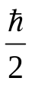

(you already know there is no Δp_{x} = 0 either in nature, things are never at rest completely, they have always some kinetic energy which is 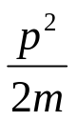non-relativistic
well if a particle enters a barrier by virtue of its accompanying matter wave, it will spread out in the barrier as well, although it can not travel in the barrier (an won’t stuck there if it is a model)

example frustrated total internal reflection

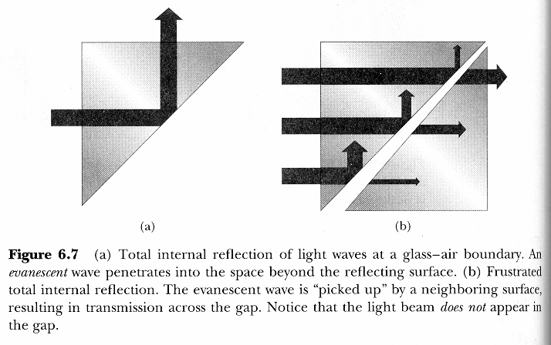

Reflection and transmission by a potential barrier

the potential energy barrier may either be lower or higher than kinetic energy of particle

if the potential barrier is lower, a part of the incident wave (intensity) gets reflected, the complementary part gets “transmitted” (goes simply over the top of the barrier)
when passing over the barrier, the kinetic energy of the particle will be lowered KE = E – U(x), less kinetic energy means it moves slower as KE = 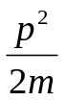and is has a longer wavelength, as p is smaller and p = ^{h}/_{λ}

after passing, KE of particle pick up and λ of wave reduces again to original value they had before reaching the barrier, as there is no longer an influence of the force that sets up the potential energy barrier, the wave amplitude and intensity are, however, diminished as a part of the wave got reflected, in other words, a certain amount of energy = h f, or quanta of that energy (constituent particles) got reflected out of the wave in the opposite direction

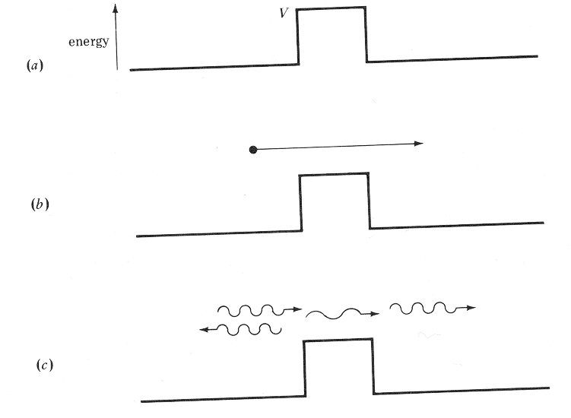

another familiar phenomenon, light reflection in a shop window, everywhere where there is a change in refractive index, wavelength of wave changes, reflection as well as transmission occurs, you see yourself in the window and the stuff that is on display, the reason is: the E vector and its first spatial derivate have to be continuous at the boundary where the change in λ takes place

Tunneling follows the same rules, the difference is that the potential energy barrier U(x) is now larger than the kinetic energy, so for classical particles we do not observe tunneling, but for quantum mechanical particles we indeed do, and we do use it in electronic devices such as quantum well lasers, resonant tunneling diodes, …

a beam of identical particles, all of which have same Ψ(x,t), potential energy before (region I) and after (region III) the barrier is zero, i.e. no forces act on the particles if they are not in the barrier, so KE = E before and after
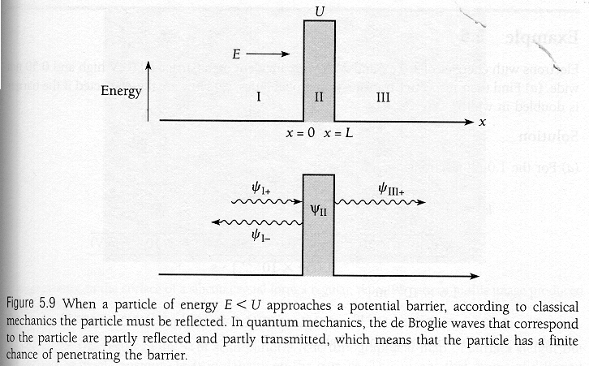
the barriers are stationary, U(x) does not vary with time, so we can perform separation of variables and use time independent (one dimensional) Schrödinger equation for regions I and III

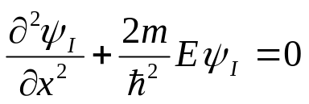

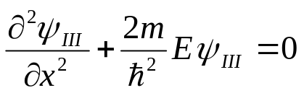

solutions, as usual

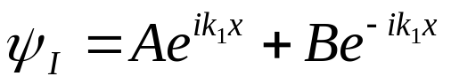 is a superposition of a wave
that moves to the right and one that moves to the left )– sign in exponent)

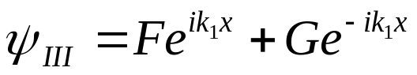

where 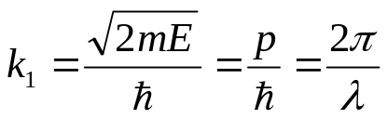 is wave number outside barrier

for 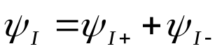

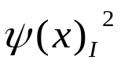probability density, with group velocity of wave (v)
flux of particles that arrive at barrier: S = 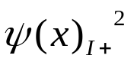v is number of particles (per square meter) arriving at the barrier per second
at x = 0 wave gets partially reflected

reflected wave: 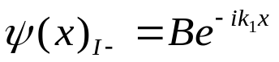

transmitted wave: 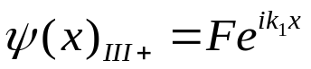

as there is no second barrier G = 0

transmission probability, T, for a particle to pass through barrier is ratio of number of particles that reach the barrier and those that emerge from the barrier

a particle is either reflected or transmitted, so both coefficients (probabilities) have to add to 1 (or 100 %)

T=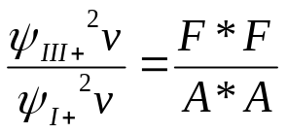

as U > E, we can rewrite Schrödinger equation as

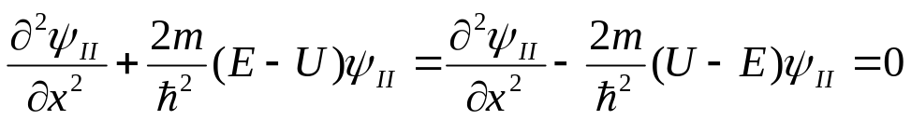

and get for wave function in the barrier

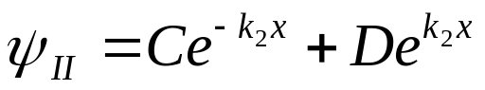
where the wave number in the barrier is k₂ = 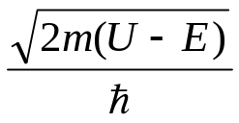

since the exponents are real 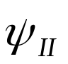does not oscillate, it does not represent a moving particle, it’s called the evanescent wave, it just decays exponentially

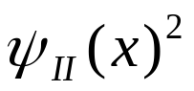≠ 0 in the barrier, so the particle can be found there, the particle may either emerge into region III or get reflected back to region I, it does not stay in the barrier as the sum of transmission and reflection coefficient (probability) is 1 (100 %)
in out model, in a real physical situation where there is absorption it may get stuck but we do not consider these here

Applying boundary conditions in order to get an approximation of T

by matching 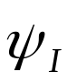,,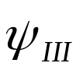 and their spatial derivates

under the assumption that the potential barrier U(x) is “formidable” i.e. both high and wide, we can approximate

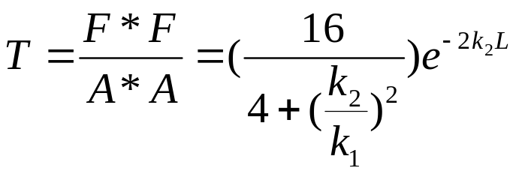
whereby 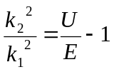
as the term in the brackets varies much less with E and U as the exponential term, we approximate it to 1 and get for a square barrier (that is constant)
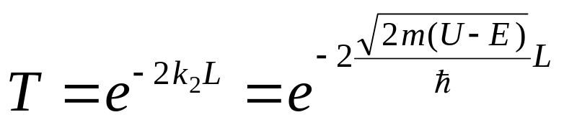

(Beiser, Concepts of Modern Physics, same formula as 6.10 in Serway et al. p. 237 if you solve the integral for square barrier)

example: a really bad and heavy guy (150 kg), say a mass murder or a former CEO of Enron or WorldCom is incarcerated for life and wants to get out by means of tunneling through a 50 cm (L) thick concrete wall, how long will it take him if he tries really hard and hits the wall with a velocity of 5 ^{m}/_{s} once every minute?

his kinetic energy is 1875 Nm, assume wall “would beak; allow him to enter” if kinetic energy impacting were to be 10⁶ Nm

T ≈ 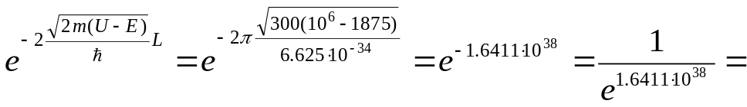

would something significant change if the wall were only 0.5 cm thick and only 1880 Nm “high”?

exp 3.67 10⁻³³ has no solution either on most pocket calculators ln 10 ⁹⁹ = 228,…so exp -228 is kind of the limit for many pocket calculators

another example: electrons with energy 1 eV are incident on a barrier 5 eV high and 0.5 nm wide

T ≈ 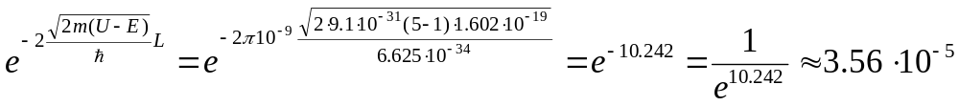

so 1 particle out of about 28061 incident particles will (in a stationary state) tunnel through 5 eV barrier and emerge on other side

if dimensions of Si microelectronics continue to shrink according to “Moore’s law” for another 5-10 years or so, tunnel effects through SiO₂ insulator in field effect transistors will render the device useless, new materials with higher dielectric constant than SiO₂ ?, new computer architecture altogether on the basis of quantum dots?

important, tunneling coefficient T is ¹/_{exponential}, i.e. it is a very sensitive effect, a small change in electrical barrier energy and thickness can change T significantly, resonant tunneling diode

a small difference in the barrier widths can even more strongly influence the tunneling coefficient – Scanning Tunneling Microscope
invented 1981 by Gerd Binnig and Heinrich Rohrer, Noble prize 1986, together with Ernst Ruska, inventor of the transmission electron microscope (1932)
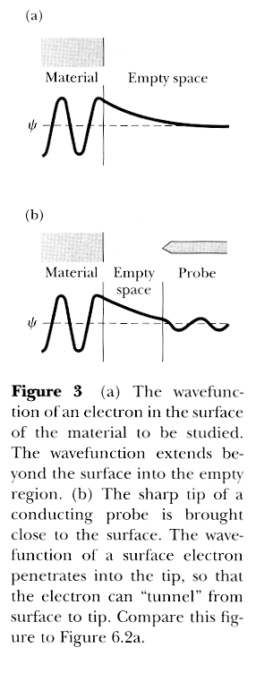
a very very very fine tip is scanned over the surface of a conductor by means of piezoelectric crystal drive, lateral resolution depends amongst other things on the sharpness of the tip and surface topography, typically order of magnitude 0.2 nm,
i.e. about the size of an atom,

but sensitivity to changes in surface heights are much greater (about 0.001 nm) due to exponential dependency of tunneling current from widths of the classically forbidden zone, (the barrier)
more scanning probe microscopes, most important is atomic force microscope with which insulating samples can be imaged at a somewhat reduced resolution

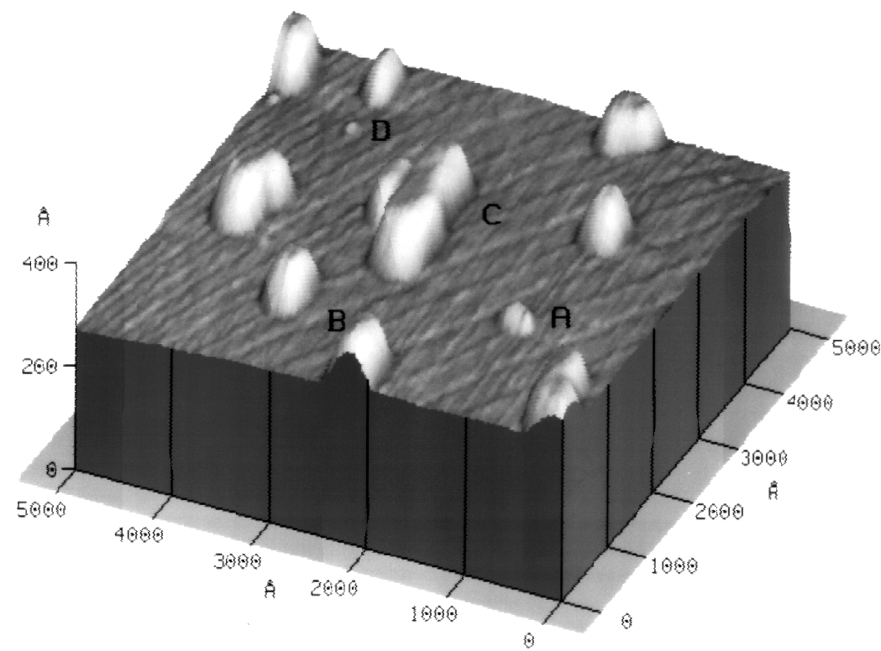
Fig. 1: High-resolution AFM image of InSb islands on GaSb, ^{III}/_{V} ratio: ⁵/₁, growth rate: 1-2 monolayers per second (ML s⁻¹). The image edges are oriented parallel to <110> directions. Terraces of ML height, which are consistent with an 0.5° misorientation, and two-dimensional islands (e.g. marker D) are depicted in addition to three different types of three-dimensional islands (markers A-C). While marker A stands for a fully strained island, markers B and C stand for partially relaxed isolated and coalesced islands. Only fully strained islands are considered to be predecessors of QDs. All of the three dimensional islands may have nucleated at the edges of ML terraces, i.e. at locations of reduced strain.

(from one of my papers on quantum dots, see web pages, if interested)
Another example of “getting out through a wall” – α decay of instable nuclei to be revisited in chapter 13

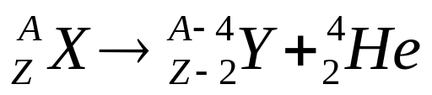 for example 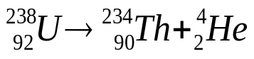

A is sum of protons and neutrons, Z is number of protons also called atomic number, the principle number that defines the place of an element in the periodic table, X is called parent nucleus for example and Y is called daughter nucleus

remember Rutherford’s experiments that lead to the discovery of the atomic nucleus?

α-particles were used to hit thin foils (atoms in a crystal), most of them went straight through the foil as atoms are pretty empty, a few of them got scattered right back (by electrostatic repulsion) when they where heading for the core, where did these α-particles come form?

the kinetic energies with which the α-particles left parent nuclei was in the range of 4 to 9 MeV, with 7.7 MeV and an Al target, he “kind of hit the nucleus” and estimated the size of the Al nucleus assuming point charges (which is not quite correct, example 3.5 on p. 115)

explanation by George Gamow 1928 (independently Gurney and Condon 1929) from quantum mechanics
for puzzling experimental observation

half-lives of the parent atoms (i.e. time for half of the substance to decay – independent of the total mass) vary over more then 10 orders of magnitude, but the kinetic energies of all the particles are of the same order of magnitude,
reasoning: surely both half-life and kinetic energy should have something to do with each other
ideas: one need an exponential dependency of half-life on small differences in energies to account for the experimental observations, remember transmission coefficient of the finite square barrier had difference between potential and total energy in exponent

assumption (approximation) total energy of α-particle within nucleus becomes (order of magnitude) of kinetic energy when emitted from nucleus (not quite correct although suggested by Serway book)
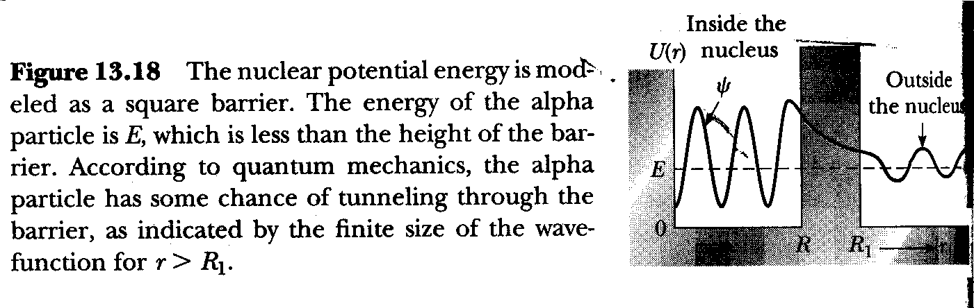
inside the nucleus it is “preformed and moves around”, potential barrier is provided by strong nuclear force, some 30-50 MeV, with is very short ranged, nearly zero outside the nucleus, α-particle simply tunnel trough this barrier, (and then get expelled by electrostatic force) so the tunneling effect is as real as anything in nature, but does only apply to quantum mechanical objects

Edward U. Condon: “According to classical mechanics, it is not possible for a particle to be in a place where its total energy is less than its potential energy. In quantum mechanics, this impossibility is changed into an improbability.”

