4. Matter waves
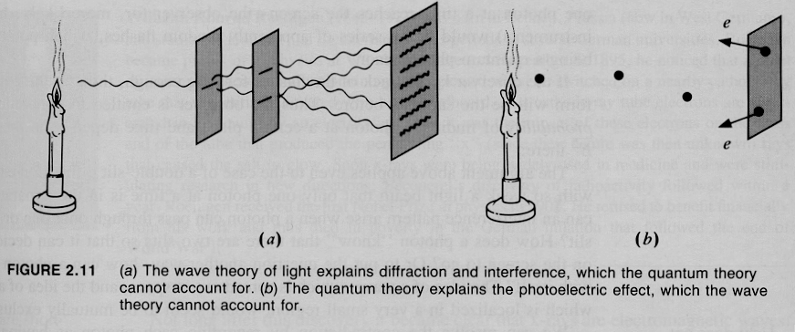

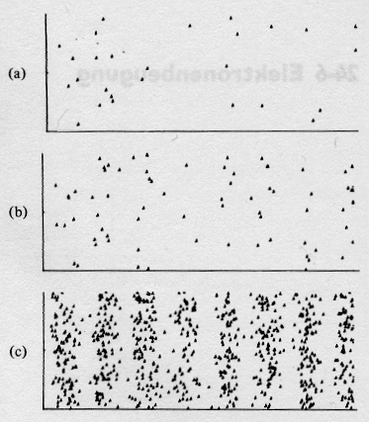
27 electrons

70 electrons

735 electrons

by 1920 shortcomings of Bohr’s model

- can not explain intensity of spectral lines
- limited success for multi electron systems

but crucial to Bohr’s model are integer numbers (n), and integers otherwise in physics only in wave phenomena such as interference

back to light: E = h f, so photons are energy, E = mc², so photons are “kind of matter” although mass less, light is a wave, c = $λ$f

Einstein 1906: p = ^{E}/_{c} = ^{h f}/_{c} must also be = ^{h}/ $λ$ (we used this to explain Compton effect)

de Broglie 1923 PhD thesis speculation; because photons have wave and particle characteristics, perhaps all forms of matter, e.g. electron, have wave as well as particle properties, p = ^{h} / $λ$ for all particles, f = ^{E} / _{h} , $λ$ = ^{h} /_{p}

If that turns out to be true, I’ll quit physics, Max von Laue, Noble Laureate 1914, author of “Materiewelleninterferenzen” the classical text on electron diffraction

(what if p = m v = 0 because particle is not moving, v = 0, h is a constant, so $λ$ must be infinite – can’t be), consequence particles can never be truly at rest, v and p can be very very very low, but never zero!!!!!
that is what is actually observed: a tiny tiny pendulum will be hit by air molecules and move all the time somewhat irregularly, a large pendulum will obey classical physics
in other words: electrons and everything else also has a dual particle-wave character, an electron is accompanied by a wave (not an electromagnetic wave!!!) which guides/pilots the electron through space

first great idea that let to acceptance of de Broglie hypothesis: the orbits of the electron in the Bohr model are of just the right size for standing waves (with multiples of wavelength $λ$) to occur, a standing wave is a stationary state and so are the atomic orbits
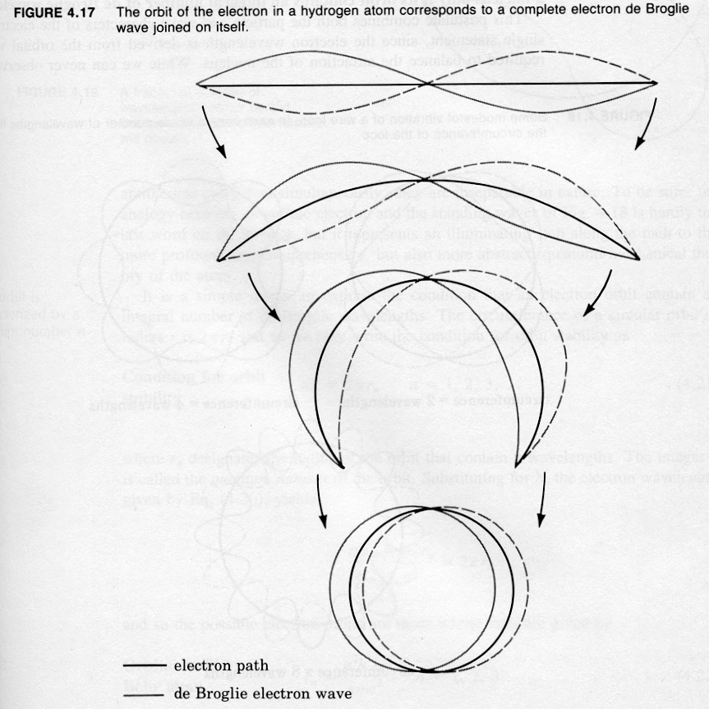

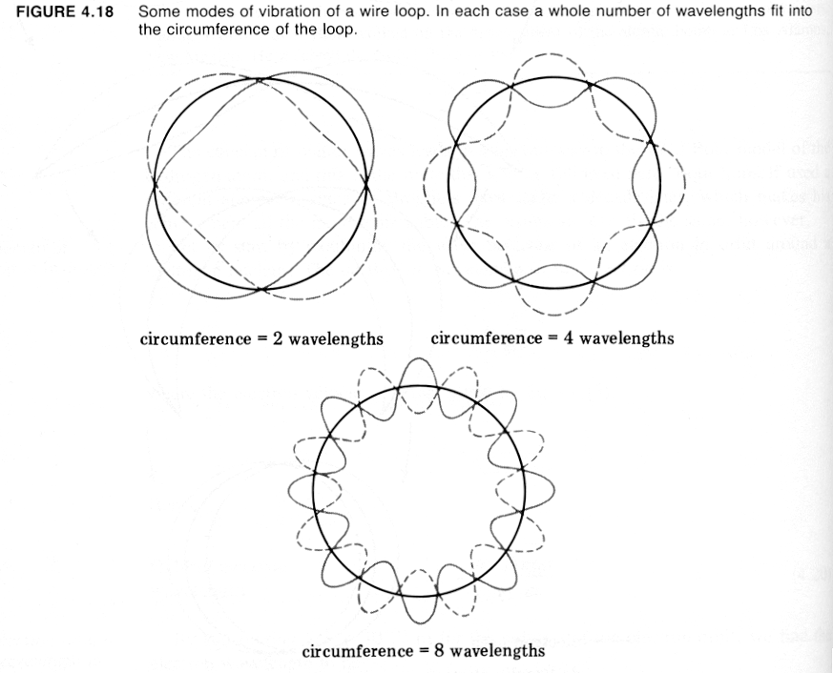

2π r = n $λ$ with r radius of electron orbit

inserting n can be even or odd but has to be an integer
$λ$ = ^{h}/_{p} = $\frac{h}{m_{0}v}$ (from Einstein’s relativistic mechanics) into condition for stable electron radia

m₀ v r = ^{n h}/_{2π} (non relativistic)

which is exactly Bohr’s quantization of angular momentum equation !!! form which energy levels of electrons follow, from which transitions between these levels with E = hf follow
let’s calculate velocity of electron in orbit in hydrogen atom and apply de Broglie relation to see what wavelength we’ll get

Force balance, Coulomb force balances centripetal force

$F_{\text{centripedal}}=\frac{{\text{mv}}^{2}}{r_{n}}=F_{\text{Columb}}=\frac{1}{4{\text{πε}}_{0}}\frac{e^{2}}{r_{n^{2}}}$

solved for velocity v_{n} = $\frac{e}{\sqrt{4{\text{πε}}_{0}{\text{mr}}_{n}}}$

with $λ$_{n} = $\frac{h}{{\text{mv}}_{n}}$ we get $λ$_{n} = $\frac{h}{e}\sqrt{\frac{4{\text{πε}}_{0}r_{n}}{m}}$

look at n = 1 where r₁ is set Bohr radius a₀= 0.5292 10⁻¹⁰ m

$λ$₁ = $\frac{6\text{.}\text{625}⋅{\text{10}}^{−\text{34}}\text{Js}}{1\text{.}\text{602}⋅{\text{10}}^{−\text{19}}C}\sqrt{\frac{4π⋅8\text{.}\text{86}⋅{\text{10}}^{−\text{12}}F⋅0\text{.}\text{5292}⋅{\text{10}}^{−\text{10}}m}{9\text{.}\text{108}⋅{\text{10}}^{−\text{31}}\text{kg}⋅m}}={\text{you}}_{\text{result}}\text{???}$

circumference of first circular electron orbit is
2$π$ a₀ = $3\text{.}\text{32506}⋅{\text{10}}^{−\text{10}}m$

so $λ$_{n} = 2 $π$ r_{n} = $\frac{h}{e}\sqrt{\frac{4{\text{πε}}_{0}r_{n}}{m}}$= $\frac{h}{{\text{mv}}_{n}}$ is the same as saying angular
momentum is quantized !!!
orbits of electron in hydrogen atom are exactly equal to n times a complete (i.e. two half waves) electron wave joined in themselves

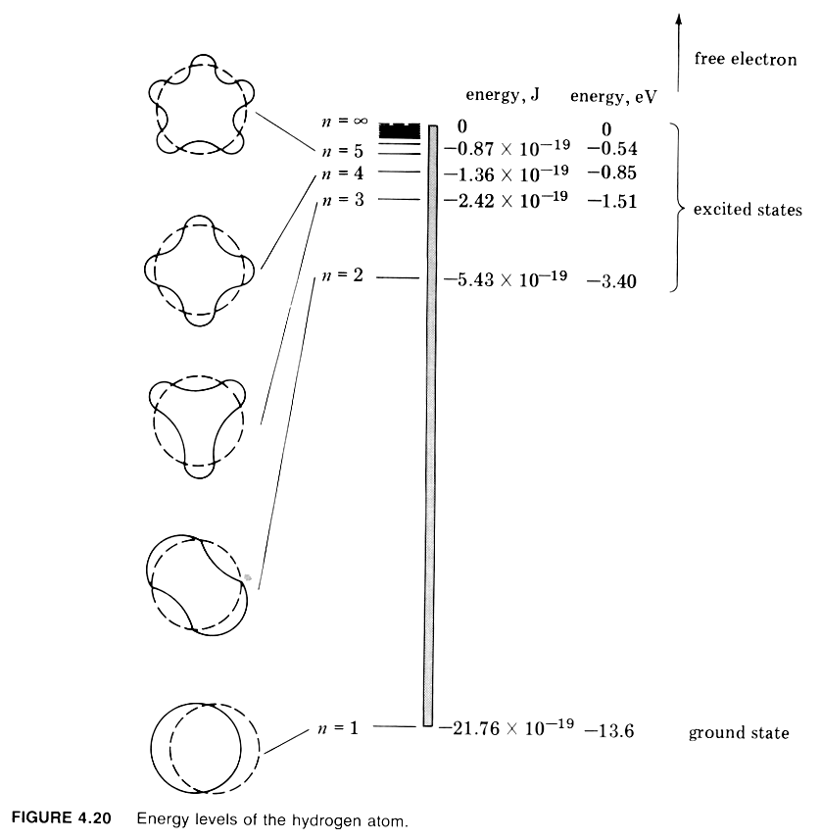
Model for Hydrogen atoms, de Broglie and Bohr give the same energy levels

for the sake of the argument, we can stretch out the circular orbit of electron in hydrogen atom into a length L and consider the electron to be trapped within this length, carefully, in the atom there is always an even number of half-waves as they have to reinforce themselves

within a fixed length, say between walls, there can be only standing waves if there are nodes at the walls

longest wavelength = λ₀ = 2L
next λ₁ = L
next λ₂ = ²/₃ L
general formula λ_{n} = ²/_{n} L n = 1,2,3

since λ_{n} = ^{h}/_{mv} (de Broglie relation), restriction by L imposes restrictions on momentum of particle, and, in turn, to limits on its kinetic energy

KE = ½ m v² = $\frac{(\text{mv})^{2}}{2m}$

with de Broglie: m v = ^{h}/_{λ} = p
KE = $\frac{h^{2}}{2{mλ}^{2}}$
permitted wavelength are λ_{n} = ²/_{n} L ,

no potential energy in this model, KE = E, inserting for λ

$E_{n}=\frac{n^{2}h^{2}}{8{\text{mL}}^{2}}$ n = 1,2,3 Energy levels, v ≠ 0 !!!

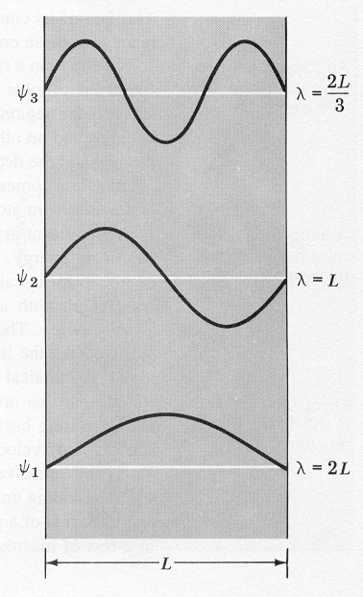
the (in)famous particle in a box

there is a minimum (kinetic) energy, in other words particle does never stand still, v ≠ 0, $λ$ always finite !!!!
say it could be a model of hydrogen atom where a box with widths
L_{circumference} = 2π a₀ (a₀ = 0.5292 10⁻¹⁰ nm Bohr radius) = 2 L (even number of half wave must fit, in this case 2 half waves), so that one full wavelength fits, contains an electron, what is the lowest energy level?

m = 9.1 10⁻³¹ kg

$$E_{1}=\frac{1^{2}h^{2}}{8{\text{mL}}^{2}}=\frac{1^{2}(6\text{.}\text{626}⋅{\text{10}}^{−\text{34}}\text{Js})^{2}}{8⋅9\text{.}1⋅{\text{10}}^{−\text{31}}\text{kg}⋅(π⋅0\text{.}\text{52927}⋅{\text{10}}^{−\text{10}}m)^{2}}=2\text{.}\text{18}⋅{\text{10}}^{−\text{19}}J=\text{13}\text{.}6\text{eV}$$
so E₁ = 13.6 eV Bohr E₁ = -13.6 eV negative per definition

for E₂ we need L_{circumference} = 2π n² a₀ = 2L (even number of half wave must fit, in this case 4 half waves)

$$E_{2}=\frac{2^{2}h^{2}}{8{\text{mL}}^{2}}=\frac{2^{2}(6\text{.}\text{626}⋅{\text{10}}^{−\text{34}}\text{Js})^{2}}{8⋅9\text{.}1⋅{\text{10}}^{−\text{31}}\text{kg}⋅(4π⋅0\text{.}\text{52927}⋅{\text{10}}^{−\text{10}}m)^{2}}=\frac{1}{4}2\text{.}\text{18}⋅{\text{10}}^{−\text{19}}J=\frac{1}{4}\text{13}\text{.}6\text{eV}=3\text{.}4\text{eV}$$
Bohr E₂ = -3.4 eV negative per definition

for derivation of Bohr model we considered force balance, kinetic and potential energy, a semiclassical/semiquantum model,

here we just consider even numbers of standing waves – and the resulting energy levels are the same, so de Broglie’s hypothesis explains the hydrogen atom just as well

---------------------------------------------------------------------

a 10 g marble in a 10 cm wide box, what is the lowest energy level, can it sand still or must it always move??
$$E_{n}=\frac{n^{2}h^{2}}{8{\text{mL}}^{2}}=\frac{n^{2}(6\text{.}\text{626}⋅{\text{10}}^{−\text{34}}\text{Js})^{2}}{8⋅{\text{10}}^{−2}\text{kg}⋅({\text{10}}^{−1}m)^{2}}=5\text{.}5⋅{\text{10}}^{−\text{64}}n^{2}J$$

that energy being kinetic, the marble can’t stand still, it has a velocity of
3.3 10^{-31 m}/_{s}

however small and light (microscopic) or large and heavy (classical) an object may be, if it is trapped (say in at least in the known universe), the size of the trap will always imposed quantization conditions on the momentum and energy

in other words, it will always have some kinetic energy, and will always move with some velocity and its wavelength will always be finite

as it always moves, its position and momentum can not be arbitrary precisely defined, i.e. there is always an Δx and Δp uncertainty, arising from the wave particle duality, (will be derived mathematically Heisenberg’s uncertainty principle)

there is no infinite wavelength resulting in a momentum of zero in the de Broglie equation p = ^{h} / _{λ} so this equation always applies (and with it the rest of Einstein’s relativity)

On the other hand, in practical terms, correspondence principle says for marble above and v = ^{1m} /_{3 s} , n would be 10³⁰, hence, it can be dealt with classically, the spacing of the energy levels is so small that it is imperceptible

back to “free” particles: another de Broglie’s prediction, depending on the velocity (acceleration potential) of electrons, they should be diffracted by an aperture in the size range of the wavelength

direct prove of λ = ^{h}/_{p ,} i.e. that moving electron possess a wavelength, have to be treated like a wave, comes from electron diffraction on crystals (Davisson-Germer (100 eV) / Thompson (several kV, here the electrons are so fast that we have to use relativistic momentum) (son of J.J. Thompson who showed that electron is a particle)

electron microscope with 200 kV acceleration potential as discussed earlier in course gives λ = 2.508 10⁻¹² m
(allows for magnification up to 10⁶)

for macroscopic particles, such as a human being of 80 kg walking at a leisurely pace (5 ^{km}/_{h} ≈ 1.39 ^{m}/_{s})

λ = ^{h}/_{p} = $\frac{6,\text{6251}⋅{\text{10}}^{−\text{34}}{\text{kgm}}^{2}s^{−1}}{\text{80}\text{kg}⋅1\text{.}\text{39}{\text{ms}}^{−1}}$ = 5.96 10⁻³⁶ m

θ (radians) ≈ ^{λ}/_{size of aperture}

there is no aperture of this size in nature (as the nucleus is only 10⁻¹⁴ m, so human beings are not behaving like waves when walking
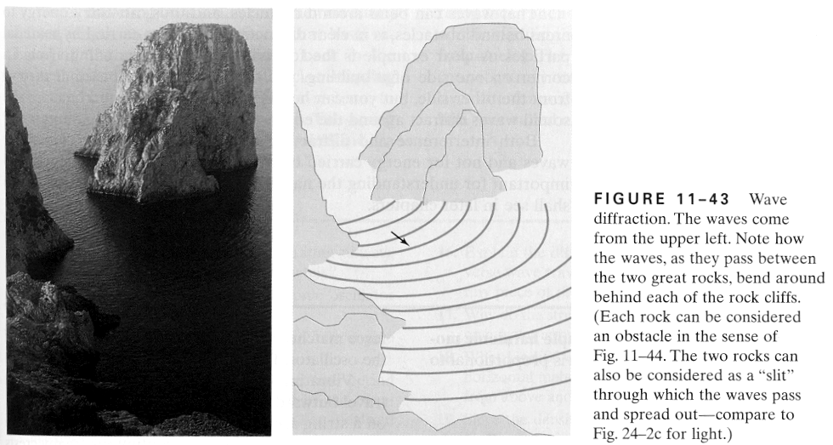

summary: pilot wave (analog to Einstein, but this time for m₀ ≠ 0):

λ = ^{h}/_{p} p: relativistic momentum, p = $\frac{1}{\sqrt{1−\frac{v^{2}}{c^{2}}}}$m₀v
f = ^{E}/_{h} Planck-Einstein equation

E² = (mc²)² = ($\frac{1}{\sqrt{1−\frac{v^{2}}{c^{2}}}}$ m₀ c²)² = p² c² + m₀² c⁴

these are results from relativity and early quantum mechanics

applicable to all particles, later on diffraction from neutrons was observed, diffraction from beams of atoms, small molecules and large molecules such as C₆₀ (buckyball, looks similar to a soccer ball)

again quantum mechanics is right regardless of mass of the moving object - the situation is similar to geometrical optics, (rays through a thin lens, lupe, microscope, mirrors – which is applicable if the size of the object, lens ect. is large in comparison to the size of the wavelength of the light) which is a good approximation of wave-optics

for light the pilot wave was the square of the electromagnetic wave, the intensity that makes the effect when light interacts with matter (sun burn)

(nature of pilot wave for particles with mass/matter comes later from interpretation of square of wave function which is a solution of the Schrödinger equation)

– the speed of the pilot wave is not v = λ f !!! because it is not a physical wave only its square has physical significant meaning as a probably density

so how fast is the wave moving, must be as fast as the particle to make sense
Waves of what?

what varies periodically?
water waves: height of the water surface
sound wave: air pressure
light wave: electric and magnetic fields,
in all cases energy is transported from a source oscillation without moving the source

quantity whose variations makes up matter waves is called wave function, Ψ

value of wave function that travels with moving body at particular point (x,y,z) in space and time (t) is related to the likelihood of finding the body there (x,y,z) and then (t)

not of physical significance, amplitude varies between max (+) and min (-), i.e. is on average zero, negative probability is meaningless

square of Ψ, is always positive, so it is indeed the likelihood of finding the body there (x,y,z) and then (t) large value of │Ψ│² ‌‌‌‌‌‌ ‌‌‌‌‌‌‌‌‌‌‌‌‌‌‌‌= │Ψ│ * │Ψ│, large likelihood, small value of │Ψ│² ‌‌‌‌‌‌ ‌‌‌‌‌‌‌‌‌‌‌‌‌‌‌‌small likelihood, as long as of │Ψ│² ‌≠ 0 it can be found there, Max Born 1926

significant difference between probability of event and event itself
in experiment whole electron is either found at (x,y,z,t) or not (there is no such thing as 20% electron), but there can be a 20% chance of finding it, this likelihood is specified by Ψ²

Intensity distribution in a double slit experiment results from many many particles, each have same Ψ function, actual density on the screen at any one point (x,y,z,t) is proportional to Ψ² the more particles the higher the factor of proportionality,

but Ψ² already contains information on the whole interference pattern, already one particle will produce an interference pattern as it is all about a distribution of probabilities

say Ψ² = 65 %

distribution of real events
Wave - a useful mathematical model

say a wave on a very long string along x axis

vibrate one end, so that wave has displacement y which depends on both position, x, and time, t

function y(x,t) that describes y as a function of both parameters is called wave function

acceleration of a point of the string is $\frac{∂^{2}y}{∂t^{2}}$a partial derivate because y = y(x,t) depends on both parameters

application of Newton’s 2nd law to a segment of the string shows that y(x,t) obeys the wave equation

$$\frac{∂^{2}y}{∂x^{2}}=\frac{1}{v^{2}}\frac{∂^{2}y}{∂t^{2}}$$

where for a perfectly flexible string the phase velocity v = $\sqrt{\frac{T}{μ}}$

with T tension in the string and μ mass per unit length

equivalent wave equation for sound and light !!!

for light y(x,t) represents electric or magnetic field vector, velocity v = ^{c} / _{n} where n is refractive index

wave functions are solutions to the wave equation

any wave function depending on x and t only in combination
x - vt or x + vt is solution of wave equation above

e.g. if y = f(x) is shape of string at time t, function f(x - vt) describes propagation of this shape to the right with speed v
function f(x + vt) describes propagation to the left

the sum of any two solutions of the wave equation (i.e. wave functions) are also solutions to this equation - superposition principle
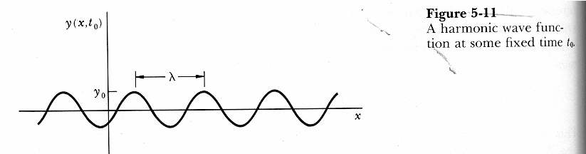

useful solution of wave equation is harmonic wave (mathematical model)

y(x,t) = y₀ cos 2 π (^{x}/_{λ} - ^{t}/_{T}) = y₀ cos ^{2π}/_{λ} (x – vt) where v = ^{λ}/_{T}
it’s a wave traveling in the positive x direction with amplitude y₀, wavelength λ, period T, frequency f = ¹/_{T} , phase velocity v = f λ

for convenience new concept: wave number, wave-vector

k = ^{2π (rad)}/_{λ} has a reciprocal length, unit is radian per
meter,

so wave number is equal to number of 2π radians corresponding to a wave train 1 m long, (2 π is equivalent to one complete wavelength)

i.e. k = 6.2831853 … m⁻¹ means 2π (rad) m⁻¹

k = 1 m⁻¹ means 1 (rad) m⁻¹

say k = 6.2831853 … m⁻¹ ; what is the wavelength?

λ = ^{2π (rad)}/_{k} = 1 m

say k = 1 m⁻¹ ; what is the wavelength?

λ = ^{2π (rad)}/_{k} = 6.2831853 …m

the wave with the shorter wavelength has the larger wave number (and vise versa – its just a mathematical convenience !!!)

radian: 1 rad = 57°17’45’’ = ¹⁸⁰ /_{π}

in a unit circle the radius is 1 length unit, the part of the circumference that is also 1 length units defines 1 rad

360° = a full circle = 2 π r circumference, as r is one unit
length: 360° = 2 π rad

rearranged

λ = ^{2π}/_{k} (carefully: in spectroscopy : λ⁻¹= ^{k} / _{2π} wave number)

since also λ = ^{h}/_{p}

p = $\frac{h}{2π}\vec{k}$

as p is a 3D vector, k can also be considered a 3D vector, is normal to the wave front

old concept angular frequency ω = 2π f = ^{2π} /_{T} has the unit of reciprocal time (radian per second)

with these change of variables harmonic wave becomes

y(x,t) = y₀ cos (kx – ωt) with shift of origin we get

y(x,t) = y₀ sin (kx – ωt) both are moving to the right

we can add them together and their sum will also be a solution to wave equation:

Ψ = Ψ₁ + Ψ₂ superposition principle

y(x,t) = y₀ {cos (kx – ωt) + sin (kx – ωt)}

with e ^{iθ} = cos θ + i sin θ,
real part of e ^{iθ} = cos θ,
imaginary part of e ^{iθ} = sin θ

we can rewrite

y(x,t) = y₀ e^{i( kx – ωt)}

harmonic waves extend from x = - infinity to + infinity and all times, very nice mathematically (and good approximation for long string where one end is under simple harmonic motion)
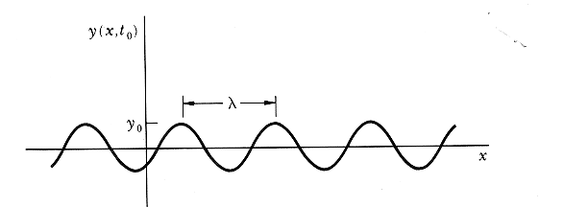
looking at harmonic wave at an instant t = t₀ the wave function y(x,t₀) describes shape of string as it would appear in a “shapshot” photograph

shape is a cosine or sin (depending on choice of origin)

if we watch what is happening at a particular point x₀ , wave function y(x₀,t) describes motion of that point on the string, as y sinusoidal function, motion of any point is simple harmonic motion with amplitude y₀ and frequency f

Important property of all waves is energy density (energy per unit volume) in the wave, η ~ y₀²
(energy density proportional to square of amplitude)

Intensity of wave is energy transported per unit time per unit area. i.e. W m⁻² , i.e. power density when particle gets detected, wave function collapses as a result of the measurement, it is no longer a superposition of states, it is a definitive probability result

Intensity of wave is energy density times wave speed
I = η v ~ y₀²

(intensity also proportional to square of amplitude)

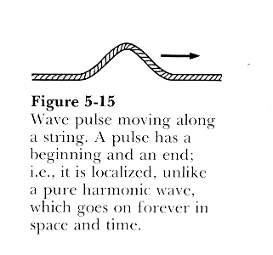
but any other type of wave pulse, i.e. a localized wave we need for traveling with particle, can be represented by superposition of harmonic waves of different frequencies and wavelength !!

Wave groups/packets/pulses – useful mathematical models

pilot wave must be localized in space and time in order to represent a particle

similar to a plus in classical wave, e.g. flip on one end of a rope that moves to the other end, sudden noise, brief opening of a shutter in a camera all these events are localized in time and space – a single harmonic wave, on the other hand, is not localized in space and time
pilot wave and (pulse) can be represented by a wave group,

model obtained by adding sinusoidal (harmonic) waves of different wavelengths

wave group, pulse, has limited extend, moves with the “group velocity” equivalent to particles velocity

sinusoidal waves interfere constructively at pulses and destructively between pulses

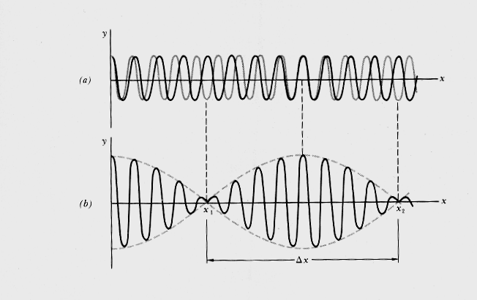
example “two sinusoidal waves result in a pulse model” (pulse is quite extended, it is – only two waves make it up) phenomenon is known as beat
two sinusoidal waves with same amplitude y₀ but different k₁, k₂ ω₁ ω₂ are added
y₁₊₂(x,t) = y₀ cos (k₁x – ω₁t) + y₀ cos (k₂x – ω₂t) = 2 y₀ {cos[½ (k₁ –k₂) x - ½ (ω ₁ – ω ₂)t] cos[½ (k₁ +k₂) x - ½ (ω ₁ + ω ₂)t] }

lets call Δk = k₁ - k₂ Δ ω = ω ₁ - ω ₂

and arithmetic mean k = ½ (k₁ +k₂) ω = ½ (ω ₁ + ω ₂)

y₁₊₂(x,t) = [2 y₀ cos (½ Δ kx – ½ Δ ωt)] cos (kx - ωt)

the two individual waves move with speed ^{mean ω}/ _{mean k} also know as phase speed

dashed curve is envelope of group of two waves, given by the term in straight brackets [ ], moves with ^{Δω}/_{Δk} = group velocity, = velocity of the particle, pulse,

if x₂ and x₁ are two consecutive values of x for which the envelope is zero, we may take Δx = x₂ - x₁ as spatial extend of group,

½Δ kx₂ - ½Δ kx₁ = π or rearranged Δx Δk = 2π

a mathematical uncertainty principle!

for a particular value of x = x₀

y(x₀,t) looks similar to y(x,t₀), then we have an interval Δt to consider (just as we did above for Δx) and we get a second mathematical uncertainty principle Δω Δt = 2π

if the “extend” of the pulse should be small in space and time, and most importantly shall be zero outside the pulse nearly everywhere, many many many different waves with different k, ω, and amplitudes are needed, problem solved in Fourier series

for such a pulse two mathematical uncertainty principles

Δx Δk ≈ 1

Δω Δt ≈ 1 (depending on how exactly the
quantities are defined!!!)

meaning: the smaller the spatial extend Δx, the more wavenumbers Δk are needed

the smaller the time duration Δt, the more circular frequencies Δω are needed

{latter also known as response-time-bandwidth relation, an amplifier must have a large bandwidth (Δω) if it is to be able to respond to signals of short duration (Δt)}

– these are mathematical results of wave particle duality as our pulse represents a particle

important distinction

there is group velocity = velocity of the particle

v_{group} = $\frac{dω}{\text{dk}}=v_{\text{phase}}−λ\frac{{\text{dv}}_{\text{phase}}}{dλ}$= v_{particle} = $\frac{p}{m}$

there is phase velocity, between two successive crests of the constituent waves of the pulse, as well

v_{phase} = $\frac{c^{2}}{v_{\text{particle}}}$= $\frac{E}{p}$ = f λ ≥ c (it’s only a model not
the real speed of anything physical !!!)

but v_{group}, i.e. the velocity of the particle is always smaller than c for particles with mass and equal c for massless particles

when an wave group describes a real physical particle we have an uncertainty principle with physical meaning (^{h}/_{2π}) – these are physical (real) results of wave particle duality

Heisenberg’s uncertainty principle

mathematical uncertainty of wave groups

Δx Δk ≈ 1

Δω Δt ≈ 1

multiply both sides by ^{h} / _{2π} and use p = ^{hk} /_{2π} and E = ^{hω} /_{2π}

you get

Δx Δp ≈ ^{h} / _{2π}

ΔE Δt ≈ ^{h} / _{2π}

if a measurement of position is made with precision Δx and a simultaneous measurement of momentum in the x direction is made with precision Δp_{x}, then the product of the two uncertainties will be about ^{h} / _{2π} and can never be smaller that ^{h}/_{4π} (where we use standard deviations of Gaussian peaks as measures for Δx, Δp, ΔE, Δt)

Δx Δp_{x} ≥ ^{h}/_{4π}

one could also say there is no Δp_{x} = 0 in nature, things are always moving,
analogously there is no Δp_{y} = 0 and Δp_{z} = 0 in nature, even if the particle is know to move only in x and v_{y} = v_{z} = 0 accordingly

it has nothing to do with difficulties to measure on a small scale precisely, nothing to do with imperfections in the measurement apparatuses, such difficulties and imperfections will increase uncertainty beyond the natural limit given above)

it is just if a particles position is to be described at a certain small accuracy Δx, one needs a correspondingly large number of wave-vectors k_{x}, i.e. a large Δk_{x} which result in a large Δp_{x} - if one uncertainty increases the other decreases
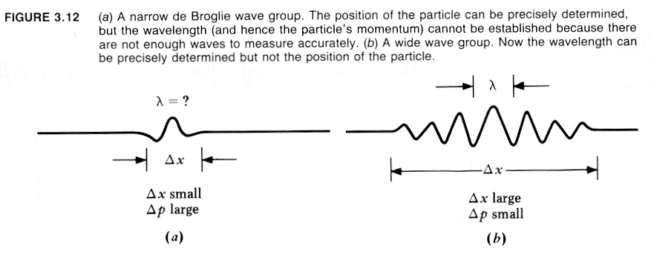

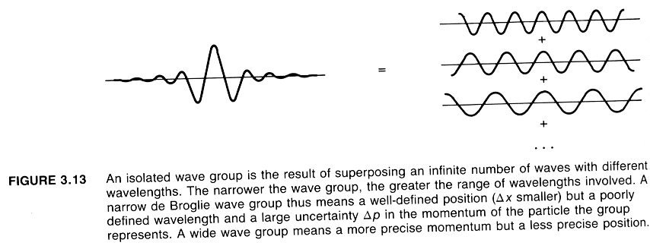

analogous: energy –time uncertainty principle

ΔE Δt ≥ ^{h}/_{4π}

the precision with which we can measure energy is limited by the time available for the measurement

pico-scopic view of uncertainty principle
thought experiment by Heisenberg (not correct, Heisenberg originally thought uncertainty was a result of measurement process –it is more a show case as the uncertainty principle is not about measurements, but Bohr thought uncertainty is a result of the wave particle duality – this is the commonly accepted view today !!! as the particle in a box is always moving in x,y,z a bit, we never have a precise position for it, as the wavelength is always finite, we do not have a precise momentum for it – that’s the prize to pay for a consistent view of the world – for engineering at the microscopic level, nanotechnolgy, ….)

Einstein was always uneasy about quantum mechanics: after a lecture by Heisenberg on uncertainty principle: ”Marvellous, what ideas the young people have these days, but I don’t believe a word of it.”

observed one electron by the scattering of one photon in a microscope
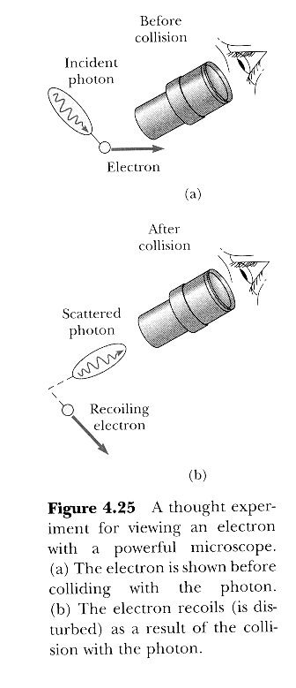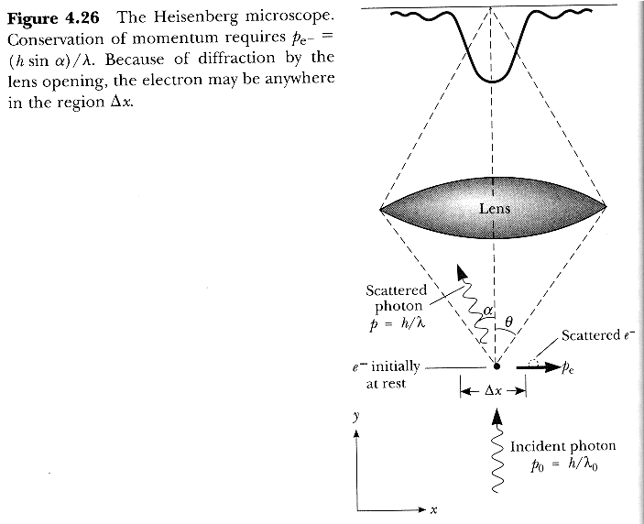

take small wavelength light photon, X- or gamma ray, bounce it off an electron to see where it is, problem a small wavelength photon has a lot of energy, a large momentum!!! so it will knock around the electron quite a bit by means of momentum transfer in a collision, which makes determining precisely its momentum impossible

take a long wavelength light photon, radio wave, bounce it off an electron, energy and momentum are small, so the uncertainty of the momentum is smaller but as the wavelength is now long, the uncertainty in the place measurement will be large as this is depended on the wavelength, remember you get only a magnification of about 10³ in a light microscope because you are looking with 550 nm, light but a 10⁶ magnification in an electron microscope because you are looking with a wavelength of 2.5 pm

conservation of momentum as in Compton effect allowing the scattered light to be observed (by objective with aperture half angle θ_{max})

range for the photon with p’ = p║’ + p┴ ‘ and λ’ to be collected by the objective is 2 θ, prime after collision

p║ = ^{h}/_{λ} = ^{h}/_{λ’} cos θ + p_{ele} cos Φ in y direction, photon coming up

(p_{ele} cos Φ not to be considered farther)

p┴ = 0 = ^{h}/_{λ’} sin θ - p_{ele} sin Φ in x-direction

say Φ is large, e.g. 90 °, electron is heading off in the x direction

sin 90 ° = 1 so for that angle the momentum of the electron is maximum

i.e. electron can have maximal momentum of either/or
(meaning +- in equation)

p_{┴ele max} = ± ^{h}/_{λ’} sin θ,

i.e. an magnitude of uncertainty Δp_{┴ele} = 2 ^{h}/_{λ’} sin θ and the photon that scatted off it (and tells us, wait a minute, there actually was an electron) will still be collected by the objective

smallest Δx that can be imaged in microscope is ^{λ’}/_{2 sin θ}

Δp_{┴ele} Δx = 2 ^{h}/_{λ’} sin θ ^{λ’}/_{2 sin θ}

= h ≥ ^{h}/_{4π} agreement with uncertainty principle

increasing the half angle of the objective allows for more precise Δx measurements, but allows at the same time a greater uncertainty of the Δp_{x}

vice versa: decreasing the half angle of the objective allows for less precise Δx measurements, but reduces at the same time the uncertainty of the Δp_{x}
– one can’t beat the principle

in order to probe the electron we needed one photon and we only knew it came up to “illuminate” and scatter at the electron – there is absolutely nothing to probe where the path of the photon actually was, so we cannot predict as a matter of principle where exactly it hit the electron and what exactly the momentum was it transferred to the electron - the limit in our measurement increased the product of Δp_{┴ele} Δx beyond that what comes out of the mathematical model for wave-particle duality entity with physical meaning

all only goes to show the impossibility of predicting (and measuring) the precise classical path of a quantum object – results: there are no precise paths in nature

luckily macroscopic objects are not at all noticeable effected by uncertainty principle

human being 80 kg, “confined” (Δx) to a class-room of 20 m length (x) running towards the door with v_{x} = 10 ^{km}/_{h} = 2.78 ^{m}/s (as determined from classical physics)

minimal uncertainty Δx Δp_{x} = ^{h}/_{4π} = Δx mΔv_{x}

so Δv_{x} = $\frac{6\text{.}\text{625}⋅{\text{10}}^{−\text{34}}{\text{kgm}}^{2}s^{−1}}{4π⋅\text{20}m⋅\text{80}\text{kg}}$= 3.295 10^{-38 m}/_{s}

i.e. velocity in x is really 2.78 ± 3.295 10⁻³⁸ ^{m}/s

assuming a height (v_{z}) of 4 m, and v_{z} = 0, there is as well an uncertainty principle for the z-direction to be taken care off

Δz Δp_{z} = ^{h}/_{4π} = Δz mΔv_{z}

but this is only going to be $\frac{6\text{.}\text{625}⋅{\text{10}}^{−\text{34}}{\text{kgm}}^{2}s^{−1}}{4π⋅4m⋅\text{80}\text{kg}}$= 6.59 10^{-38 m}/_{s}

i.e. the velocity in z is 0 ± 6.59 10^{-38 m}/_{s}

on the other hand, spectral lines have a certain widths due to uncertainty principle

ΔE Δt ≥ ^{h}/_{4π}

say the lifetime (Δt) of an excited state in an atom is 10⁻⁷ s

with ΔE = h Δf

we get Δf = ^{h}/_{4π} ¹/_{h Δt} = ¹/_{4π Δt} = 7.9577 10⁵ Hz

i.e. exited states with long lifetimes give sharp spectral lines, in other words, time is needed for a system to settle into a specific energy state, the more time there is for this settling the more precisely will the energy be defined

Uncertainty principle is not a negative statement, it’s a fundamental law of nature, can be used to calculate, e.g. the ground state size and ground state energy level of an hydrogen atom

E = KE + PE

E = ½ mv² - $\frac{{\text{ke}}^{2}}{r}$ with ½ mv² = $\frac{p^{2}}{2m}$

E = $\frac{p^{2}}{2m}$- $\frac{{\text{ke}}^{2}}{r}$

order of magnitude of position uncertainty, say Δx = 0.5 r, then uncertainty principle gives Δp² ≥ $\frac{h^{2}}{(4⋅0\text{.}5)^{2}π^{2}r^{2}}$

E ≥ $\frac{h^{2}}{4π^{2}r^{2}2m}−\frac{{\text{ke}}^{2}}{r}$

there is a radius at which E is minimum, that will be the stable radius, as lowest energy states are stable

^{dE}/_{dr} ≥ $(\frac{h^{2}}{4π^{2}2m}⋅−2r^{−3})−(\frac{{\text{ke}}^{2}}{1}⋅−1r^{−2})$= 0

resolving for

r_{minimum} = $\frac{h^{2}}{4π^{2}e^{2}\text{km}}=a_{0}=0\text{.}\text{053}\text{nm}$ exactly Bohr’s radius

resolving for E_{minimum} by using r_{minimum}

E_{minimum} = $−\frac{k^{2}e^{4}m4π^{2}}{2h^{2}}=E_{1}=−\text{13}\text{.}6\text{eV}$ exactly Bohr’s
ground state energy

now the result really depended on setting Δx = 0.5 r which is reasonable but somewhat arbitrary Δx = 1 r, or 2r, or only 0.1 r are also reasonable, important is here that the right order of magnitude comes out and would have come out for any reasonable choice of Δx !!!

back to pilot wave, it is not a wave that requires a medium, it is not a physically meaning full wave (as parts of it travel faster or at least equal to the speed of light) its “square” is a probability density function

probability density means the probability of finding a particle at a particular set of coordinates (x,y,z,t)

Wave-particle duality

all phenomena in nature are describable by a wave function that is the solution of a wave equation.

wave function for light is E(x,t) it is solution of
$\frac{∂^{2}y}{∂x^{2}}=\frac{1}{v^{2}}\frac{∂^{2}y}{∂t^{2}}$ wave equation

wave function for electron is Ψ(x,t) is solution of Schrödinger equation, i.e. a different partial equation

Ψ(x,t)² is probability per unit volume, i.e. probability density that electron is in a given region at a certain time

Ψ(x,t) behaves just like E(x,t) can diffract, interfere, so it is the mathematical description of phenomena we looked for to account of wave properties of particles

when electron or photon interact with matter, exchange of energy and momentum, wave functions “collapse” as a result of the interaction, interaction can be described by classical particle theory (we do not need wave properties there)

there are phenomena when classical particle and classical wave theory give same results, if wavelength of photon or electron is much smaller than any object or aperture, particle theory can by used as well as wave theory to describe wave/particle propagation, because diffraction and interference effects are too small to be observed, (e.g. Newton’s ray treatment of geometrical optics, classical mechanics in general)

even with classical waves that need a medium to propagate, there is a “particle” associated with the wave, that particle is called a pseudo-particle, e.g. a phonon for a sound wave propagating through a solid with a lattice structure, because the phonon does not exist in empty space we call it a pseudo-particle, but it has all other properties of a real particle which can exist in empty space

back to double slit diffraction experiment

Heisenberg’s uncertainty principle can be rephrased as: it is impossible to measure through which slit the single photon/electron passed in a double slit interference experiment without disturbing the interference pattern

experiments one electron at a time, over some time interval

1. experiment, two single slit experiments separately

only one slit open, intensity distribution according to Ψ₁² = Ψ₁ *Ψ₁

only other slit open, intensity distribution according to Ψ₂² = Ψ₂ * Ψ₂

2. experiment, two single slit experiments combined

half to the time one slit open (second blocked), then other half of time other slit open, intensity distribution Ψ₁² + Ψ₂² simply adding up of intensities for one slit experiment (Ψ₁*Ψ₁ )+(Ψ₂ *Ψ₂

3. experiment, double slit

electron is in wave function of superposition state Ψ = Ψ₁ + Ψ₂

probability of detecting electron at screen is Ψ² = (Ψ₁ + Ψ₂)²

Ψ₁ and Ψ₂ describe different path, distances to the screen, so they will have a phase difference Φ

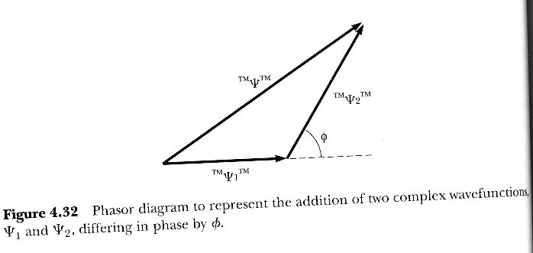
Ψ² = (Ψ₁ + Ψ₂)² = Ψ₁² + Ψ₂² + 2 │‌Ψ₁│ │Ψ₂│cos Φ describes the interference pattern even for one electron
what will happen if we try to measure through which slit the single electron passed?
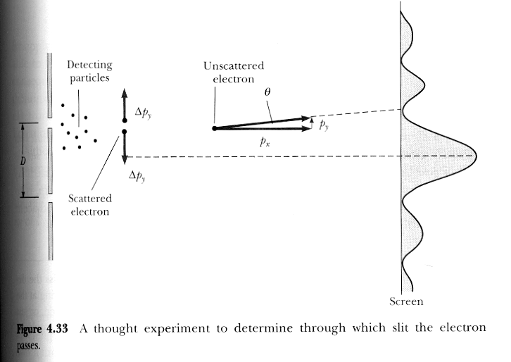

D, distance between slits is much larger that widths of the slits,

intensity minima occur when path difference between two waves originating from the slits

is D sin Θ = ^{λ}/₂
with de Broglie wavelength λ = $\frac{h}{p_{x}}$

we got for a far away screen
sin Θ = Θ = $\frac{h}{2p_{x}D}$ since angels are small

let’s assume uncertainty principle is true and look at double slit experiment again, a cloud of electrons behind one of the slits, if (beam) electron goes through that slit it will collide with one of these probing electrons

we can only use a probing electron of whom we know the position to al least Δy < ^{D}/₂

if Δy < ^{D}/₂ it follows from
Heisenberg’s statement Δy Δp_{y} ≥ ^{h}/_{4π}

that Δp_{y} ≥ ^{h}/_{2πD}

If the beam electron was originally heading towards the interference pattern maximum at θ = 0 with its momentum
p_{x} = ^{h}/_{λ} (de Broglie’s equation) it will be deflected by an angle

± Δθ ≈ $\frac{2{Δp}_{y}}{p_{x}}=\frac{2hλ}{2π\text{Dh}}=\frac{λ}{πD}$

angle to reach the interference minimum was

sin θ ≈ θ = $\frac{h}{2p_{x}D}$ with de Broglie p_{x} = ^{h}/_{λ}

θ = $\frac{λ}{2D}$, i.e. Δθ and θ are at the same magnitude,
Δθ ≈ 64% of θ, so the interference pattern will be significantly disturbed by our attempt to measure through with slit the (beam) electron went through

once upon a time, Descartes, Newton, physicists before 1927 (Heisenberg) considered nature to be strictly deterministic, there is a cause to every effect and we can work out the cause by studying the effect, clockwork universe if we know precisely the position and momentum of a planet at a point in time, we can calculate for all other times in the future and past its position and momentum.
with quantum physics, everything is down to probabilities, we can’t predict the future or figure out what caused an effect in the past, because we have only a probabilistic (not deterministic = probability always 100%) knowledge of the present

