Exoplanents Part II
Sara Marvin, Kelly Anderson, Sereane Bowstring
November 1, 2010

Radial Velocity (Doppler Shift) – currently can only find giant planets relatively close to their stars (hot Jupiters)

Observe:
- Orbital period
- average distance between planet and its star

1995: The first planet discovered by Radial Velocity
51 Pegasi:
- G type star (like our star) – yellow dwarf star
- Roughly ½ Jupiter mass
- It is located 50 light years away in constellation Pegasus
- Orbits star every 4.2 days
- Visible from Earth with binoculars or naked eye if conditions are right
- 51 Pegasi b first discovered companion
  - further companions designated c, d, e....
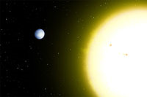
Artist's conception of 51 Pegasi and orbiting planet 51 Pegasi b.
http://en.wikipedia.org/wiki/51_Pegasi

Upsilon Andromeda:
- Binary star system = 2 stars orbiting each other
- Primary star is a yellow dwarf – F type star
- Secondary is a red dwarf – M type star 750 AU from companion
- System is located 44 light years away
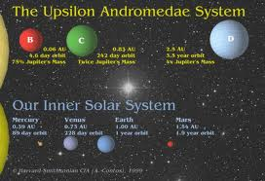
- Both have eccentric (elliptical) orbit which keeps them in the habitable zone
- Orbit is three years long
http://rst.gsfc.nasa.gov/Sect20/A11.html

47 Ursae Majoris:
- G type Star (like our star)
- 2 planets
- circular orbits (prime for habitable zones)
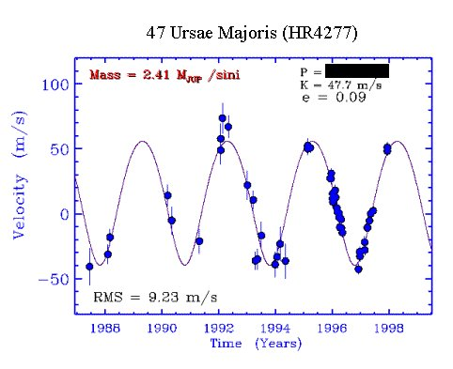
- 2010 found a third planet that orbits way for out from the other two planets
- Located 46 light years away (roughly our asteroid belt distance)
http://btc.montana.edu/ceres/html/Wobble/wobblesactivity3.htm

GL – 581 c:
- As of April 2007 – New Planet (first with possibility for life)
- Bigger than Earth with a higher gravity than Earth
- Orbits red dwarf star every 13 days
- Roughly Circular orbit
- Within habitable zone of its star
- Environment suitable for stable liquid H20 on surface (temperature between freezing and boiling points)
- Found with an Earth based telescope (in Chile)
- 20.3 light years away

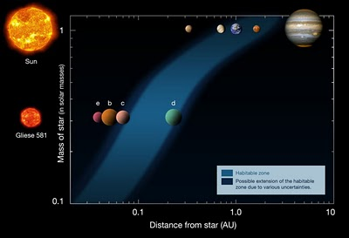
http://beforeitsnews.com/story/196/067/NASA_-Habitable_Planet_GLIESE_581_G_Could_Have_Extraterritorial_Life.html

Radial Velocity Surprises:
- Locates massive planets close to their stars (hot jupiters)
  - Which did not fit models for forming planetary systems
- Most orbits were not circular but fairly elliptical (eccentric) orbits
  - also did not fit models
  - However, it does not mean these kind of systems are most common, it’s just that “this technique can only find hot jupiters” and it, in fact, has located hundreds of them

To go further in finding exoplanets that are something other than gas giants, additional techniques are needed.
Planetary transits – detect planets when a stars light dims because of the planet passing in front of it.
- Need to view system edge on
- Detects mostly big planets (hot Jupiters) that are close to their star (rapid orbit)
- Brightness variations depend on planet eclipses (which is dependent on ratio of planet size and orbit speed)
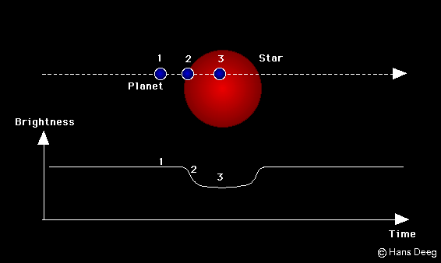
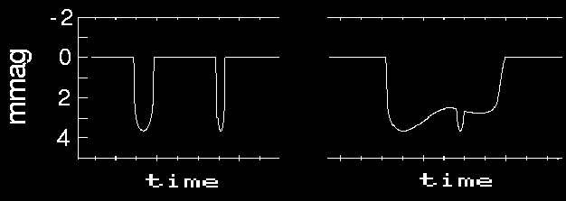
  - 1% dimming from Jupiter across the sun
  - 0.008% dimming from Earth
http://www.iac.es/proyecto/tep/transitmet.html
- The line in the graph is the brightness from the star that the planet is passing in front of.
- The dip represents the lack of light (dimness) that is caused by the mass of the planet passing.

First transit exoplanet - HD209458 – 2000 in Finland
- G type star – yellow dwarf that is 0.6 Jupiter mass
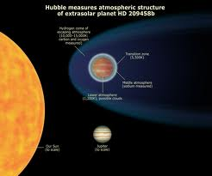
- Located roughly 150 light years away
http://astronomyonline.org/aoblog/AOBlog46.asp

As of July 2010:
- The transit method has detected 87 planets and 87 systems
- 4 multiplanet systems also detected which means there is a discrepancy somewhere in the counts
  - Most likely the counts are 87 plants and 83 or fewer systems
- Majority of planets are large gas giants, close to their star
Gravitational Lensing/microlensing:
- Taken from Einsteins theory of relativity that any object with mass bends or distorts space
- When light from distant objects pass through a deformed space around a massive object, the light is then bent and focused
- cluster of galaxies “lensing” more distant objects
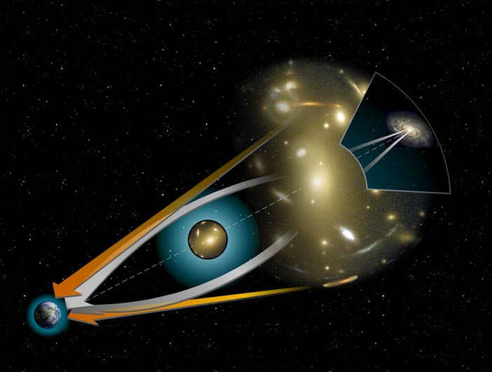
- Stars and planets magnify background star light when they pass in front
http://plus.maths.org/latestnews/may-aug08/algebra/lens.jpg

As of 2009 – 9 planets have been detected around 8 stars with the microlensing method
OGLE – 06 – 109L discovered in 2008
- ½ mass of our sun and appears to have 2 planets
- Roughly 4,920 light years away

Lensing is a promising technique for detecting smaller planets like Earth and farther from the star than the giants that have been detected thus far.
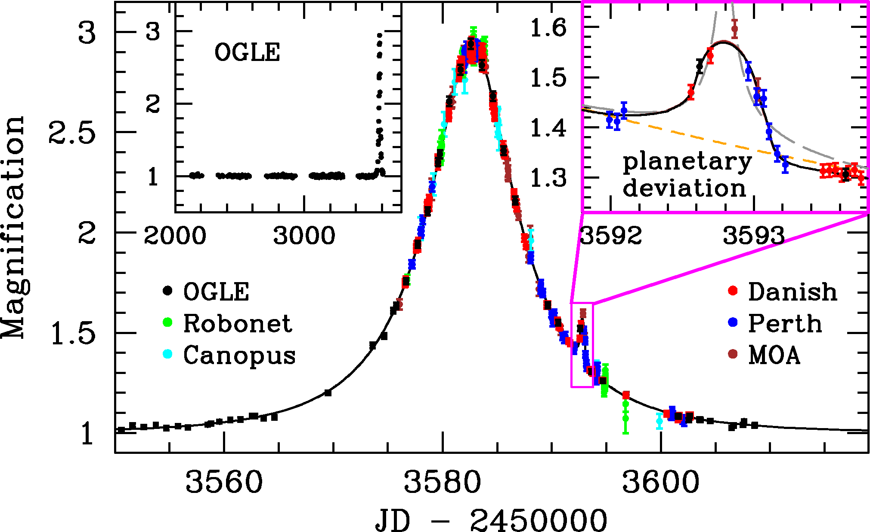
http://www.aip.de/highlight_archive/dominis_microlensing/light_curve.gif

- Brightness and magnification of the background star is the vertical
- Visible humps off to the sides of the vertical are planets
  - If hump is bigger than the planet is more massive and generally closer to the star than a hump that is smaller

Indirect Methods (those listed above):
- Only see tips of the iceberg
- Microlensing is the best possibility of finding terrestrial size exoplanets (Venus, Earth, Mars). However, all methods have been successful at detecting large gas giants (Jupiter and Saturn size exoplanets)

Direct Imaging:
- With visible light, the planet is lost to glare of the star
- Using infrared light allows the planet to be more illuminated because it dims the glare from the visible light emitted from the star
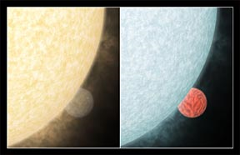
http://www.news.cornell.edu/stories/March05/Transit-still72.jpg

