Steven Brockman
Justin Harris
G345
Class Notes
November 3, 2010

Notes for 11/3

Directly Observing a planet

Visible Light Spectrum
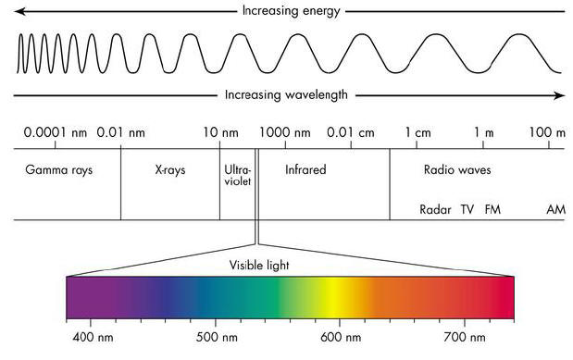
http://quarknet.fnal.gov/quarknet-summer-research/QNET2010/Astronomy/em_spectrum.jpg

Visible light is reflected light and the human eyes has a range from about 400 to 700nm.

Direct Imaging - Seeing a planets reflected sunlight or its own thermal emissions. This method looks at infrared wave lengths and visible (optical) bands.

Direct image of exoplanets around the star HR8799.
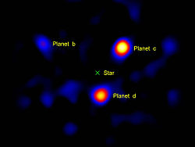
http://en.wikipedia.org/wiki/File:444226main_exoplanet20100414-a-full.jpg

WASP-

“WASP-12b is the hottest known planet in the Milky Way galaxy, and it may also be the shortest-lived. The planet is being eaten by its parent star, according to observations made by a new instrument on NASA's Hubble Space Telescope, the Cosmic Origins Spectrograph (COS). The planet may only have another 10 million years left before it is completely devoured. The discovery has been documented in The Astrophysical Journal Letters.
WASP-12 is a yellow dwarf star located approximately 600 light-years away in the winter constellation Auriga. The exoplanet was discovered by the United Kingdom's Wide Area Search for Planets (WASP) in 2008. The automated survey looks for the periodic dimming of stars from planets passing in front of them, an effect called transiting.
WASP-12b is so close to its sunlike star that it completes an orbit in 1.1 days, is superheated to nearly 2,800 degrees Fahrenheit and stretched into a football shape by enormous tidal forces. The atmosphere has ballooned to nearly three times Jupiter's radius and is spilling material onto the star. The planet is 40 percent more massive than Jupiter.”
http://www.science20.com/news_articles/sunlike_star_devours_planet_wasp12b
Direct Detection requires 3 infrared images, exposed in H, K & L wavebands with NACO- Adaptive Optics Facility & 8.2m aperture with VLT at the ESO Parnal Observatory.

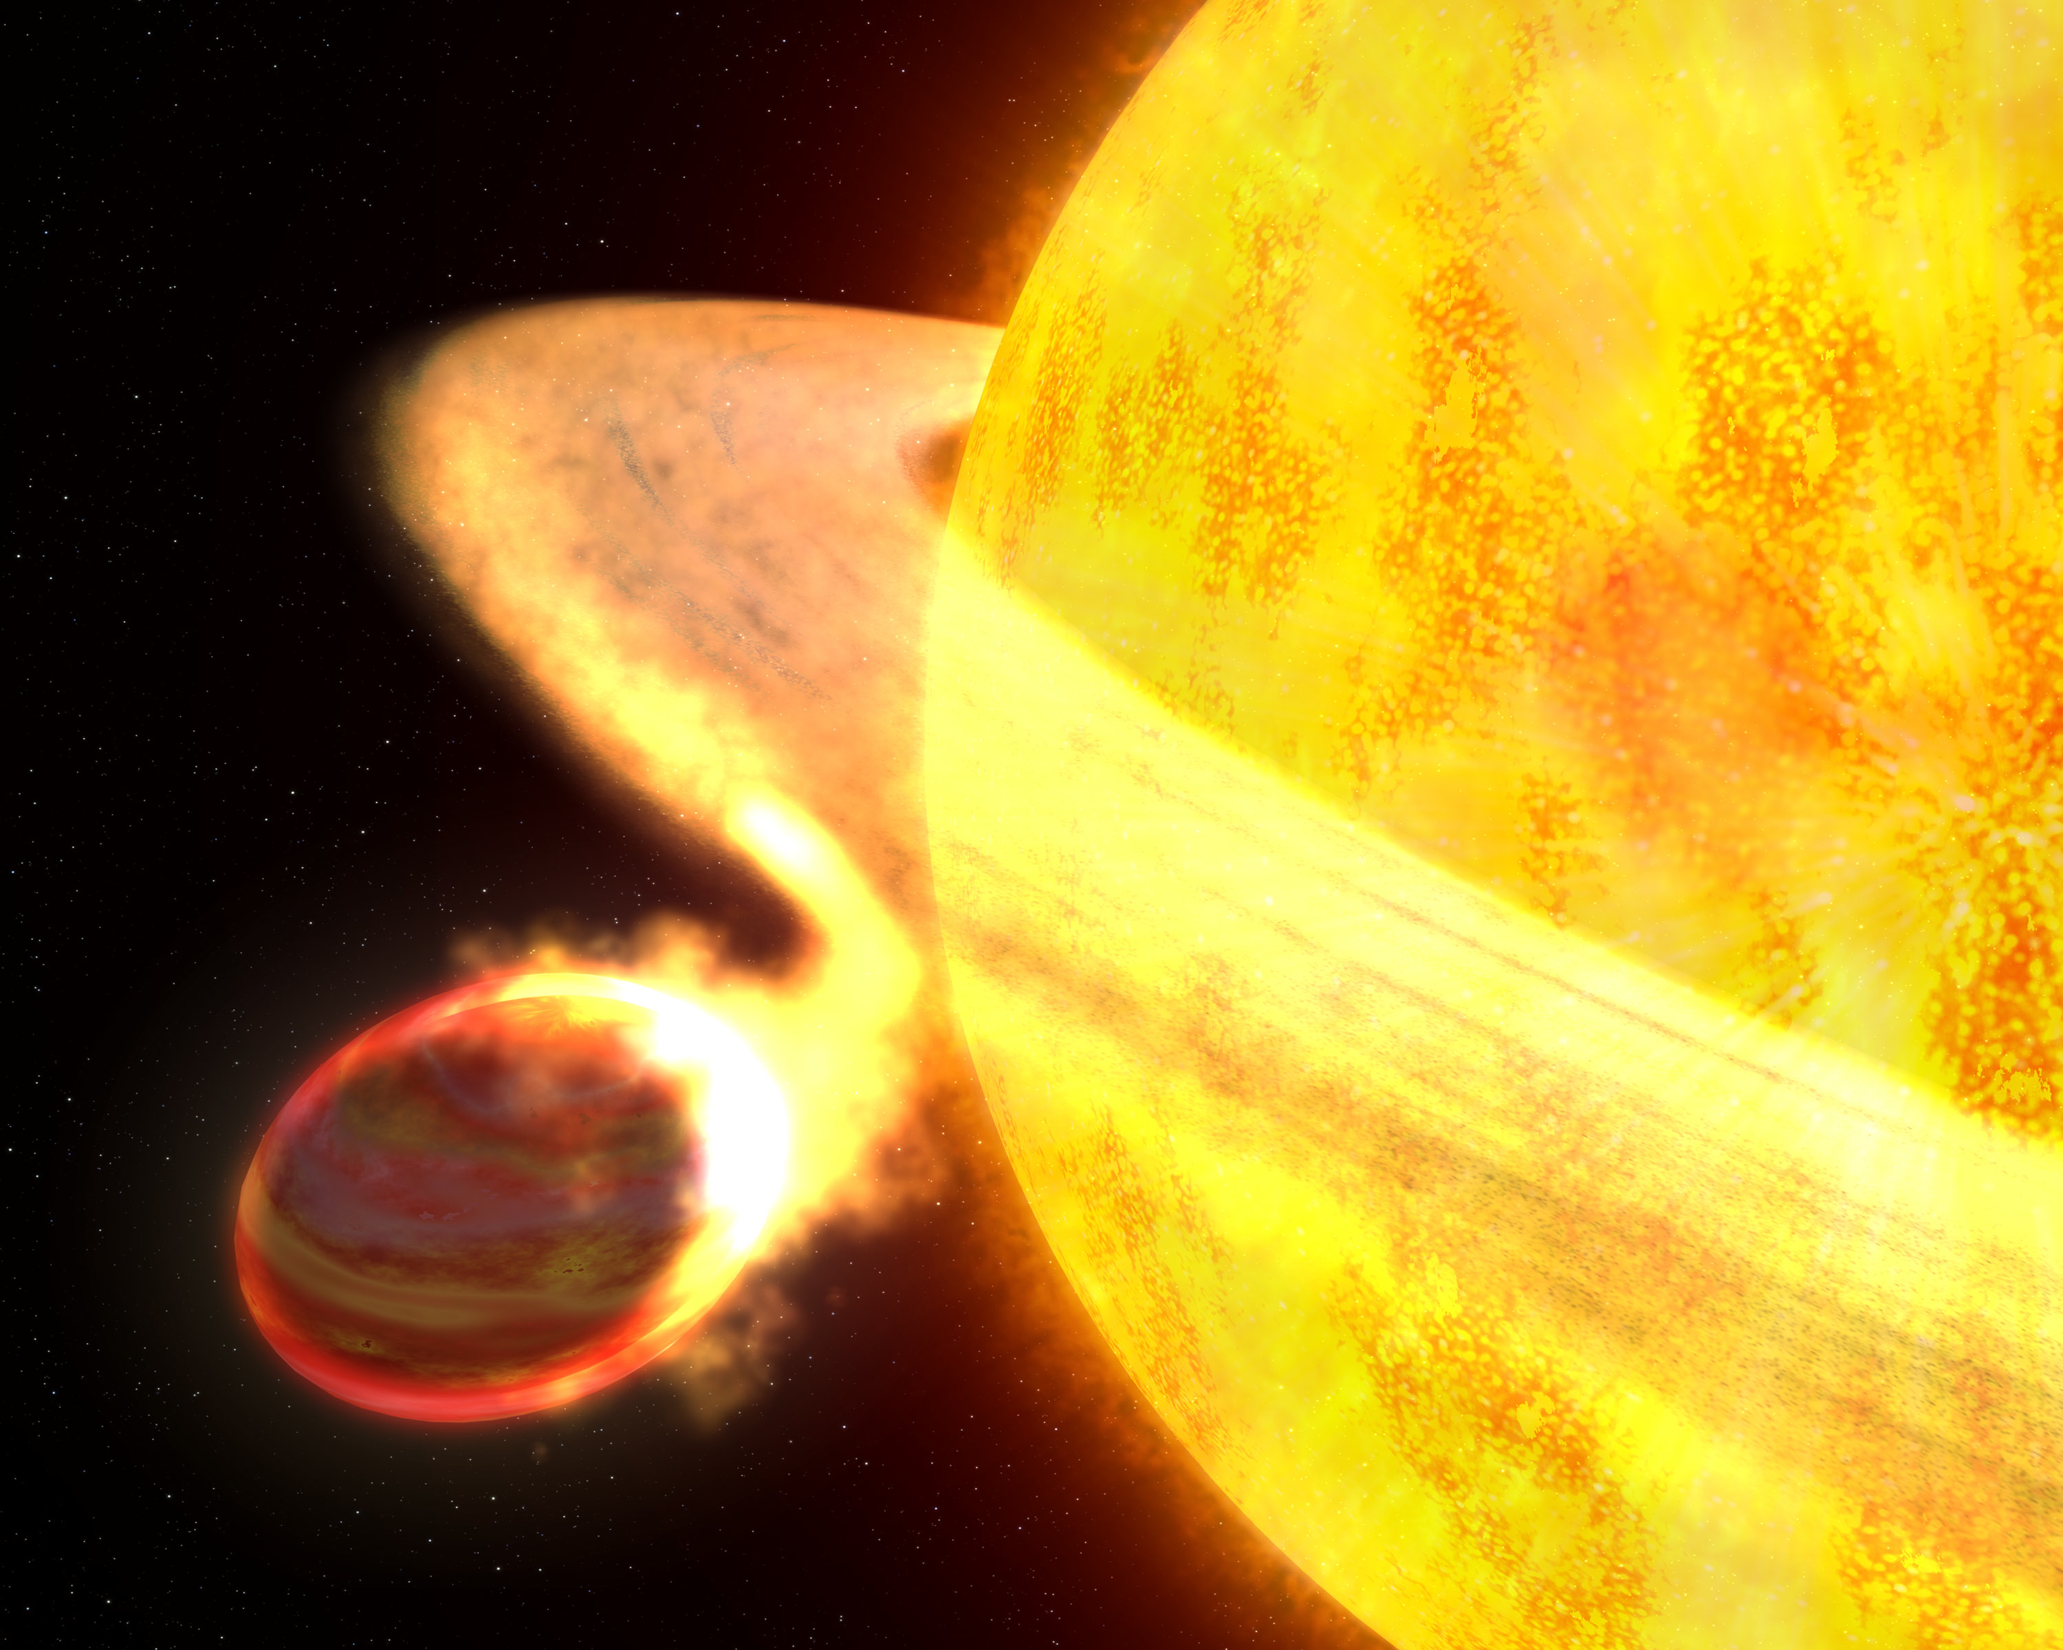
http://www.nasa.gov/images/content/456076main_hst-2010-15.jpg

Detection through planetary transits.

The link below is a good animation of a transiting planet around the star HD209458.

http://www.iac.es/proyecto/tep/transitanim.html

From NASA detecting transiting planets.
http://kepler.nasa.gov/Science/transitDetectionAndSimulation/

When a planet crosses in front of its star as viewed by an observer, the event is called a transit. Transits by terrestrial planets produce a small change in a star's brightness of about 1/10,000 (100 parts per million, ppm), lasting for 1 to 16 hours. This change must be periodic if it is caused by a planet. In addition, all transits produced by the same planet must be of the same change in brightness and last the same amount of time, thus providing a highly repeatable signal and robust detection method.

http://kepler.nasa.gov/Mission/QuickGuide/

Other good web sites:
http://Exoplanets.org/

The Hubble Telescope saw the first exoplanet in visible light in November of 2008. It was 115AU from its star and Jupiter sized. Jupiter sized planets are relatively common. As of July 2010, 453 exoplanets had been tallied. There may be anywhere from 500-600 exoplanets now.

Our solar system vs. others

The way our solar system works is a good model for many other solar systems in the galaxy but some solar systems orbit in the opposite direction and in these cases, they do not fit our models.

Earthlike planets in habitable zone planned missions

-Keck interferometer and other ground based telescopes

-Hubble Space (NASA)

-Spitzer Space (NASA)

-CORAT (ESA)

-Kepler (NASA)

-SIM Planet quest (NASA)

HR879 Planetary System compared to our solar system
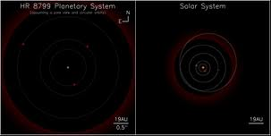
http://www.nouvelles.umontreal.ca/archives/2007-2008/content/view/2021/125/index.html

In November of 2008, the Keck Observatory found three planets imaged in near infrared,

Spitzer -

In 2007, it took first spectra of 2 extra solar planets. In 2008, it found two asteroid belts around planetary system

.

Jupiter compared to the size of HD 189733b
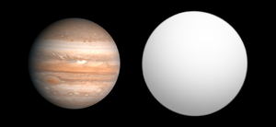
http://en.wikipedia.org/wiki/HD_189733_b
- This planet is slightly more massive than Jupiter. It orbits around its sun every 2.2 days and its atmosphere is moving rapidly

Jupiter compared to the size of HD 209458b
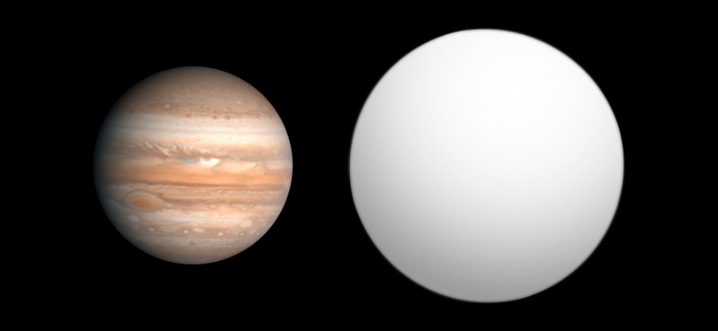
http://commons.wikimedia.org/wiki/File:Exoplanet_Comparison_HD_209458_b.png
This planet was first discovered using ground based telescopes. Later, Spitzer detected it using infrared. It has no water vapor but it has clouds of silicated dust in the atmosphere.

COROT was launched by the European Space Agency in 2008. It was designed to search for extra solar planets and to perform astroseismology. It found six large planets. It was also the first to see oscillations(sun quakes).
Corot 3b is a brown dwarf.

2009- smallest exoplanet - Corot 7b. It I sat 0.17 AU orbiting around a KO star every 20 hours. It may be an ocean planet.

Kepler Space Observatory - This has an earth trailing heliocentric orbit and will survey a large number of stars for transit indicating movement.

The final problem detecting life:
1) Small rocky planet.
2) Must be habitable zone (HZ) with liquid water.
3) Not tidally locked (restricts location relative to star).
4) Must catch planet at just the right time in it’s evolution.
Time line must be right (narrow window for complex life).

