Overview of Section IV:
International Macroeconomic Policy
Part IV of the text is comprised of five chapters:
Chapter 19 International Monetary Systems: An Historical Overview

Chapter 20 Optimum Currency Areas and the European Experience
Chapter 21 Financial Globalization: Opportunities and Crisis
Chapter 22 Developing Countries: Growth, Crisis, and Reform

Section Overview
This final section of the book, which discusses international macroeconomic policy, provides historical and institutional background to complement the theoretical presentation of the previous section. These chapters also provide an opportunity for students to hone their analytic skills and intuition by applying and extending the models learned in Section III to a range of current and historical issues.
The first two chapters of this section discuss various international monetary arrangements. These chapters describe the workings of different exchange rate systems through the central theme of internal and external balance. The model developed in the previous section provides a general framework for analysis of gold standard, reserve currency, managed floating, and floating exchange-rate systems.
Chapter 18 chronicles the evolution of the international monetary system from the gold standard of
1870–1914, through the interwar years, and up to and including the post-war Bretton Woods period.
The chapter discusses the price-specie-flow mechanism of adjustment in the context of the discussion
of the gold standard. Conditions for internal and external balance are presented through diagrammatic analysis based upon the short-run macroeconomic model of Chapter 16. This analysis illustrates the strengths and weaknesses of alternative fixed exchange rate arrangements. The chapter also draws upon earlier discussion of balance of payments crises to make clear the interplay between “fundamental disequilibrium” and speculative attacks. There is a detailed analysis of the Bretton Woods system that includes a case study of the experience during its decline beginning in the mid-1960s and culminating
with its collapse in 1973.
Chapter 19 focuses on recent experience under floating exchange rates. The discussion is couched in
terms of current debate concerning the advantages of floating versus fixed exchange rate systems.
The theoretical arguments for and against floating exchange rates frame two case studies, the first on the experience between the two oil shocks in the 1970s and the second on the experience since 1980. The transmission of monetary and fiscal shocks from one country to another is also considered. Discussion
of the experience in the 1980s points out the shift in policy toward greater coordination in the second
half of the decade. Discussion of the 1990s focuses on the strong U.S. economy from 1992 on and the extended economic difficulties in Japan. Current topics, such as the funding of the large U.S. current account deficit and the general problem of today’s “global imbalances” are also discussed. Finally, the chapter considers what has been learned about floating rates since 1973. The appendix illustrates losses arising from uncoordinated international monetary policy using a game theory setup.
Europe’s switch to a single currency, the euro, is the subject of Chapter 20, and provides a particular example of a single currency system. The chapter discusses the history of the European Monetary
System and its precursors. The early years of the E.M.S. were marked by capital controls and frequent realignments. By the end of the 1980s, however, there was marked inflation convergence among E.M.S. members, few realignments and the removal of capital controls. Despite a speculative crisis in 1992–3, leaders pressed on with plans for the establishment of a single European currency as outlined in the Maastricht Treaty which created Economic and Monetary Union (EMU). The single currency was viewed as an important part of the EC 1992 initiative which called for the free flow within Europe of labor, capital, goods and services. The single currency, the euro, was launched on January 1, 1999 with eleven original participants. These countries have ceded monetary authority to a supranational central bank and constrained their fiscal policy with agreements on convergence criteria and the stability and growth pact. A single currency imposes costs as well as confers benefits. The theory of optimum currency areas suggests conditions which affect the relative benefits of a single currency. The chapter provides a way
to frame this analysis using the GG-LL diagram which compares the gains and losses from a single currency. Finally, the chapter examines the prospects of the EU as an optimal currency area compared
to the United States and considers the future challenges EMU will face.
The international capital market is the subject of Chapter 21. This chapter draws an analogy between the gains from trade arising from international portfolio diversification and international goods trade. There
is discussion of institutional structures that have arisen to exploit these gains. The chapter discusses
the Eurocurrency market, the regulation of offshore banking, and the role of international financial supervisory cooperation. The chapter examines policy issues of financial markets, the policy trilemma of the incompatibility of fixed rates, independent monetary policy, and capital mobility as well as the tension between supporting financial stability and creating a moral hazard when a government intervenes in financial markets. The chapter also considers evidence of how well the international capital market has performed by focusing on issues such as the efficiency of the foreign exchange market and the existence of excess volatility of exchange rates.
Chapter 22 discusses issues facing developing countries. The chapter begins by identifying characteristics of the economies of developing countries, characteristics that include undeveloped financial markets, pervasive government involvement, and a dependence on commodity exports. The macroeconomic analysis of previous chapters again provides a framework for analyzing relevant issues, such as inflation in or capital flows to developing countries. Borrowing by developing countries is discussed as an attempt to exploit gains from intertemporal trade and is put in historical perspective. Latin American countries’ problems with inflation and subsequent attempts at reform are detailed. Finally, the East Asian economic miracle is revisited (it is discussed in Chapter 10), and the East Asian financial crisis is examined. This final topic provides an opportunity to discuss possible reforms of the world’s financial architecture.

Chapter 19
International Monetary Systems: An Historical Overview

Chapter Organization
Macroeconomic Policy Goals in an Open Economy
Internal Balance: Full Employment and Price-Level Stability
External Balance: The Optimal Level of the Current Account
Classifying Monetary Systems: The Open Economy Trilemma
International Macroeconomic Policy under the Gold Standard, 1870–1914
Origins of the Gold Standard
External Balance under the Gold Standard
The Price-Specie-Flow Mechanism
The Gold Standard “Rules of the Game”: Myth and Reality

Internal Balance under the Gold Standard
Box: Hume vs. the Mercantilists
Case Study: The Political Economy of Exchange Rate Regimes:
Conflict over America’s Monetary Standard During the 1890s
The Interwar Years, 1918–1939
The Fleeting Return to Gold
International Economic Disintegration
Case Study: The International Gold Standard and the Great Depression
The Bretton Woods System and the International Monetary Fund
Goals and Structure of the IMF
Convertibility and the Expansion of Private Capital Flows
Speculative Capital Flows and Crises
Analyzing Policy Options for Reaching Internal and External Balance

Maintaining Internal Balance
Maintaining External Balance
Expenditure-Changing and Expenditure-Switching Policies
The External-Balance Problem of the United States Under Bretton Woods
Case Study: The End of Bretton Woods, Worldwide Inflation, and the Transition to Floating Rates

The Mechanics of Imported Inflation
Assessment
The Case for Floating Exchange Rates
Monetary Policy Autonomy
Symmetry
Exchange Rates as Automatic Stabilizers
Exchange Rates and External Balance
Case Study: The First Years of Floating Rates, 1973-1990
Macroeconomic Interdependence Under a Floating Rate
Case Study: Transformation and Crisis in the World Economy
What Has Been Learned Since 1973?
Monetary Policy Autonomy
Symmetry
The Exchange Rate as an Automatic Stabilizer
External Balance
The Problem of Policy Coordination
Are Fixed Exchange Rates Even an Option for Most Countries?
Summary

Chapter Overview
This is the first of five international monetary policy chapters. These chapters complement the preceding theory chapters in several ways. They provide the historical and institutional background students require to place their theoretical knowledge in a useful context. The chapters also allow students, through study of historical and current events, to sharpen their grasp of the theoretical models and to develop the intuition those models can provide. (Application of the theory to events of current interest will hopefully motivate students to return to earlier chapters and master points that may have been missed on the first pass.)
Chapter 18 chronicles the evolution of the international monetary system from the gold standard of
1870–1914, through the interwar years, and up to and including the post-World War II Bretton Woods regime that ended in March 1973. The central focus of the chapter is the manner in which each system addressed, or failed to address, the requirements of internal and external balance for its participants.
A country is in internal balance when its resources are fully employed and there is price level stability. External balance implies an optimal time path of the current account subject to its being balanced over the long run. Other factors have been important in the definition of external balance at various times, and these are discussed in the text. The basic definition of external balance as an appropriate current-account level, however, seems to capture a goal that most policy-makers share regardless of the particular circumstances.
The price-specie-flow mechanism described by David Hume shows how the gold standard could ensure convergence to external balance. You may want to present the following model of the price-specie-flow mechanism. This model is based upon three equations:

1. The balance sheet of the central bank. At the most simple level, this is just gold holdings equals the money supply: G = M.

2. The quantity theory. With velocity and output assumed constant and both normalized to 1, this yields the simple equation M = P.

3. A balance of payments equation where the current account is a function of the real exchange rate and there are no private capital flows: CA = f(E × P*/P)
These equations can be combined in a figure like the one below. The 45° line represents the quantity theory, and the vertical line is the price level where the real exchange rate results in a balanced current account. The economy moves along the 45° line back towards the equilibrium Point 0 whenever it is out of equilibrium. For example, the loss of four-fifths of a country’s gold would put that country at Point a with lower prices and a lower money supply. The resulting real exchange rate depreciation causes a current account surplus which restores money balances as the country proceeds up the 45° line from
a to 0.

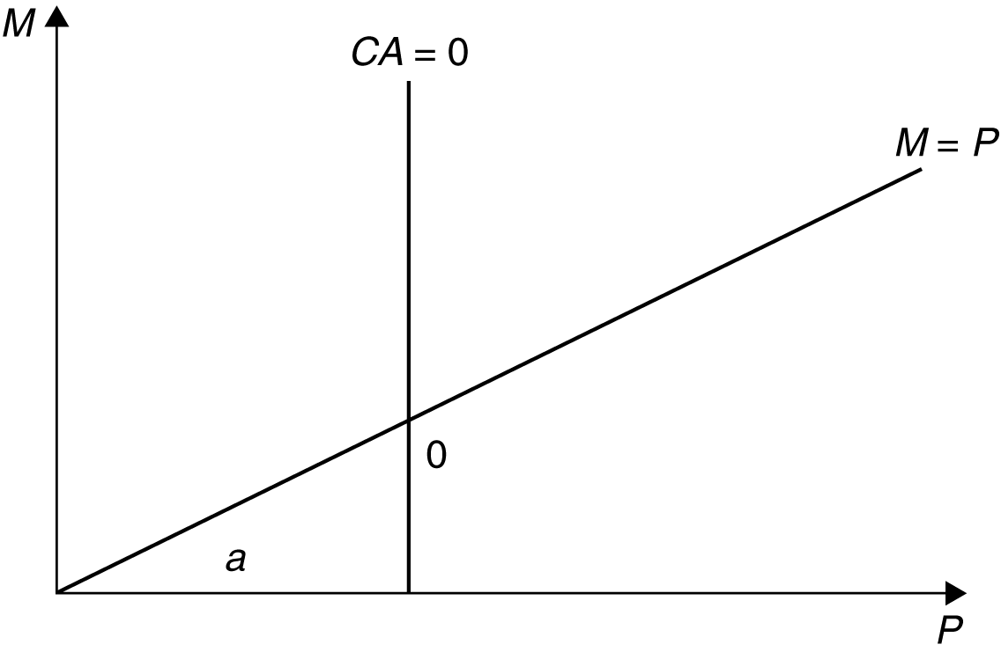

Figure 19.1
The automatic adjustment process described by the price-specie-flow mechanism is expedited by following “rules of the game” under which governments contract the domestic source components of
their monetary bases when gold reserves are falling (corresponding to a current-account deficit) and expand when gold reserves are rising (the surplus case).
In practice, there was little incentive for countries with expanding gold reserves to follow the “rules of the game.” This increased the contractionary burden shouldered by countries with persistent current account deficits. The gold standard also subjugated internal balance to the demands of external balance. Research suggests price-level stability and high employment were attained less consistently under the gold standard than in the post-1945 period.
The interwar years were marked by severe economic instability. The monetization of war debt and of reparation payments led to episodes of hyperinflation in Europe. An ill-fated attempt to return to the
pre-war gold parity for the pound led to stagnation in Britain. Competitive devaluations and protectionism were pursued in a futile effort to stimulate domestic economic growth during the Great Depression.
These beggar-thy-neighbor policies provoked foreign retaliation and led to the disintegration of the world economy. As one of the case studies shows, strict adherence to the Gold Standard appears to have hurt many countries during the Great Depression.
Determined to avoid repeating the mistakes of the interwar years, Allied economic policy-makers met
at Bretton Woods in 1944 to forge a new international monetary system for the postwar world. The exchange-rate regime that emerged from this conference had at its center the U.S. dollar. All other currencies had fixed exchange rates against the dollar, which itself had a fixed value in terms of gold.
An International Monetary Fund was set up to oversee the system and facilitate its functioning by lending to countries with temporary balance of payments problems.
A formal discussion of internal and external balance introduces the concepts of expenditure-switching and expenditure-changing policies. The Bretton Woods system, with its emphasis on infrequent adjustment
of fixed parities, restricted the use of expenditure-switching policies. Increases in U.S. monetary growth to finance fiscal expenditures after the mid-1960s led to a loss of confidence in the dollar and the termination of the dollar’s convertibility into gold. The analysis presented in the text demonstrates
how the Bretton Woods system forced countries to “import” inflation from the United States and shows that the breakdown of the system occurred when countries were no longer willing to accept this burden.

Answers to Textbook Problems

1. a. Since it takes considerable investment to develop uranium mines, you would want a larger current account deficit to allow your country to finance some of the investment with foreign savings.

b. A permanent increase in the world price of copper would cause a short-term current account deficit if the price rise leads you to invest more in copper mining. If there are no investment effects, you would not change your external balance target because it would be optimal simply to spend your additional income.

c. A temporary increase in the world price of copper would cause a current account surplus. You would want to smooth out your country’s consumption by saving some of its temporarily higher income.

d. A temporary rise in the world price of oil would cause a current account deficit if you were an importer of oil, but a surplus if you were an exporter of oil.

2. Because the marginal propensity to consume out of income is less than 1, a transfer of income from B to A increases savings in A and decreases savings in B. Therefore, A has a current account surplus and B has a corresponding deficit. This corresponds to a balance of payments disequilibrium in Hume’s world, which must be financed by gold flows from B to A. These gold flows increase A’s money supply and decrease B’s money supply, pushing up prices in A and depressing prices in B. These price changes cease once balance of payments equilibrium has been restored.

3. Changes in parities reflected both initial misalignments and balance of payments crises. Attempts to return to the parities of the prewar period after the war ignored the changes in underlying economic fundamentals that the war caused. This made some exchange rates less than fully credible and encouraged balance of payments crises. Central bank commitments to the gold parities were also less than credible after the wartime suspension of the gold standard, and as a result of the increasing concern of governments with internal economic conditions.

4. A monetary contraction, under the gold standard, will lead to an increase in the gold holdings of the contracting country’s central bank if other countries do not pursue a similar policy. All countries cannot succeed in doing this simultaneously since the total stock of gold reserves is fixed in the short run. Under a reserve currency system, however, a monetary contraction causes an incipient rise in the domestic interest rate, which attracts foreign capital. The central bank must accommodate the inflow of foreign capital to preserve the exchange rate parity. There is thus an increase in the central bank’s holdings of foreign reserves equal to the fall in its holdings of domestic assets. There is no obstacle to a simultaneous increase in reserves by all central banks because central banks acquire more claims on the reserve currency country while their citizens end up with correspondingly greater liabilities.

5. The increase in domestic prices makes home exports less attractive and causes a current account deficit. This diminishes the money supply and causes contractionary pressures in the economy
which serve to mitigate and ultimately reverse wage demands and price increases.

6. An increase in the world interest rate leads to a fall in a central bank’s holdings of foreign reserves as domestic residents trade in their cash for foreign bonds. This leads to a decline in the home country’s money supply. The central bank of a “small” country cannot offset these effects since
it cannot alter the world interest rate. An attempt to sterilize the reserve loss through open market purchases would fail unless bonds are imperfect substitutes.

7. Capital account restrictions insulate the domestic interest rate from the world interest rate. Monetary policy, as well as fiscal policy, can be used to achieve internal balance. Because there are no offsetting capital flows, monetary policy, as well as fiscal policy, can be used to achieve internal balance. The costs of capital controls include the inefficiency which is introduced when the domestic interest rate differs from the world rate and the high costs of enforcing the controls.

8. An inflow attack is different from capital flight, but many parallels exist. In an “outflow” attack, speculators sell the home currency and drain the central bank of its foreign assets. The central bank could always defend if it so chooses (they can raise interest rates to improbably high levels), but if it is unwilling to cripple the economy with tight monetary policy, it must relent. An “inflow” attack is similar in that the central bank can always maintain the peg, it is just that the consequences of doing so may be more unpalatable than breaking the peg. If money flows in, the central bank must buy foreign assets to keep the currency from appreciating. If the central bank cannot sterilize all the inflows (eventually they may run out of domestic assets to sell to sterilize the transactions where they are buying foreign assets), it will have to either let the currency appreciate or let the money supply rise. If it is unwilling to allow and increase in inflation due to a rising money supply, breaking the peg may be preferable.

9. a. We know that China has a very large current account surplus, placing them high above the XX line. They also have moderate inflationary pressures (described as “gathering” in the question, implying they are not yet very strong). This suggests that China is above the II line, but not too far above it. It would be placed in Zone 1 (see below).

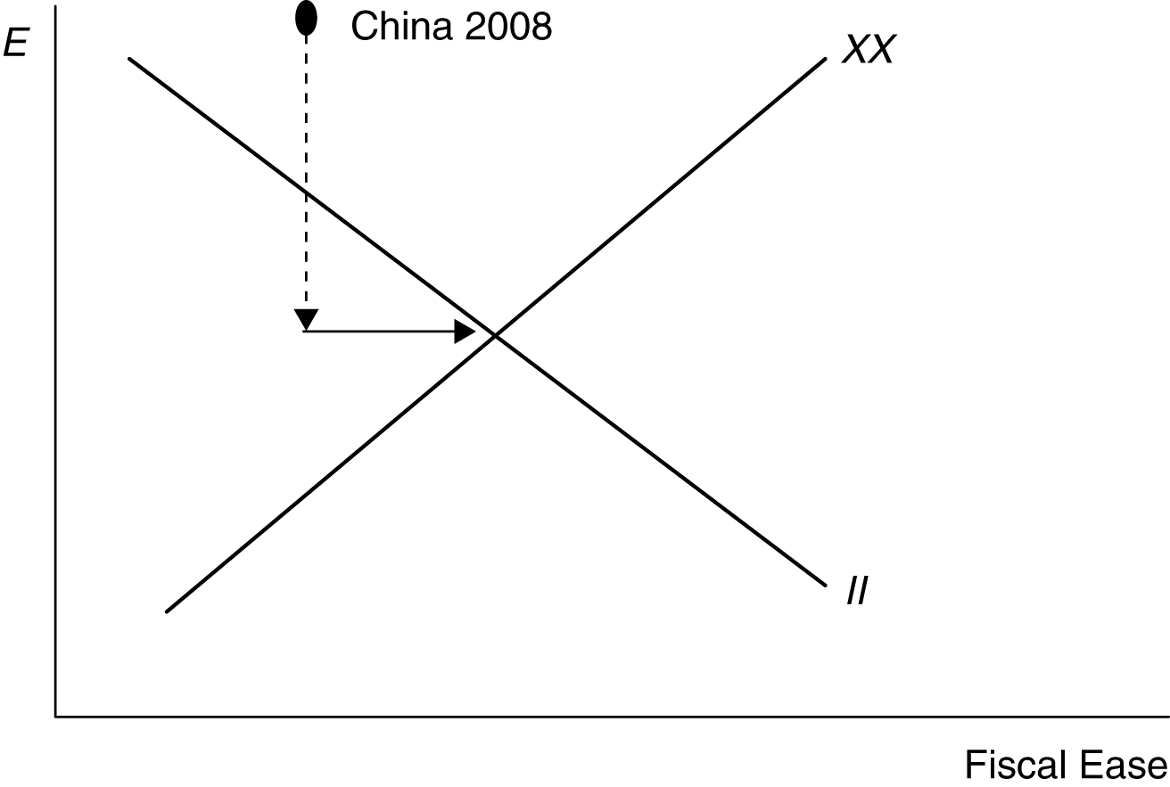

b. China needs to appreciate the exchange rate to move down on the graph towards balance. (Shown on the graph with the dashed line down)

c. China would need to expand government spending to move to the right and hit the overall balance point. Such a policy would help cushion the negative aggregate demand pressure
that the appreciation might generate.

10. The increase in foreign prices will shift the DD curve out to the right as demand for home products increases (exports rise, imports fall). If the expected exchange rate also falls, then there will be a leftward shift in the AA curve as foreign assets pay a lower home currency return. In the end, the home currency will appreciate by the same proportion as the increase in foreign prices, leaving output unchanged. There will be no change in the country’s internal or external balance.

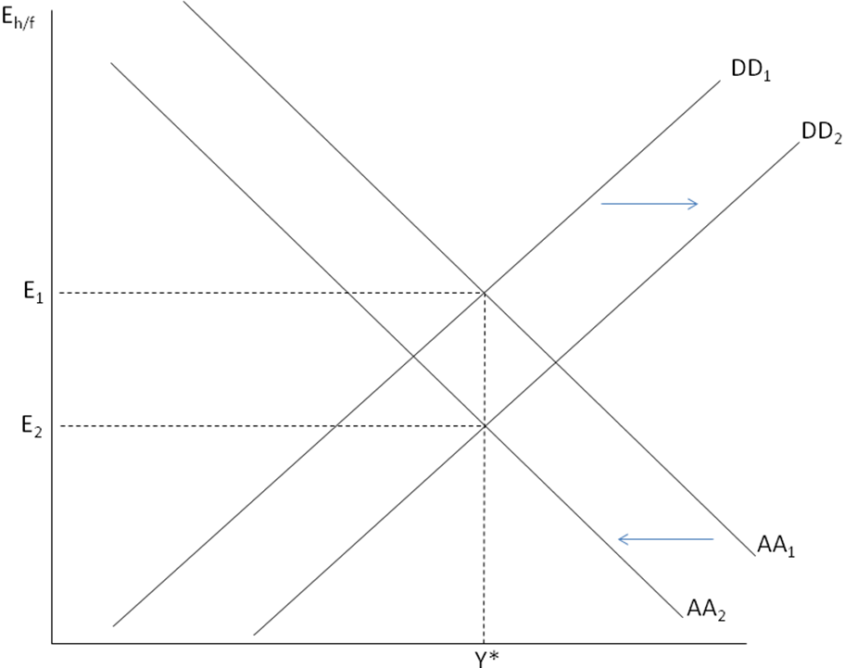

11. An increase in the foreign inflation rate should lead to a short run appreciation of the domestic currency as consumers shift their consumption toward relatively cheaper domestic goods. The appreciation of the domestic currency will mitigate the effects of foreign inflation by reducing the price of imported goods. Thus, the flexible exchange rate does a better job of insulating the economy from foreign inflation than a fixed exchange rate would.

In the long run, the increase in foreign inflation will work through relative PPP to cause home interest rates to fall relative to domestic rates. We can see this by combining the interest rate parity condition: %ΔE_{h/f} = R_{h} – R_{f} with the relative PPP condition: %ΔE_{h/f} = π_{h} – π_{f} to get: π_{h} – π_{f} = R_{h} – R_{f}. Thus, an increase in π_{f} will cause R_{h} – R_{f} to fall proportionately.

12. An increase in the risk premium on domestic assets will shift the AA curve to the right, reflecting the fact that asset market equilibrium is now attained at a higher exchange rate (depreciated domestic currency). With floating exchange rates, the depreciated currency will stimulate export demand, leading to a movement along the DD curve until general equilibrium is restored at both a depreciated currency (E₂) and higher level of output (Y₂). With a fixed exchange rate, the central bank would have to respond to the higher risk premium on domestic assets by raising domestic interest rates to keep the exchange rate constant at E₁. As a result, the AA curve would shift back to its original level and output would remain unchanged. Thus, the effect on output would be smallest for a fixed exchange rate regime.

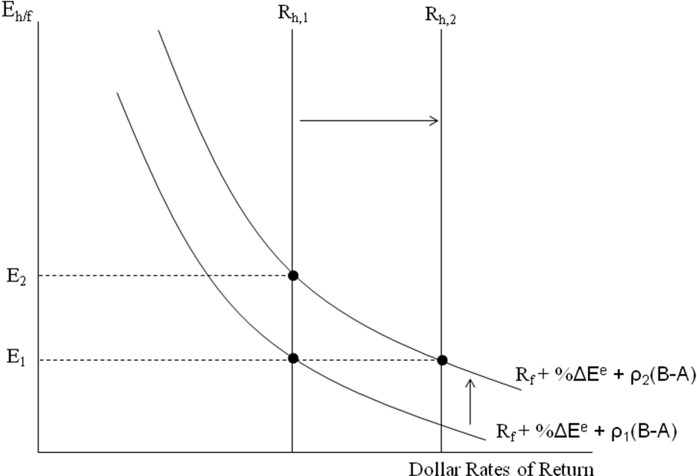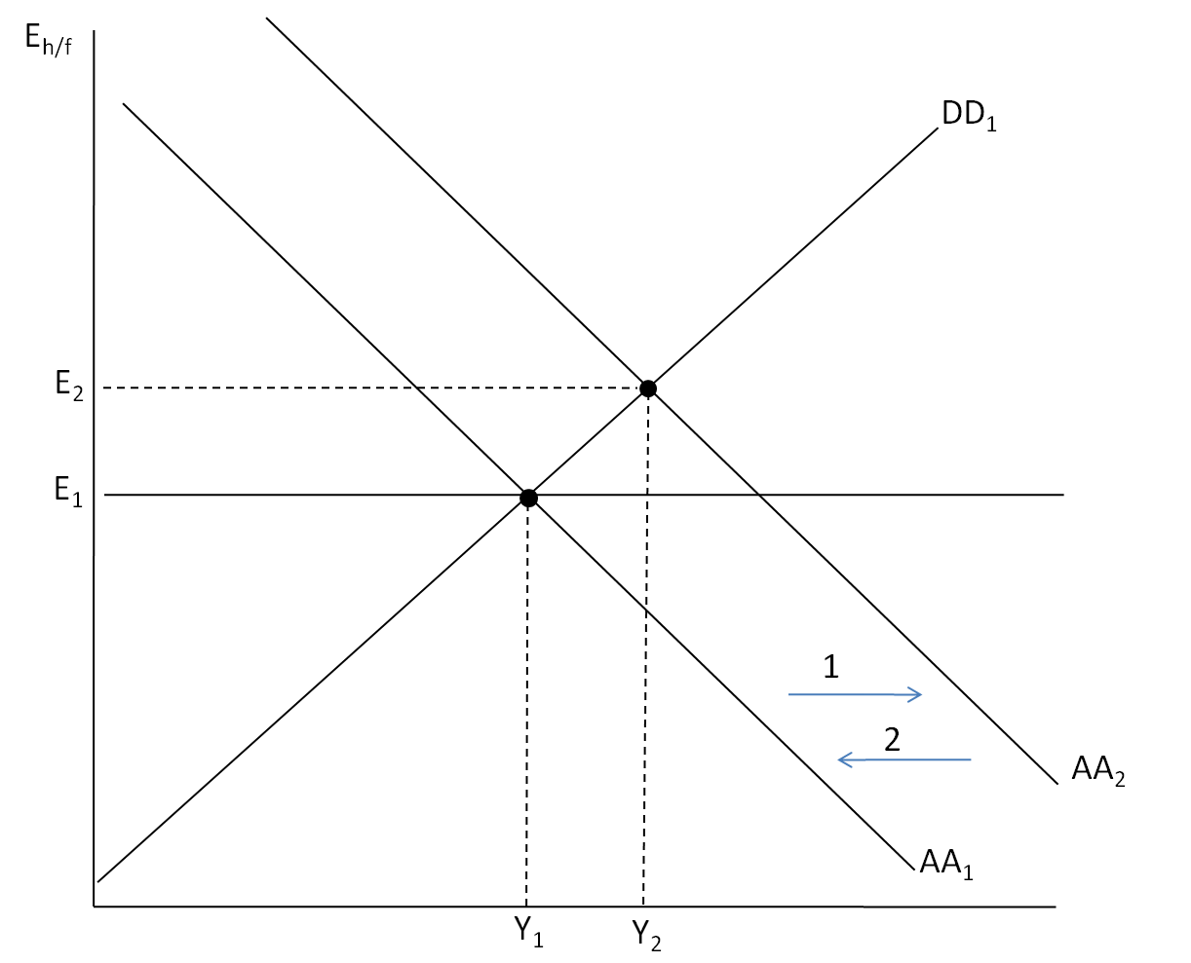

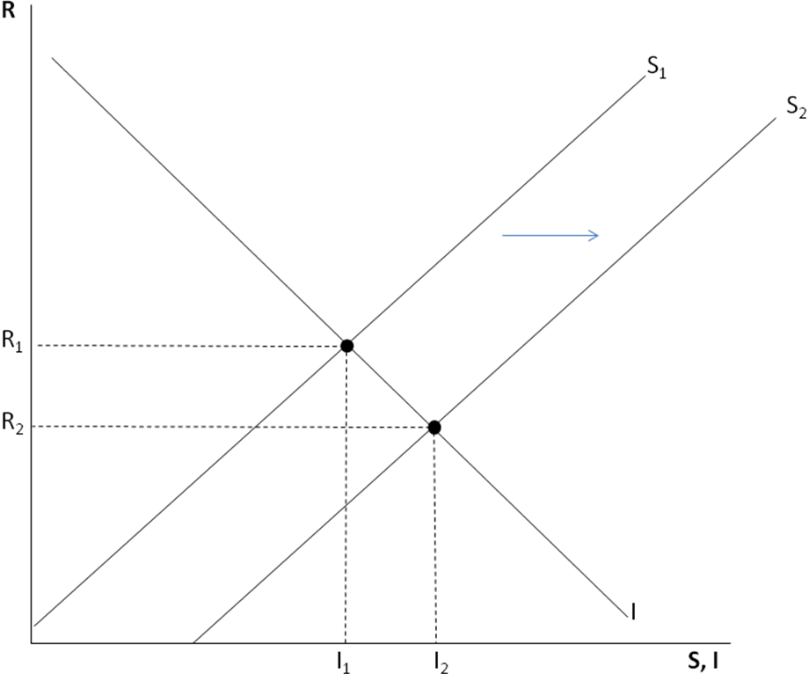13. The simple model of savings and investment against the real interest rate can be drawn as follows below. The increase in world savings can be shown as a rightwards shift in the savings schedule.
The result is that the world real interest rate falls and the amount of savings and investment rises.
We can think of the “global savings glut” story here. World interest rates went down as large scale savings (public and private), in emerging market countries in particular, increased the supply of world savings. This falling interest rate should lead to an increase in world investment. If this investment is in countries other than the ones who increased savings, then the increased investment
and constant savings (or possibly falling savings due to the falling world real interest rate) in countries like the U.S. will lead to current account deficits in the U.S. and like countries and current account surpluses in the savings countries.

14. The table below shows U.S. money market interest rates and inflation rates from 1970 to 1976.
You can find these data in the IMF’s International Financial Statistics, available in most libraries. Assuming that expected inflation equals actual inflation, we can generate the real interest rates.
The first oil shock starts at the end of 1973, so 1974 is the first year we would see its effects. The three years following the oil shocks have negative real interest rates as opposed to the positive rates in prior years, consistent with the theory. (Note that if inflation is surprisingly high in the years following the oil shocks, and hence expected inflation was lower than the numbers in this table,
the real interest rate would be higher and the theory may not be reflected in the data.)
Year | Nominal interest rate | Inflation | Real interest rate
1970 | 7.2% | 5.9% | 1.3%
1971 | 4.7% | 4.3% | 0.4%
1972 | 4.4% | 3.3% | 1.1%
1973 | 8.7% | 6.2% | 2.5%
1974 | 10.5% | 11.0% | −0.5%
1975 | 5.8% | 9.1% | −3.1%
1976 | 5.1% | 5.7% | −0.6%

15. If other Central Banks sell dollars for euros, then it is equivalent to a sterilized sale of dollars because neither the U.S. nor any other central bank’s asset side of the balance sheet has changed. Thus, the money supply is unchanged everywhere. On the other hand, there is a larger supply of dollar assets relative to euro assets in circulation than before. If this is not viewed as a signal of U.S. or euro area monetary policy and assets are substitutable, there should be no impact on the exchange rate. If the action moves the risk premium on U.S. assets because the outstanding supply becomes too large (and assets are not perfectly substitutable, see Chapter 18), the action could cause a depreciation of the dollar against the euro.

