Chapter 18
Fixed Exchange Rates and
Foreign-Exchange Intervention

Chapter Organization
Why Study Fixed Exchange Rates?
Central Bank Intervention and the Money Supply
The Central Bank Balance Sheet and the Money Supply
Foreign Exchange Intervention and the Money Supply
Sterilization
The Balance of Payments and the Money Supply
How the Central Bank Fixes the Exchange Rate
Foreign Exchange Market Equilibrium Under a Fixed Exchange Rate
Money Market Equilibrium Under a Fixed Exchange Rate
A Diagrammatic Analysis
Stabilization Policies with a Fixed Exchange Rate
Monetary Policy
Fiscal Policy
Changes in the Exchange Rate
Adjustment to Fiscal Policy and Exchange Rate Changes
Balance of Payments Crises and Capital Flight

Managed Floating and Sterilized Intervention
Perfect Asset Substitutability and the Ineffectiveness of Sterilized Intervention
Box: Brazil’s 1998-1999 Balance of Payments Crisis
Foreign Exchange Market Equilibrium Under Imperfect Asset Substitutability
The Effects of Sterilized Intervention with Imperfect Asset Substitutability
Evidence on the Effects of Sterilized Intervention
Reserve Currencies in the World Monetary System
The Mechanics of a Reserve Currency Standard
The Asymmetric Position of the Reserve Center
The Gold Standard
The Mechanics of a Gold Standard
Symmetric Monetary Adjustment Under a Gold Standard
Benefits and Drawbacks of the Gold Standard
Bimetallic Standard
The Gold-Exchange Standard
Case Study: The Demand for International Reserves
Summary
Appendix I: Equilibrium in the Foreign-Exchange Market with Imperfect Asset Substitutability
Appendix II: The Timing of Balance of Payments Crises
Online Appendix: The Monetary Approach to the Balance of Payments
Online Appendix: Fixing the Exchange Rate to Escape from a Liquidity Trap

Chapter Overview
Open-economy macroeconomic analysis under fixed exchange rates is dual to the analysis of flexible exchange rates. Under fixed exchange rates, attention is focused on the effects of policies on the balance of payments (and the domestic money supply), taking the exchange rate as given. Conversely, under flexible exchange rates with no official foreign-exchange intervention, the balance of payments equals zero, the money supply is a policy variable, and analysis focuses on exchange rate determination. In the intermediate case of managed floating, both the money supply and the exchange rate become, to an extent which is determined by central-bank policies, endogenous.
This chapter analyzes various types of monetary policy regimes under which the degree of exchange-
rate flexibility is limited. The reasons for devoting a chapter to this topic, almost thirty years after
the breakdown of the Bretton Woods system, include the prevalence of managed floating among industrialized countries, the common use of fixed exchange rate regimes among developing countries,
the existence of regional currency arrangements such as the Exchange Rate Mechanism through which some European nations peg to the euro, the recurrent calls for a new international monetary regime based upon more aggressive exchange-rate management, and the irrevocably fixed rates among countries which use the euro (a topic addressed in depth in Chapter 20).
The chapter begins with an analysis of a stylized central bank balance sheet to show the link between
the balance of payments, official foreign-exchange intervention, and the domestic money supply. Also described is sterilized intervention in foreign exchange, which changes the composition of interest-bearing assets held by the public but not the money supply. This analysis is then combined with the exchange-rate determination analysis of Chapter 14 to demonstrate the manner in which central banks alter the money supply to peg the nominal exchange rate. The endogeneity of the money supply under fixed exchange rates emerges as a key lesson of this discussion.
The tools developed in Chapter 16 are employed to demonstrate the impotence of monetary policy and the effectiveness of fiscal policy under a fixed exchange rate regime. The short-run and long-run effects of devaluation and revaluation are examined. The setup already developed suggests a natural description of balance of payments crises as episodes in which the public comes to expect a future currency devaluation. Such an expectation causes private capital flight and, as its counterpart, sharp official reserve losses. Different explanations of currency crises are explored, both those that argue that crises result from inconsistent policies and those that maintain crises are not necessarily inevitable but instead result from self-fulfilling expectations. (See Appendix II to this chapter for a more detailed analysis.)
Equipped with an understanding of the polar cases of fixed and floating rates, the student is in a position to appreciate the more realistic intermediate case of managed floating. The discussion of managed floating focuses on the role of sterilized foreign-exchange intervention and the theory of imperfect
asset substitutability. The inclusion of a risk premium in the model enriches the analysis by allowing governments some scope to run independent exchange rate and monetary policies in the short run. The chapter reviews the results of attempts to demonstrate empirically the effectiveness of sterilized foreign-exchange operations which, however, are generally negative. Also discussed is the role of central bank intervention as a “signal” of future policy actions and the credibility problems entailed by such a strategy. The case study at the end of the chapter considers how the need for reserves in a crisis—and the potential difficulty of acquiring them during one—leads to a strong incentive to hold reserves in a precautionary manner if they want to cushion a balance of payments crisis.
At this point, the discussion abandons the small-country framework in favor of a systemic perspective to discuss the properties of two different fixed exchange rate systems: the reserve-currency systems and the gold standards. A key distinction between these systems is the asymmetry between the reserve center and the rest of the world compared to the symmetric adjustment among all countries under the gold standard. It is shown that this asymmetry gives the reserve center exclusive control over world monetary conditions (at least when interest parity links countries’ money markets).
The chapter ends with a discussion of the pros and cons of the gold standard and the gold-exchange standard. Appendix I presents a more detailed model of exchange-rate determination with imperfect asset substitutability. Appendix II provides an analysis of the timing of balance of payments crises. One online appendix describes the monetary approach to the balance of payments and its usefulness as a tool of policy analysis, and another considers liquidity traps.

Answers to Textbook Problems

1. An expansion of the central bank’s domestic assets leads to an equal fall in its foreign assets, with
no change in the bank’s liabilities (or the money supply). The effect on the balance-of-payments accounts is most easily understood by recalling how the fall in foreign reserves comes about. After the central bank buys domestic assets with money, there is initially an excess supply of money. The central bank must intervene in the foreign exchange market to hold the exchange rate fixed in the face of this excess supply: the bank sells foreign assets and buys money until the excess supply of money has been eliminated. Since private residents acquire the reserves the central bank loses, there is a non-central bank capital outflow (a financial-account debit) equal to the increase in foreign assets held by the private sector. The offsetting credit is the reduction in central bank holdings of foreign assets, an official financial inflow.

2. An increase in government spending raises income and also money demand. The central bank prevents the initial excess money demand from appreciating the domestic currency by purchasing foreign assets from the domestic public. Central bank foreign assets rise, as do the central bank’s liabilities and, with them, the money supply. The central bank’s additional reserve holdings show up as an official capital outflow, a capital-account debit. Offsetting this debit is the capital inflow
(a credit) associated with the public’s equal reduction in its own foreign assets.

3. A one-time unexpected devaluation initially increases output; the output increase, in turn, raises money demand. The central bank must accommodate the higher money demand by buying foreign assets with domestic currency, a step that raises the central bank’s liabilities (and the home money supply) at the same time as it increases the bank’s foreign assets. The increase in official foreign reserves is an official capital outflow; it is matched in the balance of payments accounts by the equal capital outflow associated with the public’s own reduction in net foreign asset holdings. (The public must exchange foreign assets for the money it buys from the central bank, either by selling foreign assets or by borrowing foreign currency abroad. Either course of action is a capital inflow.)

A more subtle issue is the following: when the price of foreign currency is raised, the value of the initial stock of foreign reserves rises when measured in terms of domestic currency. This capital gain in itself raises central-bank foreign assets (which were measured in domestic currency units in our analysis)—so where is the corresponding increase in liabilities? Does the central bank inject more currency or bank-system reserves into the economy to balance its balance sheet? The answer is that central banks generally create fictional accounting liabilities to offset the effect of exchange-rate fluctuations on the home-currency value of international reserves. These capital gains and losses do not automatically lead to changes in the monetary base.

4. As shown in Figure 18.1, a devaluation causes the AA curve to shift to A′A′ which reflects an expansion in both output and the money supply in the economy. Figure 17.1 also contains an XX curve along which the current account is in balance. The initial equilibrium, at point 0, was on the XX curve, reflecting the fact that the current account was in balance there. After the devaluation,
the new equilibrium point is above and to the left of the XX curve, in the region where the current account is in surplus. With fixed prices, a devaluation improves an economy’s competitiveness, increasing its exports, decreasing its imports, and raising the level of output.

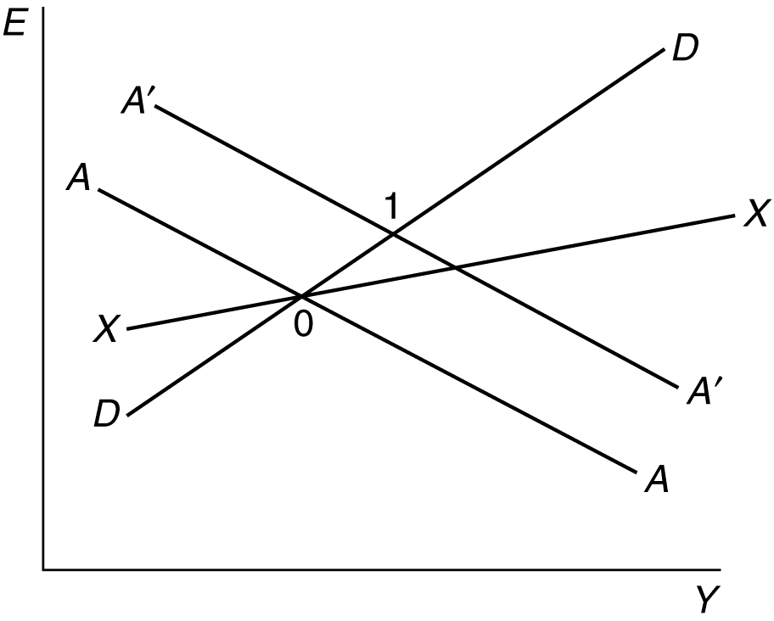

Figure 18.1

5. a. Germany clearly had the ability to change the dollar/DM exchange simply by altering its money supply. The fact that “billions of dollars worth of currencies are traded each day” is irrelevant because exchange rates equilibrate markets for stocks of assets, and the trade volumes mentioned are flows.

b. One must distinguish between sterilized and nonsterilized intervention. The evidence
regarding sterilized intervention suggests that its effects are limited to the signaling aspect.
This aspect may well be most important when markets are “unusually erratic,” and the signals communicated may be most credible when the central bank is not attempting to resist clear-cut market trends (which depend on the complete range of government macroeconomic policies, among other factors). Nonsterilized intervention, however, is a powerful instrument in affecting exchange rates.

c. The “psychological effect” of a “stated intention” to intervene may be more precisely stated as an effect on the expected future level of the exchange rate. If the central bank is able to convince people that it will intervene to depreciate its currency, those people will sell the currency in anticipation of the depreciation. This action will in turn depreciate the currency without any intervention having taken place. Of course, the “stated intention” only has a psychological effect if the central bank has credibility.

d. A rewrite might go as follows:

To keep the dollar from falling against the West German mark, the European central banks would have to sell marks and buy dollars, a procedure known as intervention.

Because the available stocks of dollar and mark bonds are so large, it is unlikely that sterilized intervention in the dollar/mark market, even if carried out by the two most economically influential members of the European Community—Britain and West Germany—would have much effect. The reason is that sterilized intervention changes only relative bond supplies and leaves national money supplies unchanged. Intervention by the United States and Germany that was not sterilized, however, would affect those countries’ money supplies and have a significant impact on the dollar/mark rate.

Economists believe that the direct influence of sterilized intervention on exchange rates is
small compared with that of nonsterilized intervention. Even sterilized intervention can affect exchange rates, however, through its indirect influence on market expectations about future policies. Such psychological effects, which can result from just the stated intention of the Community’s central banks to intervene, can disrupt the market by confusing traders about official plans. The signaling effect of intervention is most likely to benefit the authorities when their other macroeconomic policies are already being adjusted to push the exchange rate in the desired direction.

6. Exchange rate stability may be preferred to monetary policy autonomy for several reasons. First, a country with a history of high inflation may need to commit to a fixed exchange rate regime to get inflation under control. This is most often seen in countries without independent central banks that use monetary policy as a means of supporting expansionary fiscal policy. Second, a reduction in currency risk can remove a significant barrier to international trade and investment. Finally, policymakers may choose to sacrifice autonomy to enter into cooperative agreements with other countries to reduce the risk of “beggar thy neighbor” policies. All of these benefits must be weighed against the cost of losing monetary autonomy. If a nation fixes its exchange rate to a country with which it has a highly coordinated business cycle, this may not be a large cost. If however, the country is hit by frequent idiosyncratic shocks, the loss of monetary policy as a tool to deal with these shocks may exceed any gain from exchange rate stability.

7. By raising output, fiscal expansion raises imports and thus worsens the current-account balance.
The immediate fall in the current account is smaller than under floating, however, because the currency does not appreciate and crowd out net exports.

8. The reason that the effects of temporary and permanent fiscal expansions differ under floating exchange rates is that a temporary policy has no effect on the expected exchange rate while a permanent policy does. The AA curve shifts with a change in the expected exchange rate. In terms
of the diagram, a permanent fiscal expansion causes the AA curve to shift down and to the left
which, combined with the outward shift in the DD curve, results in no change in output. With fixed exchange rates, however, there is no change in the expected exchange rate with either policy since the exchange rate is, by definition, fixed. In response to both temporary and permanent fiscal expansions, the central bank must expand the money supply (shift AA out) to prevent the currency from appreciating (due to the shift out in the DD curve). Thus, Y goes up and E does not change
after a permanent or temporary fiscal expansion when exchange rates are fixed.

9. By expanding output, a devaluation automatically raises private saving, since part of any increase in output is saved. Government tax receipts rise with output, so the budget deficit is likely to decline, implying an increase in public saving. We have assumed investment to be constant in the main text. If investment instead depends negatively on the real interest rate (as in the IS-LM model), investment rises because devaluation raises inflationary expectations and thus lowers the real interest rate.
(The nominal interest rate remains unchanged at the world level.) The interest-sensitive components of consumption spending also rise, and if these interest rate effects are strong enough, a current-account deficit could result.

10. An import tariff raises the price of imports to domestic consumers and shifts consumption from imports to domestically produced goods. This causes an outward shift in the DD curve, increasing output and appreciating the currency. Since the central bank cannot allow exchange rates to change, it must increase the money supply, an action depicted in the diagram as an outward shift in the AA schedule. Corresponding to this monetary expansion is a balance of payments surplus and an equal 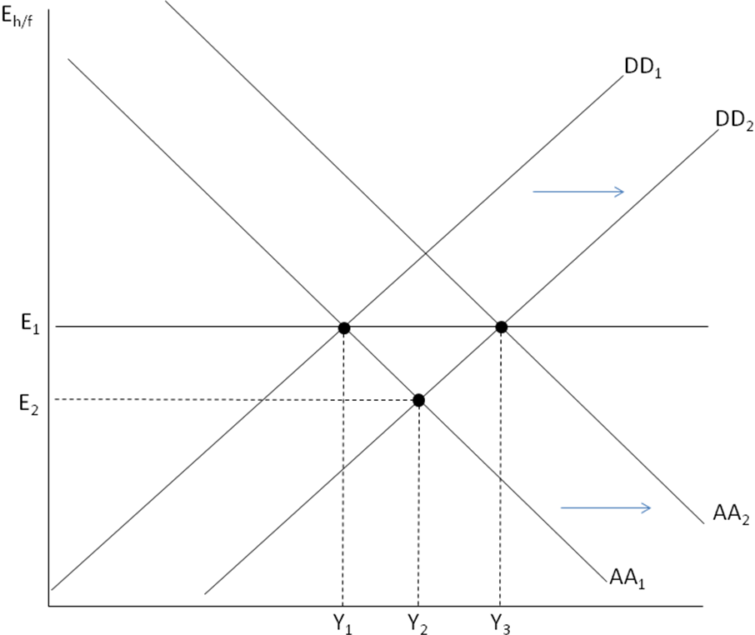increase in official foreign reserves.

The fall in imports for one country implies a fall in exports for another country, and a corresponding inward shift of that country’s DD curve necessitating a monetary contraction by the central bank to preserve its fixed exchange rate. If all countries impose import tariffs, then no country succeeds in turning world demand in its favor or in gaining reserves through an improvement in its balance of payments. Trade volumes shrink, however, and all countries lose some of the gains from trade.

11. If the market expects the devaluation to “stick,” the home nominal interest rate falls to the world level afterward, money demand rises, and the central bank buys foreign assets with domestic money to prevent excess money demand from appreciating the currency. The central bank thus gains official reserves, according to our model. Even if another devaluation was to occur in the near future, reserves might be gained if the first devaluation lowered the depreciation expected for the future and, with it, the home nominal interest rate. An inadequate initial devaluation could, however, increase the devaluation expected for the future, with opposite effects on the balance of payments.

12. If the Bank of Japan holds U.S. dollars instead of Treasury bills, the adjustment process is symmetric. Any purchase of dollars by the Bank of Japan leads to a fall in the U.S. money supply
as the dollar bills go out of circulation and into the Bank of Japan’s vaults. A Japanese balance of payments surplus increases the Bank of Japan’s money supply (if there is no sterilization) and reduces the U.S. money supply at the same time.

13. A central bank that is maintaining a fixed exchange rate will require an adequate buffer stock of foreign assets on hand during periods of persistent balance of payments deficits. If a central bank depletes its stock of foreign reserves, it is no longer able to keep its exchange rate from depreciating in response to pressures arising from a balance of payments deficit. Simply put, a central bank can either choose the exchange rate and allow its reserve holdings to change or choose the amount of foreign reserves it holds and allow the exchange rate to float. If it loses the ability to control the amount of reserves because the private demand for them exceeds its supply, it can no longer control the exchange rate. Thus, a central bank maintaining a fixed exchange rate is not indifferent about using domestic or foreign assets to implement monetary policy.

14. An ESF intervention to support the yen involves an exchange of dollar-denominated assets initially owned by the ESF for yen-denominated assets initially owned by the private sector. Since this is
an exchange of one type of bond for another, there is no change in the money supply and thus
this transaction is automatically sterilized. This transaction increases the outstanding stock of
dollar-denominated assets held by the private sector, which increases the risk premium on dollar-denominated assets.

15. With imperfect asset substitutability, a central bank can change the domestic interest rate without affecting the exchange rate. For example, if the central bank wants to lower the domestic interest rate, it can purchase domestic assets and increase the money supply. In order to sterilize this intervention, the central bank would have to also sell foreign assets it holds in reserve. In the diagram below, the increase in the money supply from M₁ to M₂ causes the home interest rate to fall from R_{h,1} to R_{h,2}. However, the purchase of domestic assets causes the risk premium that domestic assets have to pay to fall from ρ(B-A₁) to ρ(B-A₂) as the stock of domestic assets held by the central bank rises from A₁ to A₂. This decrease in the expected domestic currency return on foreign assets offsets the decrease in domestic interest rates and leaves the exchange rate unchanged at E₁.

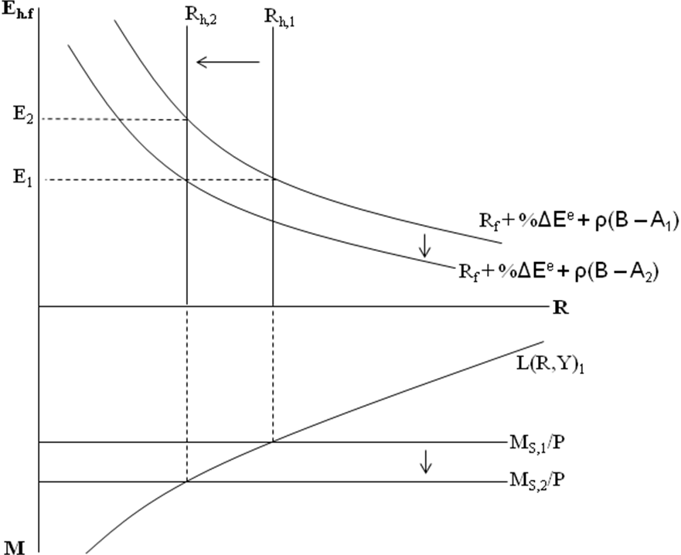

16.
Assets | Liabilities
FA: 900 | Deposits held by banks: 400
DA: 1500 | Currency: 2000

The central bank’s foreign assets still drop, and consequently liabilities must still drop also. In this case, though, currency has not changed, but after the check clears, the issuing bank has $100 less held as a deposit at the central bank.

17. Yes, there is some room within a target zone for domestic interest rates to move independently of
the foreign rate. For a one-year rate, we might see that when R* rises 1%, the home currency depreciates 1%, setting an expected appreciation of the home currency back to the middle of the band, thus offsetting the 1% lower interest rate. On a shorter maturity, one could—in theory—expect a change in the exchange rate of up to 2% (top to bottom of the band) in three months. This allows three-month rates to be 2% apart, meaning annualized rates could be over 8% apart. The shorter the maturity, the difference becomes essentially unbounded. But, this would require that the fixed exchange rate remains credible. On a ten-year bond, there can be only a 0.2% difference in rates as expected appreciation could be a maximum of 0.2% a year for the ten years.

18. In a three country world, a central bank fixes one exchange rate but lets the other float. It is still constrained in its ability to use monetary policy. It must manipulate the money supply to keep the interest rate at the level that maintains interest parity. It has no autonomy. At the same time, it cannot keep more than one exchange rate fixed.

19. Consider an example where France sells domestic assets (DA) for gold. If other central banks want
to hold onto their monetary gold, they will raise interest rates (by selling domestic assets to reduce the money supply) to keep gold from leaving their country. The consequence may be that all central banks reduce their DA holdings and still hold the same amount of gold. Put differently, if France tries to sell domestic assets for gold and all other central banks do the same thing, the net effect is that there is still the same amount of gold on the asset side of all central banks balance sheets combined, but the domestic assets have gone down. Thus, the total assets have declined and there has been a monetary contraction. In contrast, if France buys U.S. dollar assets to hold as reserves in a reserves currency system, they can buy the dollars on the open market in exchange for domestic assets. If the investors want to hold dollars and the price of dollars begins to rise, the Fed can easily increase the supply of dollars by purchasing foreign assets in exchange for dollars. Thus, both have increased their foreign reserves, and there was no need for the assets side of the balance sheet to decline.

20. When a country devalues against the reserve currency, the value of its reserves in foreign currency is unchanged, but the local currency value is now different. A devaluation, where the foreign currency can now buy more local currency leads to an increase in the value of reserves measured in local currency. If a country revalues, this will lead to local currency losses. These potential valuation
gains and losses will affect the costs of reserves. A country receiving a lower interest rate on U.S. treasury bills than it pays on its own debt is experiencing a cost of holding reserves, but if uncovered interest parity holds, this interest rate gap loss should be exactly offset by exchange rate changes
and valuation gains as the local currency is expected to depreciate versus the dollar (because local
R is > R_{U.S.}). On the other hand, countries with large stocks of dollar reserves expose themselves to losses if the dollar depreciates rapidly. As long as U.S. interest rates are greater than local rates (which if the dollar is expected to depreciate, they should be), these losses will be offset by interest rate gains. On the other hand, if there are unexpected changes in the exchange rate, then we will see the valuation gains or losses materialize without any offsetting interest rate payments. In some sense, one cost of holding large stocks of reserves is exposure to these unexpected changes.

21. An economy caught in a liquidity trap has an AA curve with a flat section at output levels far below full employment output Y_{f}. When the interest rate is equal to zero, then holding the expected exchange rate fixed, interest rate parity determines the exchange rate as E_{h/f} = E^{e}/(1-R_{f}). Thus, any attempt to depreciate the currency through an expansion in the money supply will leave the exchange rate unchanged since interest rates cannot be negative. A temporary increase in the money supply would simply shift the AA curve to the right, expanding the flat section of the AA curve and leaving both the exchange rate and output unchanged. Thus, a country caught in a liquidity trap finds it difficult to increase output through monetary policy. They could raise interest rate by cutting the money supply, but this would actually make the recession (Y₁ < Y_{f}) worse!

If, however, the central bank committed to a permanent increase in the money supply and permanent devaluation of the exchange rate, they could conceivably stimulate the economy through monetary policy. A permanent devaluation, if credible, will change the expected exchange rate. In the diagram below, the expected exchange rate rises from E^{e}₁ to E^{e}₂. This shifts the AA curve up and to the right (since the permanent devaluation is executed by increasing the money supply). The change in the expected exchange rate causes the currency to devalue today, leading to an increase in spending on domestic output. All of this is contingent on the central bank credibly committing to a devaluation. If the central bank is unable to convince people that it will permanently devalue (and not just change course later on), the expected exchange rate never changes and output is unaffected.

