Overview of Section II:
International Trade Policy
Section II of the text is comprised of four chapters:
Chapter 9 The Instruments of Trade Policy
Chapter 10 The Political Economy of Trade Policy
Chapter 11 Trade Policy in Developing Countries
Chapter 12 Controversies in Trade Policy

Section II Overview
Trade policy issues figure prominently in current political debates and public policy discussions. The
first two chapters of this section of the text are concerned with the instruments of trade policy and
the arguments for free trade and managed trade. The second two chapters consider these concepts in the context of specific sets of countries that face common problems. Throughout, the use of case studies provides the student with real world examples that clearly illustrate the theoretical arguments.
Chapter 9 discusses various instruments of trade policy including tariffs, quotas, voluntary export restraints, and local content requirements. The effects of these policies on prices and trade volumes are determined in the context of a partial equilibrium framework. The chapter reviews the analytical tools
of consumer and producer surplus, and uses these tools to consider the welfare effects of various protectionist measures. The specific incidents of trade restrictions presented as case studies include import quotas on sugar entering United States markets, voluntary export restraints on Japanese autos,
and oil import quotas.
Chapter 10 presents the set of ideas known as the political economy of trade theory. These ideas enable
you to understand why certain trade restrictions exist, despite the force of general economic arguments which suggest that they reduce aggregate welfare. Possible motivations for trade restrictions are identified as those which increase national welfare, such as the optimum tariff, and those which foster either income redistribution or the preservation of status quo. While sometimes politically popular, these motivations for trade restrictions ignore the possibility of retaliation and usually fail tests based upon basic welfare analysis. Trade agreements of the 1990s are discussed, including the Uruguay Round, and distinctions
are made between Free Trade Areas and Customs Unions as well as between trade creation and trade diversion.
Chapter 11 considers the possible uses of trade policies to promote the growth of developing economies. The chapter reviews the relative successes of different development strategies. It examines arguments for and the results of import-substituting industrialization. It also discusses the decline of import-substituting industrialization and the increase in trade liberalization in developing countries since the mid-1980s. The chapter concludes with a discussion of export led growth and the experience of the high performing Asian economies.
Chapter 12 considers recent controversies in trade policy. The first part of the chapter considers the
notion of strategic trade policy, which first arose in the 1990s. Strategic trade policy refers to the use of trade (and other) tools for channeling resources to sectors targeted for growth by industrial country governments. The chapter presents some commonly voiced arguments for intervention in particular sectors of the economy, and then shows how these arguments are critically flawed. The second part of the chapter introduces more sophisticated arguments for strategic trade policy. The most persuasive of these is the existence of some form of market failure. The third part of the chapter considers the impact of rising trade on workers in developing countries, and more broadly, the debate over globalization. This debate has been argued in academia and policy circles, but also on the streets of Seattle, Genoa, and other cities hosting global economic summits. Finally, the chapter considers links between trade and the environment.

Chapter 9
The Instruments of Trade Policy

Chapter Organization
Basic Tariff Analysis
Supply, Demand, and Trade in a Single Industry
Effects of a Tariff
Measuring the Amount of Protection
Costs and Benefits of a Tariff
Consumer and Producer Surplus
Measuring the Costs and Benefits
Other Instruments of Trade Policy
Export Subsidies: Theory
Case Study: Europe’s Common Agricultural Policy
Import Quotas: Theory
Case Study: An Import Quota in Practice: U.S. Sugar
Voluntary Export Restraints
Case Study: A Voluntary Export Restraint in Practice: Japanese Autos
Local Content Requirements
Box: American Buses, Made in Hungary
Other Trade Policy Instruments
The Effects of Trade Policy: A Summary
Summary

Appendix: Tariffs and Import Quotas in the Presence of Monopoly
The Model with Free Trade
The Model with a Tariff
The Model with an Import Quota
Comparing a Tariff with a Quota

Chapter Overview
This chapter and the next three focus on international trade policy. Students will have heard various arguments for and against restrictive trade practices in the media. Some of these arguments are sound and some are clearly not grounded in fact. This chapter provides a framework for analyzing the economic effects of trade policies by describing the tools of trade policy and analyzing their effects on consumers and producers in domestic and foreign countries. Case studies discuss actual episodes of restrictive trade practices. An instructor might try to underscore the relevance of these issues by having students scan newspapers and magazines for other timely examples of protectionism at work.
The analysis presented here takes a partial equilibrium view, focusing on demand and supply in one market, rather than the general equilibrium approach followed in previous chapters. Import demand and export supply curves are derived from domestic and foreign demand and supply curves. There are a number of trade policy instruments analyzed in this chapter using these tools. Some of the important instruments of trade policy include specific tariffs, defined as taxes levied as a fixed charge for each unit
of a good imported; ad valorem tariffs, levied as a fraction of the value of the imported good; export subsidies, which are payments given to a firm or industry that ships a good abroad; import quotas, which are direct restrictions on the quantity of some good that may be imported; voluntary export restraints, which are quotas on trading that are imposed by the exporting country instead of the importing country; and local content requirements, which are regulations that require that some specified fraction of a good is produced domestically.
The import supply and export demand analysis demonstrates that the imposition of a tariff drives a wedge between prices in domestic and foreign markets, and increases prices in the country imposing the tariff
and lowers the price in the other country by less than the amount of the tariff. This contrasts with most textbook presentations which make the small country assumption that the domestic internal price
equals the world price times one plus the tariff rate. The actual protection provided by a tariff will
not equal the tariff rate if imported intermediate goods are used in the production of the protected good. The proper measurement, the effective rate of protection, is described in the text and calculated for a sample problem.
The analysis of the costs and benefits of trade restrictions require tools of welfare analysis. The text explains the essential tools of consumer and producer surplus. Consumer surplus on each unit sold is defined as the difference between the actual price and the amount that consumers would have been willing to pay for the product. Geometrically, consumer surplus is equal to the area under the demand curve and above the price of the good. Producer surplus is the difference between the minimum amount for which a producer is willing to sell his product and the price which he actually receives. Geometrically, producer surplus is equal to the area above the supply curve and below the price line. These tools are fundamental to the student’s understanding of the implications of trade policies and should be developed carefully.
The costs of a tariff include distortionary efficiency losses in both consumption and production. A tariff provides gains from terms of trade improvement when and if it lowers the foreign export price. Summing the areas in a diagram of internal demand and supply provides a method for analyzing the net loss or gain from a tariff. The gain from a tariff is larger the greater the decrease in foreign export price from the tariff (as the tariff imposing country is able to pass some of the costs of the tariff onto foreign exporters). Since large countries will have a larger influence on export prices than small countries, a large country is more likely to gain, and therefore impose an import tariff.
Other instruments of trade policy can be analyzed with this method. An export subsidy operates in
exactly the reverse fashion of an import tariff. An import quota has similar effects as an import tariff
upon prices and quantities, but revenues, in the form of quota rents, accrue to the quota license holders, who are often foreign producers. Voluntary export restraints are a form of quotas in which import licenses are held by foreign governments. Local content requirements raise the price of imports and domestic goods and do not result in either government revenue or quota rents.

Throughout the chapter the analysis of different trade restrictions are illustrated by drawing upon specific episodes. Europe’s common agricultural policy provides and example of export subsidies in action. The case study corresponding to quotas describes trade restrictions on U.S. sugar imports. Voluntary export restraints are discussed in the context of Japanese auto sales to the United States. The oil import quota in the United States in the 1960’s provides an example of a local content scheme.

The Appendix discusses tariffs and import quotas in the presence of a domestic monopoly. Free trade eliminates the monopoly power of a domestic producer and the monopolist mimics the actions of a firm in a perfectly competitive market, setting output such that marginal cost equals world price. A tariff raises domestic price. The monopolist, still facing a perfectly elastic demand curve, sets output such that marginal cost equals internal price. A monopolist faces a downward sloping demand curve under a quota. A quota is not equivalent to a tariff in this case. Domestic production is lower and internal price higher when a particular level of imports is obtained through the imposition of a quota rather than a tariff.

Answers to Textbook Problems

1. The import demand equation, MD, is found by subtracting the home supply equation from the home demand equation. This results in MD = 80 − 40 × P. Without trade, domestic prices and quantities adjust such that import demand is zero. Thus, the price in the absence of trade is 2.

2. a. Foreign’s export supply curve, XS, is XS = −40 + 40 × P. In the absence of trade, the price is 1.

b. When trade occurs, export supply is equal to import demand, XS = MD. Thus, using the equations from Problems 1 and 2a, P = 1.50, and the volume of trade is 20.

3. a. The new MD curve is 80 − 40 × (P + t) where t is the specific tariff rate, equal to 0.5. (Note: In solving these problems, you should be careful about whether a specific tariff or ad valorem tariff is imposed. With an ad valorem tariff, the MD equation would be expressed as MD = 80 − 40 × (1 + t)P.) The equation for the export supply curve by the foreign country is unchanged.

MD = XS

80 – 40 × ( P + 0.5) = 40P – 40

80 – 20 – 40P = 40P – 40

80P = 100

P^{World} = 1.25

P^{Home} = P^{World} + t = 1.25 + 0.5 = 1.75

Trade = MD = XS = 40*1.25 – 40 = 10

D^{Home} = 100 – 20*1.75 = 65

S^{Home} = 20 + 20*1.75 = 55

D^{Foreign} = 80 – 20*1.25 = 55

S^{Foreign} = 40 + 20*1.25 = 65

b. and c. The welfare of the home country is best studied using the combined numerical and graphical solutions presented below in Figure 8.1.

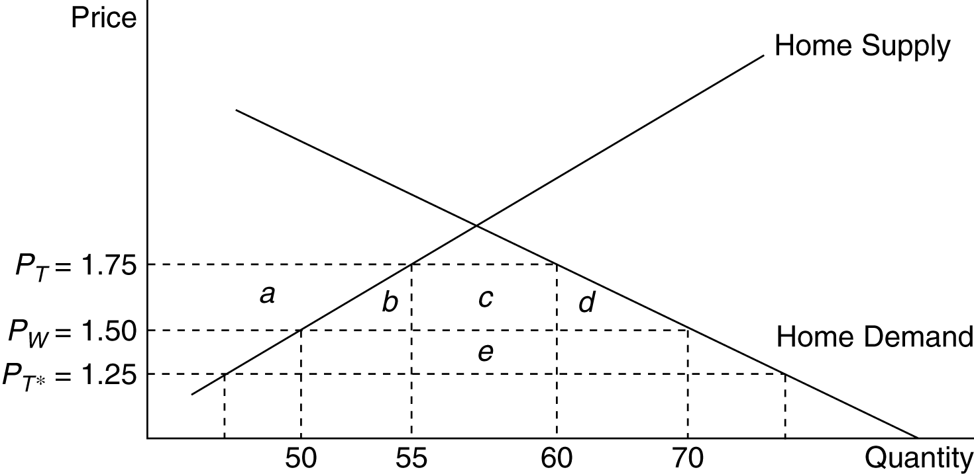

Figure 8.1

where the areas in the figure are:

a. 55(1.75 − 1.50) −0.5(55 − 50)(1.75 − 1.50) = 13.125

b. 0.5(55 − 50)(1.75 − 1.50) = 0.625

c. (65 − 55)(1.75 − 1.50) = 2.50

d. 0.5(70 − 65)(1.75 − 1.50) = 0.625

e. (65 − 55)(1.50 − 1.25) = 2.50

Consumer surplus change: −(a + b + c + d) = −16.875. Producer surplus change: a = 13.125. Government revenue change: c + e = 5. Efficiency losses b + d are exceeded by terms of trade gain e. (Note: In the calculations for the a, b, and d areas, a figure of 0.5 shows up. This is because we are measuring the area of a triangle, which is one-half of the area of the rectangle defined by the product of the horizontal and vertical sides.)

4. Using the same solution methodology as in Problem 3, when the home country is very small relative to the foreign country, its effects on the terms of trade are expected to be much less. The small country is much more likely to be hurt by its imposition of a tariff. Indeed, this intuition is shown in this problem. The free trade equilibrium is now at the price $1.09 and the trade volume is now 36.40.

With the imposition of a tariff of 0.5 by Home, the new world price is $1.045, the internal home price is $1.545, home demand is 69.10 units, home supply is 50.90, and the volume of trade is 18.20. When Home is relatively small, the effect of a tariff on world price is smaller than when Home is relatively large. When Foreign and Home were closer in size, a tariff of 0.5 by home lowered world price by 25 percent, whereas in this case the same tariff lowers world price by about 5 percent. The internal Home price is now closer to the free trade price plus t than when Home was relatively large. In this case, the government revenues from the tariff equal 9.10, the consumer surplus loss is 33.51, and the producer surplus gain is 21.089. The distortionary losses associated with the tariff (areas
b + d) sum to 4.14 and the terms of trade gain (e) is 0.819. Clearly, in this small country example, the distortionary losses from the tariff swamp the terms of trade gains. The general lesson is the smaller the economy, the larger the losses from a tariff since the terms of trade gains are smaller.

5. The effective rate of protection (ERP) is defined as (V_{t} – V_{w})/V_{w} , where V_{t} is the value added under protection and V_{w} is the value added under free trade. We define value added as the difference between the price of the final good and the price of components. So V_{w} = $200 - $100 = $100. With a 50% tariff on bicycles (and a 0% tariff on components), V_{t} = $200*1.5 - $100 = $300 - $100 = $200. Therefore, the ERP = (200-100)/100 = 100%

6. The effective rate of protection takes into consideration the costs of imported intermediate goods. Here, 55% of the cost can be imported, suggesting with no distortion, home value added would be 45%. A 15% increase in the price of ethanol, though, means home value added could be as high as 60% (45% home value added under free trade + 15% increase in the price of ethanol). Effective rate of protection = (V_{t} − V_{w})/V_{w}, where V_{t} is the value added in the presence of trade policies, and V_{w} is the value added without trade distortions. In this case, we have (60 − 45)/45 = 33% effective rate of protection.

7. We first use the foreign export supply and domestic import demand curves to determine the new world price. The foreign supply of exports curve, with a foreign subsidy of 0.5per unit, becomes XS = −40 + 40(1 + 0.5) × P. The equilibrium world price is 1.2 and the internal foreign price is 1.8. The volume of trade is 32. The foreign demand and supply curves are used to determine the costs and benefits of the subsidy. Construct a diagram similar to that in the text and calculate the area of the various polygons. The government must provide (1.8 − 1.2) × 32 = 19.2 units of output to support the subsidy. Foreign producers surplus rises due to the subsidy by the amount of 15.3 units of output. Foreign consumers surplus falls due to the higher price by 7.5 units of the good. Thus, the net loss to Foreign due to the subsidy is 7.5 + 19.2 − 15.3 = 11.4 units of output. Home consumers and producers face an internal price of 1.2 as a result of the subsidy. Home consumers surplus rises by 70 × 0.3 + 0.5 (6 × 0.3) = 21.9, while Home producers surplus falls by 44 × 0.3 + 0.5(6 × 0.3) = 14.1, for a net gain of 7.8 units of output.

8. a. False, unemployment has more to do with labor market issues and the business cycle than with tariff policy. Empirical estimates suggest that the cost to society of jobs saved through tariffs is exorbitantly high and tariffs may actually increase unemployment in non-protected industries.

b. False, the opposite is true because tariffs by large countries can actually reduce world prices which helps offset their effects on consumers.

c. This kind of policy might reduce automobile production and Mexico, but also would increase the price of automobiles in the United States, and would result in the same welfare loss associated with any quota.

9. At a price of $10 per bag of peanuts, Acirema imports 200 bags of peanuts. A quota limiting the import of peanuts to 50 bags has the following effects:

a. Set MD = 50 to find the post-quota price: 350 – 15P = 50. The price of peanuts rises to $20 per bag.

b. The quota rents are ($20 − $10) × 50 = $500.

c. The consumption distortion loss is 0.5 × 100 bags × $10 per bag = $500.

d. The production distortion loss is 0.5 × 50 bags × $10 per bag = $250.

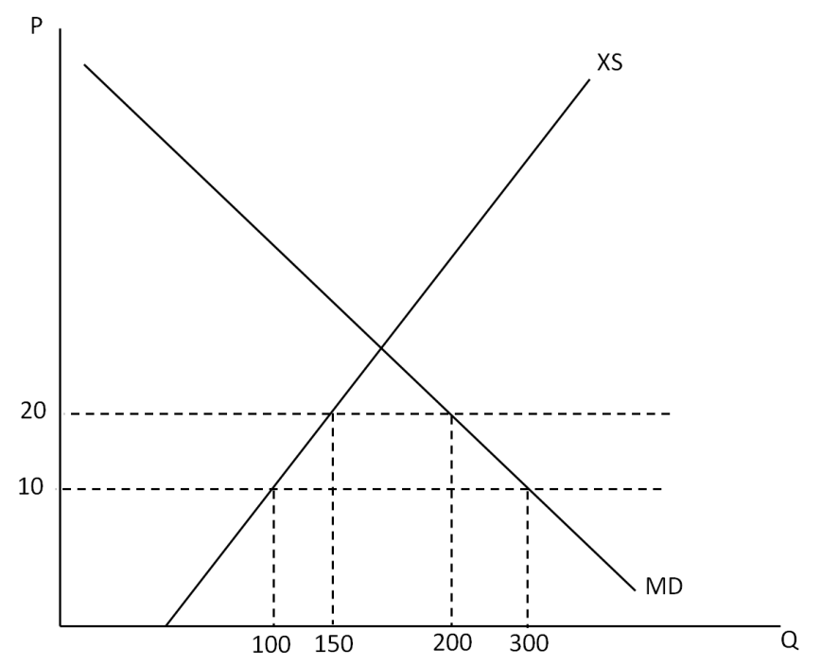

10. The reason is largely that the benefits of these policies accrue to a small group of people and the costs are spread out over many people. Thus, those that benefit care far more deeply about these policies. These typical political economy problems associated with trade policy are probably even more troublesome in agriculture, where there are long standing cultural reasons for farmers and farming communities to want to hold onto their way of life, making the interests even more entrenched than they would normally be.

11. It would improve the income distribution within the economy since wages in manufacturing would increase, and real incomes for others in the economy would decrease due to higher prices for manufactured goods. This is true only under the assumption that manufacturing wages are lower than all others in the economy. If they were higher than others in the economy, the tariff policies would worsen the income distribution.

