Chapter 7
External Economies of Scale and the International Location of Production

Chapter Organization
Economies of Scale and International Trade: An Overview
Economies of Scale and Market Structure

The Theory of External Economies
Specialized Suppliers
Labor Market Pooling
Knowledge Spillovers
External Economies and Increasing Returns
External Economies and International Trade
External Economies, Output, and Prices
External Economies and the Pattern of Trade
Box: Holding the World Together
Trade and Welfare with External Economies

Dynamic Increasing Returns

Interregional Trade and Economic Geography
Box: Tinseltown Economics
Summary

Chapter Overview
In previous chapters, trade between nations was motivated by their differences in factor productivity or relative factor endowments. The type of trade which occurred, for example of food for manufactures, is based on comparative advantage and is called interindustry trade. This chapter introduces trade based on economies of scale in production. Such trade in similar productions is called intraindustry trade, and describes, for example, the trading of one type of manufactured good for another type of manufactured good. It is shown that trade can occur when there are no technological or endowment differences, but when there are economies of scale or increasing returns in production, as opposed to the constant returns to scale assumed in previous chapters.
Economies of scale can either take the form of (1) external economies, whereby the cost per unit depends on the size of the industry but not necessarily on the size of the firm; or as (2) internal economies, whereby the production cost per unit of output depends on the size of the individual firm but not necessarily on the size of the industry. Internal economies of scale give rise to imperfectly competitive markets, unlike the perfectly competitive market structures that were assumed to exist in earlier chapters. Industries characterized by purely external economies of scale will typically consist of many small firms and be perfectly competitive. The focus of this chapter is on external economies, while the next chapter looks at internal economies.
External economies of scale (EES) lead to a clustering of firms in one location for three main reasons:
1. Specialized Suppliers: By locating next to firms in the same industry, you are able to specialize in one aspet of the production process and outsource other stages of production to neighboring firms.
2. Labor Market Pooling: Firms with specific skill needs will prefer to locate near a large pool of workers with those skills to limit labor market shortages. At the same time, skilled workers prefer to locate close to the firms that hire them to limit unemployment.
3. Knowledge Spillovers: Having similar firms located next to one another can lead to increased sharing of ideas and partnerships.
Market equilibrium in an EES industry is determined by the intersection of market demand and supply as in the constant returns case. The key difference here is that the market supply curve is forward falling, reflecting the fact that average costs in the industry actually fall as industry production (i.e. size) rises. This distinction is the key driver of trade in this model. When two countries trade, it makes sense to concentrate production in one country, since this will lead to lower average costs than splitting production across two countries. With trade, the country with the lower average cost will export the good. This will lead to more production in the exporting country and less production in the importing country. As the industry is characterized by EES, this will cause costs in the exporting country to fall and costs to rise in the importing country. Eventually, all production will locate in the exporting country at a lower market price than would have prevailed without trade.
The pattern of trade is only partially explained by comparative advantage. Rather, it may be a historical accident that led to the formation of an industry in a particular location. The chapter gives the example of why global button manufacturing is concentrated in one town in China, mostly because one firm in the 1980’s began producing buttons there. That the location of production is not entirely dependent on comparative advantage presents situations in which trade can actually make a country worse off. For example, if button production is already established in China, then Chinese button producers have an advantage over firms in countries without an established button industry (due to external economies of scale in the button industry). Without trade, the button industry in a low wage country could develop to the point where it is actually producing at a scale such that the price of buttons is lower than the world price established by the Chinese button industry. This suggests that a country could actually make itself better off by closing off from trade to let external economies of scale industries develop. However, these cases may be difficult to identify and protectionism can lead to unintended consequences such as retaliatory tariffs.
External economies may also be the result of learning curves (dynamic increasing returns). In this scenario, the unit cost of production falls as the cumulative output of an industry rises. Industries that have been around for a long time are further out on their learning curves and will have an advantage over new industries that still have to undergo the process of “learning by doing.” The presence of these learning curves may justify infant industry tariff protection, as a new industry in a country could potentially be competitive, but needs to be protected until it develops the acquired knowledge of established global competitors. However, these cases are hard to identify and present several problems to be discussed in later chapters (notably rent seeking behavior by protected firms).

Answers to Textbook Problems

1. Cases a and d reflect external economies of scale since concentration of the production of an industry in a few locations reduces the industry’s costs even when the scale of operation of individual firms remains small. External economies need not lead to imperfect competition. The benefits of geographical concentration may include a greater variety of specialized services to support industry operations and larger labor markets or thicker input markets. Cases b and c reflect internal economies of scale and occur at the level of the individual firm. The larger the output of a product by a particular firm, the lower its average costs. This leads to imperfect competition as in petrochemicals, aircraft, and autos.

2. This view is flawed in the sense that countries produce more than one good. Trade allows a country to free up resources from a relatively less efficient industry and expand production in industries with more efficient production. With increasing returns, this expansion of production will drive down costs.

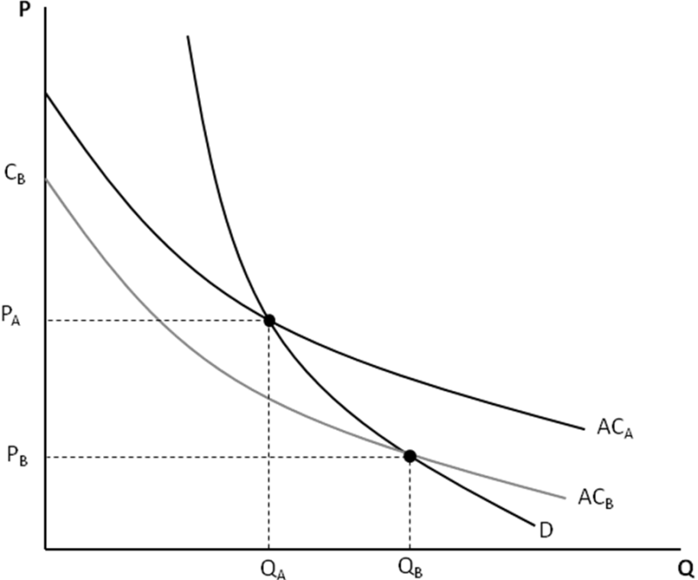

There may be a case made for external economies leading to losses from trade however. Consider the diagram above. Country A is an established producer and produces at quantity Q_{A} and price P_{A}. If Country B were to enter into the industry, it’s initial startup cost would be at C_{B}. Since this is greater than P₁, Country B will import this good. However, if Country B were to be closed off from trade, then production would be at Q_{B} and price would be P_{B}. Thus, trade actually represents a situation worse than autarky for country B and protection may be warranted. However, actually identifying these situations is difficult and protection may lead to unintended consequences (such as retaliatory tariffs).

3. Dynamic increasing returns occur whenever average costs fall with cumulative output. In other words, there exists a learning curve that favors established producers over startups. This is an open ended question, though the examples in question 9 provide some ideas. Two industries characterized by dynamic increasing returns are Biotechnology and Aircraft Design. Biotechnology is an industry in which innovation fuels new products, but it is also one where learning how to successfully take an idea and create a profitable product is a skill set that may require some practice. Aircraft Design requires both innovations to create new planes that are safer and or more cost efficient, but it is also an industry where new planes are often subtle alterations of previous models and where detailed experience with one model may be a huge help in creating a new one.

4. a. The relatively few locations for production suggest external economies of scale in production.
If these operations are large, there may also be large internal economies of scale in production.

b. Since economies of scale are significant in airplane production, it tends to be done by a small number of (imperfectly competitive) firms at a limited number of locations. One such location
is Seattle, where Boeing produces airplanes.

c. Since external economies of scale are significant in semiconductor production, semiconductor industries tend to be concentrated in certain geographic locations. If, for some historical reason, a semiconductor is established in a specific location, the export of semiconductors by that country is due to economies of scale and not comparative advantage.

d. “True” scotch whiskey can only come from Scotland. The production of scotch whiskey requires a technique known to skilled distillers who are concentrated in the region. This labor market pooling suggests external economies of scale. Also, soil and climactic conditions are favorable for grains used in local scotch production. This reflects comparative advantage.

e. France has a particular blend of climactic conditions and land that is difficult to reproduce elsewhere. This generates a comparative advantage in wine production.

5. a. Both countries have identical forward falling supply curves, so the pattern of production will depend entirely on which country establishes its industry first. The country that moves first will have a cost advantage over the other country since it is producing a larger quantity of the good. That country will produce the entire output of the good and export to the second country.

b. Both countries benefit from international trade in this case as the price of the good will be lower when one country produces the entire output as compared to both countries producing half of the output. The only way that the importing country would not benefit from trade is if it were a much more efficient producer than the exporting country (but due to increasing returns, cannot compete with an established industry). However, both countries have the same supply curve so they both gain from trade.

6. The three forces driving external economies of scale are access to specialized suppliers, labor market pooling, and knowledge spillovers. As these forces weaken, so too do the cost advantages of geographic clustering. The location of production becomes increasingly driven by factor costs when industries move away from external economies of scale toward traditional constant returns to scale.

7. Even with higher wages in China, the external economies of scale industries located in China may not move to lower wage countries. Consider Figure 7-4 in the text. China’s average cost curve lies above Vietnam’s reflecting higher wages in China. However, the fact that Chinese industry is established gives it a cost advantage over any Vietnamese firms who would enter into the industry and face an initial cost higher than the established Chinese firms. Production would only shift to Vietnam if China’s average cost curve were to shift up enough so that the new equilibrium price and cost in China lies above the startup cost in Vietnam.

8. Consider again two different scenarios: In scenario 1, there are two firms in the same location and a local labor supply of 200 for both firms. In scenario 2, the two firms are far apart and each firm has a local labor supply of 100. Now suppose that both firms are expanding, increasing their demand for labor up to 150 each. In the first case, each firm will face a local labor shortage of 50 workers (assuming each firm is able to hire 100 workers). In the second case, each firm will experience the same local labor shortage of 50 workers! Thus, locating next to each other does not present any disadvantages over locating far apart when both firms are expanding. There still is, however, an advantage when one firm is expanding and the other is contracting.

9. a. External economies of scale are likely due to the need to have a common pool of labor with technical skills. Dynamic increasing returns may be likely due to the need for continual innovation and learning.

b. External economies are unlikely since it is difficult to see how the costs of a single firm would fall if other firms are present in the asphalt industry. Dynamic increasing returns are also unlikely as the asphalt industry is pretty well established and learning curves are likely to be low.

c. External economies are highly likely because having a great number of support firms and an available pool of skilled labor in filmmaking are critical to film production. Dynamic returns are also likely because film making is an industry in which learning is important.

d. External economies are somewhat likely in that it may be advantageous to have other researchers nearby. Dynamic returns are highly likely because such research builds on itself through a learning-by-doing process.

e. External economies are somewhat likely if there are a set of skills unique to the timber industry that would lead to a clustering of timber firms and timber workers. Dynamic returns are unlikely as the technology used in timber harvesting is relatively stable (i.e. a low learning curve.)

