Chapter 6
The Standard Trade Model

Chapter Organization
A Standard Model of a Trading Economy
Production Possibilities and Relative Supply
Relative Prices and Demand
The Welfare Effect of Changes in the Terms of Trade
Determining Relative Prices
Economic Growth: A Shift of the RS Curve
Growth and the Production Possibility Frontier
World Relative Supply and the Terms of Trade
International Effects of Growth
Case Study: Has the Growth of Newly Industrializing Countries Hurt Advanced Nations?

Tariffs and Export Subsidies: Simultaneous Shifts in RS and RD
Relative Demand and Supply Effects of a Tariff
Effects of an Export Subsidy
Implications of Terms of Trade Effects: Who Gains and Who Loses?
International Borrowing and Lending
Intertemporal Production Possibilities and Trade
The Real Interest Rate
Intertemporal Comparative Advantage
Summary
Appendix: Representing International Equilibrium with Offer Curves
Deriving a Country’s Offer Curve
International Equilibrium

Chapter Overview
Previous chapters have highlighted specific sources of comparative advantage which give rise to international trade. This chapter presents a general model which admits previous models as special cases. This “standard trade model” is the workhorse of international trade theory and can be used to address a wide range of issues. Some of these issues, such as the welfare and distributional effects of economic growth, transfers between nations, and tariffs and subsidies on traded goods are considered in this chapter.
The standard trade model is based upon four relationships. First, an economy will produce at the point where the production possibilities curve is tangent to the relative price line (called the isovalue line). Second, indifference curves describe the tastes of an economy, and the consumption point for that economy is found at the tangency of the budget line and the highest indifference curve. These two relationships yield the familiar general equilibrium trade diagram for a small economy (one which takes as given the terms of trade), where the consumption point and production point are the tangencies of the isovalue line with the highest indifference curve and the production possibilities frontier, respectively.
You may want to work with this standard diagram to demonstrate a number of basic points. First, an autarkic economy must produce what it consumes, which determines the equilibrium price ratio; and second, opening an economy to trade shifts the price ratio line and unambiguously increases welfare. Third, an improvement in the terms of trade increases welfare in the economy. Fourth, it is straightforward to move from a small country analysis to a two country analysis by introducing a structure of world relative demand and supply curves which determine relative prices.
These relationships can be used in conjunction with the Rybczynski and the Stolper-Samuelson Theorems from the previous chapter to address a range of issues. For example, you can consider whether the dramatic economic growth of countries like Japan and Korea has helped or hurt the United States as a whole, and also identify the classes of individuals within the United States who have been hurt by the particular growth biases of these countries. In teaching these points, it might be interesting and useful to relate them to current events. For example, you can lead a class discussion of the implications for the United States of the provision of forms of technical and economic assistance to the emerging economies around the world or the ways in which a world recession can lead to a fall in demand for U.S. export goods.
The example provided in the text considers the popular arguments in the media that growth in Japan or Korea hurts the United States. The analysis presented in this chapter demonstrates that the bias of growth is important in determining welfare effects rather than the country in which growth occurs. The existence of biased growth, and the possibility of immiserizing growth is discussed. The Relative Supply (RS) and Relative Demand (RD) curves illustrate the effect of biased growth on the terms of trade. The new terms
of trade line can be used with the general equilibrium analysis to find the welfare effects of growth. A general principle which emerges is that a country which experiences export-biased growth will have a deterioration in its terms of trade, while a country which experiences import-biased growth has an improvement in its terms of trade. A case study points out that growth in the rest of the world has made other countries more like the United States. This import-biased growth has worsened the terms of trade for the United States.

The second area to which the standard trade model is applied are the effects of tariffs and export subsidies on welfare and terms of trade. The analysis proceeds by recognizing that tariffs or subsidies shift both the relative supply and relative demand curves. A tariff on imports improves the terms of trade, expressed in external prices, while a subsidy on exports worsens terms of trade. The size of the effect depends upon the size of the country in the world. Tariffs and subsidies also impose distortionary costs upon the economy. Thus, if a country is large enough, there may be an optimum, non-zero tariff. Export subsidies, however, only impose costs upon an economy. Internationally, tariffs aid import-competing sectors and hurt export sectors while subsidies have the opposite effect.
The chapter then closes with a discussion of international borrowing and lending. The standard trade model is adapted to trade in consumption across time. The relative price of future consumption is defined as 1/(1+r), where r is the real interest rate. Countries with relatively high real interest rates (newly industrializing countries with high investment returns for example) will be biased toward future consumption, and will effectively “export” future consumption by borrowing from established developed countries with relatively lower real interest rates.

Answers to Textbook Problems

1.

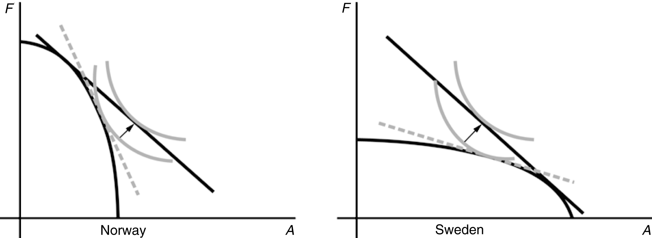

Note how welfare in both countries increases as the two countries move from production
patterns governed by domestic prices (dashed line) to production patterns governed by world
prices (straight line).

2.

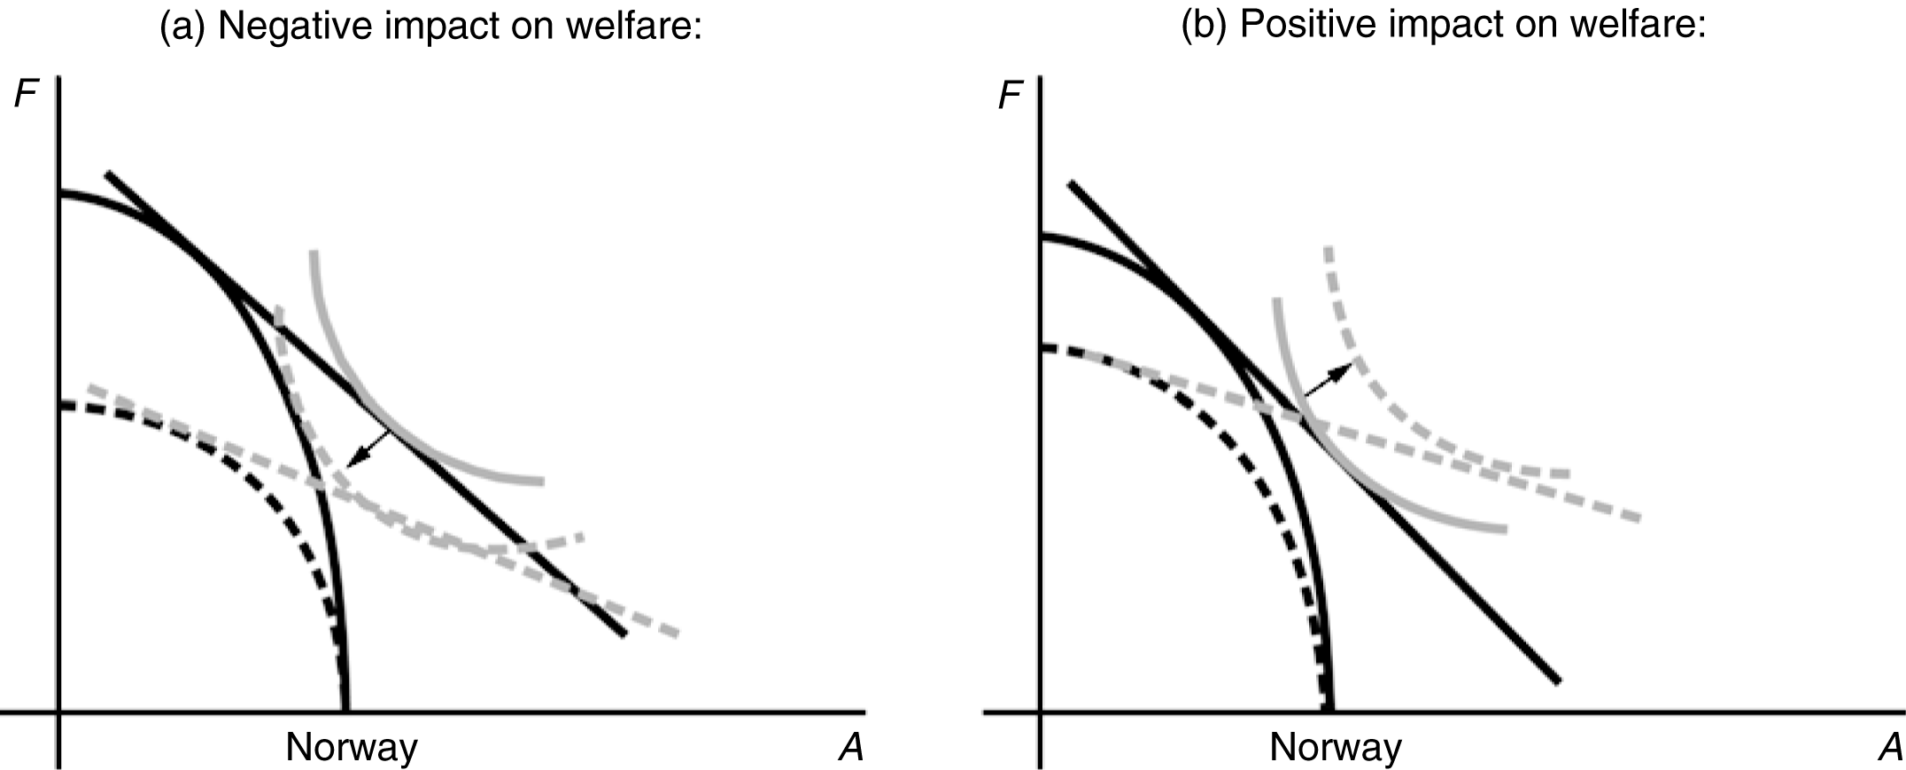

In panel a, the reduction of Norway’s production possibilities away from fish cause the production of fish relative to automobiles to fall. Thus, despite the higher relative price of fish exports, Norway moves down to a lower indifference curve representing a drop in welfare.

In panel b, the increase in the relative price of fish shifts causes Norway’s relative production of fish to rise (despite the reduction in fish productivity). Thus, the increase in the relative price of fish exports allows Norway to move to a higher indifference curve and higher welfare.

3. An increase in the terms of trade increases welfare when the PPF is right-angled. The production point is the corner of the PPF. The consumption point is the tangency of the relative price line and the highest indifference curve. An improvement in the terms of trade rotates the relative price line about its intercept with the PPF rectangle (since there is no substitution of immobile factors, the production point stays fixed). The economy can then reach a higher indifference curve. Intuitively, although there is no supply response, the economy receives more for the exports it supplies and pays less for the imports it purchases.

4. The difference from the standard diagram is that the indifference curves are right angles rather than smooth curves. Here, a terms of trade increase enables an economy to move to a higher indifference curve. The income expansion path for this economy is a ray from the origin. A terms of trade improvement moves the consumption point further out along the ray.

5. The terms of trade of Japan, a manufactures (M) exporter and a raw materials (R) importer, is the world relative price of manufactures in terms of raw materials (p_{M}/p_{R}). The terms of trade change can be determined by the shifts in the world relative supply and demand (manufactures relative to raw materials) curves. Note that in the following answers, world relative supply (RS) and relative demand (RD) are always M relative to R. We consider all countries to be large, such that changes affect the world relative price.

a. Oil supply disruption from the Middle East decreases the supply of raw materials, which increases the world relative supply of manufactures to raw materials. The world relative supply curve shifts out, decreasing the world relative price of manufactured goods and deteriorating Japan’s terms of trade.

b. Korea’s increased automobile production increases the supply of manufactures, which increases the world RS. The world relative supply curve shifts out, decreasing the world relative price of manufactured goods and deteriorating Japan’s terms of trade.

c. U.S. development of a substitute for fossil fuel decreases the demand for raw materials. This increases world RD, and the world relative demand curve shifts out, increasing the world relative price of manufactured goods and improving Japan’s terms of trade. This occurs even if no fusion reactors are installed in Japan since world demand for raw materials falls.

d. A harvest failure in Russia decreases the supply of raw materials, which increases the world RS. The world relative supply curve shifts out. Also, Russia’s demand for manufactures decreases, which reduces world demand so that the world relative demand curve shifts in. These forces decrease the world relative price of manufactured goods and deteriorate Japan’s terms of trade.

e. A reduction in Japan’s tariff on raw materials will raise its internal relative price of manufactures (p_{M}/p_{R}). This price change will increase Japan’s RS and decrease Japan’s RD, which increases the world RS and decreases the world RD (i.e., world RS shifts out and world RD shifts in). The world relative price of manufactures declines and Japan’s terms of trade deteriorate.

6. The declining price of services relative to manufactured goods shifts the isovalue line clockwise so that relatively fewer services and more manufactured goods are produced in the United States, thus reducing U.S. welfare.

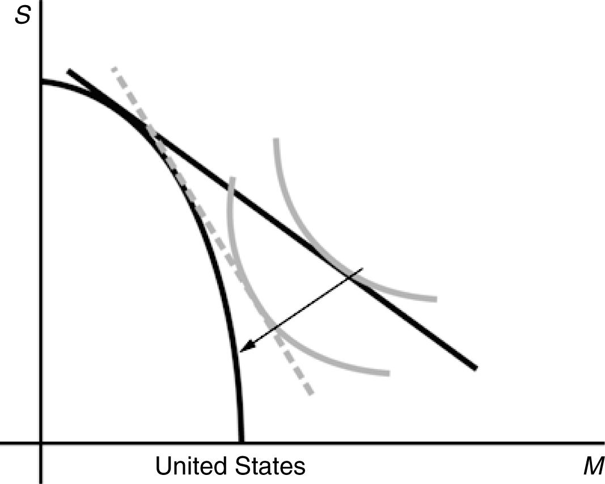

7. These results acknowledge the biased growth which occurs when there is an increase in one factor of production. An increase in the capital stock of either country favors production of Good X, while an increase in the labor supply favors production of Good Y. Also, recognize the Heckscher-Ohlin result that an economy will export that good which uses intensively the factor which that economy has in relative abundance. Country A exports Good X to Country B and imports Good Y from Country B.
The possibility of immiserizing growth makes the welfare effects of a terms of trade improvement due to export-biased growth ambiguous. Import-biased growth unambiguously improves welfare for the growing country.

a. The relative price of good X falls, causing country A’s terms of trade to worsen. A’s welfare may increase or, less likely, decrease, and B’s welfare increases.

b. The relative price of good Y rises, causing A’s terms of trade to improve. A’s welfare increases and B’s welfare decreases.

c. The relative price of good X falls, causing country B’s terms of trade to improve. B’s welfare increases and A’s welfare decreases (they earn less for the same quantity of exports).

d. The relative price of good X rises, causing country B’s terms of trade to worsen. B’s welfare may increase or, less likely, decrease, and A’s welfare increases.

8. Immiserizing growth occurs when the welfare deteriorating effects of a worsening in an economy’s terms of trade swamp the welfare improving effects of growth. For this to occur, an economy must undergo very biased growth, and the economy must be a large enough actor in the world economy such that its actions spill over to adversely alter the terms of trade to a large degree. This combination of events is unlikely to occur in practice.

9. India opening should be good for the U.S. if it reduces the relative price of goods that China sends to the U.S. and hence increases the relative price of goods that the U.S. exports. Obviously, any sector in the U.S. hurt by trade with China would be hurt again by India, but on net, the U.S. wins. Note that here we are making different assumptions about what India produces and what is tradable than we are in Question #6. Here we are assuming India exports products the U.S. currently imports and China currently exports. China will lose by having the relative price of its export good driven down by the increased production in India.

10. What matters for welfare are the external terms of trade. Suppose that country X exports good A and imports good B, while country Y exports good B and imports good A. The export subsidy in country X will raise the internal price of the export good A, leading to an increase in production of good A and decrease demand of good A. As a result, the world price of the good A falls. The tariff on good A in country Y will increase production and decrease demand for good A in country Y, leading to a reduction in the world price of good A relative to good B. Thus, the terms of trade in country X falls and the terms of trade in country Y rise. Country X is worse off, while Country Y is better off.

If instead country Y had imposed an export subsidy on good B, then the internal price of good B would rise. Production of good B rises and demand for good B falls. As a result, the world price of good B falls. The net effect on welfare is ambiguous and depends on the relative declines in the world prices of goods A and B.

11. International borrowing and lending implies a tradeoff between the production of current and future consumption much like trade in goods implies a tradeoff between production of different goods. The more current consumption you select the less future consumption you will be able to engage in. International borrowing and lending is driven by differences between countries in intertemporal preferences much like international trade is driven by differences between countries in technology or factor endowments. Countries with a relative preference for current consumption will “export” current consumption in exchange for future consumption. In other words, these countries will borrow in the current period from countries that have a relative preference for future consumption. Much like international trade, the relative amount of current consumption that is traded for future consumption is determined by the relative price of future consumption, defined as 1/(1+r), where r is the real interest rate.

12. Comparative advantage in international borrowing and lending is driven by the relative price of future consumption, and more specifically, the real interest rate. As the real interest rate rises, the relative price of future consumption 1/(1+r) falls. Effectively, a country with a high real interest rate is one that has high returns on investment. Such a country will prefer to borrow today and take advantage of the high return on investment and enjoy the fruits of current investment with high returns in the future.

a. Countries like Argentina and Canda should have high real interest rates as there are large investment opportunities that have yet to be exploited. These countries will have a low price of future consumption and will be biased toward future consumption, preferring to borrow today.

b. Countries like the UK in the 19th century or the US today will have relatively lower real interest rates as they already have a high level of capital and limited returns on new investments. As a result, the relative price of future consumption is high and they will be biased toward present consumption.

