Chapter 14
Money, Interest Rates, and Exchange Rates

n Chapter Organization
Money Defined: A Brief Review
Money as a Medium of Exchange
Money as a Unit of Account
Money as a Store of Value
What Is Money?
How the Money Supply Is Determined
The Demand for Money by Individuals
Expected Return
Risk
Liquidity
Aggregate Money Demand
The Equilibrium Interest Rate: The Interaction of Money Supply and Demand
Equilibrium in the Money Market
Interest Rates and the Money Supply
Output and the Interest Rate
The Money Supply and the Exchange Rate in the Short Run
Linking Money, the Interest Rate, and the Exchange Rate
U.S. Money Supply and the Dollar/Euro Exchange Rate
Europe’s Money Supply and the Dollar/Euro Exchange Rate
Money, the Price Level, and the Exchange Rate in the Long Run
Money and Money Prices
The Long-Run Effects of Money Supply Changes
Empirical Evidence on Money Supplies and Price Levels
Money and the Exchange Rate in the Long Run
Inflation and Exchange Rate Dynamics
Short-Run Price Rigidity versus Long-Run Price Flexibility
Box: Money Supply Growth and Hyperinflation in Bolivia
Permanent Money Supply Changes and the Exchange Rate
Exchange Rate Overshooting
Case Study: Can Higher Inflation Lead to Currency Appreciation? The Implications of Inflation Targeting
Summary

n Key Themes
This chapter combines the foreign exchange market model of the previous chapter with an analysis of the demand for and supply of money to provide a more complete analysis of exchange rate determination in the short run. The chapter also introduces the concept of the long-run neutrality of money which states that, in the long run, changes in money supply will have no permanent effect on real variables such as the real GNP, interest rates, or the real exchange rate. Combining the short-run analysis with the long-run neutrality of money allows us to examine the dynamics of the exchange rate, that is the movement of the exchange rate over time.
The chapter begins by reviewing the roles played by money. Money facilitates transactions, and an important part of the demand for it reflects this. Since money is demanded for the purchasing power it provides, money demand is a demand for real money balances, which are nominal balances divided by the price level (M/P). An increase in GNP reflects an increase in the number or size of transactions that people want to undertake, and thus money demand rises with GNP. Money also serves as a way to store wealth over time, but in this role it is overshadowed by other ways to store wealth that pay interest. As the interest rate rises, the opportunity cost of holding money rather than other assets also rises, and so money demand decreases with an increase in the interest rate.

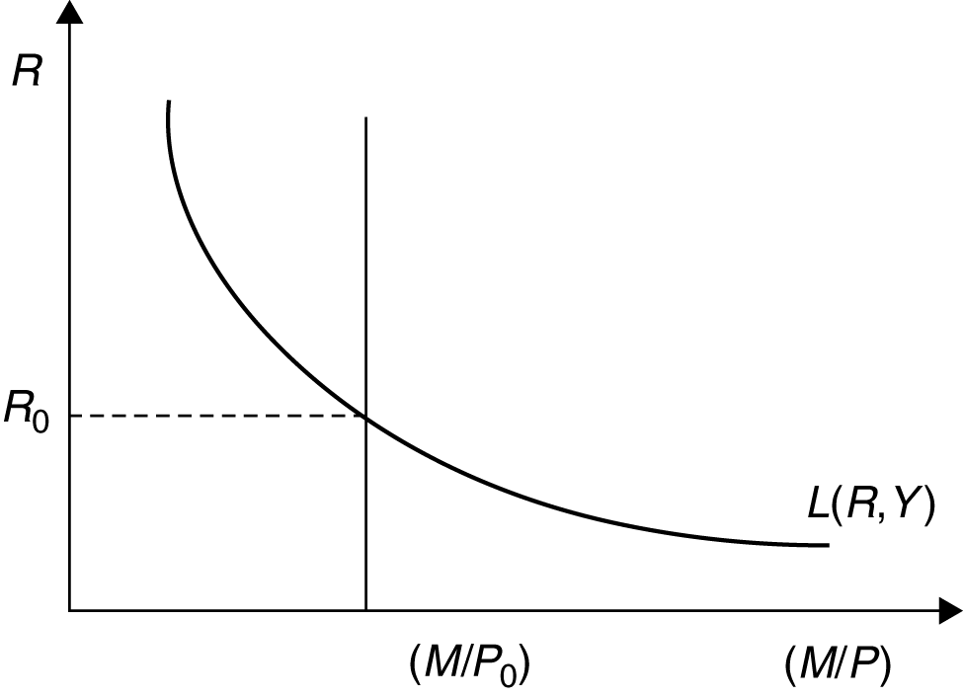

Figure 14-1
These two effects are summarized in the function L(R,Y) which increases with an increase in Y and decreases with an increase in R. The supply of nominal money balances is determined by the central bank. Money-market equilibrium—the equality of real money demand and the supply of real money balances—determines the equilibrium interest rate, as shown in the money market equilibrium Figure 14-1 where the equilibrium interest rate, R₀, reflects the interaction of money demand, L(R,Y), and the supply of money equal to (M₀/P₀).
Combining the diagram portraying money-market equilibrium with the interest rate parity diagram presented in the previous chapter gives us a model of monetary influences on exchange rate determination, as shown below. The domestic interest rate, determined in the domestic money market, affects the exchange rate through the interest parity mechanism. Thus, an increase in domestic money supply from (M₀/P₀) to (M₁/P₀) leads to a fall in the domestic interest rate from R₀ to R₁. The home currency depreciates from E₀ to E₁. At this new equilibrium, interest parity holds. With a fixed future exchange rate, the exchange rate depreciation implies an expected future appreciation, and this expected appreciation equates expected returns on interest-bearing assets denominated in domestic currency and in foreign currency. By simply reversing the steps of this argument, you can see how a contraction in the money supply leads to an exchange rate appreciation.

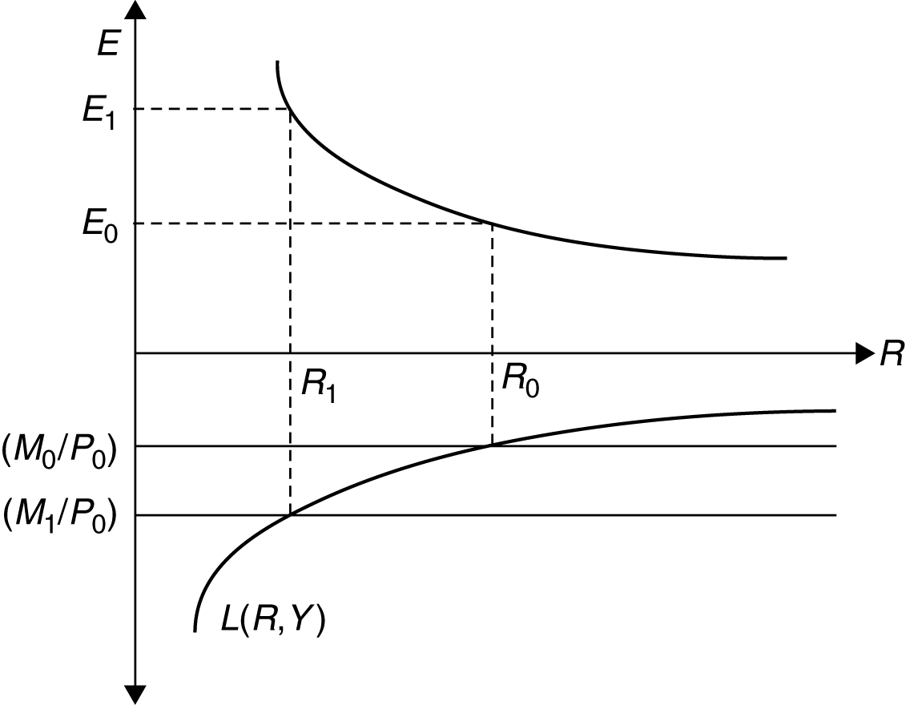

Figure 14-2
The chapter next describes the movement in the exchange rate over time in response to a permanent change in the money supply. The long-run neutrality of money is used to tie down the ultimate effect of monetary changes. The long-run neutrality of money is a condition that states that all else equal, a permanent increase in the money supply affects only the general price level—and not interest rates, relative prices, or real output—in the long run. Money prices, including, importantly, the money prices of foreign currencies, move in the long run in proportion to any change in the money supply’s level. Thus, an increase in the money supply ultimately results in a proportional exchange rate depreciation and a decrease in the money supply ultimately results in a proportional exchange rate appreciation.
The long-run neutrality of money is instrumental in understanding an important difference between permanent and temporary changes in money supply. Since a permanent increase in the money supply ultimately changes the long-run value of the exchange rate, it also has an effect on today’s expectation
of the future exchange rate. We saw in the previous chapter how expectations of the future value of the exchange rate affect its value today; for example, when the expected future value of the exchange rate becomes more depreciated, the interest parity curve shifts out and to the right, and, at any interest rate, the exchange rate depreciates today. Incorporating these types of effects in our model enables us to consider exchange rate dynamics.
One dynamic result which emerges from our model is exchange rate overshooting in response to a permanent change in the money supply. For example, consider a permanent money-supply expansion. There are two immediate effects of this; the interest rate falls due to the increase in real balances from (M₀/P₀) to (M₁/P₀) and expectations of a proportional long-run currency depreciation shift the interest parity curve out from
I₀ to I₁. Thus the immediate effect is a depreciation of the exchange rate from its initial value of E₀ to E₁ as the equilibrium point in the top half of the diagram moves from point 0 to point 1. Foreign-exchange market equilibrium requires an initial depreciation of the currency large enough to equate expected returns on foreign and domestic bonds and since the domestic interest rate falls in the short run from R₀ to R₁, the currency must actually appreciate beyond (and thus overshoot) its new expected long-run level to maintain interest parity. Over time, money neutrality tells us that real balances must return to their original level, so
domestic prices rise and M/P falls, the interest rate returns to its previous level and the exchange rate falls (appreciates) back to its long-run level (E₂), higher than the starting point, but not as high as the initial reaction. The real exchange rate does not change in the long run since the more depreciated value of the nominal exchange rate is matched by a higher long-run price level.

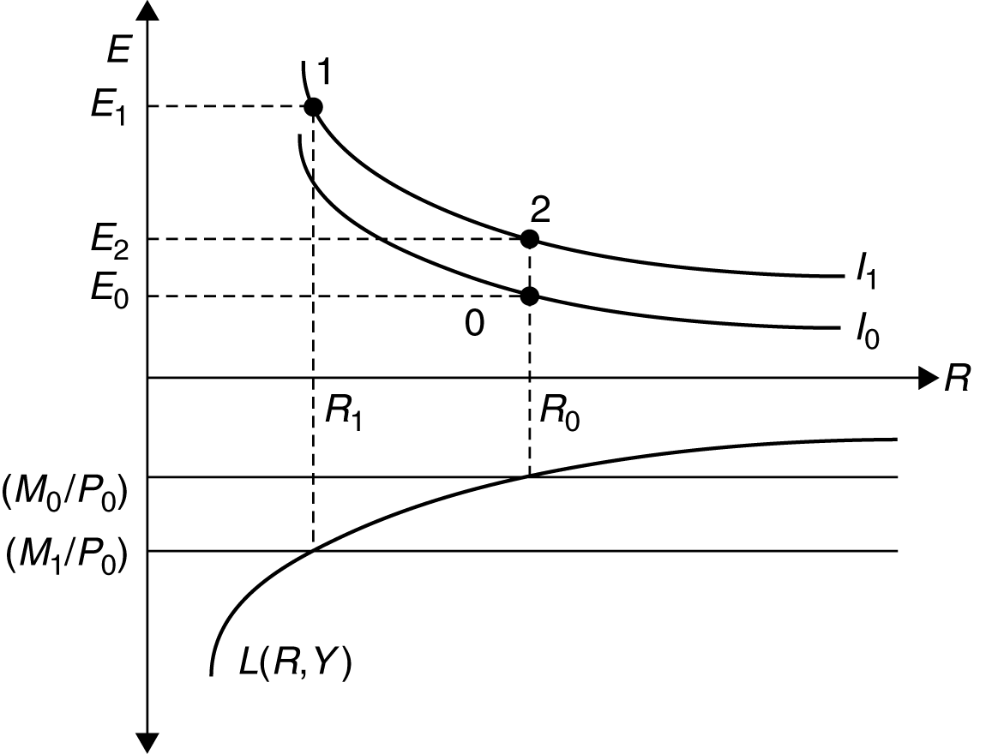

Figure 14-3
The chapter concludes with a useful case study that helps bridge the gap between the stylized world of the model and the real world of central bank policy making where the central bank sets the interest rate rather than money and news about inflation may change expectations about future money supply changes when the central bank has committed to a particular level of inflation.

n Key Terms
Define the following key terms:

1. Money Supply

.

2. Aggregate Money Demand

.

3. Short Run

.

4. Long Run

.

5. Exchange-Rate Overshooting

.

n Review Questions

1. The following data is for the small country of Lilliput:
Year | Money  Supply | Price  Level | Nominal  Interest Rate | GNP
1997 | 1000 | 100 | 8% | 1000
1998 | 1500 | 100 | 6% | 1200
1999 | 1500 | 150 | 8% | 1000
2000 | 1500 | 200 | 12% | 700
2001 | 2000 | 200 | 8% | 1000

a. Draw a money demand schedule and a money supply schedule for Lilliput in 1997 in the graph below. Make sure that the equilibrium corresponds to the data given in the table.

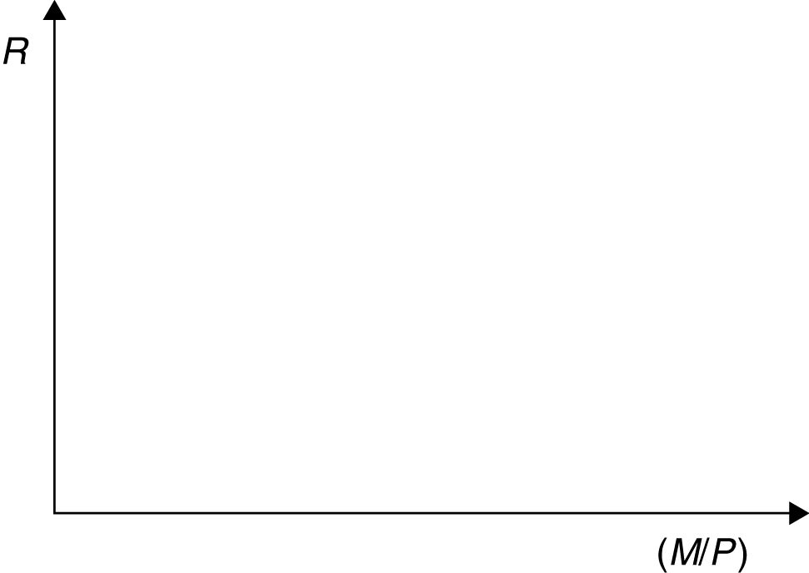

Graph 1

b. Now use a dashed line to draw, in Graph 1, the money demand and money supply schedules
for 1998. Be sure that the intersection of the money demand and money supply schedules correspond to the equilibrium level of real money balances and the nominal interest rate given
in the Lilliput data.

c. Would you need to draw another money demand schedule and money supply schedule in Graph 1 to depict the situation in Lilliput in 1999? Discuss why or why not, noting that the values of at least some of the variables in 1999 differ from their values in both 1997 and 1998.

.

d. In Graph 1d, draw a money demand and money supply schedule for Lilliput for 2000, using a solid line for each. Then use a dashed line to show the money demand and money supply schedules for 2001.

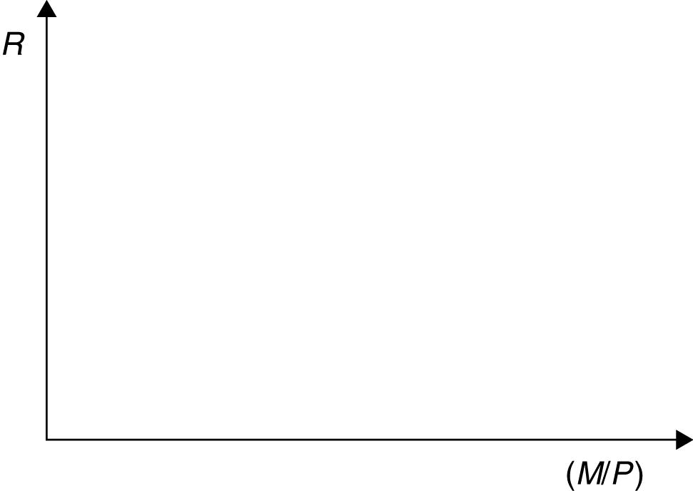

Graph 1d

2. Graphs 2-1 through 2-3 represent initial schedules for the money demand, money supply, and interest parity schedules such that the equilibrium interest rate is R in each graph and the equilibrium exchange rate is E in each graph. Change one or more lines in the graph, as needed, to represent each of the following.

a. A temporary increase in the money supply.

b. An increase in the price level.

c. A decrease in expected future exchange rates.

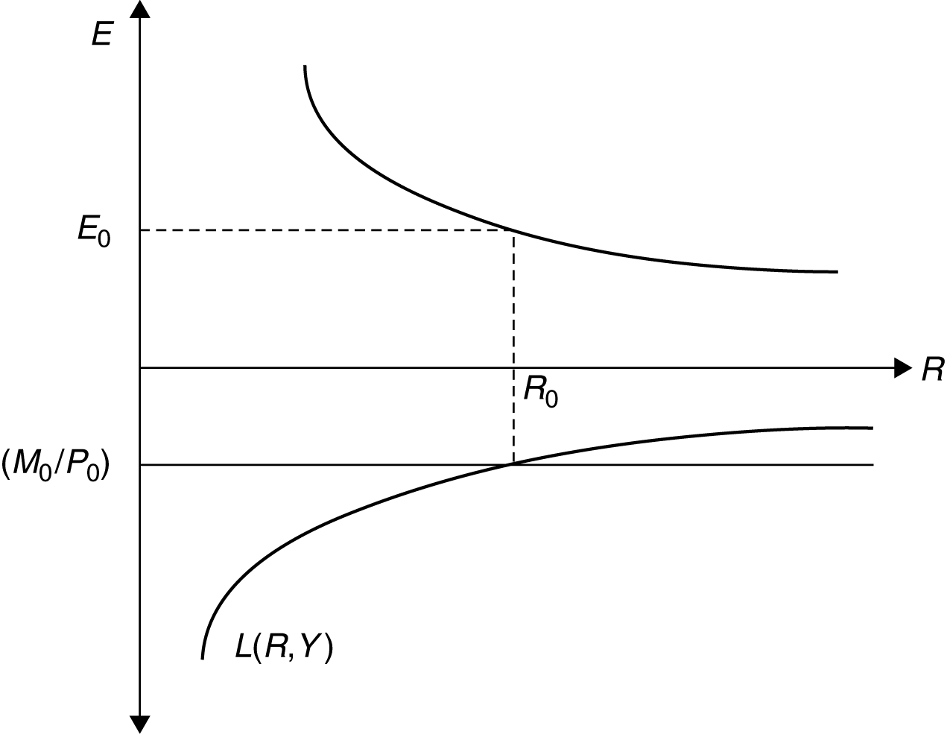

Graph 2-1

Graph 2-2

Graph 2-3

3. Fill in the following table with an I (for increase), N (for no change), or D (for decrease) to show the effects of a permanent increase in the money supply on each of the following variables in the short run and in the long run. (“Exchange Rate” is represented by “E.R.”)

 | Short-Run Effect | Long-Run Effect
Prices | ______ | ______
Output | ______ | ______
Nominal E.R. | ______ | ______
Real E.R. | ______ | ______
Real Money Balances | ______ | ______

4. Graph 4-1 demonstrates an equilibrium where the money supply is $400 million, the U.S. price level is equal to 100, the U.S. interest rate is 7%, and the U.S. dollar/U.K. pound exchange rate equals its long-run expected level of 2. Not shown in the graph is the U.K. price level, which is equal to 50.

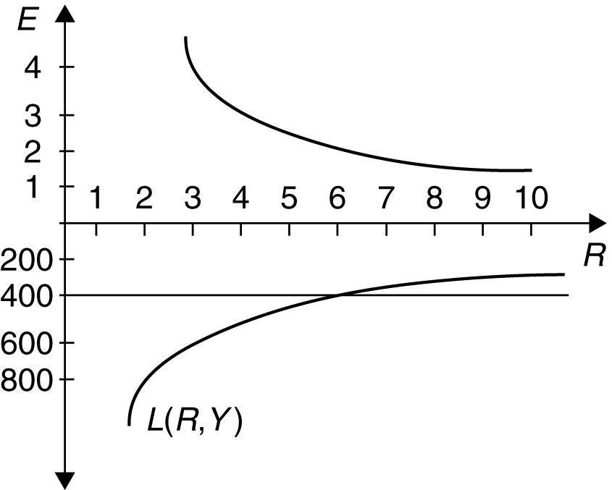

Graph 4-1

a. Demonstrate the immediate effect of a temporary decrease in the money supply to $300 in
Graph 4-1. Discuss the immediate effect on the nominal and real exchange rates.

.

b. Now suppose instead that the decrease in the money supply to $300 million is permanent rather than temporary. How does the immediate effect of this permanent change differ from the immediate effect of the temporary change discussed in your answer to part (a)?

.

c. What is the long-run value of the U.S. price level, the U.S. interest rate, and the dollar/pound exchange rate in response to the permanent decrease in the U.S. money supply to $300 million?

.

d. Continuing with your analysis of the effects of a permanent decrease in the money supply, show what happens in Graph 4-1 over time. Use the information you obtain in your analysis to fill in the time Graphs 4-3 and 4-4 when the money supply follows the permanent change shown in the time Graph 4-2.

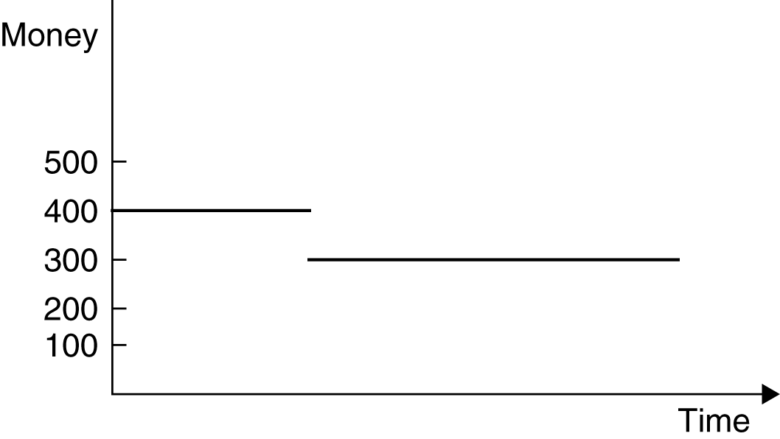

Graph 4-2

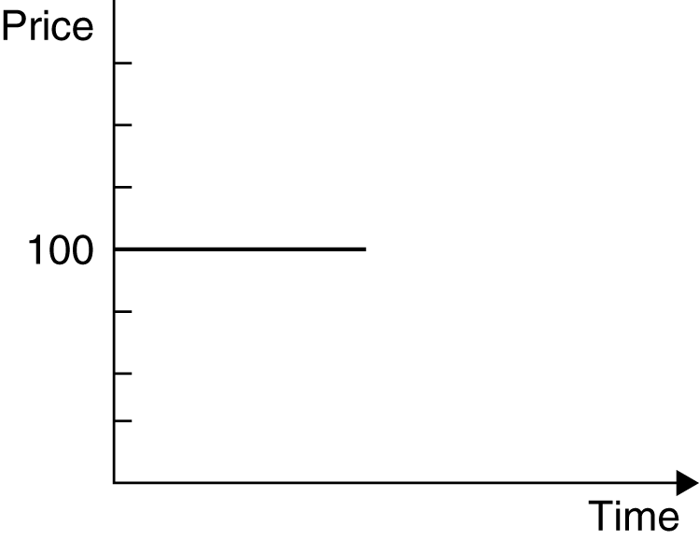

Graph 4-3

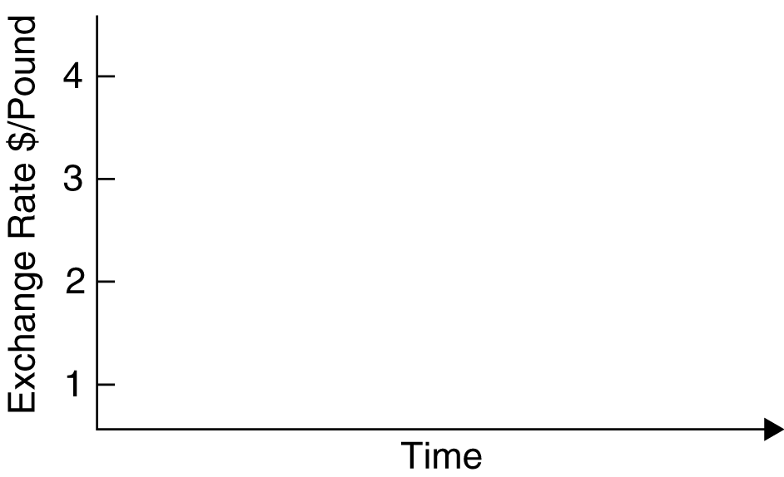

Graph 4-4

n Answers to Odd-Numbered Textbook Problems

1. A reduction in real money demand has the same effects as an increase in the nominal money supply. In Figure 14-4, the reduction in money demand is depicted as a backward shift in the money demand schedule from L₁ to L₂. The immediate effect of this is a depreciation of the exchange rate from E₁ to E₂, if the reduction in money demand is temporary, or a depreciation to E₃ if the reduction is permanent. The larger impact effect of a permanent reduction in money demand arises because this change also affects the future exchange rate expected in the foreign exchange market. In the long run, the price level rises to bring the real money supply into line with real money demand, leaving all relative prices, output, and the nominal interest rate the same and depreciating the domestic currency in proportion to the fall in real money demand. The long-run level of real balances is (M/P₂), a level where the interest rate in the long run equals its initial value. The dynamics of adjustment to a permanent reduction in money demand are from the initial point 1 in the diagram, where the exchange rate is E₁, immediately to point 2, where the exchange rate is E₃ and then, as the price level falls over time, to the new long-run position at point 3, with an exchange rate of E₄.

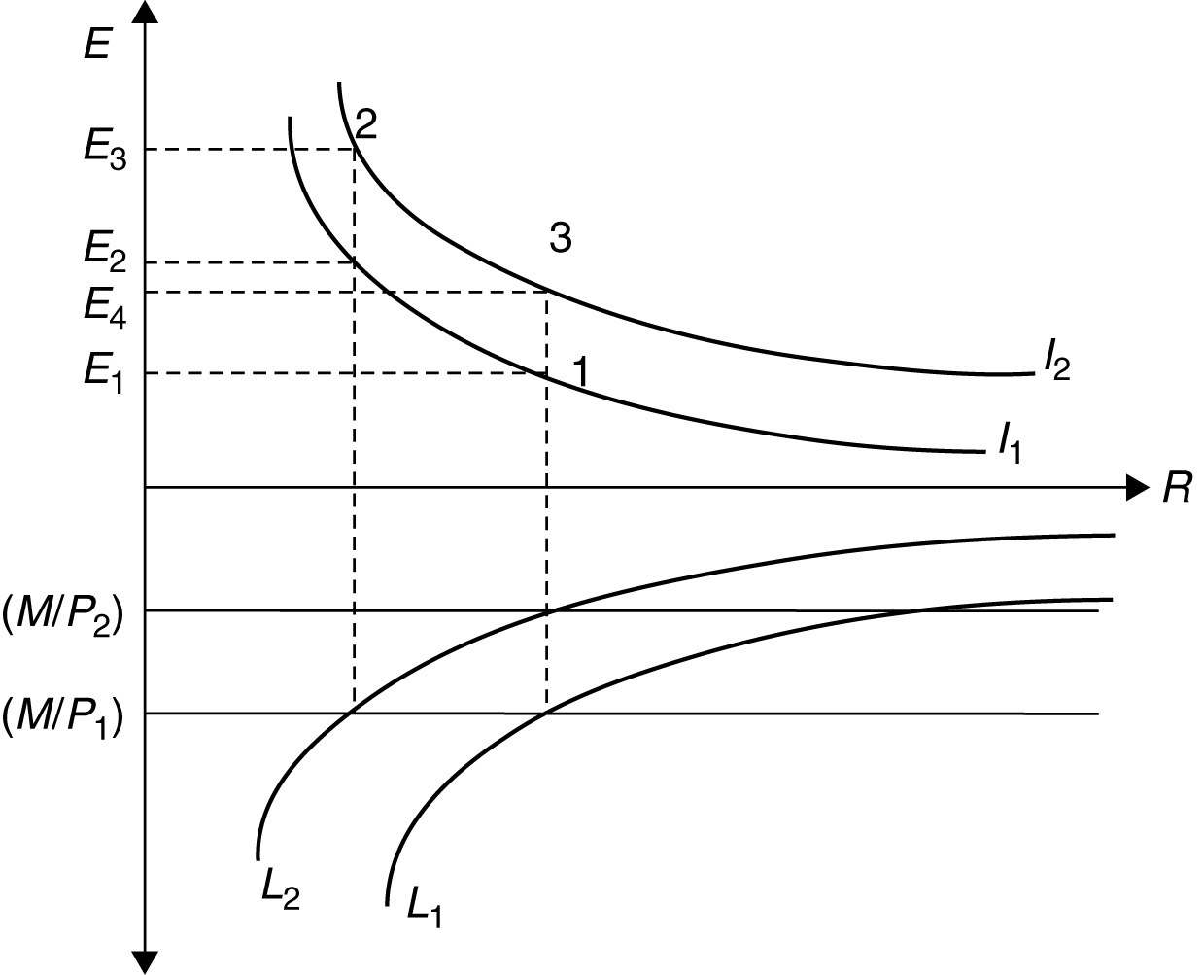

Figure 14-4

3. Equation 14-4 is M^{s}/P = L(R,Y). The velocity of money, V = Y/(M/P). Thus, when there is equilibrium in the money market such that money demand equals money supply, V = Y/L(R,Y). When R increases, L(R,Y) falls and thus velocity rises. When Y increases, L(R,Y) rises by a smaller amount (since the elasticity of aggregate money demand with respect to real output is less than one) and the fraction Y/L(R,Y) rises. Thus, velocity rises with either an increase in the interest rate or an increase in income. Since an increase in interest rates as well as an increase in income cause the exchange rate to appreciate, an increase in velocity is associated with an appreciation of the exchange rate.

5. Just as money simplifies economic calculations within a country, use of a vehicle currency for international transactions reduces calculation costs. More importantly, the more currencies used in trade, the closer the trade becomes to barter, since someone who receives payment in a currency she does not need must then sell it for a currency she needs. This process is much less costly when there is a ready market in which any nonvehicle currency can be traded against the vehicle currency,
which then fulfills the role of a generally accepted medium of exchange.

7. The interest rate at the beginning and at the end of this experiment are equal. The ratio of money to prices (the level of real balances) must be higher when full employment is restored than in the initial state where there is unemployment: the money-market equilibrium condition can be satisfied only with a higher level of real balances if GNP is higher. Thus, the price level rises, but by less than twice its original level. If the interest rate were initially below its long-run level, the final result will be one with higher GNP and higher interest rates. Here, the final level of real balances may be higher or lower than the initial level, and we cannot unambiguously state whether the price level has more than doubled, less than doubled, or exactly doubled.

9. Velocity is defined as real income divided by real balances or, equivalently, nominal income divided by nominal money balances (V = P*Y/M). Velocity in Brazil in 1985 was 13.4 (1418/106.1) while velocity in the United States was 6.3 (4010/641). These differences in velocity reflected the different costs of holding cruzados compared to holding dollars. These different costs were due to the high inflation rate in Brazil which quickly eroded the value of idle cruzados, while the relatively low inflation rate in the United States had a much less deleterious effect on the value of dollars.

11. We saw in Chapter 14 that as the interest rate falls, people prefer to hold more cash and fewer financial assets. If interest rates were to fall below zero, people would strictly prefer cash to financial assets as the zero return on cash would dominate any negative return. Thus, interest rates cannot fall below zero because no one would hold a financial asset with a negative rate of return when another asset at a zero rate of return (cash) exists.

13. a. If money adjusts automatically to changes in the price level, then any number of combinations of money and prices could satisfy the money supply/money demand equations. There would be no unique solution.

b. Yes, a rule such as this one would help anchor the price level and imply there is no longer an infinite number of money and price combinations that could satisfy money supply and money demand.

c. A one time permanent unexpected fall in “u” would imply that R would have to fall until prices have a chance to rise and balance out the equation. As prices rise, R would return to its initial level. The story described is essentially identical to that in Figure 14-13. The interest rate would drop and then rise slowly over time and the price level would start out static and then rise over time. The exchange rate should overshoot (assuming that expectations are tied to future prices in the same way they are described in the text).

